Evaluated UVA Irradiances over a Twelve Year Period at a Sub-tropical Site from Ozone Monitoring Instrument Data Including the Influence of Cloud

A Jebar, M. A.¹, Parisi, A. V., ^{1,*} Downs. N. J¹ and Turner, J.¹

¹Faculty of Health, Engineering and Sciences, University of Southern Queensland, Toowoomba, Queensland

*Corresponding author: Email: parisi@usq.edu.au

ABSTRACT
This research investigated the influence of cloud on the broadband UVA solar noon irradiances evaluated from the solar noon satellite based OMI spectral UV data that were compared to the irradiances of a ground-based radiometer from 1 October 2004 to 31 December 2016. The correlation between ground-based radiometer data and the evaluated OMI broadband UVA data evaluated with a model were dependent on whether or not the solar disc was obscured by the presence of cloud and the total sky cloud fraction. For conditions when the sun was not obscured by cloud, the evaluated satellite and the ground-based UVA irradiance correlation was best for cloud cover between 0-2 octa (R² = 0.77) and the worst for high cloud cover of >4 to 8 octa (R² between 0.3 and 0.4). The R² reduced with increasing cloud amount and showed significantly weaker correlation when the sun was obscured. The correlation between the evaluated satellite broadband UVA and the ground-based measurements over the twelve years for total cloud cover conditions of 4 or less octa confirmed that the broadband UVA satellite evaluation model for the OMI spectral data is valid for approximately 71% of the days at the Southern Hemisphere sub-tropical study site.

Keywords: Satellite; UVA; Cloud; OMI; Irradiance; UV

INTRODUCTION
The earth’s surface is exposed to a significant quantity of solar ultraviolet (UV) radiation, with 8-9% of the available total global solar irradiance reaching the top of the earth’s atmosphere [1]. Of this radiation, UVA radiation (defined here as the greatest portion of UVA, specifically from 320 nm to 400 nm) is the dominant component making up 6.3% of the available irradiance and, unlike the shorter wavelength UVB (280 nm to 320 nm), which is strongly attenuated by stratospheric ozone, is mostly transmitted to the earth’s surface without absorption. UVA however is prone to scattering and attenuation by aerosols, water droplets and ice crystals in tropospheric cloud layers and experiences natural fluctuations in magnitude depending on total cloud fraction and cloud optical depth.

UV radiation, including UVA is potentially damaging to several biological systems on the earth affecting human health, aquatic ecosystems and plant species ([2], [3], [4], [5], [6] and [7]). In addition, solar ultraviolet, especially UVB radiation, negatively affects physical material properties by photo-degradation that lead to a decrease in the quality of materials such as wood, paper, biopolymers and plastics (polymers) [8]. Consequently, this could decrease the outdoor service life of these materials. Satellite based monitoring of UV and the associated atmospheric influencing factors play an important role by providing ongoing measurements of wide spatially diverse regions not able to be monitored at the surface locally. Effective satellite monitoring that takes into account variation in local atmospheric profiles that affect surface measurements requires validation to ground based UV monitoring stations [9].

Kazantzidis et al. (2006) [10] have conducted a comparison between the Total Ozone Mapping Spectrometer (TOMS) UV data and four-ground stations in Europe depending on the cloud conditions. This study has shown a 15% overestimation for TOMS when the value of cloud optical depth is lower than five for most conditions. Cloud optical depth is a measure of the amount of attenuation of the solar radiation as it passes through the atmosphere due to the influence by clouds [11]. It depends on the thickness of the cloud, the moisture content and makeup and size of the cloud particles [12]. Anton et al. (2011) [13] have measured simultaneous total ozone column (TOC) data which were taken from the GOME-2 (Global Ozone Monitoring Experiment) and Infrared Atmospheric Sounding Interferometer (IASI) satellites compared to five calibrated Brewer instruments located on the Iberian Peninsula in Spain. This study showed GOME-2 provides a slight underestimation of the Brewer ozone data by 1.6%. In contrast, IASI clearly overestimated Brewer surface measurements by 4.4%. These differences are attributed to the differences between the vertical sensitivity of IASI and GOME-2. However, in general, the performance of GOME-2 and IASI present an excellent agreement of column ozone data with ground-based instruments, especially in cloud-free conditions. Cochorro et al. (2010) [14] have addressed the comparison between the satellite based TOMS and Ozone Monitoring Instrument (OMI), with Brewer instruments located at a station in the south of Spain. The measurements were taken from 2004 to 2008 for three wavelengths: two wavelengths within the UVB range (305, 310 nm) and one within the UVA range (324 nm). In this case, Brewer measurements overestimated satellite data from 10 to 15% for all UV wavelengths and included an approximate 13% overestimation of the erythemal UV. Many factors were attributed to this difference including cloud conditions, aerosols, ozone and solar elevation. Kazadzis et al. (2009) [15] have presented a comparison of the UV measurements of OMI and ground based instruments located in urban areas (Thessaloniki, Greece). This study considered data from 2004 to 2007. The results showed a large OMI overestimation in the UVB where 305 nm was overestimated by 30% for all sky conditions (clear and cloudy), with lower overestimation in the more abundant surface UVA with overestimates at 324 and 380 nm reaching 20% and 16% respectively. Kerr et al. (2002) [16] have provided a comparison between UV measurements of Brewer instruments, located in different Canadian areas and UV measurements of TOMS, with differences ranging from 3 to 11%. This study attributed these differences to many predictable factors that could affect the results such as solar zenith angle (SZA), clouds, angular response error, calibration errors, local microclimate and aerosols. McKenzie et al. (2001) [17] focused on the differences of UV dose measurements between satellite (TOMS) and ground-based instruments in the southern and northern hemisphere. This study found that the values of ground-based instruments were less than the satellite values at most surface sites while in some unpolluted sites there was satisfactory agreement between satellite and ground-based measurements. In addition, southern hemisphere sites have better agreement due to lower ozone and less pollution. These differences were attributed to the effects of ozone, aerosols, and local cloud conditions.

Of all the atmospheric factors, influencing the satellite based monitoring of surface UV irradiance; cloud is perhaps the most significant influencing factor. The physical influences of atmospheric scattering, refraction and reflection are enhanced by the presence of cloud [18]. Water and ice particles that make up clouds scatter solar radiation contributing to the diffuse UV that reaches the earth’s surface [19]. In recent years, studies have assessed the radiative contribution of clouds to the global surface irradiance because of the potential climatological importance of energy budgets to global warming. As a result, it has been found that clouds either attenuate or enhance the amount of UV radiation that reaches the earth’s surface. However, in general, the influence of clouds is more explicit in the longer wavelength visible spectrum than for UV radiation, due to the predominance of longer wavelength visible radiation in the direct solar spectrum and following scattering according to Rayleigh’s criterion. So, in contrast to visible radiation, the level of diffuse UV radiation can still be high, even though the sky may be covered completely and optically dim [20]. The attenuating impact of clouds on the solar UV at a certain wavelength can be accounted for by using a cloud modification factor (CMF) [21], defined here as;

$$CMF=\frac{{E\left(λ\right)}_{w}}{{E\left(λ\right)}_{k}} , (1)$$

This is the ratio between the measured UV irradiance under cloud cove${r, E\left(λ\right)}_{w}$ and the UV irradiance expected for cloud-free conditions$, {E\left(λ\right)}_{k}$. It is difficult to quantify the effects of clouds accurately because of the spatial and temporal inhomogeneity of clouds [22]. Cloud conditions (cover, type, spatial and temporal) play an important role and influence on the UV irradiance measured either by surface or satellite based instruments [23].

The research reported here extends previous research by considering the influence of cloud on a long-term record of solar noon broadband UVA irradiances evaluated with a model from OMI satellite spectral measurements. Specifically, recent studies have compared the OMI broadband UVA irradiances evaluated with a model and the discrete satellite spectral irradiances for solar noon on cloud-free days to the corresponding values measured with a ground-based UVA radiometer and a spectroradiometer over a 12-month period [24]. However, no such evaluation and validation has been undertaken for broadband UVA irradiances derived from discrete OMI spectral irradiances at a sub-tropical Southern Hemisphere site to the ground-based data recorded from an independent radiometer over a long-term (decadal) period. Subsequently there remains limited information in the literature to develop an understanding of the direct seasonal influence of cloud. This is an important consideration, given the prevalence of cloud cover in the day-to-day environment. In this study, comparison of the OMI reconstructed solar noon UVA broadband irradiances with ground-based measurements obtained from 2004 to 2016 are reported for all sky coverage conditions at an elevated regional sub-tropical Southern Hemisphere site free from major sources of anthropogenic pollution.

MATERIALS AND METHODS
Ground based data
The sources of the ground-based measurements of this study are three instruments located at a sub-tropical Australian site, at the University of Southern Queensland Toowoomba (27°36’ S 151°55’ E, 692 m asl). The first instrument is a UVA biometer (model 501A, Solar Light Inc, PA, USA), which provides broadband UVA irradiance data every 5 minutes. The UVA biometer is periodically calibrated to a second instrument, a scanning spectroradiometer (Bentham Instruments, model DTM300, Reading, UK) which records the global ultraviolet in 10 minute intervals daily. The DTM300 [25] is traceable to the UK National Physical Laboratory standard and records the spectral UV radiation from 280 nm to 400 nm at a resolution of 0.5 nm. The average calibration factor of the UVA biometer to the UVA irradiance derived from the scanning spectroradiomter was 1.007 for the 12-year period of this study. The third instrument installed at the University of Southern Queensland measurement site is a Total Sky Imager (TSI) (model TSI 440, Yankee Environmental Systems, PA, USA). This imager is designed to determine the total sky cloud conditions or cloud fraction (the fraction of the hemispherical sky that has clouds [26]) every five minutes [27]. Image analysis of the sky images recorded by this instrument provides the amount of the sky covered by cloud (reported here in octa) and information on whether the sun is obscured by optically thick cloud. The location, structure, technique, and calibration of all three instruments have recently been described [24]. In this current research, 1,920 days of data were used in the comparison between the biometer UVA irradiances measured at solar noon and the OMI evaluated UVA data at solar noon. The data spans the period from 1 October 2004 to 31 December 2016. The total number of days depends on when both the Total Sky Imager and the UVA Biometer were concurrently collecting data at solar noon the OMI satellite. A total of 115 days (5.9%) were excluded from the analysis due to surface instrument malfunction. The available data set was split into four cloud categories at solar noon of 0 to 2, > 2 to 4, > 4 to 6 and > 6 to 8 octa based on the TSI image data record at solar noon. These four cloud cover categories were each further sub-divided into the days when the sun’s disc at solar noon was and was not obscured by optically thick cloud.

OMI data
The OMI spectral UV data at solar noon for the three wavelengths of 310, 324, 380 nm were collected from the Giovanni website (http: //giovanni.gsfc. nasa.gov/giovanni/) for the period 1 October 2004 to 31 December 2016. To calculate the satellite broadband UVA irradiance [W m⁻²] over the waveband of 320 to 400 nm from the OMI measurements, this study has applied a broadband UVA evaluation model [24],

${UVA}_{irrad}=0.57 {Ir}_{310}+31.429 {Ir}_{324}+48 {Ir}_{380}$. (2)

UVA_{irrad} is the trapezoidal rule approximation of the irradiance integral where Ir is the satellite spectral UV irradiance for the specified wavelengths of 310, 324 and 380 nm. The evaluated satellite broadband UVA irradiance data were compared with the Biometer broadband solar noon UVA irradiance for the four cloud categories and the cases of sun obscured and sun not obscured.

RESULTS AND DISCUSSION

All sky conditions
Figure 1(a) shows the time series of the evaluated satellite UVA irradiances at solar noon for the Toowoomba study site from October 2004 to December 2016 for all sky conditions. This included 3,861 values over 3,861 days from satellite-based data representing 88% of the available days. The number of values available as recorded by the TSI, for the cloud-free days in the period was 1,082 (n = 1,082). For cloudy days (> 2 octa), the number of values when there was available TSI data was 733 (n=733). The annual cyclical pattern of high and low irradiances with the changing seasons is seen in Figure 1(a) with the variation of the solar noon UVA irradiances changing annually between approximately 30 Wm⁻² and 60 Wm⁻². The influence of absorption due to ozone is minimal in the UVA waveband. Additionally, the aerosol index over the measurement site is generally low due to unpolluted skies, apart from a small number of days that reported significant dust levels [28]. There is no snow at the sub-tropical site of the research, with no resulting large variation in the ground surface albedo. Consequently, measured reduction of the UVA irradiance below the cloud-free envelope is predominantly due to clouds.

A histogram of the complete set of UVA irradiances is provided in Figure 1(b). The maximum solar noon UVA irradiance over this period is greater than 60 Wm⁻² with the median solar noon UVA irradiance being 38.8 Wm⁻². The first and third quartile values are 30.8 and 48.4 Wm⁻² respectively. The predominance of low amounts of cloud cover at the sub-tropical measurement site is evident in the positively skewed distribution of the 12 years data set toward higher noon time UVA irradiance measurements.

The total dataset, split by calendar year is presented as box and whisker plots in Figure 1c. The box and whisker plot of 2004 is shifted to higher irradiances due to only the last three months of the year being available (Figure1(c)). As this is the last two months of the austral spring and the first month of summer, the median is higher than that for the other years. For all but two years in the twelve year study period, the distribution of noon time annual solar UVA irradiance appears consistent. Red outliers in Figure1(c) represent 26th of June 2007 and 7th of December 2011, which were completely overcast days.

The solar UVA irradiances for the years of 2009 and 2010 are noteworthy due to the change in the climatic conditions between these two consecutive years. The year 2009 was a particularly dry year characterised by a severe dust storm in September 2009 [28]. Annual rainfall for 2009 totalled only 433 mm, a difference of 38.4% from the decadal mean for Toowoomba reported by the Australian Bureau of Meteorology of 703.1 mm. For 2009, the mean UVA irradiance was 40.4 Wm⁻² and the median was 40.9 Wm⁻² compared to the mean and median of the total remaining years of 38.9 W m⁻² and median 38.8 Wm⁻² respectively. Mann-Whitney – u tests show that there was a statistically significant difference in the 2009 irradiance measurements compared to the total remaining years (p < 0.0264). Previous research, reporting comparative OMI to ground based UVA irradiance [24] was evaluated from the 2009 data. Given this year was drier than other years, the current research reports on satellite to ground based measurements more typical of the sub-tropical climate experienced at the Toowoomba measurement site taken over a longer decadal time period.

Cloud data
Table 1 shows the number of occurrences of days with the different amounts of solar noon cloud cover from October 2004 to December 2016. At this sub-tropical site, the majority of the data (62.4%) is in the category of 0-2 octa, with a median of 0.1728 octa. The number of days in the two cloud categories of 0 to 2 and > 2 to 4 octa of cloud at solar noon was 1,285, representing 70.7% of the total number of study days. This means that the broadband UVA evaluation model from the OMI spectral data is applicable for approximately 70% of the days at the Toowoomba sub-tropical site. The number of the plotted cloud-free days (0 to 2 octa) is 1,262 as this takes into account the days when the Biometer data was employed to confirm a cloud free day [29]. The number of the plotted data from > 2 to 8 octa was less than the total TSI data available due to missing Giovani satellite data and Biometer data not available on some days.
Table 1: Distribution statistics for the 2004 to 2016 dataset according to the full range solar noon (between 0 to 8). Q1 is the first quartile of the range, Q3 is the third quartile of the range and N is a number of days with data in the respective category
Octas | Q1 | Median | Q3 | n | n  (plotted data) | n  (obscured)
0-2 | 0.032 | 0.1728 | 0.7608 | 1082 | 1262 | 0
>2-4 | 2.456 | 2.8672 | 3.4328 | 203 | 150 | 115
>4-6 | 4.4448 | 4.9008 | 5.352 | 138 | 116 | 102
>6-8 | 7.212 | 7.9936 | 8 | 392 | 352 | 368
0-8 | 0.1024 | 1.132 | 5.0256 | 1815 | 1880 | 585
2-8 | 3.7336 | 6.2624 | 8 | 733 | 618 | 585

Sun not obscured sky conditions
The evaluated broadband UVA satellite irradiance at solar noon for the cases of when the solar disc was not obscured by cloud have been compared with the corresponding broadband ground-based UVA irradiances recorded by the ground based radiometer at the research site over the 1 October 2004 to 31 December 2016 period. This data set of sun not obscured sky conditions is provided in Figure 2 for the four cloud cover categories of 0 to 2, > 2 to 4, > 4 to 6 and > 6 to 8 octa.
According to Figure, 2a, which shows data for sun not obscured sky conditions on days with ≤ 2 octa (65.7% of the available data), there is a correlation between the solar noon evaluated UVA satellite and the ground based irradiances with an R² (coefficient of determination) of 0.77, and an rRMSE (relative root mean square error) of 18% and MAE (mean absolute error) of 3.58 (W/m²). Figure 2b shows the broadband UVA comparison between the satellite and the ground based data when the quantity of cloud was from > 2 to 4 octa (7.8% of the available data). As expected, this figure shows lower correlation between the satellite and ground based data than the correlation for the 0 to 2 octa data in Figure 2a. However, despite the low number of data values there is comparable correlation between the data sets (R² is 0.64, rRMSE is 16% and MAE is 4.8 (W/m²)). Figure 2c and 2d for the cases of > 4 to 6 octa and > 6 to 8 octa show a poor correlation between the satellite and the ground based measurements due to the (50%-100% cloud coverage) with an R² of 0.31 and 0.4, an rRMSE of 53% and 25.5% and a MAE of 8.5 and 7.2 (W/m²) respectively. Temporal differences between the cloud observation by satellite at about 1 pm and the actual cloud cover at solar noon for the ground-based measurements are likely to be a significant contributor to the poor correlation in these cloudy condition cases [30]. In this case, the satellite over-prediction is greatest. A possible explanation could be due to differences in local cloud cover measured at noon and the sampled satellite data measured at a different time during satellite overpass time. This is evident as a trend to a lower gradient with increasing cloud cover at noon. Additionally, there are likely variations in the local site cloud cover and satellite samples measured over the pixel size of 40 km × 80 km.

Sun obscured sky conditions
Figure 3 shows the data for sun obscured sky conditions in the three categories of cloud cover of > 2 to 4, > 4 to 6 and > 6 to 8 octas. Figure 3a represents a comparison for > 2 to 4 octa. For this range of sky coverage, there is a weaker correlation compared to that with the sun not obscured data with an R² of 0.51, an rRMSE of 41% and a MAE of 9.2 (W/m²). Figures 3b (> 4 to 6 octa) and 3c (> 6 to 8 octa) show there is a similarity in the correlation of the comparisons for the sun obscured and sun not obscured sky condition for the > 4 octa cloud cases with a R² of 0.36 and 0.42, an rRMSE of 79% and 68% respectively and a MAE of 10.6 and 8.8 (W/m²). For all three categories of sun obscured cloud conditions, the spread of the data about the fitted trend line increases with increasing solar noon irradiance. A possible explanation for this is due to the more noticeable relative amplification and attenuation by cloud with increasing irradiance. For cloud cover greater than 4 octa, the gradient of the graphs presented in Figure 3(b) and (c) is closer to unity than the sun not obscured graphs of Figure 2 (c) and (d). When the sun is obscured, the attenuating cloud reduces the typical overestimation of the satellite UVA.

CONCLUSION
The broadband UVA solar noon irradiances derived from the OMI satellite spectral UV irradiances at the three wavelengths 310 nm, 324 nm and 380 nm have been provided for the long-term data series of over 12 years at a sub-tropical Southern Hemisphere site. This study has applied this model for the sky conditions of sun not obscured and sun obscured conditions. For sun not obscured sky conditions, four categories of the amount of cloud cover of 0 to 2, > 2 to 4, > 4 to 6 and > 6 to 8 octa have been used to investigate the comparisons between remote estimates of the broadband surface UVA evaluated from the satellite UVA spectral irradiances and local ground based measurements. These categories show an inverse relationship between the amount of cloud and the correlation for the satellite and ground based data. In this case, the evaluated broadband UVA satellite irradiance model is likely to be less suitable for cloudy sky conditions of more than four octa. For sun obscured sky conditions, an increasing of the cloud amount led to poorer correlation of the satellite derived UVA irradiance model than for sun not obscured sky conditions. There was also an observed increase in the spread of the data with increasing UVA irradiance. Investigation on the effect of cloud on the satellite derived UVA irradiances has shown that the model is valid for sun not obscured conditions with cloud of up to four octa (with an R² of 0.77, and an rRMSE of 18% for 0 to 2 octa and R² is 0.64 and rRMSE is 16% for > 2 to 4 octa). At the sub-tropical site of this research, the satellite derived UVA irradiances can be calibrated to surface measurements for most conditions, accounting for approximately 71% of the days in the 12 year study period.

Acknowledgements – The authors acknowledge the OMI mission scientists and associated NASA personnel for the production of the data used in this research effort.

REFERENCES
[1] Frederick, J.E., Snell, H.E. and Haywood, E.K. (1989) Solar ultraviolet radiation at the earth's surface. Photochemistry and Photobiology, 50(4), pp.443-450.
[2] Hollósy, F., 2002. Effects of ultraviolet radiation on plant cells. Micron, 33(2), pp.179-197.
[3] Rass, K. and Reichrath, J (2008) UV damage and DNA repair in malignant melanoma and nonmelanoma skin cancer. In Sunlight, Vitamin D and Skin Cancer (pp. 162-178). Springer New York.
[4] Grant, W.B. (2007) Roles of solar UV radiation and vitamin D in human health and how to obtain vitamin D. Expert Review of Dermatology, 2(5), pp.563-577.

[5] Häder, D.P., Kumar, H.D., Smith, R.C. and Worrest, R.C. (2007) Effects of solar UV radiation on aquatic ecosystems and interactions with climate change. Photochemical and Photobiological Sciences, 6(3), pp.267-285.

[6] Caldwell, M.M., Björn, L.O., Bornman, J.F., Flint, S.D., Kulandaivelu, G., Teramura, A.H. and Tevini, M (1998) Effects of increased solar ultraviolet radiation on terrestrial ecosystems. Journal of Photochemistry and Photobiology B: Biology, 46(1), pp.40-52.

[7] Calbó, J. and González, J.A. (2005) Empirical studies of cloud effects on UV radiation: A review. Reviews of Geophysics, 43(2).

[8] Andrady, A.L., Hamid, S.H., Hu, X. and Torikai, A (1998) Effects of increased solar ultraviolet radiation on materials. Journal of Photochemistry and Photobiology B: Biology, 46(1), pp.96-103.

[9] Parisi, A.V., Downs, N., Turner, J. and King, R (2017) Comparison of GOME-2 UVA Satellite Data to Ground-Based Spectroradiometer Measurements at a Subtropical Site. IEEE Transactions on Geoscience and Remote Sensing, 55(6), pp.3145-3149.
[10] Kazantzidis, A., Bais, A.F., Gröbner, J., Herman, J.R., Kazadzis, S., Krotkov, N., Kyrö, E., Den Outer, P.N., Garane, K., Görts, P. and Lakkala, K (2006) Comparison of satellite‐derived UV irradiances with ground‐based measurements at four European stations. Journal of Geophysical Research: Atmospheres, 111(D13).
[11] Giovanni website, 2018. Giovanni Parameters Definitions, viewed May 2018,
<https://disc.gsfc.nasa.gov/information/glossary/58ac98c7cac5244b115f80e7/giovanni-parameter-definitions#MOD08_M3_6_Cloud_Optical_Thickness_Liquid_Mean_Mean>
[12] Blanchard, Y., Royer, A., T O'Neill, N., Turner, D.D. and Eloranta, E.W., 2017. Thin ice clouds in the Arctic: cloud optical depth and particle size retrieved from ground-based thermal infrared radiometry. Atmospheric Measurement Techniques, 10(6), p.2129.
[13] Antón, M., Loyola, D., Clerbaux, C., López, M., Vilaplana, J.M., Banón, M., Hadji-Lazaro, J., Valks, P., Hao, N., Zimmer, W. and Coheur, P.F (2011) Validation of the Metop-A total ozone data from GOME-2 and IASI using reference ground-based measurements at the Iberian Peninsula. Remote sensing of environment, 115(6), pp.1380-1386.

[14] Cachorro, V.E., Toledano, C., Antón, M., Berjón, A., Frutos, A.D., Vilaplana, J.M., Arola, A. and Krotkov, N.A (2010) Comparison of UV irradiances from Aura/Ozone Monitoring Instrument (OMI) with Brewer measurements at El Arenosillo (Spain)–Part 2: analysis of site aerosol influence. Atmospheric Chemistry and Physics, 10(23), pp.11867-11880.

[15] Kazadzis, S., Bais, A., Arola, A., Krotkov, N., Kouremeti, N. and Meleti (2009)Ozone Monitoring Instrument spectral UV irradiance products: comparison with ground based measurements at an urban environment.Atmospheric Chemistry and Physics, 9(2), pp.585-594.

[16] Kerr, J.B (2005) Understanding the factors that affect surface ultraviolet radiation. Optical Engineering, 44(4), pp.041002-041002.

[17] McKenzie, R.L., Seckmeyer, G., Bais, A.F., Kerr, J.B. and Madronich, S (2001) Satellite retrievals of erythemal UV dose compared with ground-based measurements at northern and southern. Journal of Geophysical Research, 106(D20), pp.24-051.

[18] Antón, M. and Loyola, D (2011) Influence of cloud properties on satellite total ozone observations. Journal of Geophysical Research: Atmospheres, 116(D3208).
[19] Kazantzidis, A., Eleftheratos, K. and Zerefos, C.S (2011) Effects of cirrus cloudiness on solar irradiance in four spectral bands. Atmospheric Research, 102(4), pp.452-459.

[20] Herman, J., DeLand, M.T., Huang, L.K., Labow, G., Larko, D., Lloyd, S.A., Mao, J., Qin, W. and Weaver, C (2013) A net decrease in the Earth's cloud, aerosol, and surface 340 nm reflectivity during the past 33 yr (1979–2011). Atmospheric Chemistry and Physics, 13(16), pp.8505-8524.

[21] Simic, S., Fitzka, M., Schmalwieser, A., Weihs, P. and Hadzimustafic, J (2011) Factors affecting UV irradiance at selected wavelengths at Hoher Sonnblick. Atmospheric Research, 101(4), pp.869-878.

[22] Bais, A.F., McKenzie, R.L., Bernhard, G., Aucamp, P.J., Ilyas, M., Madronich, S. and Tourpali, K (2015) Ozone depletion and climate change: Impacts on UV radiation. Photochemical & Photobiological Sciences, 14(1), pp.19-52.

[23] Udelhofen, P.M., Gies, P., Roy, C. and Randel, W.J (1999) Surface UV radiation over Australia, 1979–1992: effects of ozone and cloud cover changes on variations of UV radiation. Journal of Geophysical Research: Atmospheres, 104(D16), pp.19135-19159.

[24] A Jebar, M.A., Parisi, A.V., Downs, N.J. and Turner, J.F (2017) Validation of OMI UV satellite data using spectral and broadband surface based measurements at a Queensland site. Photochemistry and Photobiology, 93(5), pp.1289-1293.
[25] Parisi, A.V. and Downs, N (2004) Cloud cover and horizontal plane eye damaging solar UV exposures. International Journal of Biometeorology, 49(2), pp.130-136.

[26] Kassianov, E., Long, C.N. and Ovtchinnikov, M. (2005) Cloud sky cover versus cloud fraction: Whole-sky simulations and observations. Journal of Applied Meteorology, 44(1), pp.86-98.
[27] Sabburg, J.M. and Long, C.N (2004) Improved sky imaging for studies of enhanced UV irradiance. Atmospheric Chemistry and Physics, 4(11/12), pp.2543-2552.
[28] Downs, N., Butler, H. and Parisi, A.V (2016) Solar ultraviolet attenuation during the Australian (Red Dawn) dust event of 23 September 2009. Bulletin of the American Meteorological Soceity, 98, pp.2039-2050.
[29] Long, C. N. and Ackerman T. P (2000) Identification of clear skies from broadband pyranometer measurements and calculation of downwelling shortwave cloud effects. Journal of Geophysical Research: Atmospheres, 105, 15609-15626.

[30] Tanskanen, A., Lindfors, A., Määttä, A., Krotkov, N., Herman, J., Kaurola, J., Koskela, T., Lakkala, K., Fioletov, V., Bernhard, G. and McKenzie, R (2007) Validation of daily erythemal doses from Ozone Monitoring Instrument with ground‐based UV measurement data. Journal of Geophysical Research: Atmospheres, 112(D24).

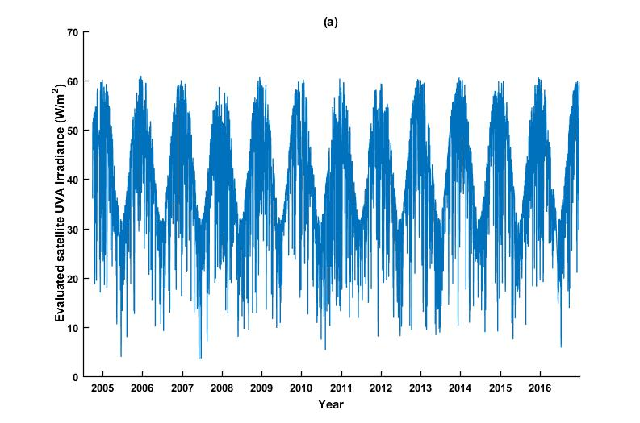

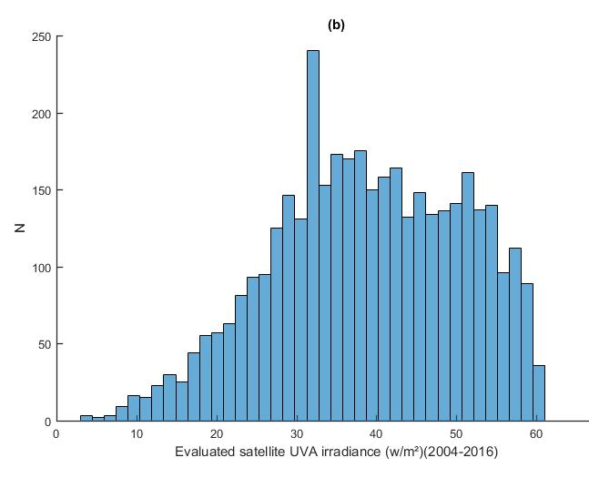
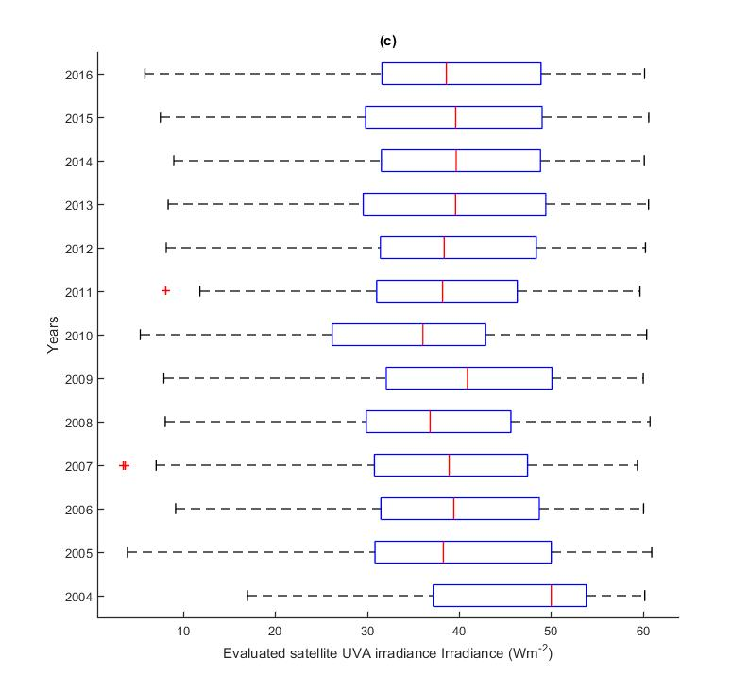
Figure 1. (a) Time series of solar noon time UVA irradiances, (b) solar noon UV irradiance distribution, and (c) box and whisker plots of the broadband UVA irradiances evaluated from the OMI spectral data from October 2004 to 31 December 2016 for all sky conditions. The line within each box is the median and the box is the data within quartiles one and three. The dashed line of the whiskers represents the range of the data up to ±5 standard deviations, with two outliers. The dataset for 2004 is shifted to higher irradiances due to only the last three months of the year being available.

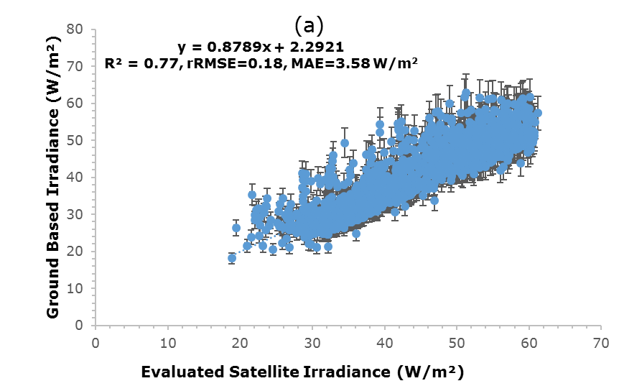
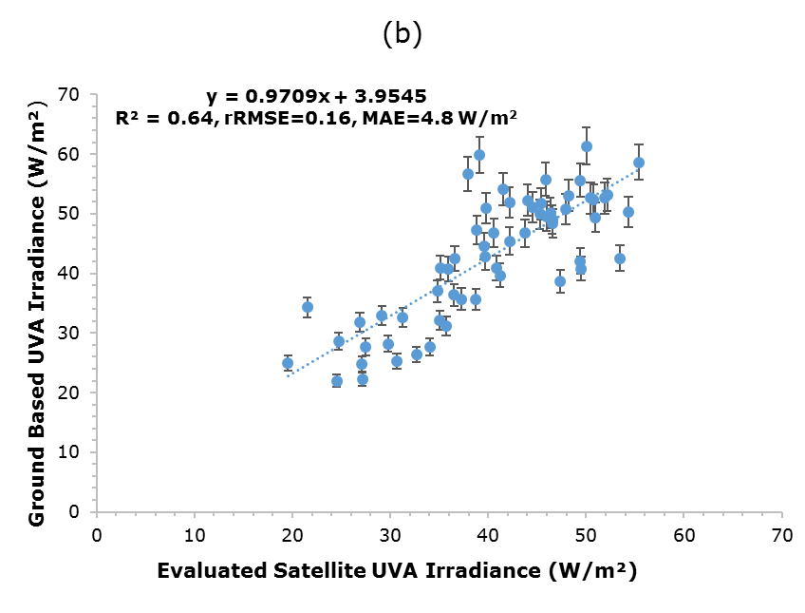
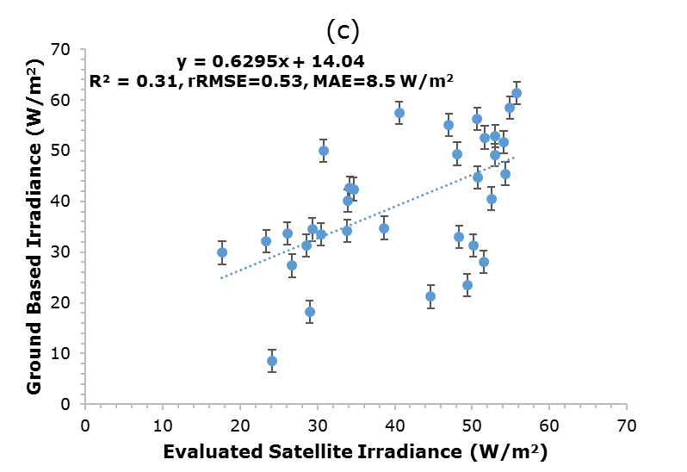
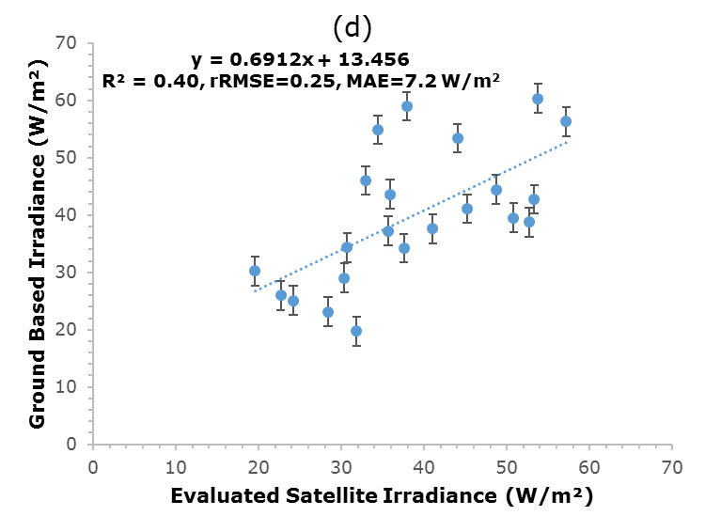
Figure 2. Comparison of the evaluated OMI satellite solar noon UVA irradiances with ground-based UVA data for the four categories of cloud cover of (a) 0 to 2, (b) > 2 to 4, (c) >4 to 6 and (d) > 6 to 8 octa for sun non obscured sky conditions. The error bars are the ±10% error associated with the ground-based data. The dashed line is the fitted trend line.

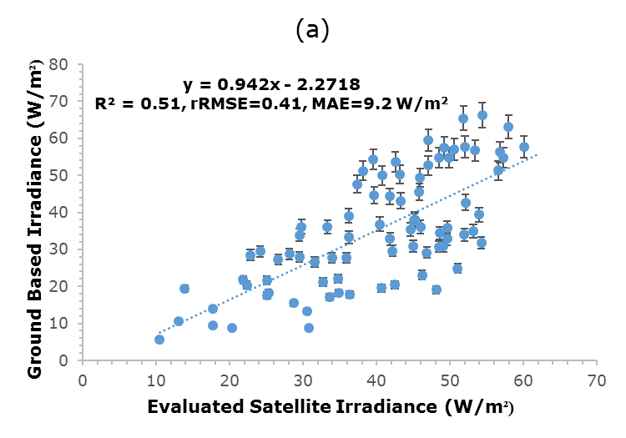
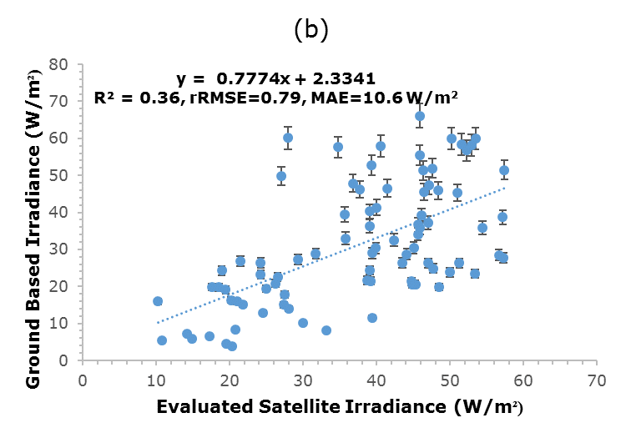

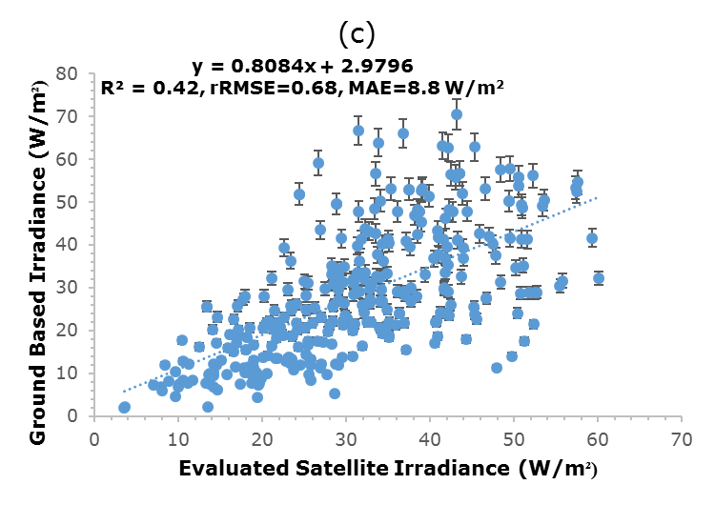

Figure 3. Comparison of the evaluated OMI satellite solar noon UVA irradiances with ground-based UVA data. The data are plotted for the three categories of the amount of cloud cover of (a) > 2 to 4, (b) > 4 to 6 and (c) > 6 to 8 octa for sun obscured sky conditions. The error bars are the ±10% error associated with the ground-based data. The dashed line is the fitted trend line.

