THE STREPTOZOTOCIN-DIABETIC RAT AS A MODEL OF THE CHRONIC COMPLICATIONS OF HUMAN DIABETES

Michael Wei¹ BSc, Leslie Ong¹ BSc, Maree T. Smith² PhD, Fraser B. Ross² PhD, Katrina Schmid³ PhD, Andrew J. Hoey⁴ PhD, Darryl Burstow⁵ MBBS FRACP and Lindsay Brown¹ PhD

Departments of Physiology and Pharmacology¹ and Pharmacy², The University of Queensland, Brisbane; ³School of Optometry, Queensland University of Technology, Brisbane; ⁴ Department of Biological and Physical Sciences, University of Southern Queensland, Toowoomba; and the ⁵Echocardiography Laboratory, The Prince Charles Hospital, Brisbane, Queensland, Australia.

Corresponding author: Dr Lindsay Brown, Department of Physiology and Pharmacology, School of Biomedical Sciences, The University of Queensland 4072, Australia; email: l.brown@mailbox.uq.edu.au; tel +61 7 3365 3098; fax +61 7 3365 1766.

Running title: Chronic complications in the STZ rat

Key words: Diabetes, echocardiography, electrophysiology, neuropathic pain, cataracts, retinopathy

Short abstract:
The chronic complications of diabetes in humans include cardiomyopathy, neuropathic pain, cataract development and retinopathy. The rat is the most commonly used model of human disease. This study has determined whether chronic diabetes induced by streptozotocin in rats mimics the complications associated with human diabetes.

Abstract:

Background: Diabetes in humans induces chronic complications such as cardiovascular damage, cataracts and retinopathy, nephropathy and polyneuropathy. The most common animal model of human diabetes is streptozotocin(STZ)-induced diabetes in the rat.
Methods: This project has assessed cardiovascular, ocular and neuropathic changes over a period of 24 weeks post-STZ treatment in rats.
Results: STZ-diabetic rats (n=96) showed stable signs of diabetes (hyperglycaemia, increased water and food intake with no increase in body weight); 52% of untreated STZ-diabetic rats (n=50) survived 24 weeks. STZ-diabetic rats were normotensive with slowly developing systolic and diastolic dysfunction and an increased ventricular stiffness. Ventricular action potential durations were markedly prolonged. STZ-diabetic rats developed stable tactile allodynia. Cataracts developed to presumed blindness at 16 weeks but proliferative retinopathy was not observed even after 24 weeks.
Conclusion: The chronic STZ-diabetic rat mimics many but not all of the chronic complications observed in the diabetic human. The chronic STZ-diabetic rat may be a useful model to test therapeutic approaches for amelioration of chronic diabetic complications in humans.

Introduction

Glucose is the major energy source of cells. A stable blood glucose is necessary since energy must be supplied to all cells at all times despite intermittent food intake and variable demands, such as the level of physical activity. The major regulatory hormone for intermediary metabolism is insulin, produced and secreted by the β-cells of the islets of Langerhans of the pancreas. Impaired control of blood glucose concentrations by insulin leads to diabetes mellitus. In patients with diabetes, an increased blood glucose concentration (hyperglycaemia) causes an increased thirst, hunger and urine volume, but it is the chronic complications of diabetes that are the major health issues ¹⁻⁶.

Diabetes is reaching epidemic proportions in developed countries ⁷. Estimations suggest that diabetes affects about 6% of the population in the USA or 12-15 million people, with up to half being undiagnosed ^{8,9}. The prevalence of diabetes increases with age with up to 25-30% of the elderly suffering from the condition and another 10-25% having impaired glucose tolerance ¹⁰. For many patients, diabetes is only diagnosed and aggressively treated when one of characteristic diabetic complications develops. These include cataracts and retinopathy which lead to blindness, impaired kidney function leading to end-stage renal disease, diabetic neuropathy which may lead to tactile allodynia, ulcers or amputations, macrovascular disease such as atherosclerosis and impotence, or heart disease and stroke. In humans, diabetes is associated with long-term cardiovascular damage (especially endothelial dysfunction, fibrosis and cardiomyopathy) with a much higher risk of coronary artery disease, heart failure, myocardial infarction and death ¹¹.

Diabetes can be induced by selective destruction of the insulin-producing β-cells of the pancreas with a single, rapid injection of streptozotocin (STZ), a glucose moiety with a very reactive nitrosourea group from the mould Streptomyces griseus. This procedure, first introduced in 1963, has since been used in over 7600 PubMed citations, probably making this the second most used animal model of human disease after the spontaneously hypertensive rat (SHR); cardiovascular changes following streptozotocin have been reviewed previously ¹¹. STZ doses of 50-65 mg/kg lead to hyperglycaemia (20-30 mM) but severe ketosis does not develop even if insulin is not administered. Higher doses (75 mg/kg and above) result in spontaneous ketosis and death within days if insulin is not given.

Most investigations using STZ-diabetic rats have followed the course of the condition for 4-6 weeks, sometimes 8 weeks. However, few studies have extended their measurement period to 24 weeks which is necessary to study the mechanisms of the chronic complications of diabetes such as neuropathy ^{12,13}, retinopathy ¹⁴ and nephropathy ¹⁵. Since human diabetics have a markedly increased morbidity and mortality due to cardiovascular disease ^{1,2}, we emphasise in this report the chronic changes in the cardiovascular system that accompany chronic STZ-induced diabetes in the rat. A comparison with the chronic changes in human diabetes will indicate whether the STZ-diabetic rat is an adequate model of the human disease.

Methods

Diabetes was induced in 8 week old male Wistar rats (n=96) using a single rapid injection of streptozotocin (STZ; 65 mg/kg) ¹⁶ into the femoral vein. The success rate of inducing diabetes (defined as a blood glucose concentration ≥15 mM and a water intake of >100 ml/day at 7 days) was approximately 90%. Insulin was not administered. All control age-matched male Wistar rats (n=10) survived the 24 week period; 52% of STZ-diabetic rats (n=50) survived 24 weeks after STZ injection. Food and water intakes and body weight were measured daily for 24 weeks. Blood glucose concentrations were monitored every four weeks by a Precision Q.I.D kit; values ≥ 15 mM were considered diabetic. Systolic blood pressure was measured every four weeks by a tail-cuff method ¹⁷. Echocardiography was performed every four weeks to non-invasively assess left ventricular size, wall thickness and systolic function ¹⁸.

Cardiac contractility, relaxation and stiffness were measured using the isolated Langendorff heart preparation ¹⁹. A latex balloon catheter was inserted into the left ventricle for measurement of isovolumic left ventricular function via connection to a disposable pressure transducer (MLT1010) linked to a PowerLab system. Hearts were paced at 250bpm by attaching two electrodes to the surface of the right atria. End diastolic pressure was initially set to 5 mmHg by balloon inflation and all hearts received an equilibration period of approximately 25 minutes. End-diastolic pressure was measured for 3 minutes at 5mmHg increments beginning at 0mmHg up to a maximum of 30mmHg. Measurements of diastolic pressure and systolic pressure were made after 2 minutes of each 3 minute recording for further calculation of diastolic stiffness and left ventricular developed pressure. Myocardial diastolic stiffness was defined by the stiffness constant (k, dimensionless), the slope of the linear relation between the tangent elastic modulus (E, dyne/cm²) and stress (σ, dyne/cm²) ¹⁹. At the end of the experiment, the atria were removed and the weight of the ventricles plus septum was recorded.

Conventional microelectrode techniques were applied to the left ventricular papillary muscles to record action potential duration ²⁰. A stainless steel hook was placed in one end of the papillary muscle fixed at the other end with a small stainless steel pin embedded into a rubber base. The hook was attached to a modified sensor element (SensoNor AE801) connected to an amplifier (World Precision Instruments, TBM-4). The muscle was slowly stretched to maximum preload over one minute. Contractions were induced by field stimulation (Grass SD-9) via electrodes on either side of the muscle (stimulation frequency 1 Hz, pulse width 0.5 msec; stimulus strength 20% above threshold). After maximum preload was attained, the muscle was allowed to equilibrate for a further 45 min before impalement with a glass microelectrode (World Precision Instruments, filamented borosilicate glass, outer diameter 1.5 mm) which had a tip resistance of 5-15 mΩ when filled with 3 M KCl. The reference electrode was an Ag/AgCl electrode. A Cyto 721 electrometer (World Precision Instruments) was used to record bioelectrical activity. All signals were recorded via an Analogue Digital Converter (MacLab4S) connected to a Power PC G3. Data were acquired, derived and analysed using MacLab4S Chart 4.0 software (AD Instruments). Continual impalement throughout an experiment was not always possible. However, if displacement occurred, then the results of a subsequent impalement were accepted provided the data fitted the above criteria.

Collagen deposition in the heart was visualised following picrosirius red staining ^{16,17} and quantified using laser confocal microscopy.

Calibrated Von Frey filaments ²¹ were used for weekly assessment of the development and maintenance of tactile allodynia in the hindpaws of diabetic relative to non-diabetic rats. Von Frey filaments of varying tensile strength (2 – 20g) were applied to the plantar surface of the hindpaw of the rat in ascending order of force, until there was a brisk paw withdrawal response. If the rat failed to withdraw its paw, a response of 20 g was recorded. Higher forces were not used in order to prevent tissue damage to the footpad of the rat.

Every 4 weeks, rats were lightly anaesthetised for assessment of cataract genesis by examination of the rat lens magnified x36 with a slit-lamp biomicroscope. Tropicamide (1% solution) was administered to the eyes to dilate the pupils so as to give a clear view of the lens. Cellufresh® eye drops (carmellose sodium) were administered periodically to avoid drying of the cornea. Rat lens cataracts were graded using a grading scale: 0, normal clear lens; 1, visible posterior sutures; 2, isolated vacuoles; 3, coalescing peripheral vacuoles; 4, radial streaks and dense central opacities ²². Rat retinae were isolated at 24 weeks for histochemical evaluation using a diaminobenzidine and glucose oxidase staining procedure for blood vessels.

Data are presented as mean ± SEM. Comparisons of the groups was made using the unpaired Student’s t test; p<0.05 was considered significant.

Results

STZ treatment rapidly produced the characteristic signs of diabetes such as increased intake of both water and food, failure to gain weight and increased blood glucose concentrations; these changes were maintained for the 24 weeks of observation (figure 1). As in humans, untreated diabetes in rats increases mortality as only 52% of STZ-diabetic rats survived 24 weeks of diabetes.

Systolic blood pressure remained normal in STZ-treated rats for the full 24 weeks with mean systolic blood pressure measurements between 100 and 120 mmHg in both control and STZ-diabetic rats. Non-invasive measurement of left ventricular dimensions showed decreased wall thickness and increased internal diameter after 24 weeks only (figure 2). Systolic function using fractional shortening as an estimate was unchanged. Diastolic function was assessed as the ratio of the initial mitral inflow (maximal E wave velocity) to the second mitral inflow (maximal A wave velocity) ¹⁸. Using this parameter, diastolic function was significantly decreased 24 weeks after STZ treatment (figure 2). Both contractility (dP/dt) and relaxation (-dP/dt) were impaired in the isolated hearts of STZ rats when measured in the perfused Langendorff heart preparation (figure 3). Further, the diastolic stiffness of STZ rat hearts was increased after 24 weeks (control: 0 week, 20.6±2.0; 12 week, 23.4±0.9; 24 week, 24.6±1.3; STZ-diabetic: 12 week, 24.6±1.3; 24 week, 32.7±2.1). In addition, STZ treatment was associated with a markedly prolonged action potential duration (APD at 20, 50 or 90% repolarisation in msec) measured at all stages of repolarization (12 week rats: control, APD20 7.1±0.7; STZ, APD20 17.7±2.2; control, APD50 15.1±1.2; STZ, APD50 34.3±4.0; control APD90 38.7±1.9; STZ, APD90 77.1±6.6; 24 week rats: control, APD20 6.4±0.9; STZ, APD20 21.7±4.6; control, APD50 13.0±2.1; STZ, APD50 43.8±8.3; control, APD90 29.0±3.7; STZ, APD90 101.0±13.8). The resting membrane potential was significantly less depolarised in papillary muscles from STZ-treated rats (control –72.3±0.7 mV; STZ –67.5±0.5 mV; n=6).

In control rats (n=6), von Frey testing gave values of 14±0.6g, 14.9±0.7g and 15.6±0.7g after 0, 12 and 24 weeks. Tactile allodynia developed in STZ-diabetic rats (n=14) after 7-10 days and reached a maximum after 2 weeks; this persisted unchanged for 24 weeks (0 weeks, 14.7±0.6g; 12 weeks, 7.4±0.5g; 24 weeks, 6.4±1.0g). Bilateral cataracts developed early, with lens changes in the form of posterior streak opacities observed at 4 weeks in STZ-treated rats. Cataract development was progressive with severe cataracts with presumed blindness in all eyes 16 weeks post-treatment (figure 4) while vascular changes were less pronounced, even after 24 weeks, with no significant differences in vessel numbers between normal and diabetic rats. However, ghost or loop-like vessels as well as microaneurysm formation was evident in retinas from STZ-treated rats (figure 5).

Discussion

Our studies on the chronic STZ-diabetic rat show that this model reliably produces many of the signs and symptoms of chronic human diabetes, in particular diastolic cardiac dysfunction, cataracts and neuropathy. An important difference is that rats do not develop atherosclerosis and remain normotensive unlike human diabetics, at least over a 24 week observation period. However, these characteristics of the chronic STZ-diabetic rat allow investigation of hyperglycaemia-induced changes which are independent of the development of atherosclerosis and hypertension.

Diabetes in humans is characterised by a progressive accumulation of complications which markedly increase morbidity and mortality. In both type 1 and type 2 diabetics, cardiovascular disease, especially coronary artery disease due to atherosclerosis, remains the major cause of this increase with a 2-3 fold increase over age- and gender-matched non-diabetic patients ¹⁻³. However, there are important contributions from chronic renal, ocular and nerve damage. In a 10-year study of type 2 diabetics, 38% developed microalbuminuria as a symptom of nephropathy ⁴ while 55% had signs of retinopathy ⁵. Polyneuropathy is also an insidious complication of diabetes affecting about 42% of type 2 diabetics 10 years after diagnosis ⁶. Understanding the basis for these complications requires an animal model of chronic diabetes that mimics the changes observed in humans.

Hypertension, obesity, dyslipidaemia, microalbuminuria, endothelial dysfunction, autonomic neuropathy and diabetic cardiomyopathy are amongst the many factors that contribute to the high prevalence of cardiovascular disease in human diabetes ^{1,2}. STZ-diabetic rats slowly developed both diastolic dysfunction and systolic dysfunction as shown in vivo by echocardiography and also in the isolated heart. The diastolic stiffness was also increased in the isolated heart, consistent with an increased collagen deposition ¹⁶. Fibrosis of the myocardium may be associated with inefficient conduction of cardiac pacemaker electrical impulses resulting in arrhythmia. Further, STZ-diabetic rats have a significant increase in duration of action potential in all phases of repolarisation possibly due to a reduction in the transient outward potassium current and the inward calcium current ²³.

The STZ-diabetic rat models diabetic neuropathy due to the similarities of the structural, functional and biochemical abnormalities in the periphery to human diabetic patients ²². This study has extended this to the progression of tactile allodynia and painful diabetic neuropathy in chronic diabetes.

Glucose-stressed lens have increased oxidative stress or reduced ability to remove reactive oxygen species or both. Ten- to twenty-fold increases in sorbitol concentration in the lenses due to membrane impermeability and slow conversion to fructose may lead to increased osmotic stress or an erosion of the components required to counter such stress ²². This study demonstrated that the development of senile cataracts in diabetic lenses was rapid and severe especially considering the lack of cataract development in age-matched control lenses.

Early degeneration of the endothelium by free radical damage, production of AGEs (advanced glycation end-products) and hypersecretion of various basement membrane proteins may affect transport, permeability and integrity of tight junctions and the blood-retinal barrier ²⁴. This leads to increased capillary leakage as well as microaneurysms which compromises blood and nutrient flow in the retina, causing an ischaemic state. A low oxygen tension stimulates VEGF (vascular endothelial growth factor) synthesis and VEGF receptor expression in an attempt to revascularise the ischaemic retina. Despite this, retinal vascular proliferation is a rare occurrence in animal models of diabetes ²⁵, as observed in this study. However, we observed the formation of numerous microaneurysms and ghost vessels as well as loop-like vessels, all of which are indicative of progression towards proliferative retinopathy. This suggests that retinopathy does occur and vascular proliferation would be observed if the measurement period could be extended.

The incidence and severity of chronic complications in diabetic humans necessitates therapeutic interventions. The chronic STZ-diabetic rat has been used for testing the effects of novel pharmacological agents, for example troglitazone in neuropathy ¹² and ramipril or valsartan in nephropathy ¹⁵. These chronic studies should provide useful options for testing therapeutic approaches to ameliorate chronic diabetic complications in humans.

In conclusion, these results indicate that the chronic STZ-diabetic rat mimics many but not all of the chronic complications observed in the diabetic human.

References

- Butler R, Macdonald TM, Struthers AD, Morris AD: The clinical implications of diabetic heart disease. Eur Heart J 1998; 19: 1617-27.

- Marks JB, Raskin P: Cardiovascular risk in diabetes. A brief review. J Diab Complications 2000; 14: 108-15.

3. Torffvit O, Agardh C-D: The prognosis for type 2 diabetic patients with heart disease. A 10-year observation study of 385 patients. J Diab Complications 2000; 14: 301-6.

4. Torffvit O, Agardh C-D: The impact of metabolic and blood pressure control on incidence and progression of nephropathy. A 10-year study of 385 type 2 diabetic patients. J Diab Complications 2001; 15: 307-13.

5. Voutilainen-Kaunisto RM, Terävirta ME, Uusitupa MIJ, Niskanen LK: Occurrence and predictors of retinopathy and visual acuity in type 2 diabetic patients and control subjects 10-year follow-up from the diagnosis. J Diab Complications 2001; 15: 24-33.

6. Partanen J, Niskanen L, Lehtinen J, Mervaala E, Siitonen O, Uusitupa M: Natural history of peripheral neuropathy in patients with non-insulin-dependent diabetes mellitus. N Engl J Med 1995; 333: 89-94.

7. Zimmet P, Boyko EJ, Collier GR, de Courten M: Etiology of the metabolic syndrome: potential role of insulin resistance, leptin resistance, and other players. Ann N Y Acad Sci 1999; 892: 25-44.

8. Dagogo-Jack S: Pathophysiology of type 2 diabetes and modes of action of therapeutic interventions. Arch Int Med 1997; 157: 1802-17.

9. Anonymous: The dangerous toll of diabetes. http://www.diabetes.org/ada/facts.asp accessed 20.4.01

10. Valle T, Tuomilehto J, Eriksson J: Epidemiology of NIDDM in Europids. In: Alberti KGMM, Zimmet P, DeFronzo RA, Keen H (eds): International textbook of diabetes mellitus, 2nd edition, London: John Wiley & Sons, 1997: pp.125-42.

11. Tomlinson KC, Gardiner SM, Hebden RA, Bennett T: Functional consequences of streptozotocin-induced diabetes mellitus, with particular reference to the cardiovascular system. Pharmacol Rev 1992; 44: 103-50.

12. Qiang X, Satoh J, Sagara M, Fukuwara M, Masuda T, Sakata Y, Muto G, Takakashi K, Toyoto T: Inhibitory effect of troglitazone on diabetic neuropathy in streptozotocin-diabetic rats. Diabetologia 1998; 41: 1321-6.

13. Cameron NE, Cotter MA: Diabetes causes an early reduction in autonomic ganglion blood flow in rats. J Diab Complic 2001; 15: 198-202.

14. Gilbert RE, Kelly DJ, Cox AJ, Wilkinson-Berka JL, Rumble JR, Osicka T, Panagiotopoulos S, Lee V, Hendrich EC, Jerums G, Cooper ME: Angiotensin converting enzyme inhibition reduces retinal overexpression of vascular endothelial growth factor and hyperpermeability in experimental diabetes. Diabetologia 2000; 43: 1360-7.

15. Mifsud SA, Allen TJ, Bertram JF, Hulthen UL, Kelly DJ, Cooper ME, Wilkinson-Berka JL, Gilbert RE: Podocyte food process broadening in experimental diabetic nephropathy: amelioration with renin-angiotensin blockade. Diabetologia 2001; 44: 878-82.

16. Miric G, Dallemagne C, Endre Z, Margolin S, Taylor SM, Brown L: Reversal of cardiac and renal fibrosis by pirfenidone and spironolactone in streptozotocin-diabetic rats. Br J Pharmacol 2001; 133: 687-94.

17. Brown L, Fenning A, Shek A, Burstow D: Reversal of cardiovascular remodeling with candesartan. J Renin-angiotensin-aldosterone System 2001;2(suppl 1): S141-7.

18. Brown L, Fenning A, Chan V, Loch D, Wilson K, Anderson B, Burstow D: Echocardiographic assessment of cardiac structure and function in rats. Heart, Lung and Circulation, accepted for publication in December 2002.

19. Brown L, Duce B, Miric G, Sernia C: Reversal of cardiac fibrosis in deoxycorticosterone acetate-salt hypertensive rats by inhibition of the renin-angiotensin system. J Am Soc Nephrol 1999;10:S143-8.

20. Hoey A, Amos G, Wettwer E, Raven U: Differential effects of BDF 9148 and DPI 201-106 on action potential and contractility in rat and guinea pig myocardium. J Cardiovasc Pharmacol 1994; 23: 907-15.

21. Calcutt NA, Chaplan SR. Spinal pharmacology of tactile allodynia in diabetic rats. Br J Pharmacol 1997; 122: 1478-82.

22. Mitton KP, Dean PA, Dzialoszynki T, Xiong H, Sanford SE, Trevithick JR. Modelling cortical cataractogenesis. 13. Early effects on lens ATP/ADP and glutathione in the streptozotocin rat model of the diabetic cataract. Exper Eye Res 1993; 56: 187-98.

23. Wang DW, Kiyosue T, Shigematsu S, Arita M. Abnormalities of K⁺ and Ca²⁺ currents in ventricular myocytes from rats with chronic diabetes. Am J Physiol 1995;269:H1288-H1296.

24. Cagliero E: Characteristics and mechanisms of high-glucose induced overexpression of basement membrane components in cultured human endothelial cells. Diabetes 1991; 40: 102-9.

25. Yu DY, Cringle SJ, Su EN, Yu PK, Jerums G, Cooper ME: Pathogenesis and intervention strategies in diabetic retinopathy. Clin Exper Ophthalmol 2001; 29: 164-6.

Legends to figures

Figure 1: Water (A) and food (B) consumption, body weight (C) and blood glucose concentration (D) in control (open circles) and STZ-treated rats (closed circles); n=10 (control) and 37 (STZ-treated) for water and food consumption and body weight; n=10 (control) and 20 (STZ-treated) for glucose measurements; *p<0.05 vs control.

Figure 2: Ventricular dimensions and function as derived from echocardiography in control (open circles) and STZ-treated rats (closed circles): left ventricular wall thickness (A) and internal diameter (B), % fractional shortening (C) and maximal mitral E/A flow ratio (D); n=11 (controls) and 10 (STZ-treated rats) except for (D) where n=8 (control) and 6 (STZ-treated); *p<0.05 vs control.

Figure 3: dP/dt (circles) and –dP/dt values (squares) in isolated Langendorff heart preparations from control rats (open symbols; n=7) and STZ-treated rats (closed symbols) after 12 weeks (n=9) and 24 weeks (n=7); *p<0.05 vs control.

Figure 4: Cataract grade in lenses of control rats (n=6; open circles) and of rats for up to 24 weeks after STZ-treatment (n=6; closed circles); *p<0.05 vs control.

Figure 5: Retinal blood vessels in a rat 24 weeks after STZ treatment (x20 magnification); loop-like vessels are shown by a blue arrow, microaneurysms are shown by a green arrow and ghost vessels are shown by a red arrow.

FIGURE 1:
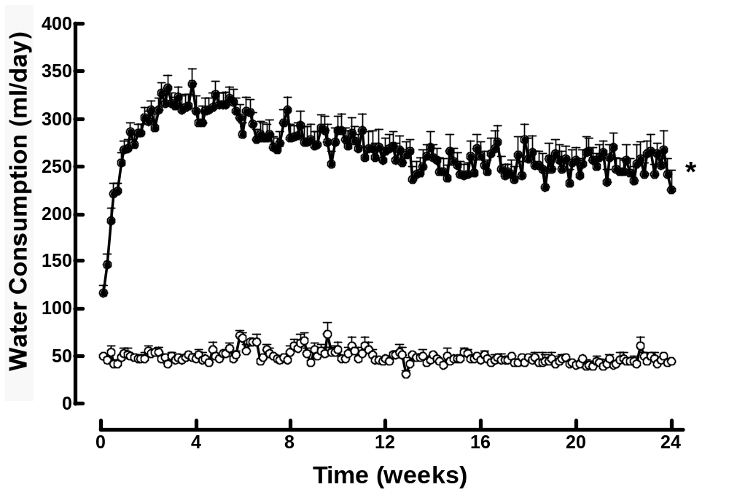
A

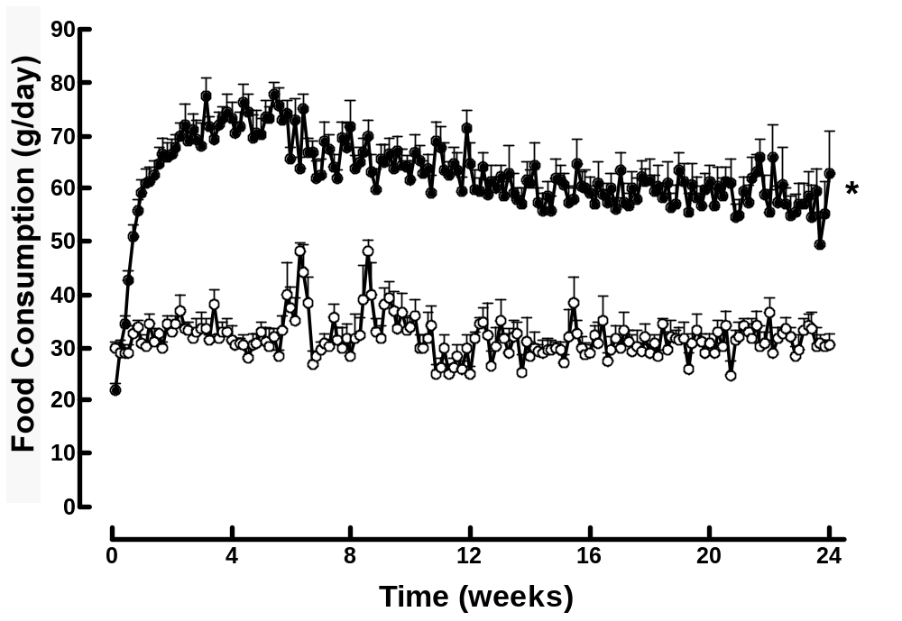
B

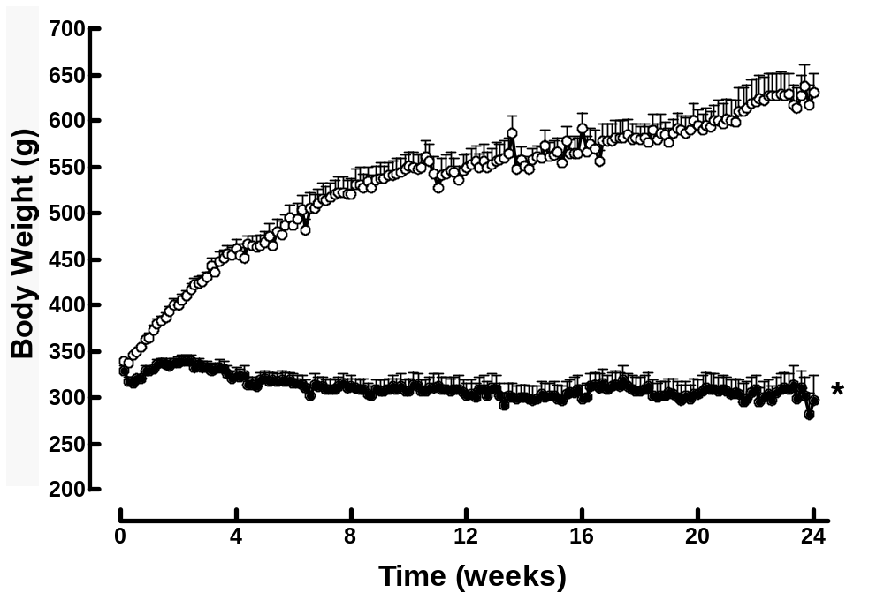
C

D
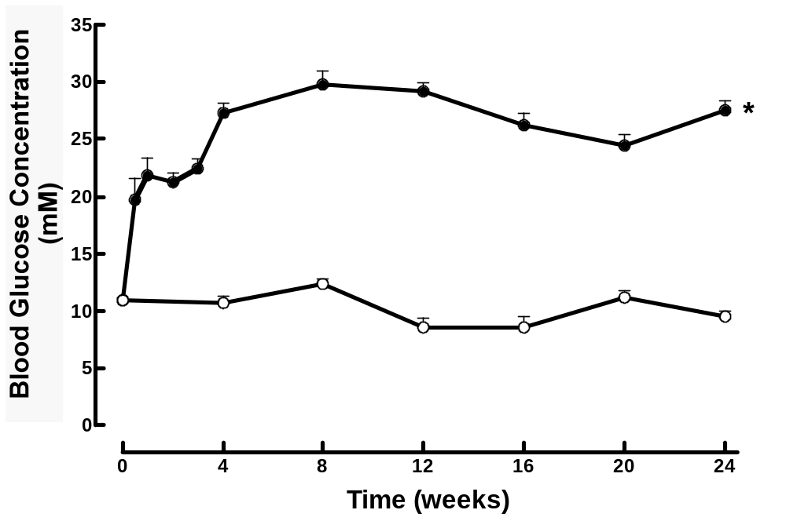

FIGURE 2:

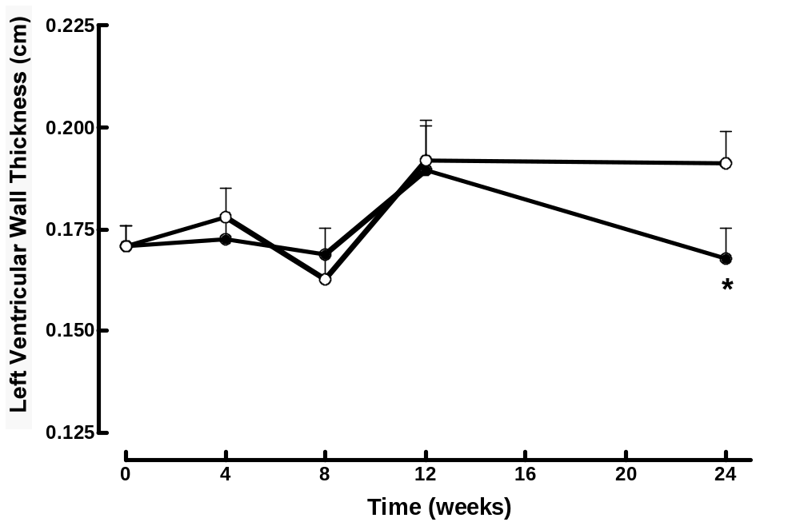
A

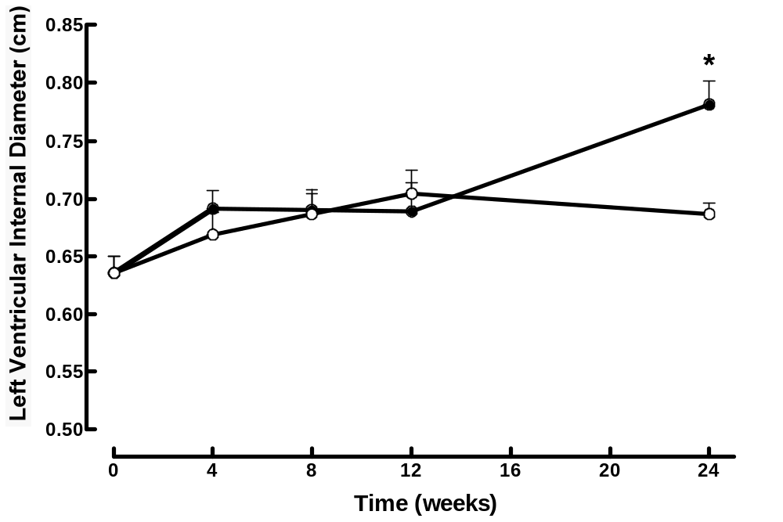
B

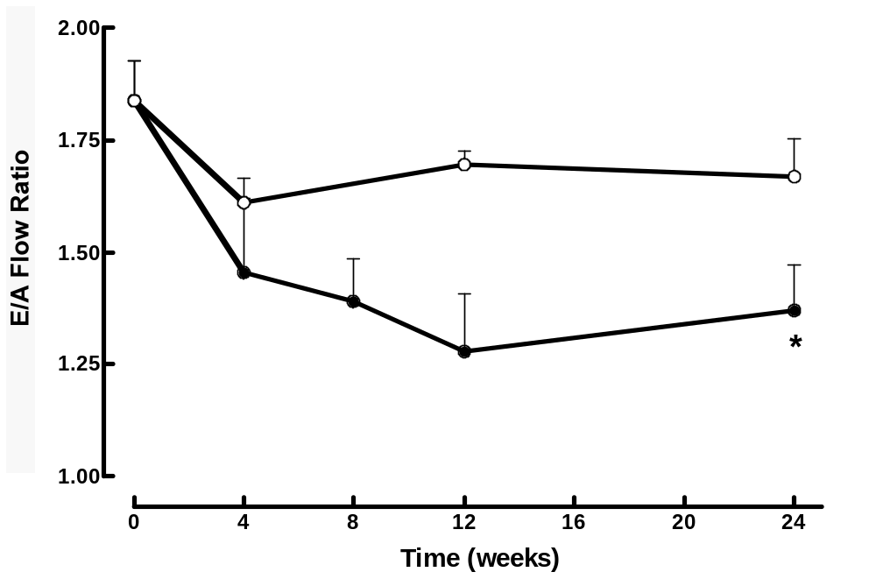
C
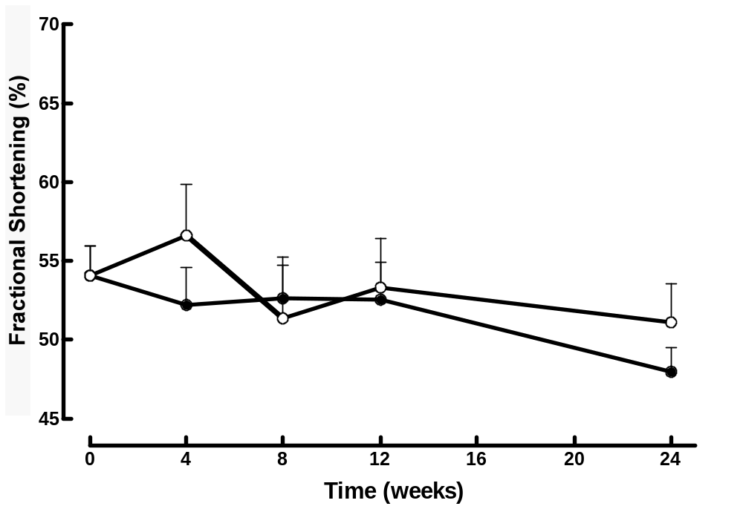

D

FIGURE 3:

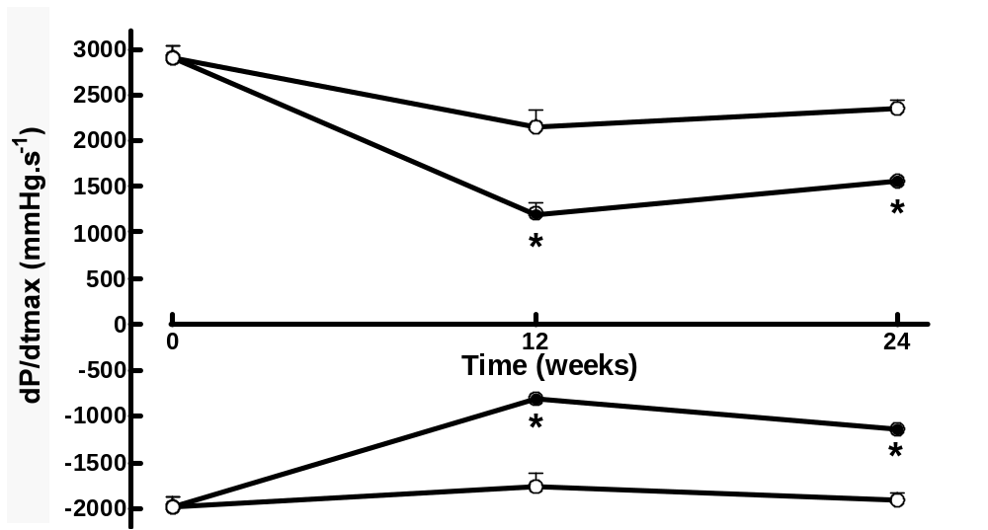

FIGURE 4:

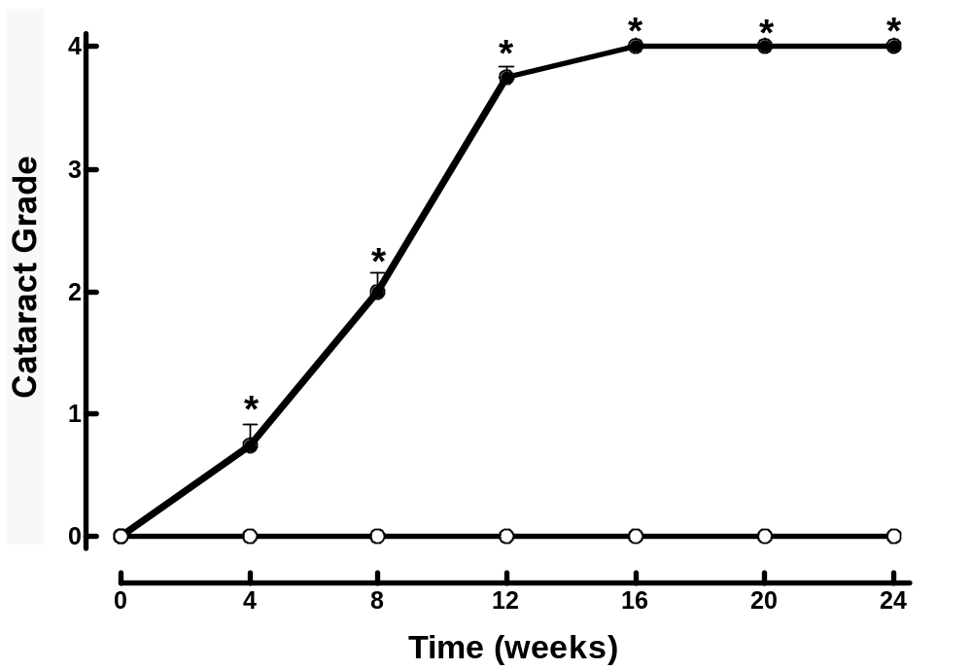

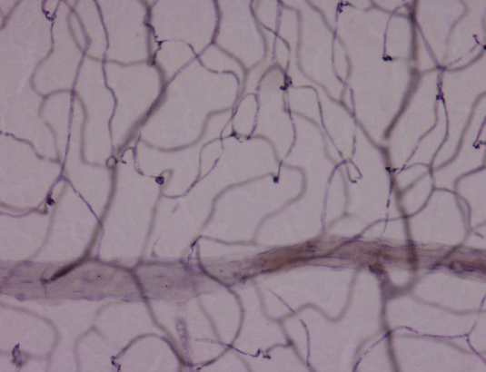
Figure 11. Deep capillary layer of
an STZ rat retina magnified x20.
Loop-like vessel
Microaneurysm
Ghost vessel

FIGURE 5:

