Seasonal Minimum and Maximum Solar Ultraviolet Exposure Measurements of Classroom Teachers residing in Tropical North Queensland, Australia

Nathan J. Downs,^{1,2} Damien P. Igoe,¹ Alfio V. Parisi,^{1,*} Olivia Taylor,² Shari L. Lazzaroni,² Alex Rawlings,^{1,2} Daniel R. Garzón-Chavez,^{3,2,1} and Simone L. Harrison,^{4,2,1}

- Faculty of Health, Engineering and Sciences, University of Southern Queensland, Toowoomba 4350, Australia.

- Skin Cancer Research Unit, School of Public Health, Medical and Veterinary Sciences, James Cook University, Townsville 4810, Australia.

- School of Human Medicine, College of Health Sciences, Universidad San Francisco de Quito, Ecuador.

- College of Medicine and Dentistry, James Cook University, Townsville 4810 Australia

*To whom correspondence should be addressed, alfio.parisi@usq.edu.au, Faculty of Health, Engineering and Sciences, USQ, Toowoomba, 4350 Australia, ph:+61746312226

Keywords: Teachers, Occupation, Skin cancer, Dosimetry, Ultraviolet

Abstract

The risk of keratinocyte skin cancer, malignant melanoma and ultraviolet radiation (UVR)-induced eye disease is disproportionately higher in Australia and New Zealand compared to equivalent northern hemisphere latitudes. While many teachers are aware of the importance of reinforcing sun-safety messages to students, many may not be aware of the considerable personal exposure risk while performing outdoor duties in locations experiencing high to extreme ambient-UVR year-round. Personal erythemally-effective exposure of classroom teachers in tropical Townsville (19.3º S) was measured to establish seasonal extremes in exposure behavior. Mean daily personal exposure was higher in winter (91.2 J m⁻², 0.91 Standard Erythema Dose (SED)) than summer (63.3 J m⁻², 0.63 SED). The range of exposures represent personal exposures that approximate current national guidelines for Australian workers at the study latitude of approximately 1.2 SED (30 J m⁻² effective to the International Commission on Non-Ionizing Radiation Protection). Similar proportions of teachers spent more than 1 hour outdoors per day in winter (28.6%) and summer (23.6%) as part of their teaching duties with seasonal differences having little effect on the time of exposure. Personal exposures for teachers peaked during both seasons near school meal-break times at 11:00 am and 1:00 pm respectively.

INTRODUCTION

Keratinocyte skin cancer (KSC) is the most common malignancy in Caucasians [1] with incidence increasing over the past four decades such that between 2 and 3 million cases are treated worldwide annually [2]. Fueled by increased longevity and an aging population, the global rise in skin cancer incidence is an emerging clinical and public health concern of epidemic proportions [3-4] representing a major economic burden to the health system, particularly in Australia, New Zealand, the USA, Britain, Northern Europe, Canada and Scandinavia [5-7].

Queensland experiences high levels of ambient ultraviolet radiation (UVR) year-round [8] and has the highest reported incidence of both KSC [9] and cutaneous melanoma [10]. Sun exposure is the major environmental risk factor for both KSC [11] and melanoma [12] with childhood sun exposure being particularly important in the etiology of melanoma [13] making primary prevention strategies to reduce sun-exposure in early childhood [14] and school settings particularly important [15-16]. Teachers as role models, however fail to act consistently and appropriately [3]. Some of the apathy may be due to the long latency period, which generally spans decades, before the effects of childhood sun exposure manifest themselves [13]. Additionally, research suggests that many schools in Queensland do not reschedule outdoor activities away from solar noon [16].

The Queensland school year typically begins in late January and runs through to mid-December, from the Southern Hemisphere summer through to the proceeding summer break. Two-week vacation breaks occur around April, June/July and September/October. Teachers attend school usually for 5 days a week (Monday to Friday) for approximately 200 days per year. Students typically attend school from 8:30 am to 3:00 pm, corresponding with times of peak UVR [16-18], with their teachers often in attendance both before and beyond these hours. Most teachers are considered to be indoor workers, and as such, are exposed to intermittent UVR which may cause sunburn, as well as contributing to lifetime cumulative UVR exposure and increased skin cancer risk [7].

Most teachers are rostered on for playground duty during morning recess, usually around 10 to 11 am and during all or part of the lunch break, usually between 12 to 2 pm, where duties are often 20 to 30 minutes in duration. These times, particularly lunch break duties often coincide with times of peak UVR [16,18-19]. Physical Education teachers are outside for considerably more time, for outdoor sport and physical education lessons. These can occur at any time during the day [19-20] with many schools not considering times of peak UVR in the scheduling of events [16]. Yard duty and sport lesson timetables are typically rostered on a regular weekly or fortnightly cycle [18].

The school’s duty of care includes keeping students as safe from risks and hazards as much as possible [19]. A major component of this is a school’s expectation that teachers will model sun safe behaviors while performing playground duty or teaching sport lessons. Sun protection policies for students in public schools are mandated by the state departmental authorities, whereas private schools tend to develop their own policies [16]. Although these policies are mirrored as expectations for staff while attending to outdoor duties or classes, it is often the case that they are not strictly enforced in many schools [17]. Previous research has measured the UVR exposures received by school teachers in late spring in Queensland at two sub-tropical sites [18] and at a tropical and a sub-tropical site [19]. This research will extend this previous research to provide an analysis of the winter erythemal UV exposures experienced by classroom teachers at schools in a city at tropical Southern Hemisphere latitudes.

MATERIALS AND METHODS

Classroom teachers were recruited from government and Catholic schools situated in Townsville (19.3º S, 146.8º E), North Queensland. Research ethics approvals were granted by the University of Southern Queensland (USQ) H1 4REA089, James Cook University approval H6088, The Queensland Department of Education, Training and Employment approvals ref 11/54273 and 550/27/1497, and the Catholic Education Office (Townsville Diocese) 2015-07 to approach and recruit volunteer study participants. Inclusion in the study group was dependent on teaching classification, and included both part-time, contract and permanent employees who were either employed as primary school teachers (teaching prep and years 1 through to 6) or secondary school subject specialists (teaching years 7 through 12) whose discipline areas included mathematics, science, English, drama, art, music and language. The study sample did not include Physical Education teachers.

Study recruits wore miniaturized polysulphone (PS) dosimeters for a minimum of 5 working days during the early summer of 2014 and/or late winter in 2015. Daily erythemally effective personal UVR exposures measured using the PS dosimeters were collected from 10 to 21 November 2014, (late austral spring). Hereafter, this period is referred to as “summer”, as the period 10 to 21 November includes daily exposure periods between 40 and 30 days from the summer solstice of 21 December and therefore is typical of summer time ambient UVR exposures received between 20 and 30 January (the end of annual summer vacation). Thus, exposures measured toward the end of the Queensland school calendar year generally represent the greatest occupational exposures experienced by teachers annually. The summer exposure trial was conducted at the end of November rather than the beginning of December to avoid the period when high school timetables are effectively reduced because senior students (years 10, 11 and 12) are on summer vacation and younger students are completing their final exams prior to starting their vacation. Consequently, most school teachers in Queensland are either on vacation or cease employment during or before December.

Winter time exposures were recorded from 26 August to 1 September. Winter time exposures were measured late in the season due to Queensland school winter vacation which spans from mid-June to early July and to also avoid the beginning of the school teaching term, where volunteer participants are typically busy preparing for the semester. A total of 29 volunteer participants were recruited across both seasons from 3 local schools, including 1 primary school and 2 secondary schools. Two classroom teachers participated in both the summer and winter exposure trials (Table 1).

PS film dosimetry has been used extensively in personal UVR exposure studies [21-23]. For the current study, involving 29 individual participants, daily sets of miniaturized PS dosimeters and paper sun diaries were preferred for recording personal exposure over UVR electronic dosimeters. Here, miniaturized PS film dosimetry offered significant cost benefits, in addition to being small and lightweight, making the dosimeters easily able to be stored on site by the participants. For erythemally effective exposures not exceeding 1500 J m⁻² (several hours in tropical Queensland), the coefficient of variation in the calibrated exposure measured using PS film is typically 10% [24].

While erythemally effective exposures are a convenient comparative measure for assessing potential biological damage to study subjects caused by solar UVR, national guidelines used to assess the limiting exposure for Australian workers are based upon the recommendations of the International Commission on Non-Ionizing Radiation Protection (ICNIRP), which apply different spectral weightings to the erythema action spectrum [25]. Gies and Wright [26] provide a thorough assessment of the comparative differences between the erythema and ICNIRP weighted spectra as they apply in practice over a UV index range between 2 and 16 for workers employed in the Queensland building industry. In all cases, the time required to reach 200 J m⁻² (2 SED) is greater than the time required to reach the ICNIRP effective limit of 30 J m⁻². Thus, national exposure guidelines recommend daily exposures for Australian workers do not exceed 2 SED. A more precise measure of this limit can be expressed relative to the erythemally effective exposure by multiplying the erythemally effective irradiance for each respective UV index in the range 2 to 16 by the number of seconds required to reach the ICNIRP occupational limits quoted by Gies and Wright [26] for UV indices of 2, 4, 6, 8, 10, 12, 14 and 16. Each whole number increment in UV index represents 0.025 J s⁻¹ m⁻² of erythemally effective solar radiation. Thus, for the above indices, the ICNIRP occupational limit of 30 J m⁻² ranges from between 108 to 119 J m⁻² erythemally effective exposure. For the current study, in which the UV index varies from above 3 at the beginning of the school day and reaches a maximum of 12 at solar noon, the erythemally effective exposure limit varies from 118.5 to 118.8 J m⁻². The occupational exposure limit for our study cohort of Townsville Classroom teachers may therefore be safely assumed to be the equivalent of 120 J m⁻² erythemally effective solar radiation.

<Table 1>

Measurement of erythemal UVR exposure: Volunteer recruits all received a participant pack consisting of an opaque envelope containing 10 PS dosimeters and a personal sun exposure diary. Participants wore dosimeters on the shoulder in an approximate horizontal position. New dosimeters were attached daily to clothing at the shoulder site from 7:00 am, to ensure the PS film would not reach saturation. Used dosimeters were stored in an opaque envelope at the conclusion of each working day, between 3:00 pm and 5:00 pm depending on each participant’s chosen finishing time after attending to extra-curricular responsibilities, such as after-school bus duties, marking, or teaching preparation time. Used dosimeters were collected from the study participants immediately after the summer exposure trial ended and again after the winter exposure trial. Post exposure absorbance of the collected dosimeters were measured two weeks after the conclusion of summer and winter trials to eliminate post exposure (dark reaction) absorbency changes in the PS film [31].

The PS film dosimeters used in this study were manufactured at the University of Southern Queensland and comprised of a thin PS film of thickness 40 microns which was adhered to a polymer badge plate measuring approximately 25 x 10 mm. The film was attached to dosimeter badge plates across a clear circular aperture, measuring 6 mm in diameter. The change in PS film absorbance was measured using a spectrophotometer (model UV-2700, Shimadzu Kyoto, Japan) and represents the difference in post and pre-exposure dosimeter absorbance measured at 330 nm, ∆A₃₃₀.

Participant dosimeters were calibrated at the James Cook University Townsville campus for each of the winter and summer trial periods using a integrating UVR meter calibrated to a calibrated scanning spectroradiometer (Bentham Instruments DTM300, Reading UK) [32]. Field dosimeters were calibrated locally in each respective season to account for variation in PS film response with seasonal exposure rate [33]. Here, change in PS film absorbance was calibrated to the cumulative solar UVR exposure after weighting to the CIE reference action spectrum for erythema [34]. When plotted as a function of ∆A₃₃₀, the calibration of PS film follows the general form of a cubic, with the erythemally effective UVR exposure, H_{CIE} rising steeply as ∆A₃₃₀ increases up to the saturation limit of the dosimeter,

$$H_{CIE}= aΔA_{330}^{3}+bΔA_{330}^{2}+cΔA_{330}. (1)$$

In the current study, the coefficients a, b and c varied from 9,620, -3,200 and 1,670 respectively for the calibration of summer, to 20,050, -4,240 and 1,340 respectively for winter (Equation 1). For the tropical latitude of Townsville, the seasonal calibration curves derived according to the respective summer and winter coefficients were similar up to 0.3 ∆A₃₃₀, representing an approximate erythemally effective exposure limit of 400 J m⁻².

The erythemally effective exposures used to derive the calibration functions of Equation (1) were determined according to Equation (2),

$$H_{CIE}= \int_{t1}^{t2}{E_{CIE}\left(t\right)dt}, (2)$$

where the limits of the exposure integral, t1 and t2 represent the start and end time of the exposure interval for dosimeters used in the derivation of each seasonal calibration curve. E_{CIE} is the erythemally effective ultraviolet irradiance. This was calculated after weighting the ultraviolet irradiance, E to the spectral effectiveness of erythema in human skin, S_{CIE} [34] from 290 to 400 nm (Equation 3). Details describing the field calibration of PS dosimeters have previously been presented by the authors [19,35].

$$E_{CIE}= \sum_{290}^{400}{S_{CIE}}E\left(λ\right)Δλ. (3)$$

Self-reported exposure time: Self-reported outdoor exposure time was monitored by study participants for each of the summer and winter trial periods. Sun exposure diaries were completed daily. Participants were instructed to complete their daily sun activity diaries by indicating outdoor exposure times to the nearest 5 minutes. Days on which participants were not at school were indicated on the returned sun diary as non-working days. Study participants were asked to record daily time intervals of exposure outside of enclosed buildings. This included periods in full-sun, shade and areas protected by awnings, shade structures and verandahs. Here, the assumption was that any period outside classrooms, staff rooms or enclosed buildings would involve some exposure to solar UVR, either from diffuse or reflected radiation. Figure 1 is a sample participant sun exposure diary divided hourly between 7:00 am and 5:00 pm. Exposures of 5 minutes duration (minimum allowable exposure period) would be marked as a horizontal line covering 1/3 of a quarterly hour interval in the sun diary (Figure 1) with continuous periods of exposure being marked as an unbroken horizontal line for the duration of outdoor exposure.

<Figure 1>

RESULTS
Exposure comparisons
Of the summer cohort consisting of 23 primary and secondary classroom teachers, a total of 185 daily H_{CIE} exposures were evaluated as a subset of a larger teaching cohort examined in previous work [19], which originally included physical education teachers and teacher aides. Of the 230 dosimeters issued to the classroom teachers in summer, 45 dosimeters (20%) were either damaged, lost or returned unused due to sick days and time off work in the 10-day summer trial. Most of the issued dosimeter badges were returned from the winter cohort of 7 classroom teachers reporting exposures over a 5-day working period. This resulted in a total of 32 personal exposures (dosimeter-days) being made over winter from the 35 dosimeters issued at the beginning of the study. Table 2 summarizes the daily H_{CIE} exposures of both study cohorts.

Of the returned winter trial dosimeters, a higher proportion recorded daily erythemal UV exposures greater than 100 J m⁻² or 1 Standard Erythema Dose (SED) (28.1% in winter trial vs 22.7% in summer trial). Furthermore, the frequency of nil daily exposures was also much lower in the winter cohort compared to the summer cohort. This was a contributing factor to the higher daily H_{CIE} exposure cohort summaries in winter (Table 2), where only 1 dosimeter-day (3.1% of the winter cohort) recorded a nil exposure, in contrast to the summer trial cohort, where 28 dosimeters (15.1% of the returned summer dosimeters) recorded a nil exposure after being worn for a full teaching day. In summary, compared to the summer trial, a higher proportion of classroom teachers in the winter trial recorded daily exposures to solar erythemally effective UV, indicating a seasonal difference in outdoor exposure. This was also confirmed by comparison of the two study participants who were available for both the summer and winter trials. Both of these participants (Subject A and Subject B) provided daily exposure data for all 5 winter trial days. Median erythemally effective exposures of 58.0 and 86.4 J m⁻² were recorded by Subject A and B respectively in winter. During the summer trial, Subject A contributed 10 dosimeter-days while Subject B contributed to 8 dosimeter-days. For both of these study participants, erythemally effective summertime exposures were lower than recorded in winter, with median exposures of 14.7 and 23.1 J m⁻² being recorded by Subject A and B respectively.

<Table 2>

Figure 2 shows the distribution of daily H_{CIE} exposure in both study groups as a percentage of the cohort size. The distribution shows there is potential for very high personal H_{CIE} exposure to classroom teachers in summer, with the maximum returned exposure per day reaching 305 J m⁻² (3.05 SED) compared to winter, where the maximum daily recorded H_{CIE} exposure reached 204 J m⁻² (2.04 SED). However, differences in peak daily exposure distribution clearly indicate that maximum cohort exposures occur in the lowest daily exposure bracket, between 0 and 10 J m⁻² in summer (22.7% of cohort), and shift considerably to a higher daily exposure in winter, between 80 to 90 J m⁻² (18.8% of cohort). To record nil, or very low daily H_{CIE} exposure in summer, when the annual ambient UV irradiance is approaching its highest annual value, suggests that a significant proportion of classroom teachers spend a greater period of time protected from solar UVR in summer than in winter, when the ambient UVR is lower.

For the current study, the peak daily ambient UV index in Townsville was higher by only 1 unit during the summer of 10 to 21 November 2014 compared to winter between 26 August and 1 September 2015. Table 3 lists the maximum daily UV index for Townsville reported by the Australian Radiation and Nuclear Safety Authority (ARPANSA) [36] for each study day during the summer and winter trials. The predicted daily ambient H_{CIE} exposure for a cloud-free day was estimated from the ARPANSA daily maximum UV index according to the approximation of Diffey [37] and is also listed in the Table 3 for comparison. Air temperature and global solar radiation are listed in Table 3 for each of the study days [38,39]. As seen in Table 3, classroom teachers exposed to ambient solar UVR in Townsville during summer were exposed to elevated ambient UVR conditions, approximately 20% higher than those experienced in winter.

<Figure 2>

<Table 3>

Self-reported outdoor exposure time
The personal daily H_{CIE} exposure of classroom teachers does not correlate with differences in seasonal ambient conditions. Elevated personal exposures in winter compared to summer are the result of personal behavior. Periods of exposure to solar UVR due to supervision or playground duties, and periods of daily intermittent exposure experienced upon arriving and leaving work contribute to the total daily H_{CIE} exposure of the classroom teachers. Figure 3 shows the comparative distribution of self-reported periods of exposure time for the summer and winter teacher cohorts. Unlike the personal H_{CIE} exposure distribution of Figure 2, the self-reported daily time periods of exposure outdoors shown in Figure 3 are remarkably similar.

<Figure 3>

The median self-reported daily exposure time of classroom teachers in summer was 30 minutes (mean, 39 minutes) compared to a median of 28 minutes (mean 38 minutes) in winter. Both daily exposure time distributions show that a significant number of classroom teachers reported nil to low daily periods of time outdoors with a similar proportion of both study populations reporting a high percentage of diary-days in the 0 to 10 minutes total exposure category (24% in the summer trial vs 31% in the winter trial). A slightly greater proportion of the winter cohort spent more than 1 hour outside daily (28.6% in winter vs 23.8% summer, Table 4). This may have contributed to the higher daily ambient H_{CIE} exposures for the winter cohort.

<Table 4>

Exposure timing
Another contributing factor, likely to explain the generally higher H_{CIE} exposure of the winter classroom teachers, compared to the summer cohort is the time at which most teachers spend their daily exposure periods outdoors. Peak daily radiant ultraviolet exposure occurs at solar noon. In tropical North Queensland, this time varies from between 11:55 am in mid-November (summer) to 12:15 pm in late August (winter). Periods of outdoor exposure at or near these times will have the greatest impact on daily H_{CIE} exposure because these times represent the time when solar radiation is least affected by atmospheric absorption (lowest air mass and highest solar elevation). Figure 4 plots the percentage of classroom teachers in each summer and winter cohort outdoors with time of day (Australian Eastern Standard Time, AEST). In both cases, the percentage of teachers outdoors at the respective solar noon of 11:55 am in summer and 12:15 pm in winter is low, however a significant proportion of classroom teachers report outdoor exposure periods within 1 hour of the respective solar noon time in both seasons. In summer, the highest percentage of classroom teachers (24%) are outdoors at 11:00 am (55 minutes from solar noon). In winter an even greater proportion of classroom teachers reported outdoor exposure times at 11:00 am (38%) with a significant proportion (31%) also spending time outdoors at 1:00 pm (45 minutes from solar noon). These patterns are unique to classroom teachers who are required to spend part of the working week on rostered playground duties. In Queensland schools, where there is no local variation in civil time due to daylight saving, schools often have two meal breaks per day for lunch and morning tea. In summer, outdoor exposures due to meal breaks represent the highest proportion of classroom teachers self-reporting an outdoor exposure at 11:00 am (24%) and 1:30 pm (21%). In winter, the percentage of the cohort outdoors is also high during meal break times, as seen in Figure 3(b) by cohort fraction peaks occurring at 11:00 am (38%) and 1:00 pm (31%). Comparison of Figure 3(a) and Figure 3(b) shows also that the proportion of classroom teachers outdoors rises at or near 9:00 am and 3:00 pm. These times represent the start and finish of the teaching day.

<Figure 4>

DISCUSSION
Classroom teachers are role models for students. Life-long habits developed in childhood and early adolescence contribute to behaviors that may significantly affect health later on [12-13]. In an environment that experiences extreme levels of solar UVR, the day to day habits of classroom teachers have the potential to impact upon personal health and to model behaviors that may be regarded as appropriate for school children. The results of this study show that seasonal differences in ambient UVR have little effect on the cumulative daily H_{CIE} exposure of classroom teachers in a study population from tropical North Queensland, with the daily UV exposures being high in winter and requiring UVR minimization strategies to be employed. These findings have important implications for strategies aimed at reducing solar UVR exposure to prevent skin cancer and UVR-related eye disease. Classroom teachers who practice sun avoidance strategies where they can, apply sunscreens of a high Sun Protection Factor, and model shade seeking behaviors together while wearing sun-protective hats and clothing will minimize their personal cumulative exposure risk year-round and demonstrate good sun protection practice for primary and secondary school aged children that may compliment a comprehensive strategy to sun safety. This could include role modeling, curriculum interventions [40] or formalization of school sun safety policies [41]. Although not collected in this study, future comparisons of personal sun protection utilized by teachers working in North Queensland between summer and winter may further enhance the findings presented in this work.

In the current study we examined the distribution of personal H_{CIE} exposure in summer and winter between classroom teachers. Measurements of personal UVR exposure were taken at a shoulder site and are not representative of exposures received by all possible sun-exposed skin surfaces, nor do the results express the actual H_{CIE} exposure received by the study participants as personal protection, including the use of hats, sunglasses, sunscreens or protective clothing was not recorded. The focus of this study was an assessment of the seasonal distribution of H_{CIE} exposure measured in working classroom teachers from tropical North Queensland. The teachers participating in this study were employed as classroom specialists, with no particular requirement to supervise children outdoors, apart from scheduled playground supervision duties. Physical Education teachers, who are required to supervise children outdoors frequently have been studied previously in Queensland and show a very high level of H_{CIE} exposure exceeding 200 J m⁻² per day [19,42], demonstrating an obvious need for protection. Personal exposures to solar UVR in classroom teachers studied here were shown to reach limits that may result in visible sunburn in fair skin types, exceeding 200 J m⁻² per day in both summer and winter and exceed occupational exposure limits which are likely to be reached at an erythemally effective exposure of approximately 120 J m⁻² [26].

For Townsville, being located in tropical Queensland, local climatology plays a significant role in influencing both the ambient UVR environment and likely behavior of residents [43]. Tropical Queensland does not experience a four-season climate. Ambient air temperatures in the study location do not vary greatly between winter and summer, however variation in humidity (and perceived comfort) is significant. Increases in humidity and temperature preceding the tropical wet season, in late October to mid-December may play a role in encouraging sun avoidance to reduce heat stress and general discomfort. In Queensland, subsidies for air-conditioned classrooms are available for schools located north of 20°S [44]. Given the potential of indoor environments for schools in North Queensland to be more comfortable in summer, this is likely to play a role in tropical sun exposure behavior that is different from the behaviors of residents living at higher latitudes. At high latitude, summer time exposures are likely to be more welcomed, and likely to contribute to higher outdoor exposure times, different behavior patterns, and differences in the seasonal use of protective clothing as recently observed in residents of southern Australia compared with those living in Townsville [43].

Comparisons between reported outdoor exposure times presented in Figure 3 for the winter and summer teacher cohort show a similar distribution, with the most frequent daily recorded exposure time being between 0 and 10 minutes per day. These results contrast with the measured H_{CIE} exposure, which shows a higher proportion of teachers experiencing between 0 and 10 J m⁻² in summer compared to winter (80 to 90 J m⁻², Figure 2). It is possible that summertime conditions in tropical Queensland and general summertime discomfort may have contributed to elevated winter time exposures. Given longer periods of outdoor exposure were not however recorded in personal sun diaries in winter, other reasons for this observed trend may be required. One possible reason may include inaccuracies in the self-reported sun exposure diaries. ‘Thermal comfort’, relating to the perception of heat for teachers working in the tropics is however likely to be an important factor, with maximum ambient air temperatures exceeding 30ºC and often being accompanied by high humidity during the northern Australian summer. Compared to the summer, the north Australian dry season (May to October) is much milder, with lower humidity and maximum ambient temperatures not often exceeding 30ºC (Table 3). Seasonal variations in cloud cover, between the summer (high cloud fraction) and drier winter (low cloud fraction) [45] may also explain some of the observed differences between our winter and summer cohort exposures.

For the results presented in this research, personal daily exposures recorded in winter were generally higher than in summer (Table 2). More nil exposure days were also recorded by classroom teachers in summer (28 dosimeter days) compared to daily exposures recorded in winter (1 dosimeter day). Excluding 10 November 2014, the maximum recorded daily UV index in Townsville showed that the ambient UV was higher in summer than in winter (Table 3). This suggests, apart from potential differences in timetabled duties between the cohort populations, that personal behavior and total exposure to sunlight is likely to play an important role in affecting seasonal differences in daily H_{CIE} exposure. Figure 4 further supports this hypothesis, showing a high percentage of classroom teachers self-reported outdoor activity during both meal breaks (11:00 am and 1:00 pm) and during periods before and after school. This is very important for the classroom teacher who may be restricted to fixed yard duty times scheduled for outdoor activity. Schools that are able to make seasonal adjustments to meal break times could have an impact on reducing sun exposure to classroom teachers (and school children) by avoiding solar noon periods. Installing quality shade structures and providing physical protection by scheduling activities such as playground duties in areas of cover will also reduce the potential for over exposure to solar ultraviolet radiation. These are strategies currently employed in Australian SunSmart schools [46], however compliance and monitoring of established school policies [47], including hat wearing policies for teachers and role models at SunSmart accredited schools are not universally applied [17].

The exposure patterns studied in the summer and winter teacher cohorts of Townsville highlight the importance of sun protection in all seasons in the tropics during playground duty supervisions, during intermittent exposure at the beginning and end of each day and to possible temporary supervision of sport and outdoor classes that may not take place during meal breaks. Our results suggest that the typical classroom teacher, who may not necessarily consider themselves at risk, has the potential to receive a noticeable sunburn as a consequence of their teaching and supervision duties. This can occur in as little as 15 minutes at UV index 11, where exposure in H_{CIE} exceeds 250 J m⁻² and has the potential to cause a sunburning reaction. This may be calculated using Equation (4), where UVI is the UV index and T is the total exposure time in seconds.

$$H_{CIE}=\frac{UVI}{40}× T (4)$$

Although potential recommendations can be developed from the current work, there remains significant scope for further investigation into sun exposures received in Queensland schools. Specifically, the polysulphone dosimeters implemented for the measurement of personal H_{CIE} exposure provided information at only one anatomical site and did not provide the exposures to all uncovered skin surfaces. Ratios of exposure for other regions of the body have been calculated previously and may be used to develop more holistic exposure scenarios for teachers. For the current study, the exposures measured to one site on each participant provide a reasonable indication of the daily erythemal UV. Future research employing recently developed electronic sun journals [48] for recording outdoor time periods may further improve the results and so remove any recall errors when the participants are completing their daily activity diaries. Cost effective electronic sun journals may also help in future studies that plan to recruit a greater proportion of the teaching population. A new study is currently being planned by the authors to investigate the yard duty rostering strategies currently used by Queensland schools and the effects of moving outdoor related school activities away from solar noon and also equitably redistributing solar noon playground duties among staff to prevent consecutive day intense UVR exposures in both summer and winter. This may mean that playground duties need to be spread across admin and support staff in addition to teaching staff to prevent overexposure of any individual. This and future research is needed to inform development of a model that can assist with more equitable allocation of playground duty in terms of UVR exposure to ensure teachers do not exceed occupational exposure limits. These future results will contribute to a growing body of evidence that occupational UVR exposures in Queensland are high in all seasons but largely preventable, provided suitable protection strategies (including informed rostering) are implemented.

Recommendations
Ensuring children eat under cover or indoors, in addition to implementing the relevant no-hat policies would contribute to teachers on supervision duty spending less time being exposed to ambient solar UVR. The results presented here indicate that personal sun-protection should be promoted to Queensland teachers year round, particularly in the tropical north. In Australia, school teachers can claim tax deductions for purchasing hats and sunscreen. Extension of this to long sleeved shirts would be appropriate. The high level of personal H_{CIE} exposure measured in the current study suggests that teachers could certainly benefit from utilizing personal protective equipment year round to minimize their exposure risk.

Further exposure reduction strategies may include sharing of the total exposure burden by equitable allocation/rostering of near-noon (peak-UVR) playground duties across teaching staff and perhaps even administration staff. This would avoid some staff exceeding occupational exposure limits because they are allocated a disproportionately high number of peak-UVR shifts while some teachers are rostered on for few/no peak UVR playground duties.

Strategies put into place that aim to reduce the potential harm to teaching staff as a consequence of exposure to sunlight may also include:

- Queensland Teacher education programs, especially for beginning teachers, highlighting the risk of receiving sun damage as a result of normal supervision duties.

- Adherence to maximum playground duty exposure periods per day, typically not exceeding 15 minutes in unprotected playground areas when the UV index is extreme, along with the avoidance of playground duty on consecutive days.

- Recognition that the potential for harm also exists in the winter and may even result in higher daily exposures as a consequence of personal behavior.

Summary
Personal erythemal occupational UV exposures and the timing of outdoor activities were collected in winter and summer for classroom teachers from tropical North Queensland, Australia. In winter there was a higher percentage of time outdoors and a higher proportion of time outdoors within one hour of solar noon. Mean daily personal exposures were actually higher in winter than summer (91.2 J m⁻², 0.91 SED vs 63.3 J m⁻², 0.63 SED) due to the differences in the timing of outdoor behavior. Outdoor exposures among both winter and summertime cohorts were highest during school meal-break times and school dismissal time.

ACKNOWLEDGMENTS
The authors acknowledge the Australian Radiation and Nuclear Safety Authority for making the Townsville UV index data available. Dr Downs and Harrison were supported by a James Cook University infrastructure block grant to facilitate manufacture and calibration of the UVR dosimeters. Dr Harrison received some travel funding from the University of Southern Queensland to facilitate meetings with the co-authors.

Declarations of interest: none.

REFERENCES
- Lomas, A., J. Leonardi-Bee and F. Bath-Hextall (2012) A systematic review of worldwide incidence of nonmelanoma skin cancer. Br. J. Dermatol. 166, 1069-1080.
- World Health Organisation (WHO) (2018) Ultraviolet Radiation and the INTERSUN Program. Available at: http://www.who.int/uv/faq/skincancer/en/index1.html. Accessed on 8 March 2018.
- Duarte, A. F., B. Correla, A. Picoto, A. Costa Pereira, E. Nagore and O. Correia (2017) Behaviour towards sun exposure, skin self-regulation and skin cancer knowledge of educators, health professionals and the general population – cross-sectional study. J. Eur. Acad. Dermatol. 31, e132-e135.
- Garcovich, S., G. Colloca, P. Sollena, B. Andrea, L. Balducci, W. C. Cho, R. Bernabei and K. Peris (2017) Skin cancer epidemics in the elderly as an emerging issue in geriatric oncology. Aging Dis. 8, 643–661.
- Gordon, L. G. and D. Rowell (2015) Health system costs of skin cancer and cost-effectiveness of skin-cancer prevention and screening: a systematic review. Eur. J. Cancer Prev. 24, 141-149.
- Guy, G. P., S. R., Machlin, D. U. Ekwueme and K. R. Yabroff (2015) Prevalence and costs of skin cancer treatment in the US, 2002-2006 and 2006-2011. Am. J. Prev. Med. 48, 183-187.
- Leiter, U., T. Eigentler and C. Garbe (2014) Epidemiology of skin cancer. Adv. Exp. Med. Biol. 810, 120-140.
- Berhard, G., B. Mayer, G. Seckmeyer and A. Moise (1997) Measurements of spectral solar UV irradiance in tropical Australia. J. Geophys. Res-Atmos. 102, 8719-8730.
- Perera, E., N. Gnaneswaran, C. Staines, A. K. Win and R. Sinclair (2015) Incidence and prevalence of non-melanoma skin cancer in Australia: a systematic review. Austral. J. Dermatol. 56, 258-267.
- Cancer Council Queensland (CCQ) (2016) Queensland still the skin cancer capital of the world. Available at: https://cancerqld.org.au/news/queensland-still-the-skin-cancer-capital-of-the-world/. Accessed on 8 March 2018.
- Xiang, F., R. Lucas, S. Hales and R. Neale (2014) Incidence of nonmelanoma skin cancer in relation to ambient UV radiation in white populations, 1978-2012: empirical relationships, JAMA Dermatol. 150, 1063–1071.
- Harrison, S. L. and R. MacLennan (2006) The incidence of melanocytic naevi (moles) in young children. In Progress in Skin Cancer Research (Horizons in Cancer Research Volume 30), (Edited by V. L. Heinz), pp. 41-64. Nova Science Publishers, New York.
- Green, A. C., S. A. Wallingford, P. McBride (2011) Childhood exposure to ultraviolet radiation and harmful skin effects: epidemiological evidence. Prog. Biophys. Mol. Bio. 107, 349-355.
- Harrison, S. L., P. G., Buettner and R. MacLennan (2005) The north Queensland sun-safe clothing study: design and baseline results of a randomized trial to determine the effectiveness of sun-protective clothing in preventing melanocytic nevi. Am. J. Epidemiol. 161, 536-45.
- Moise, A. F., P. G, Büttner and S. L. Harrison (1999) Sun exposure at school. Photochem. Photobiol. 70, 269-274.
- Harrison, S. L., D. R., Garzón-Chavez and C. J. Nikles (2016) Sun protection policies of Australian primary schools in a region of high sun exposure. Health Educ. Res. 31, 416-428.
- Turner, D., S.L., Harrison, P. Buettner and M. Nowak (2014) Does being a ‘SunSmart school’ influence hat-wearing compliance? An ecological study of hat-wearing rates at Australian primary schools in a region of high sun exposure. Prev. Med. 60, 107-114.
- Downs, N. J., A. V., Parisi and D. P. Igoe (2014) Measurements of occupational ultraviolet exposure and the implications of timetabled yard duty for school teachers in Queensland, Australia: preliminary results. J Photochem Photobiol B: Biol. 131, pp. 84-89.
- Downs, N. J., S. L. Harrison, D. R. Garzón-Chavez and A. V. Parisi (2016) Solar ultraviolet and the occupational radiant exposure of Queensland school teachers: a comparative study between teaching classifications and behaviour patterns. J. Photochem. Photobiol. B: Biol. 158, 105-112.
- Gies, P., C. Roy and S. Toomey (1998) Solar UVR exposures of primary school children at three locations in Queensland. Photochem. Photobiol. 68, 78-83.
- Schmalwieser, A. W and A. M. Siani (2018) Review on nonoccupational personal solar UV exposure measurements. Photochem. Photobiol. DOI:10.1111/php.12946.
- Gies, P. and C. Roy (2017) UV measurements. In Non-ionizing Radiation Protection: Summary of Research and Policy Options. (Edited by A. W. Wood and K. Karipidis), Wiley, 94-109.
- Wright, C. Y. and A. I. Reeder (2007) Youth solar ultraviolet radiation exposure, concurrent activities and sun-protective practices: a review. Photochem. Photobiol. 81, 1331-1342.
- Diffey, B. L. (1989) Ultraviolet radiation dosimetry with polysulphone film. In Radiation Measurement in Photobiology. (Edited by B. L. Diffey), London, Academic Press, 135-159.
- Australian Radiation and Nuclear Safety Authority (ARPANSA) (2006) Occupational Exposure to Ultraviolet Radiation, Radiation Protection Series no.12. Available at: http://www.arpansa.gov.au/pubs/rps/rps12.pdf. Accessed 13 December 2018.
- Gies, P. and J. Wright (2003) Measured solar ultraviolet radiation exposures of outdoor workers in Queensland in the building and construction industry. Photochem. Photobiol. 78, 342-348.
- Queensland College of Teachers (QCT) (2016) Queensland College of Teachers Statistical Data, Trends and Forecasts. Report 2016, Brisbane. Available at: http://www.qct.edu.au/pdf/QLDTeachersReport2016.pdf. Accessed on 1 July 2018.
- Queensland College of Teachers (QCT) (2016) 2016 Teacher Profile. Brisbane. Available at: http://www.qct.edu.au/pdf/2016TeacherProfileReport.pdf. Accessed on 1 July 2018.
- Australian Curriculum, Assessment and Reporting Authority (ACARA) (2018) My School. Available at: https://www.myschool.edu.au/. Accessed on 4 July 2018.
- Education Queensland (EQ) (2018) Department of Education Schools Directory. Available at: https://schoolsdirectory.eq.edu.au/. Accessed on 1 July 2018.
- Davis, A., G. H. W. Deane and B. L. Diffey (1976) Possible dosimeter for ultraviolet radiation. Nature 261, 169-170.
- Parisi, A. V. and N. Downs (2004) Cloud cover and horizontal plane damaging solar UV exposures. Int. J. Biometeorol. 49, 130-136.
- Casale, G. R., M. Borra, A. Colosimo, M. Colucci, A. Militello, A. M. Siani and R. Sisto (2006) Variability among polysulphone calibration curves. Phys. Med. Biol. 51, 4413-4427.
- Commission Internationale de l’Eclairage (CIE). (1998) Erythema reference action spectrum and standard erythema dose, ISO 17166:1999 CIE S 007/E:1998.
- Downs, N. and A. V. Parisi (2008) Patterns in the received facial UV exposure of school children measured at a subtropical latitude. Photochem. Photobiol. 84, 90-100.
- Australian Radiation and Nuclear Safety Authority (ARPANSA) (2018) Ultraviolet radiation index, 2018. Available at: https://www.arpansa.gov.au/services/monitoring/ultraviolet-radiation-monitoring/ultraviolet-radiation-index. Accessed on 22 February 2018.
- Diffey, B. (2009) A simple technique for estimating daily ambient erythemal ultraviolet from the ultraviolet index. Photodermatol. Photoimmunol. Photomed. 25, 227-229.
- Australian Bureau of Meteorology (ABOM) (2018) Long-term temperature record: Australian Climate Observations Reference Network – Surface Air Temperature (ACORN-SAT), Australian Government, 2018. Available at: http://www.bom.gov.au/climate/change/acorn-sat. Accessed on 3 July 2018.
- Australian Bureau of Meteorology (ABOM) (2018) Climate data online, Australian Government, 2018. Available at: http://www.bom.gov.au/climate/data/. Accessed on 3 July 2018.
- Lowe, J. B., K. P., Balanda and W. R. Stanton (1999) Evaluation of a three-year school-based intervention to increase adolescent sun protection. Health Educ. Behav. 26, 396-408.
- Jones, S. B. W., K. Beckmann and J. Rayner (2008) Australian primary schools’ sun protection policy and practice: evaluating the impact of the national sunsmart school program. Health Promotion J. Aust. 19, 86-90.
- Vishvakarman, D., J. C. F. Wong and B. W. Boreham (2001) Annual occupational exposure to ultraviolet radiation in Central Queensland. Health Phys. 81, 536-544.
- Xiang, F., S. Harrison, M. Nowak, M. Kimlin, I. van der Mei, R. E. Neale, C. Sinclair and R. M. Lucas (2015) Weekend personal ultraviolet radiation exposure in four cities in Australia: influence of temperature, humidity and ambient ultraviolet radiation. J. Photochem. Photobiol. B: Biol. 143, 74-81.
- Queensland Government (2005) Cooler Schools Subsidy Program Guideline. Available at: http://education.qld.gov.au/schools/grants/resources/nss-cooler-schools-guide.pdf. Accessed on 3 July 2018.
- Jovanovic, B., D. Collins, K. Braganza, D. Jakob and D. A. Jones (2011) A high-quality monthly total cloud amount dataset for Australia. Climatic Change, 108, 485-517.
- Montague, M., R. Borland and C. Sinclair (2001) Slip!Slop!Slap! and SunSmart, 1980-2000: skin cancer control and 20 years of population-based campaigning. Health Ed. Behav. 28, 290-305.
- Kirsner, R. S., D. F., Parker, N. Brathwaite, A. Thomas, F. Tejada and E. J. Trapido (2005) Sun protection policies in Miami-Dade county public schools: opportunities for skin cancer prevention. Pediatric Dermatol. 22, 513-519.
- Downs, N. J., A. V. Parisi, H. Butler, A. Rawlings and R. S. Elrahoumi (2017) An inexpensive high temporal resolution electronic sun journal for monitoring personal day to day sun exposure patterns. Front. Pub. Health, 16 DOI:10.3389/fpubh.2017.00310.

Table 1: Queensland school and teacher demographics expressed relative to the study school and participant lists for summer and winter, Townsville, North Queensland. Participant age was not recorded.

 | Queensland | Townsville  (19.3ºS) | Summer Trial | Winter Trial
School characteristics
Government | 1 240 (71%) | 5 (56%)§ | 2 (67%) | 0
Non-government | 511 (29%) | 4 (44%)§ | 1 (33%) | 1 (100%)
Primary | 1 140 (65%) | 4 (44%)§ | 2 (67%) | 0
Secondary | 286 (16%) | 2 (22%)§ | 1 (33%) | 1 (100%)
Combined (Primary & Secondary) | 276 (16%) | 1(11%)§ | 0 | 0
Special Needs | 49 (3%) | 2 (22%)§ | 0 | 0
Participant characteristics
Primary Specialization | ~ 59 300 (57%)* | ~1280 (57%) | 16 (70%) | 0
Secondary Specialization | ~ 44 700 (43%)* | ~ 970 (43%) | 7 (30%) | 7 (100%)
Female | ~ 78 600 (76%)* | ~ 1700 (76%) | 20 (87%) | 7 (100%)
Male | ~ 25 400 (24%)* | ~ 550 (24%) | 3 (13%) | 0
Age < 35 years | 26 950 (26%)‡ | ~ 630 (28%)† | 5 (22%) | 1 (14%)
Age 35 to < 50 years | 38 680 (37%)‡ | ~ 900 (40%)† | 9 (39%) | 3 (43%)
Age 50+ | 38 395 (37%)‡ | ~ 720 (32%)† | 9 (39%) | 3 (43%)

*QCT [27, 28] statewide teaching specializations and gender distribution derived from reported fraction of the total number of registered Queensland teachers of 104 025. Includes all registered teachers, including those not currently employed.

‡QCT[27] age distribution of registered teachers in Queensland.

§ACARA [29] and EQ[30] school directory data for Townsville district.

†QCT [27] estimate of age distribution where between 30 and 34% (average 32%) of between 1000 and 3500 (average of 2 250) registered teachers in the Townsville district are reported to be 50+ years of age.

Table 2: Erythemally effective ultraviolet daily exposure summary (MATLAB R2013b, The MathWorks Inc.) for classroom teachers in summer and winter, Townsville, North Queensland.

Participants | Dosimeter-days  N | Erythema radiant exposure  (J m⁻²)
 |  | Median (mean) | IQR | Range
Summer
Classroom teachers | 185 | 40.2 (63.3) | 11.8 – 95.8 | 0 – 305.0
Winter
Classroom teachers | 32 | 86.9 (91.2) | 67.3 – 103.9 | 0 – 203.6

Table 3: Ambient ultraviolet, maximum daily temperature [38] and global solar radiation [39] measured during field trials in summer 2014 and winter 2015. Daily ambient ultraviolet exposures are approximated for cloud-free conditions according to the algorithm of Diffey [37].

Summer 2014 | Maximum  UV index | Maximum Temperature  (ºC) | Daily Ambient H_{CIE}  (J m⁻²) / Global Solar Radiation (MJ m⁻²) | Winter  2015 | Maximum  UV index | Maximum Temperature  (ºC) | Daily Ambient H_{CIE}  (J m⁻²) / Global Solar Radiation (MJ m⁻²)
10 Nov | 10.3 | 30.2 | 6000 / 28.9 | 26 Aug | 9.7 | 27.9 | 4900 / 21.5
11 Nov | 11.0 | 30.1 | 6400 / 28.6 | 27 Aug | 10.2 | 27.9 | 5200 / 21.0
12 Nov | 11.2 | 29.8 | 6600 / 27.2 | 28 Aug | 9.7 | 27.9 | 4900 / 20.3
13 Nov | 11.3 | 30.3 | 6600 / 26.9 | 31 Aug | 10.2 | 28.7 | 5200 / 20.0
14 Nov | 11.4 | 30.4 | 6700 / 27.1 | 1 Sep | 10.6 | 28.8 | 5400 / 20.8
17 Nov | 10.9 | 31.8 | 6400 / 28.7
18 Nov | 11.0 | 33.4 | 6400 / 25.9
19 Nov | 11.4 | 32.8 | 6700 / 27.1
20 Nov | 11.3 | 31.9 | 6600 / 27.9
21 Nov | 11.5 | 32.0 | 6700 / 24.3
 | mean = 11.1 | mean = 31.3 | mean = 6500 / 27.3 |  | mean = 10.1 | mean = 28.2 | mean = 5100 / 20.7

Table 4: Self-reported daily outdoor exposure time for classroom teachers in summer and winter, Townsville, North Queensland.

Participants | Diary-days  N (%) | Self-reported daily exposure category
 |  | ≤ 5 mins  N (%) | 5 and ≤ 30 mins  N (%) | 30 min and ≤ 60 min  N (%) | > 60 min  N (%)
Summer
Classroom teachers | 189 (100) | 38 (20.1) | 62 (32.8) | 44 (23.3) | 45 (23.8)
Winter
Classroom teachers | 42 (100) | 13 (31.0) | 10 (23.8) | 7 (16.7) | 12 (28.6)

FIGURE CAPTIONS
Figure 1. Sample sun diary, divided by hour and interval of a working day.

Figure 2. Measured radiant erythemal ultraviolet exposure distribution of classroom teachers working in Townsville, North Queensland during (a) summer and (b) winter.

Figure 3. Distribution of self-reported daily outdoor exposure time for classroom teachers working in Townsville, North Queensland during (a) summer and (b) winter.

Figure 4. Self-reported outdoor exposure activity in the period 0700 to 1700 for classroom teachers working in Townsville, North Queensland during (a) summer and (b) winter.

Figure 1: Sample sun diary, divided by hour and interval of a working day.

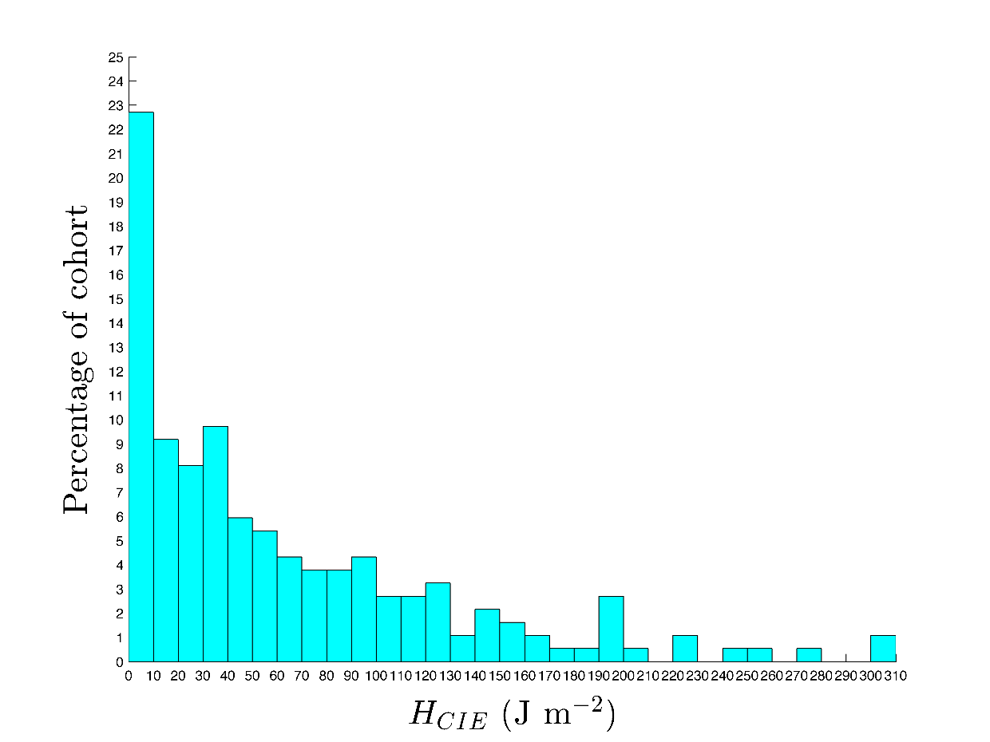
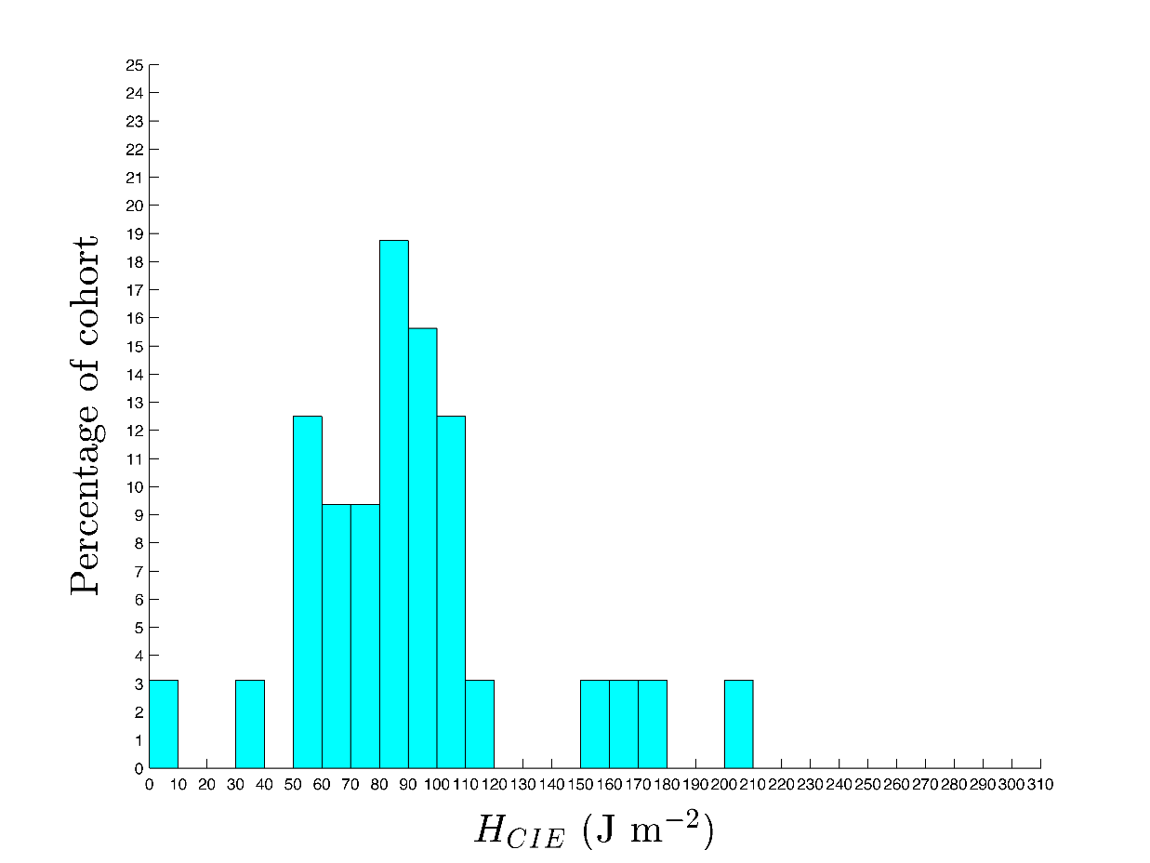
Figure 2: Measured radiant erythemal ultraviolet exposure distribution of classroom teachers working in Townsville, North Queensland during (a) summer and (b) winter.

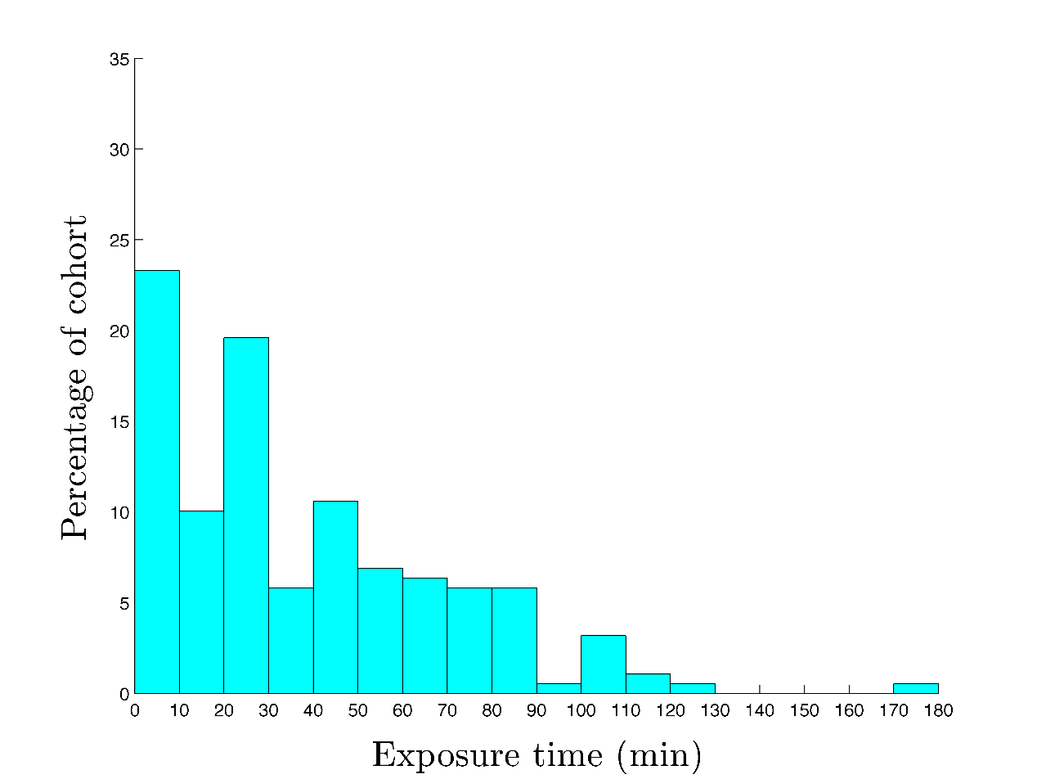
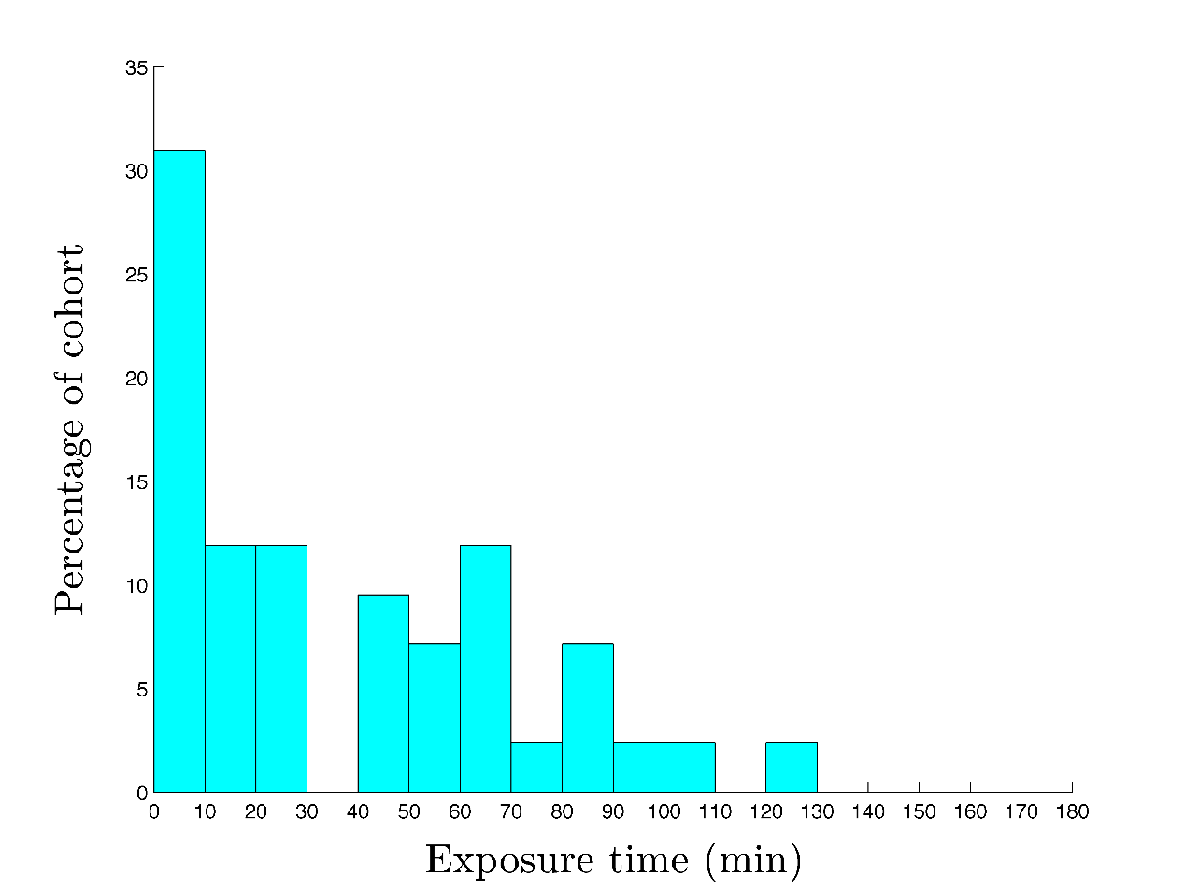
Figure 3: Distribution of self-reported daily outdoor exposure time for classroom teachers working in Townsville, North Queensland during (a) summer and (b) winter.
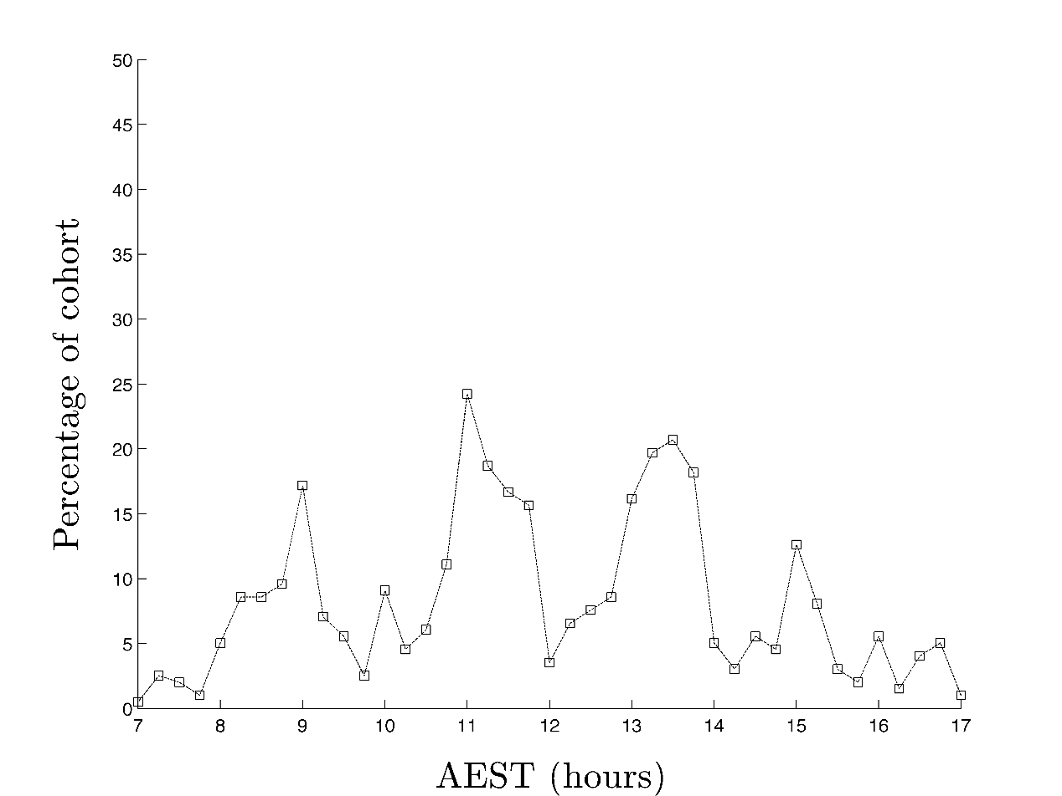
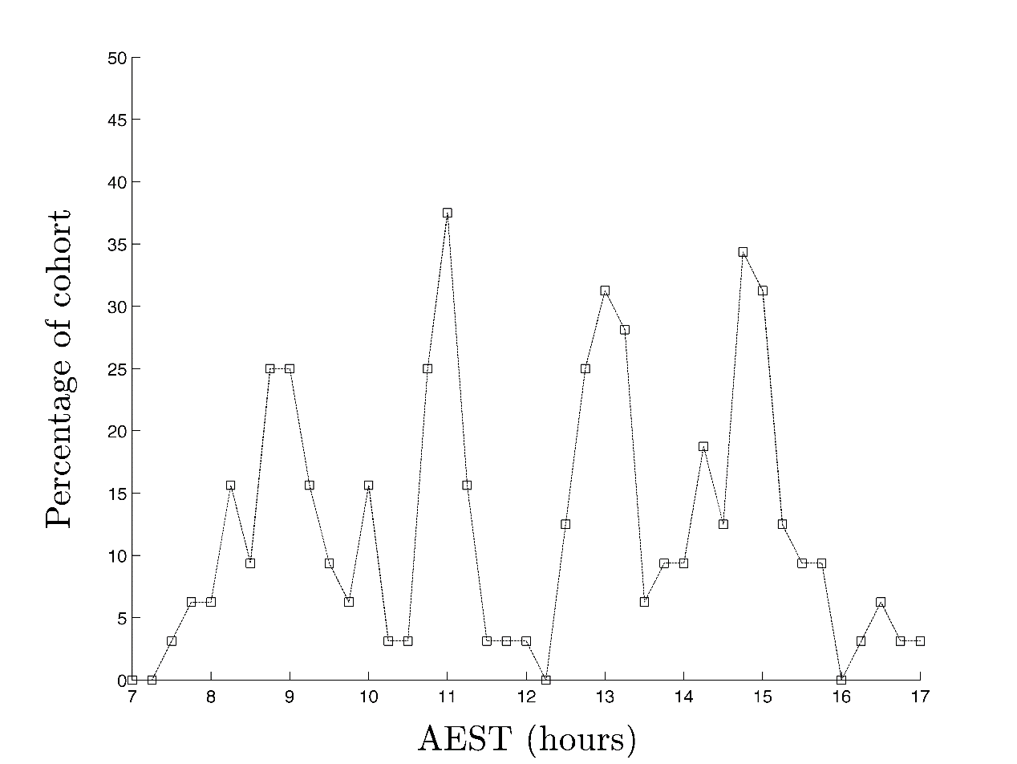
Figure 4: Self-reported outdoor exposure activity in the period 0700 to 1700 for classroom teachers working in Townsville, North Queensland during (a) summer and (b) winter.

