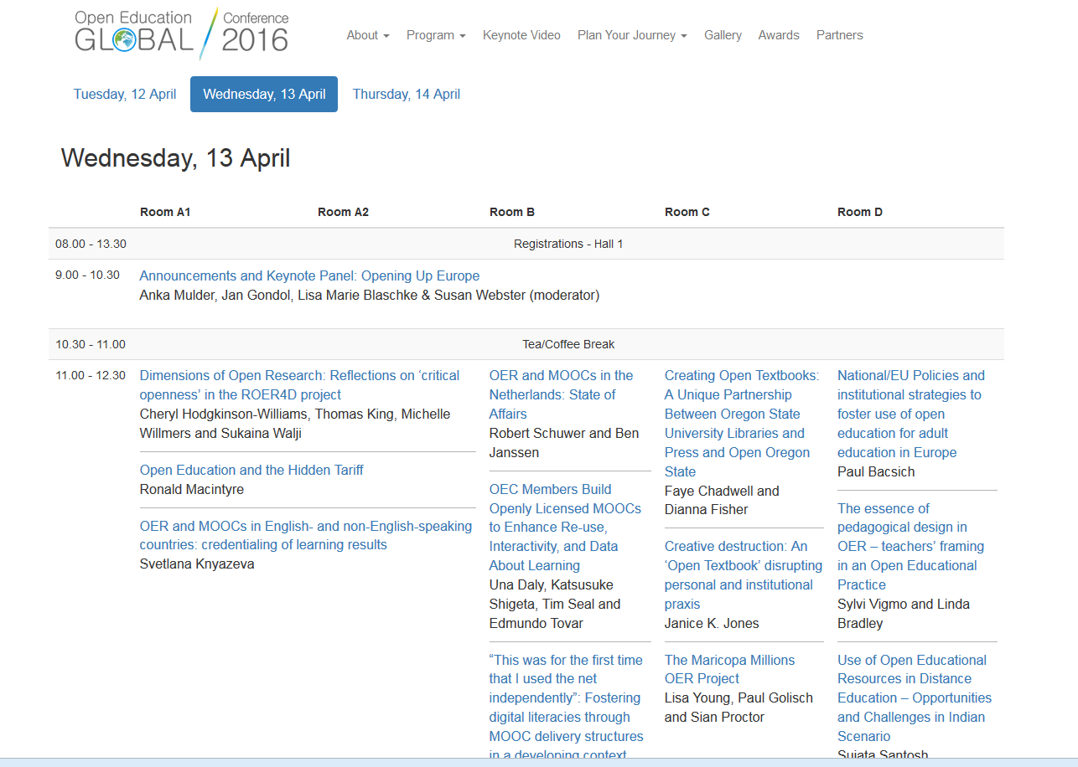
Proof of Paper. Viewed 19/10/17 https://conference.oeconsortium.org/2016/schedule/wednesday/

