**The effect of fibre volume fraction on aligned plant fibre composite properties: determining the minimum, critical and maximum fibre content**

Darshil U. Shaha, Peter J. Schubela, Mike J. Clifforda

*a Polymer Composites Group, Division of Materials, Mechanics and Structures, Faculty of Engineering, The University of Nottingham, Nottingham, NG7 2RD, UK*

Abstract

The effect of fibre volume fraction on aligned PFCs physical and tensile properties has been investigated. There is no correlation between fibre volume fraction and porosity. However, low fibre content PFCs are prone to intra-yarn voids, while high fibre content PFCs are prone to inter-yarn voids. This is due to changing resin flow dynamics with increasing fibre content.

The tensile behaviour of PFCs with increasing fibre content is similar to that of conventional FRPs. At low fibre content brittle fracture occurs; increasing fibre content makes the fracture surface serrated and increases the occurrence and length of fibre pull-out. Interestingly, the elastic response for the plant fibres is found to be non-linear and this stress-strain response has been transferred into the composites as well.

The effect of fibre content on tensile properties is found to closely follow the rule of mixtures. A void content of up to 4% is found to have minimal effect on the tensile properties of PFCs. The minimum and critical (*vf,crit*) fibre volume fractions for aligned flax and jute polyester composites are found to be substantially higher than conventional aligned FRPs; *vf,crit* for jute-polyester and carbon-epoxy is 14.1% and 2.7%, respectively. A simple model has also been developed to approximate the theoretical maximum obtainable fibre volume fraction of PFCs reinforced with staple fibre yarns. The absolute theoretical maximum fibre content is found to be 54.3%, which agrees with experimental values in literature. A high *vf,crit* (~15%) and low *vf,max* (~45%) implies that the possible range of employable fibre volume fractions is only 30% for PFCs.

*Keywords: Natural fibres, polymer-matrix composites, structure-property relationships, fibre volume fraction, porosity, tensile properties*

# Introduction

One of the many advantages of composite materials in general is the possibility of tailoring material properties to meet different requirements. It is well-known that the macroscopic behaviour of heterogeneous FRPs depends on many factors; including the (volumetric) composition, the stress-strain behaviour of each component, the geometrical arrangement of the phases and the interface properties [1].

Renewable bio-based composite materials provide an exciting opportunity to develop sustainable materials. Natural fibres in particular are an attractive source of reinforcement for fibre reinforced plastics (FRPs). The low density, low cost of raw material, high specific properties and ecological profile of plant fibres has portrayed them as a prospective replacement for E-glass in traditional FRPs [2]. This has subjected them to several characterization and development studies for various applications.

## Structure-property relationships

In many studies on plant fibre composite (PFC) mechanical properties, the volumetric composition of the composites is not well-characterised [3]. While most researchers give estimates of fibre weight fraction, some state the fibre volume fraction assuming no porosity. There are, however, some well-documented studies on structure-property relationships of PFCs; be it for short random fibre reinforcements [4-8], uniaxially oriented fibre (roving) reinforcements [9] or staple fibre yarn reinforcements [3, 10, 11]. The aims of these studies have been to *i)* characterise the composite properties over a range of fibre volume fractions, *ii)* compare the results with predictive models (such as the rule of mixtures or Halpin-Tsai equations) and *iii)* compare the performance with E-glass composites.

However, there have been no direct studies on determining the minimum and critical fibre volume fraction for PFCs. The maximum obtainable fibre volume fraction for PFCs has also not been studied; where a maximum fibre volume fraction has been quoted [3, 9, 10], it has been based on composite processing limitations and tensile test data. For aligned PFCs, twisted plant fibre staple yarns are the readily available and widely used form of continuous reinforcement. Such staple fibre yarns themselves have a fibre volume fraction (referred to as the packing fraction *φ* by textile engineers [12]). Hence, the use of such twisted yarn reinforcements has an (unfavourable) effect on the theoretical (geometrically-permissible) maximum fibre volume fraction, which needs to be investigated. Furthermore, the influence of increasing fibre volume fraction on porosity is disputed and needs more insight; while some reports suggest an increase in porosity with fibre content [3, 13], others suggest no correlation [6, 9, 11].

The purpose of this paper is to analyse the relationship between structure and properties of aligned plant fibre composites (PFCs). Specifically, the effect of fibre volume fraction on PFC physical properties (porosity and fibre packing arrangement) and tensile properties is discussed. Parameters such as minimum, critical and maximum obtainable fibre volume fraction are also determined to identify the range of fibre volume fractions that produce PFCs with useful properties.

## Minimum and critical fibre volume fraction

In composite theory [1], for brittle fibres and a ductile matrix the strength-fibre content relationship is well understood (Fig. 1). If there are very few fibres present (0 < *vf* < *vf,min*), the stress on a composite may be high enough to break the fibres. The broken fibres, which carry no load, can be then regarded as an array of aligned holes. The net effect is that the composite tensile strength *σc* is even below that of the matrix *σm*. This defines a minimum fibre volume fraction *vf,min* below which the fibres weaken the material rather than strengthen it and composite failure is controlled by the matrix. This is illustrated in Fig. 1. The reinforcing action of the fibres is only observed once the fibre volume fraction exceeds the critical fibre volume fraction (*vf* > *vf,crit*).

A thermoset bast fibre reinforced composite, like any FRP, is a brittle-fibre ductile-matrix system, where the fibre failure strain is lower than the matrix failure strain (Fig. 2). Hence, if plant fibres are to be used as reinforcements, knowing the minimum and critical fibre volume fraction is paramount as the PFC would be designed for *vf* > *vf,crit*. There is only one study (by Ghosh *et al.* [5]) which implicitly illustrates the minimum and critical fibre volume fractions for short banana fibre reinforced vinyl-ester composites to be *vf,min* ≈ 15% and *vf,crit* ≈ 25%. The values from Ghosh *et al.* [5] and this paper are found to be substantially higher than those of conventional FRPs; an aligned carbon-epoxy composite would have *vf,min* = 2.6% and *vf,crit* = 2.7% [1].

*vf,min*

*vf,crit*

*σm*

*σf*

*σ'm*

*1*

*vf,max*

Matrix control failure

Fibre controlled failure

**Fibre volume fraction *vf***

**Composite strength *σc***



σc= σm(1-vf)

Fig. . Schematic illustration of the variation of the strength of a unidirectional (brittle fibre-ductile matrix) composite with fibre content.

Fig. . Plant fibre thermoset composites are a brittle-fibre ductile-matrix system.

## Maximum achievable fibre volume fraction

Several studies (for instance [9, 10]) have concluded that the rule of mixtures is valid for PFCs. As the fibre content exceeds *vf,crit*, the strength of the composite increases proportionally (Fig. 1). However, there is a ‘practical’ maximum fibre content above which composite properties deteriorate [6, 9] and/or porosity increases drastically [3, 10].

Madsen *et al.* [10] found that when aligned hemp-polypropylene laminates were fabricated at a nominal fibre content of 61%, the actual measured fibre content was only 51% with a larger porosity content of 17%. In essence, impregnation and wettability issues arise close to this maximum fibre volume fraction. Pan [14] has also suggested (according to Cox [15]) that at high fibre volume fractions, fibre-to-fibre spacing becomes so small that the stress transfer between fibre and matrix becomes inefficient eventually causing premature failure due to increased shear stresses on all planes parallel to the axes of the fibres. The resulting delamination has been observed in jute-polyester composites at high fibre content [9].

The experimentally determined optimal (or maximum) fibre volume fractions for PFCs range from about 60% for aligned jute roving reinforced polyester [9], 46-54% for aligned hemp yarn reinforced polyethyleneterephthalate (PET) [3, 10], and between 33%-46% for short random flax and jute reinforced polypropylene [3].

The theoretical maximum fibre volume fraction *vf,max,FRP* of a fibre reinforced composite is a function of fibre packing geometry. Quadratic arrangement of the fibres leads to a maximum fibre volume fraction *vf,max,FRP* of π/4 (= 78.5%) while hexagonally packed fibres generate a higher maximum fibre volume fraction of π/2√3 (= 90.7%) [14]. Importantly, this theoretical maximum is different for synthetic fibre reinforced plastics and plant fibre reinforced plastics. This is because the packing ability of plant fibre assemblies is lower than that of synthetic fibre assemblies [10]. For PFCs that are reinforced with staple plant fibre yarns, the theoretical maximum fibre content *vf,max* is a linear combination of the yarn packing geometry within a composite and fibre packing within the yarn *φ* (Eq. 1). This explains why PFCs made from twisted yarn reinforcements produce lower *vf* composites than conventional FRPs.

$v_{f,max}=v_{f,max,FRP}∙∅$ Eq. (1)

The maximum packing fraction of a yarn is 92% assuming hexagonal close packed fibre arrangement or 70.5% assuming an open packed structure [12]. Hence, the absolute limit of the fibre volume fraction of a PFC reinforced with twisted yarns is 55.3%, assuming quadratic arrangement of yarns within the composite. The order of this theoretical maximum is similar to the experimental values observed in literature (quoted previously).

Importantly, the yarn packing fraction *φ* is a function of the yarn twist level [16]. Pan [16] derived a semi-empirical relationship between twist level *T* (turns per meter or tpm) and packing fraction *φ* of such staple fibre yarns (Eq. 2).

$∅=0.7(1-0.78e^{-0.195T})$ Eq. (2)

Conventional staple fibre ring-spun yarns have a packing fraction *φ* of 50-60% [17]. The packing fraction of a yarn is absolute and will not usually change upon compaction (during composite processing) due to the transverse pressure in a yarn induced by the twisting process. However, if the yarn twist level (and thus the packing fraction) is very low, due to negligible transverse pressure in the yarn the yarn may be compacted further. Roe *et al.* [9] were able to produce higher fibre volume fractions in their jute-polyester composites (of up to 60%) as they were using rovings; these are compressible and thus the distance between fibres within the low twist yarn (roving) can be reduced.

Substituting Eq. 2 into Eq. 1 for *φ* results in a mathematical model (Eq. 3) for determining the maximum obtainable fibre volume fraction in PFCs reinforced with twisted staple plant fibre yarns. The result of Eq. 3 is graphically presented in Fig. 3.

$v_{f,max}=\frac{π}{4}∙0.7(1-0.78e^{-0.195T})$ Eq. (3)

While the minimum and critical fibre volume fraction set the lower limit of effective reinforcing fibre volume fraction, the maximum fibre volume fraction sets the upper limit. These limits determine the fibre content design envelope for structural PFCs.

Fig. . The effect of yarn twist level on the maximum obtainable fibre volume fraction for PFCs reinforced with such twisted yarns.

# Methodology

## Materials and composite manufacture

Unidirectional mats were prepared from two commercially available plant fibre yarns: a low twist (50 tpm) flax yarn from Composites Evolution (UK) and a high twist (190 tpm) jute yarn from Janata and Sadat Jute Ltd. (Bangladesh). The aligned mats were prepared using a drum-winding system and hydroxyethylcellulose binding/sizing agent [18, 19].

Unidirectional composite laminates (250 mm square 3-3.5 mm thick) of five different fibre volume fractions were fabricated using the vacuum infusion technique in an all-aluminium mould tool. To generate different fibre volume fractions, an increasing number of unidirectional mat layers were used.

An orthophthalic unsaturated polyester (Reichhold Norpol type 420-100) matrix was used. The resin was mixed with 0.25 wt% NL49P accelerator (1% Cobalt solution) and 1 wt% Butanox M50 MEKP initiator. Post cure was carried out at 50 °C for 6 h after ambient cure for 16 h. From manufacturer datasheet, the polyester resin has a cured density *ρm* of 1.202 gcm-3, tensile modulus *Em* of 3.7 GPa, tensile strength *σm* of 70 MPa and failure strain *εm* of 3.5%.

## Physical characterisation

The fibre volume fraction *vf*, matrix volume fraction *vm* and void volume fraction *vv* of the manufactured composites were determined using equation Eq.4-6, where *W* and *ρ* represent mass and density, respectively while the subscripts *f*, *m* and *c* denote fibres, matrix and composite, respectively. Composite and fibre density were determined using gas pycnometry.

$v_{f}=\frac{ρ_{c}}{ρ_{f}}\frac{W_{f}}{W_{c}}$ Eq. (4)

$v_{m}=\frac{ρ_{c}}{ρ_{f}}\left(1-\frac{W_{f}}{W_{c}}\right)$ Eq. (5)

$v_{v}=1-\left(v_{f}+v_{m}\right)$ Eq. (6)

Optical microscopy was then used to qualitatively image the fibre/yarn packing arrangement and porosity and in the composites. For this, three cross-sections from each composite were cast (using casting polyester resin), polished and viewed under a microscope.

## Tensile testing

Tensile tests were conducted according to ISO 527-4:1997 using an Instron 5985 testing machine equipped with a 100 kN load cell and an extensometer. At least six 250 mm long and 15 mm wide specimens were tested for each type of composite at a cross-head speed of 2 mm/min. The ultimate tensile strength *σc*, tensile modulus *Ec* (in the strain range of 0.025 - 0.10%) and the strain at failure *εc* of the specimen were measured. The fracture surfaces of the composites were also observed under an SEM (platinum sputter coated).

# Results and Discussion

## Volumetric composition

Flax and jute polyester unidirectional composites have been produced with 5 different fibre volume fractions, by simply increasing the number of layers of unidirectional mats. The density of the composites is observed to increase with fibre volume fraction; the composite density approaches the density of the flax and jute fibres of 1.529 ± 0.003 gcm-3 and 1.433 ± 0.005 gcm-3, respectively. However, a drop in density is observed for a jute-polyester composite at *vf* = 31.7% due to a relatively higher void content. The volumetric composition of fibre, matrix and void within the composites is tabulated in Table 1.

There is no correlation between composite fibre volume fraction and porosity (Fig. 4). Very low linear-regression R2 values of 0.126 and 0.272 are obtained for void content as a function of fibre content for flax and jute composites, respectively. This is in agreement with references [6, 9, 11] but disagreement with references [3, 13].

Table . Density and volumetric composition of the fabricated laminates

|  |  |  |  |  |  |  |  |  |
| --- | --- | --- | --- | --- | --- | --- | --- | --- |
| **Fibre**  **(# of layers)** | **Composite density, *ρc***  **[gcm-3]** | | **Fibre volume fraction, *vf***  **[%]** | | **Matrix volume fraction, *vm***  **[%]** | | **Void volume fraction, *vv***  **[%]** | |
|  | *average* | *stdev* | *average* | *stdev* | *average* | *stdev* | *average* | *stdev* |
| **Flax (5)** | 1.301 | 0.009 | 32.5 | 0.2 | 66.9 | 0.5 | 0.6 | 0.7 |
| **Flax (4)** | 1.282 | 0.002 | 27.3 | 0.1 | 72.0 | 0.1 | 0.7 | 0.2 |
| **Flax (3)** | 1.264 | 0.001 | 24.0 | 0.1 | 74.6 | 0.0 | 1.4 | 0.1 |
| **Flax (2)** | 1.245 | 0.001 | 17.8 | 0.0 | 80.9 | 0.1 | 1.2 | 0.1 |
| **Flax (1)** | 1.220 | 0.001 | 6.1 | 0.0 | 93.8 | 0.1 | 0.1 | 0.1 |
|  |  |  |  |  |  |  |  |  |
| **Jute (5)** | 1.276 | 0.002 | 37.8 | 0.1 | 61.1 | 0.1 | 1.1 | 0.2 |
| **Jute (4)** | 1.225 | 0.002 | 31.7 | 0.1 | 64.1 | 0.1 | 4.2 | 0.1 |
| **Jute (3)** | 1.251 | 0.004 | 25.2 | 0.1 | 74.1 | 0.2 | 0.7 | 0.3 |
| **Jute (2)** | 1.238 | 0.003 | 17.1 | 0.1 | 82.6 | 0.2 | 0.3 | 0.2 |
| **Jute (1)** | 1.215 | 0.002 | 7.6 | 0.0 | 92.0 | 0.2 | 0.4 | 0.2 |

Fig. . There is no correlation between fibre volume fraction and void volume fraction.

The volumetric composition and the presence of voids in composites of different fibre volume fractions can be visually observed from the microscopic images in Fig. 5. It is observed that for low fibre volume fractions (up to 2 layers) voids generally form within the yarn bundle (intra-yarn voids). Increasing the fibre volume fraction further results in the formation of voids between adjacent yarns (inter-yarn voids), rather than within the yarn. This is possibly due to the changing resin flow dynamics with fibre content. At low fibre content, impregnation within the yarn is difficult as high overall permeability and low yarn permeability leads to fast infusion elsewhere and slow infusion within the yarn. Essentially, the resin moves faster in the channels than in the yarn; the ‘outrun’ produces intra-yarn voids. However, at high fibre content the yarns are much closer to each other and the overall permeability is comparable to the yarn permeability. However, capillary pressure is larger within the yarn. Hence, flow is faster through the yarn so that voids are formed between yarns (inter-yarn voids). In essence, fibre content may not affect void content, but it does influence the type of voids formed.

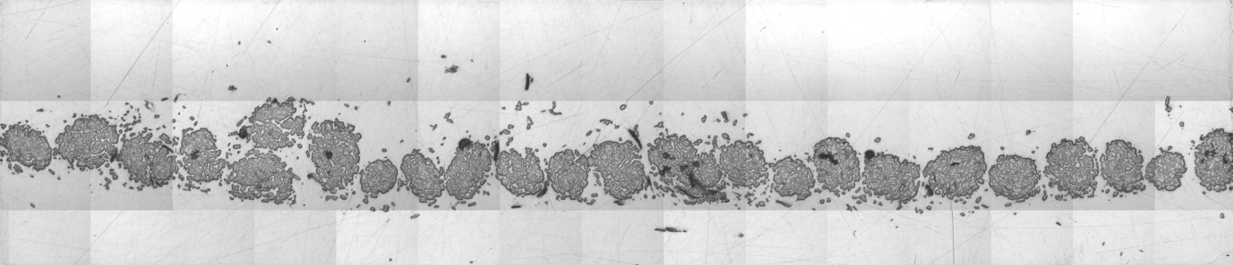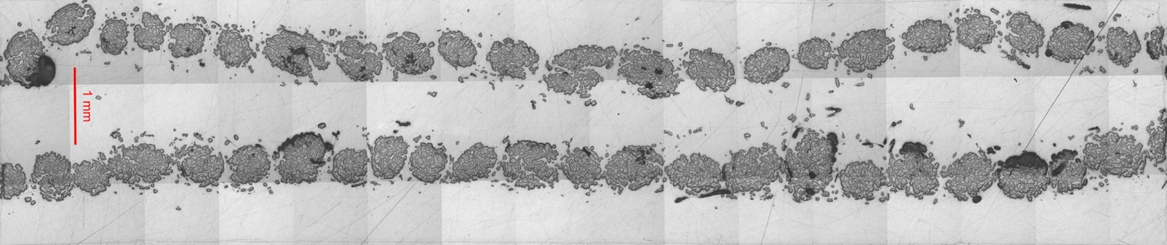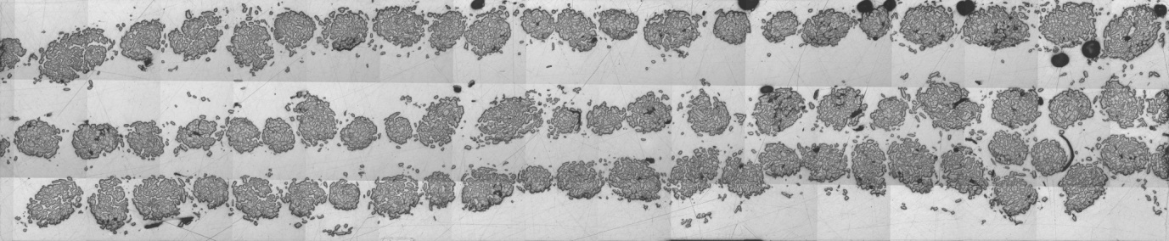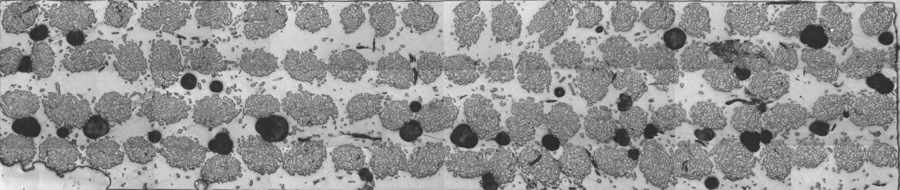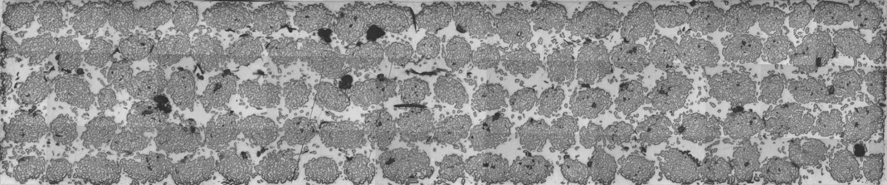

Intra-yarn voids

Inter-yarn voids

Fig. . Microscopic images of the cross-section of jute-polyester composites showing the volumetric composition and fibre/yarn packing arrangement for increasing fibre content. Scale bar is 1 mm.

## Maximum fibre volume fraction

The yarns used in this study are flax (50 tpm) and jute (190 tpm). The experimentally known packing fractions *φ* are 43.2% and 56.9% for the flax and jute yarn, respectively (from [20]). From Fig. 5, it can be seen that the yarns follow a square packing arrangement hence *vf,max,FRP* is taken to be π/4 (= 78.5%). Using Eq. 1, the derived maximum obtainable fibre volume fraction *vf,max* is 33.9% for the flax composites and 44.7% for jute composites. The bottom-most image in Fig. 5 is of jute-polyester with *vf* = 37.8% (5 layers). The yarns seem well-packed within the composite cross-section and thus a theoretical maximum fibre content of 44.7% for the jute composites is realistic.

## Tensile properties

The tensile stress-strain curves reveal the general changes in tensile properties of the composite for increasing fibre content. Fig. 7 presents stress-strain curves of representative specimens for jute-polyester composites of different fibre volume fractions. The curves are shifted upwards when fibre volume fraction increases, suggesting that the elastic modulus and tensile strength increase. It is also observed that the failure strain increases at first and then becomes fairly constant. It can be inferred from Fig. 7 that increasing the fibre volume fraction increases the toughness (area under the stress-strain curve) and thus the impact strength of the composite.

It is also interesting to note from the composite stress-strain curves in Fig. 7 that for all fibre volume fractions, PFCs show a non-linear elastic response. In fact, increasing fibre content exaggerates the non-linear elastic response. This is different from conventional FRPs whose elastic behaviour is entirely linear. Plant fibres themselves display a characteristic non-linear elastic response, as can be seen in the typical stress-strain curve of flax fibre in Fig. 2. The non-linear elastic response seems to have been transferred from the plant fibre to the composite.

Several researchers [21, 22] have observed that when single plant fibres are loaded in tension, a small initial linear region is observed after which the response is non-linear, yet elastic. Plant fibres themselves are composites, where cellulose microfibrils are embedded in a hemi-cellulose/lignin matrix. Additionally, the microfibrils are helically wounded around layers of cell walls and hence they are not perfectly aligned but rather are off-axis to the fibre. The so-called microfibril angle of the S2 cell wall (the largest layer) is in the range of 7-10° for bast fibres such as flax and jute [23]. It is thought that the non-linear elastic response could be a result of rigid body rotation of the microfibrils upon load application and subsequent stretching of the cellulose microfibrils [22]. In wood, it has been noticed that increasing microfibril angle leads to an even more non-linear response in tension [24]. Similar effect of microfibril angle on plant fibre tensile properties has also been observed [25, 26]. Some researchers suggest that the uncoiling and reorientation of the microfibrils upon tensile loading is a key factor in the non-linear elastic response [21, 25]. In essence, plant fibres impart their tensile stress-strain behaviour to the composites.

Fig. . Typical stress-strain curves of jute-polyester with variable fibre volume fraction. The elastic behaviour is non-linear.

The fracture surfaces of the tensile test specimen (Fig. 8) also give insight into the reinforcing effect of the plant fibres at different fibre volume fractions. It can be seen in Fig. 8 that for the first two specimen (up to *vf* ≈ 18%), for both flax and jute composites, tensile fracture is macroscopically brittle with a flat fracture surface. The composite failure seems to be matrix controlled. Little microscopic pull-out of the fibres is noticed in the SEM images (Fig. 9). This is also a sign of low impact strength, as fibre pull-out is more energy dissipative than fibre fracture [27].

Increasing the fibre content produces a more serrated and uneven fracture surface, as can be seen in Fig. 8. The composite failure is fibre controlled. SEM images in Fig. 9 show that the fibre pullout length is also increased implying an increase in toughness. For jute-polyester composites in particular, the fracture path becomes longer and starts running along the length of the fibres/yarns. It can be seen in Fig. 8 that at high fibre volume fractions, delamination between adjacent yarns and layers occurs. It is interesting that no sign of delamination is noticed in the flax-polyester composites. This is most likely due to the difference in structure of the yarn (specifically, twist level).

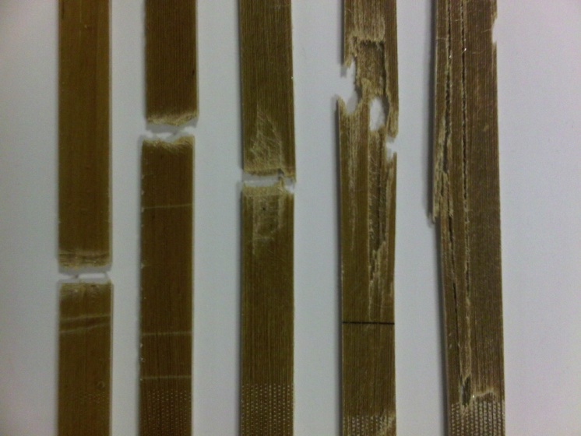 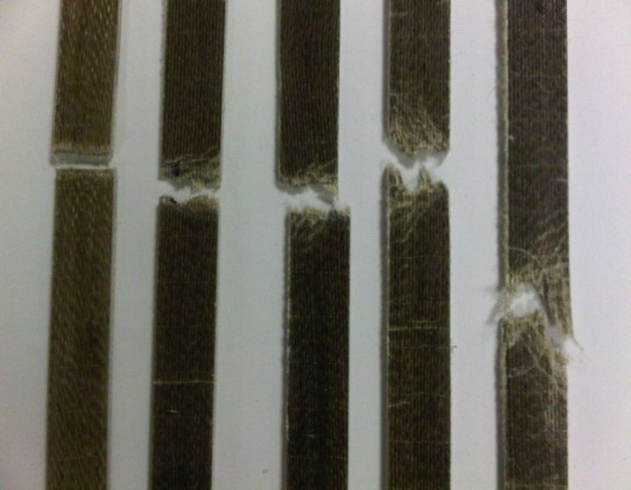

**(a)**

**(b)**

Fig. . The effect of fibre volume fraction of jute (a) and flax (b) on the fracture of tensile specimen. Increasing fibre content (left to right) produces a more serrated fracture surface and even delamination.

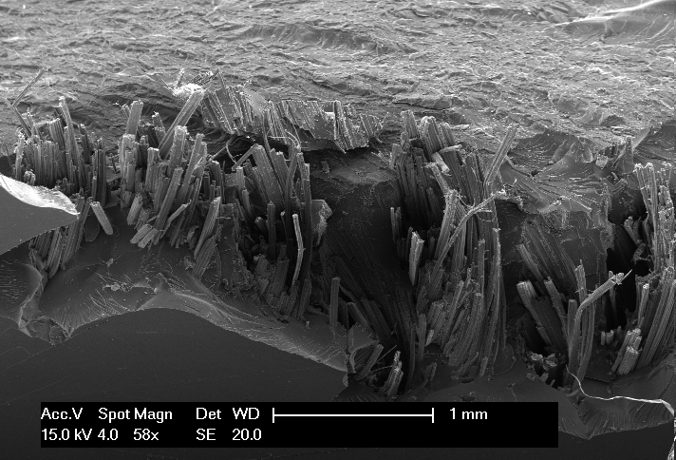 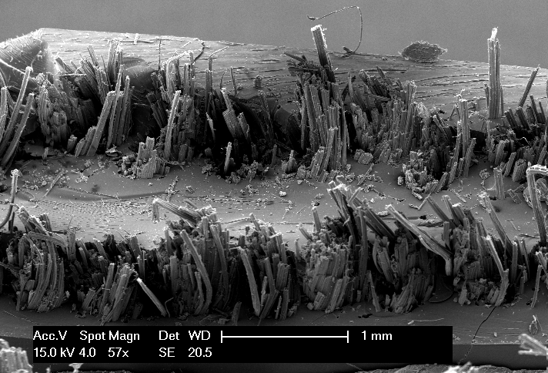 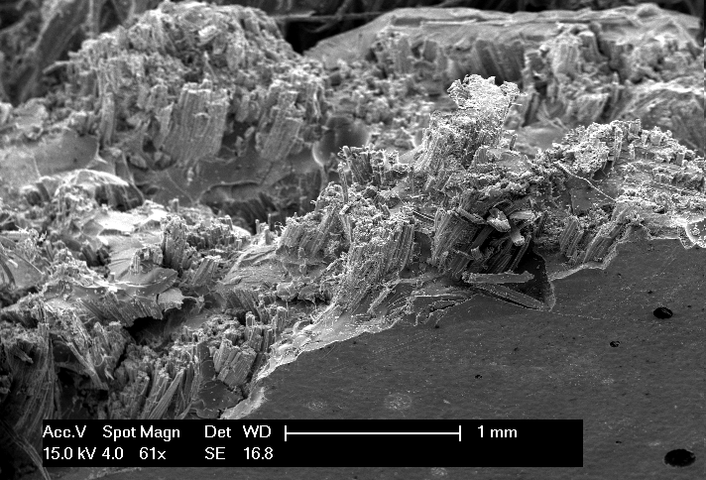

Fig. . SEM images of fracture surfaces of jute polyester composites showing increasing fibre pull-out and serrated surface for increasing fibre content. From left to right: 1 layer, 2 layers and 4 layers of unidirectional reinforcement. Scale bar is 1mm.

### Tensile modulus

The variation of the tensile modulus with fibre volume fraction (Fig. 10) of flax (R2 = 0.993) and jute (R2 = 0.992) composites demonstrates that the rule of mixtures (Eq. 7) is followed closely. This is in agreement with several other studies [7, 9].

$E_{c}=v_{f}E_{f}+(1-v_{f})E_{m}$ Eq. (7)

The back-calculated fibre modulus for flax and jute is thus obtained as 44.3 GPa and 44.0 GPa, respectively. This is in the range of literature values [23, 28] generally quoted for flax and jute, although flax can achieve a much higher tensile modulus (of about 70 GPa).

As the theoretical maximum fibre volume fraction of flax and jute composites is known, the maximum theoretical tensile modulus can be determined. This is found to be 17.3 GPa for flax-polyester (at *vf* = 33.1%) and 22.6 GPa for jute-polyester (at *vf* = 46.8%). This compares to a tensile modulus of 33.7 GPa for E-glass-polyester (at *vf* = 44.0%).

Fig. . Variation of tensile modulus with fibre volume fraction.

A note should be made here regarding the effect of porosity on the tensile modulus. The void content for flax and jute composites ranges between 0.0-1.4%, with no obvious increase with fibre content. Interestingly, despite the relatively high void content (*vv* = 4.2%) of jute-polyester with *vf* = 31.7%, no apparent drop in the elastic modulus (or tensile strength) is noticed (considering the standard deviation), despite a drop in density. Madsen *et al.* [3] show that for plant fibre thermoplastic composites, the effect of porosity on material stiffness is approximated by a factor of (1 – *vv*)2. In essence, a void content of 4.2% should reduce the potential composite stiffness (represented by the rule of mixtures) by 8.2%. An extensive study on the effect of void content on mechanical properties of E-glass thermoplastic composites was conducted by Gil [29]; it is observed that a void content of 4% would reduce the composite tensile strength or stiffness by 20 ± 10%.

However, Santulli *et al.* [30] suggest that no obvious reduction in mechanical properties is observed for void content below 3-4% for such E-glass thermoplastics. It is proposed that the same may be true for PFCs. Reviewing the results of Madsen *et al.* [10] it is found that for hemp-PET composites, for up to 3.2% void content (at 40% *vf*) there is negligible effect (considering the standard deviations) of void content on composite tensile strength and stiffness. At 50% fibre content, the void content jumps to 8.1% and is observed to reduce the stiffness and strength significantly. In essence, void content of up to 4% has minimal effect on PFC properties.

### Tensile strength

Fig. 11 shows the experimental data of tensile strength as a function of fibre content. The characteristic brittle-fibre ductile-matrix variation in composite tensile strength as a function of fibre volume fraction is noticed (as previously illustrated in Fig. 1). Again, good agreement with the rule of mixtures is noticed.

The back-calculated fibre tensile strength for flax and jute is obtained as 502.7 MPa and 615.2 MPa, respectively. This is in the range of literature values [23, 28] generally quoted for flax and jute, although flax can achieve a much higher tensile strength (of about 1100 MPa). No drop in tensile strength is observed for jute-polyester with *vf* = 31.7% with a relatively high void content (*vv* = 4.2%).

The minimum and critical fibre volume fractions can also be determined from Fig. 11. These are found to be *vf,min* = 7.6% and *vf,crit* = 12.8% for flax-polyester composites and *vf,min* = 9.5% and *vf,crit* = 14.1% for jute-polyester composites. Hence, for the design of useful aligned PFCs, where the plant fibres are reinforcing the matrix, the fibre volume fraction needs to be in excess of about 15%.

Fig. . Variation of tensile strength with fibre volume fraction.

The minimum and critical fibre volume fractions for PFCs are substantially larger than those observed in conventional unidirectional FRPs, which is *vf,min* = 2.6% and *vf,crit* = 2.7% for an aligned carbon-epoxy composite [1]. It is also interesting to note that for aligned PFCs in this study, the difference in *vf,min* and *vf,crit* is about 5%. The difference in *vf,min* and *vf,crit* for a carbon-epoxy composite is only 0.1%. The result is that *σ’m* is about 26.5 MPa for the carbon-epoxy system (which defines the matrix stress at fibre failure strain), but only 6.2 MPa for the flax-polyester system and -19.7 MPa for the jute-polyester system. *σ’m* (or in fact *σm* - *σ’m*) is only representative and relates to the work-hardening efficiency of the matrix for the fibre reinforcement. In essence, the matrix and the interface have to work harder in PFCs; more-so in jute-polyester than in flax-polyester. This is probably due to the hydrophilic nature of plant fibres which leads to improper wetting of the fibre and thus inefficient stress transfer between that fibre and the matrix.

As the theoretical maximum fibre volume fraction of flax and jute composites is known, the maximum theoretical tensile strength can be determined. This is found to be 170.6 MPa for flax-polyester (at *vf,max* = 33.1%) and 277.5 GPa for jute-polyester (at *vf,max* = 46.8%). This compares to a tensile strength of 825.7 MPa for an E-glass-polyester (at *vf* = 44.0%).

It seems that PFCs have a small window of fibre volume fractions which produce good-quality composites. A high *vf,crit* (of the order of 15%) and low *vf,max* (of the order of 45%) implies that the possible range of employable fibre volume fractions is only 30%.

### Strain at failure

The failure strain is observed to increase with increasing fibre volume fraction before levelling off to a value of about 1.62% for flax composites and 1.47% for jute composites (Fig. 12). The strain value corresponds to the effective strain at tensile failure of the fibres. This behaviour is similar to that observed in literature [9, 10].

Fig. . Variation of tensile failure strain with fibre volume fraction.

# Conclusions

The effect of fibre volume fraction on aligned PFCs physical properties (porosity and fibre packing arrangement) and tensile properties has been investigated.

There is no correlation between fibre volume fraction and porosity. However, low fibre content PFCs are prone to intra-yarn voids, while high fibre content PFCs are prone to inter-yarn voids. This is due to changing resin flow dynamics with increasing fibre volume fraction.

The tensile behaviour of PFCs with increasing fibre content is similar to that of conventional FRPs. At low fibre content brittle fracture occurs; increasing fibre content makes the fracture surface serrated and increases the occurrence and length of fibre pull-out. Interestingly, the elastic response for the plant fibres is found to be non-linear and this stress-strain response has been transferred into the composites as well.

The effect of fibre content on tensile properties is found to closely follow the rule of mixtures. A void content of up to 4% is found to have minimal effect on the tensile properties of PFCs. The minimum and critical fibre volume fractions for aligned flax and jute polyester composites are found to be substantially higher than conventional aligned FRPs; *vf,crit* for jute-polyester and carbon-epoxy is 14.1% and 2.7%, respectively.

A simple model has also been developed to approximate the theoretical maximum obtainable fibre volume fraction of PFCs reinforced with staple fibre yarns. The model is a linear combination of the yarn packing arrangement within the composite and the fibre packing arrangement within the yarn. The absolute theoretical maximum fibre content is found to be 54.3%, which is in agreement with the practical maximum fibre volume fraction quoted in literature.

A high *vf,crit* (of the order of 15%) and low *vf,max* (of the order of 45%) implies that the possible range of employable fibre volume fractions is only 30% for PFCs.

# Acknowledgements

This project is supported by the Nottingham Innovative Manufacturing Research Centre (EPSRC, project title ‘*Sustainable manufacture of wind turbine blades using natural fibre composites and optimal design tools’*).

# References

1. Harris, B., *Engineering Composite Materials*. 1999, London: The Institute of Materials,.

2. Wambua, P., Ivens J, Verpoest I, *Natural fibres: can they replace glass in fibre reinforced plastics?* Composites Science and Technology, 2003. **63**: p. 1259-1264.

3. Madsen, B., Thygesen, A., Liholt, H. , *Plant fibre composites - porosity and stiffness.* Composites Science and Technology, 2009. **69**: p. 1057-1069.

4. Cabral, H., et al., *Structure-Properties Relationship of Short Jute Fiber-reinforced Polypropylene Composites.* Journal of Composite Materials, 2005. **39**: p. 51-65.

5. Ghosh, R., et al., *Effect of fibre volume fraction on the tensile strength of Banana fibre reinforced vinyl ester resin composites.* International Journal of Advanced Engineering Sciences and Technologies, 2011. **4**(1): p. 89-91.

6. Zarate, C.N., Aranguren, M.I., Reboredo, M.M., *Influence of Fiber Volume Fraction and Aspect Ratio in Resol-Sisal Composites.* Journal of Applied Polymer Science, 2003. **89**: p. 2714-2722.

7. Peijs, T., et al., *Thermoplastic Composites Based on Flax Fibers and Polypropylene: Influence of Fibre Length and Fibre Volume Fraction on Mechanical Properties.* Macromolecular Symposia, 1998. **127**: p. 193-203.

8. Qin, C., et al., *The effect of fibre volume fraction and mercerization on the properties of all-cellulose composites.* Carbohydrate Polymers, 2008. **71**: p. 458-467.

9. Roe, P.J., Ansell, M.P., *Jute-reinforced polyester composites.* Journal of Materials Science, 1985. **20**: p. 4015-4020.

10. Madsen, B., Hoffmeyer P, Lilholt H, *Hemp yarn reinforced composites – II. Tensile properties.* Composites Part A: Applied Science and Manufacturing, 2007. **38**: p. 2204-2215.

11. Zhang, L., Miao M, *Commingled natural fibre/polypropylene wrap spun yarns for structured thermoplastic composites.* Composites Science and Technology, 2010. **70**: p. 130-135.

12. Hearle, J.W.S., Grosberg, P., Backer, S. Structural mechanics of yarns and fabrics. Vol. 1 p. 180. 1969, New York: Wiley-Interscience.

13. Madsen, B., Thygesen A, Lilholt H, *Plant fibre composites - porosity and volumetric interaction.* Composites Science and Technology, 2007. **67**: p. 1584-1600.

14. Pan, N., *Theoretical Determination of the Optimal Fiber Volume Fraction and Fibre-Matrix Property Compatibility of Short Fiber Composites.* Polymer Composites, 1993. **14**(2): p. 85-93.

15. Cox, H.L., *The elasticity and strength of paper and other fibrous materials.* British Journal of Applied Physics, 1951. **3**: p. 72-79.

16. Pan, N., *Development of a Constitutive Theory for Short Fiber Yarns: Part III: Effects of Fiber Orientation and Bending Deformation.* Textile Research Journal, 1993. **63**(7): p. 565-572.

17. Yilmaz, D., et al., *Packing Density of Compact Yarns.* Textile Research Journal, 2007. **77**(9): p. 661-667.

18. Shah, D., et al., *Mechanical characterization of vacuum infused thermoset matrix composites reinforced with aligned hydroxyethylcellulose sized plant bast fibre yarns*, in *4th International Conference on Sustainable Materials, Polymers and Composites*. 6-7 July 2011: Birmingham, UK. Submitted to Composites Part A.

19. Shah, D.U., Schubel, P.J., Clifford, M.J., Licence, P., Warrior, N.A. *Yarn optimisation and plant fibre surface treatment using hydroxyethylcellulose for the development of structural bio-based composites*. in *18th International Conference on Composite Materials (ICCM-18)*. 2011. Jeju, South Korea.

20. Shah, D.U., Schubel PJ, Licence P, Clifford MJ *Hydroxyethylcellulose surface treatment of natural fibres: the new ‘twist’ in yarn preparation and optimization for composites applicability.* Journal of Materials Science (Accepted Manuscript), 2011.

21. Baley, C., *Analysis of the flax fibres tensile behaviour and analysis of the tensile stiffness increase.* Composites Part A: Applied Science and Manufacturing, 2002. **33**: p. 939-948.

22. Herrera-Franco, P.J., Valadez-Gonzalez, A., *Mechanical properties of continuous natural fibre-reinforced polymer composites.* Composites Part A: Applied Science and Manufacturing, 2004. **35**(3): p. 339-345.

23. Lewin, M., *Handbook of Fiber Chemistry*. Third ed. 2007: Taylor & Francis Group, LLC.

24. Reiterer, A., et al., *Experimental evidence for a mechanical function of the cellulose microfibril angle in wood cell walls.* Philosophical Magazine A, 1999. **79**(9): p. 2173-2184.

25. McLaughlin, E.C., Tait R.A., *Fracture mechanism of plant fibres.* Journal of Materials Science, 1980. **15**: p. 89-95.

26. Mukherjee, P., Satyanarayana KG, *An empirical evaluation of structure-property relationships in natural fibres and their fracture behaviour.* Journal of Materials Science, 1986. **21**: p. 4162-4168.

27. Pavithran, C., et.al., *Impact properties of natural fibre composites.* Journal of Materials Science Letters, 1987. **6**: p. 882-884.

28. Pickering, K., *Properties and Performance of Natural-Fibre Composites*. 2008: Woodhead Publishing Ltd.

29. Gil, R.G., *Forming and Consolidation of Textile Composites, Thesis.* 2003, University of Nottingham: Nottingham.

30. Santulli, C., et al., *Influence of micro-structural voids on the mechanical and impact properties in commingled E-glass/polypropylene thermoplastic composites.* Journal of Materials: Design and Applications Part L, 2002. **216**(2): p. 85-100.