Cloud Segmentation Properties
Extraction from Total Sky Image Repositories using Python

Damien P Igoe¹, Alfio V. Parisi*^{,1} and Nathan J. Downs^{1,2}

¹ School of Agricultural, Computational and Environmental Sciences, University of Southern Queensland, Toowoomba, QLD 4350. AUSTRALIA
² College of Public Health, Medical and Veterinary Sciences, James Cook University, Townsville, Australia.

* Corresponding author: School of Agricultural, Computational and Environmental Sciences, University of Southern Queensland, Toowoomba, QLD 4350. Australia; Email: Alfio.Parisi@usq.edu.au; Ph: +61 7 4631 2226.

Abstract
Acquiring the reflectance, radiance and related structural cloud properties from repositories of historical sky images can be a challenging and a computationally intensive task, especially when performed manually or by means of non-automated approaches. In this paper, a quick and efficient, self-adaptive Python tool for the acquisition and analysis of cloud segmentation properties that is applicable to images from all-sky image repositories is presented and a case study demonstrating its usage and the overall efficacy of the technique is demonstrated. The proposed Python tool aims to build a new data extraction technique and to improve the accessibility of data to future researchers, utilizing the freely available libraries in the Python programming language with the ability to be translated into other programming languages. After development and testing of the Python tool in determining cloud and whole sky segmentation properties, over 42,000 sky images were analysed in a relatively short time of just under 40 minutes, with an average execution time of about 0.06 seconds to complete each image analysis.

Keywords: atmospheric composition analysis; sky imagers; Python; cloud cover; UV

Introduction
It is well established that clouds have a significant influence on the land surface climate, hydrological cycle and on surface energy budgets.^{[1-5]} The study of clouds, aerosols and the associated climate and solar radiation forecasting can have significant economic implications, such as supporting solar energy generation,^{[1,4,6,7]} and studies related to human activities and health.^{[8]} The TSI440 Total Sky Imager (Yankee Environmental Systems, MA, USA) employed in this research is one of the many instruments used to construct processed images and measure the physical cloud properties; other examples include Whole Sky and Hemispheric Sky Imagers.^{[9,10]} All sky camera systems are employed to provide ground-based observations that are often used in conjunction with satellite observations or other solar radiation measurements.^{[2-5,10-13]} Recently, smartphone-based cloud observations have also been developed,^{[14,15]} all of which aim to provide an analysis of the clouds and associated climatic and physical properties one image at a time, in real-time.^{[2,3,10,16]} Despite these sorts of analyses being the acceptable norm, it can be quite tedious for researchers who need an extensive set of information about the state of the atmosphere and cloud properties, based on repositories of historical sky imagery, which have often been collected in an ad-hoc manner,^{[17,18]} in an accurate manner and relatively short time. Automated approaches based on computational algorithms that are able to deal with multiple images can therefore provide a distinct advantage relative to the largely manual methods for cloud and other atmospheric property analysis.

Effective image analysis advocates that the pixels within a sky image must be identified as either clouds or as clear skies.^{[7]} Images are usually captured in the red-green-blue (RGB) format^{[2,8-10]} where the red and the blue intensities are typically partitioned for further sky analysis.^{[3,10,19]} The red component is the Rayleigh scattered component that is considerably less in the atmosphere compared to the blue component in the clear sky, however both colour channels are scattered significantly by the water droplets in clouds.^{[4-6]} Noting the fundamental differences, a comparative analysis of the red and the blue intensities of the pixels can lead to a viable approach for comparing the clear sky to clouds, and the different types of clouds.^{[2]} The simplest way to delineate the clouds from a clear sky is to calculate and apply a threshold based on the red and blue intensities of each pixel.^{[1-5,7,10,15,16,19]} Yang et al. ^{[10]} proposed a set of cloud detection methods based on the green colour channel to improve the cloud detection in the circumsolar region and near to the horizon, a method known as ‘differencing and threshold combination algorithm’. In another study, Spyranitos-Xioufis et al.^{[8]} applied a similar ratio approach that included all three colour channels to differentiate the aerosols present in clouds. Li et al.^{[2]} proposed a hybrid fixed and adaptive threshold (HYTA) methodology. A recent study has sought to develop an automated clear sky library (ACSL) for segmentation.^{[20]} A systematic comparison of the different colour channels and principal components has been previously reported.^{[17,18]} All of these studies focussing on different methods for cloud image analysis suggest a growing need to develop automated approaches that are not only efficient in terms of accuracy particularly as clouds often do not possess clear structures,^{[17]} but also computationally efficient and can be performed with readily available software such as Python.

Several comparisons between the red and blue intensities have previously been used in the literature. The most commonly applied ones are the red-blue-ratio (RBR) and the red-blue-difference (RBD).^{[1,3,7,9,10,15]} These comparisons, defined in equations 1 and 2, respectively, are as follows:
$RBR= \frac{R}{B}$ [1]
$RBD=R-B$ [2]
where R and B are the pixel values of each of the red and the blue channels. Also described in such analysis are the normalised-red-blue-ratio (NRBR)^{[1,7,9,10,21]} as stipulated in equation 3.

$NRBR= \frac{R-B}{R+B}$ [3]

RBR and NRBR are cited as being ‘on par’ with conventional cloud detection methods,^{[17]} both having favourable segmentation properties.^{[17,18]} RBR in particular tends to be used considerably in previous research^{[1,4,6,7,22]}. RBR also maintains a higher resolution despite the downsampling that occurs when the images are saved in JPEG format.^{[1]}

The thresholds applied in this analysis are typically taken to be the specific values of one or more of these comparisons. Many earlier studies have employed empirically determined RBR thresholds for cloud segmentation.^{[21]} Various thresholds have been used in the literature and these are usually determined by observations.^{[2,9,10,15]} The thresholds are also dependent on the local climate and camera specifications^{[1,2,4]}, and even difference between cameras of the same brand.^{[7]} The TSI440 has user defined thresholds for opaque and thin clouds^{[4,16,22]}, the latter type of clouds often presents as a difficulty in cloud segmentation, particularly in the presence of aerosols.^{[1,2]} Often, sky images with automated sky cameras are taken each minute or even in a shorter time horizon, resulting in large databases, and potentially large repositories of sky images that can be available for re-analysis and usage in further research and interpretation of the atmospheric cloud conditions.

The novelty of this research is to construct a relevant, adaptable, and user-friendly computational platform to demonstrate a time-efficient approach, denoted as the TSI_Analyser, as a major contribution towards a new methodology for historical atmospheric (i.e., sky property) analysis, particularly for researchers with limited programming knowledge or who do not have ready access to those with the necessary skills. To ensure the practicality of the method in terms of its user-friendly, enigmatic-free and inexpensive approach, the approach has been implemented under a Python programming environment, taking advantage of the widely available open source code libraries.^{[23]} The proposed Python tool is conditioned in such a way to quickly and efficiently access an entire repository of over 200,000 sky images, taken at a 1-minute interval, from which over 42,000 images were selected and analysed in this paper. The repository included the total sky images and their associated cloud properties, with the added advantage of identifying and excluding the corrupted files from the analysis. With minor modifications and fine-tuning, the proposed method has the potential for its wider implications in the analysis of large sky image datasets from similar devices and portability to other programming languages.

Methodology
The proposed Python tool, denoted hereafter as TSI_Analyser, was built specifically based on a 12-month dataset of 1-minute interval sky images (over 200,000 images collected at 480 x 320 resolution). These images were taken using the TSI440 Total Sky Imager (Yankee Environment Systems Inc. USA) installed at the University of Southern Queensland, Toowoomba, Australia, and have been used in previous research works (e.g., ^{[5,16,24]}). The TSI440 consists of a reflective dome with a camera suspended above it^{[4,22]}, pointing downwards to produce a jpeg format colour image of the sky (http://yesinc.com/products/data/tsi440/index.html). The tool used in this research for all analysis was written in a Python environment (version 3.6.3, Python.org). It was conditioned in such a way to analyse a user-defined, set number of sky images, and also tested on two Microsoft Windows 10 based computers, both having 8 GB RAM, but with different processing speeds (i.e., 2.50 GHz and 3.20 GHz). Several Python libraries were then used to execute the TSI_Analyser, and these are discussed next as part of this methodology section as examples of the functionality required for implementation of this tool.

The sky images from the TSI440 are basically a suite of files that are generated at a 1-minute interval, a time scale that is useful for studying relatively short horizon atmospheric properties from continuous data acquisition apparatus.^{[24]} The suite consists of the main sky image, saved as a full colour jpeg file; a ‘properties’ text file containing details such as the position of the sun position and the cloud fraction; and a segmented image, where the internal user-defined thresholds^{[4,22]} separate clouds from clear sky in real-time, as a png image file. The first two files are used exclusively in the Python tool, whereas the final file is used for validation to ensure the correct cloud/clear-sky segmentation has been achieved, an important benchmark measure of the proposed, automated Python tool. All files in the image suite have the same base filename in a date-time format.

A flowchart of the specific Python tool proposed for analysing the TSI440 sky images in this study and also used to develop the TSI_Analyser method has been exemplified in Figure 1. Sky image integrity is a potential issue with pre-saved (i.e., historical) datasets, which on some occasions, is expected to cause the photos to be malformed or even the acquired data to be relatively incomplete^{[16]} These corrupted files could also cause a given analysis tool to cease its functions, generate inaccurate results and even ‘crash’ prior to the end of the final execution, and provide to the user an erroneous dataset. To enable the Python tool to proceed smoothly, an if-else conditional statement was developed, which was drawn from a common feature for all coherent images. In the present research, the Python Imaging Library (PIL) was used alongside the os and linecache libraries to read a common line from the properties text file. If the common line was present, the Python tool proceeded as normal, else a ‘corrupted file’ was recorded and analysis ceased for that file. and the next image file was read.

Once a sky image is shown to be non-corrupted, the image array is read using the NumPy library via the OpenCV library’s imread command^{[25]} and converted from the OpenCV’s blue-green-red (BGR) to red-green-blue (RGB) to be used for further analysis. Reading each image in OpenCV provides the required data of appropriate dimensions, including the 8-bit colour channel array.^{[6,23,25]} This step is of great importance as it can allow the data for each image to be available as data arrays for current and also for further analysis. As the colour channel array values are composed of 8-bit integer values, they are of the uint8 (8-bit unsigned integer) data type in Python.^{[23,25]} The OpenCV library then truncates uint8 values outside of the possible colour intensities of 0 to 255 digital numbers.

In designing the TSI_Analyser tool, a set of masks were applied to eliminate the non-sky portions of the image, specifically, the background, camera housing, camera-arm and sun-shield (see Figure 2 top image). The background, camera position and camera-arm were all in fixed positions, hence a constant mask was made to mask these based on the dimensions of the image and the objects’ position.^{[4]} The background, which includes some of the horizon due to the obstructions, was masked outside of a circle, as determined by an observationally pre-determined constant radius, used as a proportion of the image height, from the image centre, calculated using geometric functions from the NumPy library.^{[25,26]} The camera housing and camera-arm were masked using the circle and line functions of the OpenCV library to provide the resultant image for further processing (Figure 2, bottom image). The mask was applied using the NumPy ma (masked array) module.^{[23]}

It should be noted that the sun-shield position is largely dependent on the solar azimuth, since the reflective dome with the black band to obscure the sun rotates during the day to obscure the solar disc.^{[5]} This solar azimuth angle is therefore recorded in the properties text file when using the TSI440 apparatus. The azimuth angle is also retrieved using the getline function of the linecache library and is made into a line-based adaptive mask, where the position is converted using trigonometric functions of the math library. This aims to convert the azimuth angle to their unit circle equivalents and mask it as a line with a width of 60 pixels^{[4]} (see Figure 2, bottom image).

In atmospheric imaging devices such as the other forms of sky-imagers or smartphone-based surveys, a properties text file may not be available, nor is the solar azimuth. However, the date and the time that the picture was taken should be accessible either as part of the filename, in the image properties or in an associated database. All of these properties can be accessed using Python scripts and processes like the ones described for this research methodology paper. The date and time of a sky-image and its geographical position can be used to calculate the azimuth^{[4]} by a relevant adapting code such as the one developed by Michalsky^{[27]} in the FORTRAN programming environment, which can be easily adapted to Python.

In the Python TSI_Analyser tool, the red and blue colour channel arrays were selected for further analysis and the masks were applied using the NumPy library. The sum of unmasked pixels were determined. The potential ‘divide by zero error’ in the RBR ratio was avoided by setting the RBR equal to 0 when the blue value was 0. In this method, the use of the ‘for-loops’ was avoided to increase time efficiency of the TSI_Analyser, achieved by vectorising the array elements in all calculations.^{[21]} The RBR pixel values were then scaled to increase contrast to be within (0, 255).^{[6]}

Considering the need to segregate the different cloud properties, a further adaptive mask was designed to separate clear sky from the cloud components. The threshold was determined by scaling a user-defined constant value with the maximum RBR value (RBR_{max}) calculated by the tool for that particular image in the same manner that all the pixels were scaled, this is an adaptation of the commonly used RBR transform. It is essential to statistically obtain the user-defined constant value threshold by comparing a training data set with the TSI data^{[1]}, particularly as the user-defined segmentation thresholds for the TSI440^{[22]} may not be known. This combination of fixed and adaptive thresholding was employed to take into consideration the variations due to hardware, climate and the types of clouds.^{[2]} The transformed data array was then binarized.^{[6]} The cloud fraction was determined for comparison with the previously ground-truthed TSI readings by taking the cloud fraction differences.^{[22]}

All data were integrated to the filename and saved as a row of a comma-separated value (.csv) text files that can be accessed in any data analysis program, such as Microsoft Excel. All sky-images in any directory with similarly defined filenames were searched for and analysed in turn, then appended as a separate row in the .csv text file. Searching and performing the same processes to multiple files in multiple directories for defined filenames and types was performed using functions of the glob library. In the glob function, only those image files at 5-minute intervals were taken by specifying that the final digit for the minutes in the date-time filename were either 0 or 5.

A practical measure of the efficiency of the Python tool was provided by the time taken to execute the program, particularly the time of the components within it. To serve this purpose, the timeit library provides a means to deduce how long each part of the Python tool takes to execute, as with the entire program. Additionally, the time-efficiency of the Python tool was tested since it was able to search through directories and perform the same processes to multiple sky-images.

Results and Discussion: Application of TSI_Analyser
The optimum cloud/clear-sky adaptive threshold (T) to be used in this Python tool followed the maximum RBR ratio (RBR_{max}) for an image, as follows:

$T= \frac{255k}{{RBR}_{max}}$ [4]

where k is between 0 – 1 and can be statistically determined for the specific case. In this paper, a factor of k = 0.56 was used (Figure 3) based on a test on a training set of 2568 randomly selected images from different times of the day and different seasons, providing suitable discrimination between clouds and the sky.

The segmentation of the images into cloud and sky was tested by comparing the resulting percentage of cloud to the percentage of cloud obtained from the TSI440 software. The cloud fractions from the TSI have been previously found to have an uncertainty of ±10% for a minimum of 94% of the images.^{[28,29]} The cloud percentages from a total of just over 42,000 images were compared to the cloud percentages from the TSI software and the median of the difference was 0.74% with an interquartile range of -3.0% to 2.0%. The comparison showed that 85% of the cases provided a difference that was within 10% of the TSI values and 66% of the cases provided a difference that was within 5% of the TSI values. There was a strong correlation of 0.93 between the original and calculated data. The cases with the bigger differences are generally due to images with high level cloud, mist and dust. Just less than 2000 images were flagged as being corrupted, but these did not cause the program to cease functionality.

The total time taken to execute the entire Python-based tool on a single sky-image averaged to about 0.06 seconds on both computers used. However, testing increasingly larger datasets in multiple directories showed that the total time taken was dependent on the number of files analysed with a linear progressive function. The program was set to only analyse the data at 5-minute intervals from 5 am to 7 pm local time for the full 12-month dataset, calling on a total of 42,084 sky-images; a task that was performed in just over 40 minutes.

Potential Limitations and Conclusion
Despite the efficacy of the proposed approach in terms of its major contribution to atmospheric image analysis, speed and accuracy, there remain some limitations in terms of running the TSI_Analyser, particularly when adapting the program to analyse the sky images from other devices. Future users of this Python tool should ensure that a careful consideration be given when developing parameters for the adaptive masks used in the approach. In any iteration of the tool, the time taken in the program execution will depend on the processing speed and available memory on the computer that the analysis is being performed.

In any sky image dataset, the presence of corrupt images is unfortunate, but these are likely to occur on an ad-hoc basis. In this research paper, we were able to account for and correct two types of errors – one where the properties file was incomplete and the second, where the image had failed to completely form. There may be other types of image corruptions that may not be able to be anticipated in this methodology, and therefore, this opens a new window of opportunity for further developing of the proposed TSI_Analyser Python tool.

In order to generate new knowledge on atmospheric dynamics, atmospheric scientists will likely wish to review and utilise useful information from significant repositories of stored sky images, just as we have done so for our 12-month sample dataset. These repositories often have thousands of images and their associated files, which is far too much for them to be analysed individually ‘by hand’. Therefore, a fast, efficient approach able to perform the analysis has been developed and described, providing a useful contribution to future data acquisition and analysis methodologies, particularly in the area of image analysis. The present study shows that the proposed Python tool remained stable when searching through the directories and analysing each sky image, gathering data about the segmentation properties of the whole sky and clouds, taking just 0.06 seconds to complete each image – a rate that remains consistent regardless of the number of images analysed. This resulted in over 42,000 images being processed in 40 minutes. The proposed method described can be adapted for other channel combinations^{[17]} and to the other types of sky images and for other properties, such as chromatic properties.

Acknowledgements: The authors thank Dr Ravinesh Deo for the productive discussions on this paper.

References
- Ghonima, M.S.; Urquhart, B.; Chow, C.W.; Shields, J.E.; Cazorla, A.; Kleissl, J. A method for cloud detection and opacity classification based on ground based sky imagery. Atmos. Meas. Tech. 2012, 5, 2881-2892.
- Li, Q.; Lu, W.; Yang, J. A hybrid thresholding algorithm for cloud detection on ground-based color images. J. Atmos. Ocean. Tech. 2011, 28, 1286-1296.
- Heinle, A.; Macke, A.; Srivastav, A. Automatic cloud classification of whole sky imagers. Atmos. Meas. Tech. 2010, 33, 557-567.
- Long, C.N.; Sabburg, J.; Calbó, J.; Pagés, D. Retrieving cloud characteristics from ground-based daytime color all-sky images. J. Atmos. Ocean. Tech. 2006, 23(5), 633-652.
- Parisi, A.V.; Sabburg, J.; Kimlin, M.G. Scattered and Filtered Solar UV Measurements; Kluwer Academic Publishers: Dordrecht, 2004.
- Richardson Jr, W.; Krishnaswami, H.; Vega, R.; Cervantes, M. A low cost, edge computing, all-sky imager for cloud tracking and intra-hour irradiance forecasting. Sustainability, 2017, 9, 482, doi:10.3390/su9040482.
- Chauvin, R.; Nou, J.; Thil, S.; Traoré, A.; Grieu, S. Cloud detection methodology based on a sky-imaging system, Energy Procedia, 2015, 69, 1970-1980.
- Spyranitos-Xioufis, E.; Mountzidou, A.; Papadopoulos, S.; Vrochidis, S.; Kompatsiaris, Y.; Georgoulias, A.R.; Alexandri, G.; Kartidis, K. Towards Improved Air Quality Monitoring using Publicly Available Sky Images. In Multimedia Tools and Applications for Environmental and Biodiversity Informatics,; Joly, A., Vrochidis, S., Karatzas, K., Karpinnen, A., Bonnet, P., Eds., Springer: Cham, 2018.
- Yang, J.; Min, Q.; Lu, W.; Ma, Y.; Yao, W.; Lu, T. An RGB channel operation for removal of the difference of atmospheric scattering and its application on total sky cloud detection. Atmos. Meas. Tech. 2017, 10(3), 1191-1201.
- Yang, J.; Min, Q.; Lu, W.; Yao, W.; Ma, Y. An automated cloud detection method based on the green channel of total-sky visible images. Atmos. Meas. Tech. 2015, 8(11), 4671-4679.
- Parisi, A.V.; Sabburg, J.; Turner, J.; Dunn, P.K. Cloud observations for the statistical evaluation of the UV index at Toowoomba, Australia. Int. J. Biomet. 2008, 52, 159-166.
- Calbó, J.; González, J.A. Empirical studies of cloud effects on UV radiation: A review. Reviews of Geophys. 2005, 43(2). RG2002, doi: 10.1029/2004RG000155.
- Pfister, G.; McKenzie, R.L.; Liley, J.B.; Thomas, A.; Forgan, B.W.; Long, C.N. Cloud coverage based on all-sky imaging and its impact on surface solar irradiance. J. Appl. Meteorol. 2003, 42, 1421-1434.
- McGonigle, A.J.S.; Wilkes, T.C.; Pering, T.D.; Willmott, J.R.; Cook, J.M.; Mims III, F.M.; Parisi, A.V. Smartphone spectrometers. Sensors, 2018, 18(1), 223, doi:10.3390/s18010223.
- Parisi, A.V.; Downs, N.J.; Igoe, D.P.; Turner, J. Characterisation of cloud cover with a smartphone camera. Inst. Sci. Tech. 2015, 44(1), 23-34.
- Sabburg, J.; Wong, J. Evaluation of a ground-based camera system for use in surface irradiance measurement. J. Atmos. Ocean. Tech. 1999, 16, 752-759.
- Dev, S.; Lee, Y.H.; Winkler, S. Systematic study of color spaces and components for the segmentation of sky/cloud images. In 2014 IEEE International Conference on Image Processing, Paris, France, 27-30 Oct 2014. https://ieeexplore.ieee.org/abstract/document/7026033 (accessed 29 March 2019).
- Dev, S.; Savoy, F.M.; Lee, Y.H.; Winkler, S. Rough-set-based color channel selection. IEEE Geosci. Rem. Sens. Lett. 2017, 14(1), 52-56.
- Shields, J.E.; Karr, M.E.; Johnson, R.W.; Burden, A.R. Day/night whole sky imagers for 24-h cloud and sky assessment: History and overview. Appl. Optics, 2013, 52(8), 1605-1616.
- Pawar, P.; Cortés, C.; Murray, C.; Kleissl, J. Detecting clear sky images. Sol. Energy, 2019, 183, 50-56.
- Jayadevan, V.T.; Rodriguez, J.J.; Cronin, A.D. A new contrast-enhancing feature for Cloud detection in ground-based sky images. J. Atmos. Ocean. Tech. 2015, 32, 209-219.
- Slater, D.W.; Long, C.N.; Tooman, T.P. Total Sky Imager/Whole Sky Imager Cloud Fraction Comparison. In 11th ARM Science Team Meeting Proceedings, Atlanta, Georgia, March 19-23, 2011.
- Oliphant, T.E. Python for scientific computing. Comp. Sci. Eng. 2007, 9(3), 10-20.
- Deo, R.C.; Downs, N.; Parisi, A.V.; Adamowski, J.; Quilty, J. Very short-term reactive forecasting of the solar ultraviolet index using an extreme learning machine integrated with the solar zenith angle. Env. Res. 2017, 155, 141-166.
- Van der Walt, S.; Schrönberger, J.L.; Nunez-Iglesias, J.; Boulogne, F.; Warner, J.D.; Yager, N.; Gouillart, E.; Yu, T. scikit-image: Image processing in Python. PeerJ, 2014, 2, e453. doi.org/10.7717/peerj.453.
- Van der Walt, S.; Colbert, C.; Varoquaux, G. The NumPy array: a structure for efficient numerical computation. Comp. Sci. Eng. 2011, 13(2), 22-30.
- Michalsky, J.J. The astronomical almanac’s algorithm for approximate solar position (1950-2050). Sol. Energy, 1988, 40, 227-235.
- Long, C.N.; Slater, D.W.; Tooman, T. 2001. Total sky imager model 880 status and testing results. Report DOE/SC-ARM/TR-006. https://arm.gov/publications/tech_reports/arm-tr-006.pdf (accessed March, 2019).
- Sabburg, J.; Long, C.N. Improved sky imaging for studies of enhanced UV irradiance. Atmos. Chem. Phys. 2004, 4, 2543-2552.

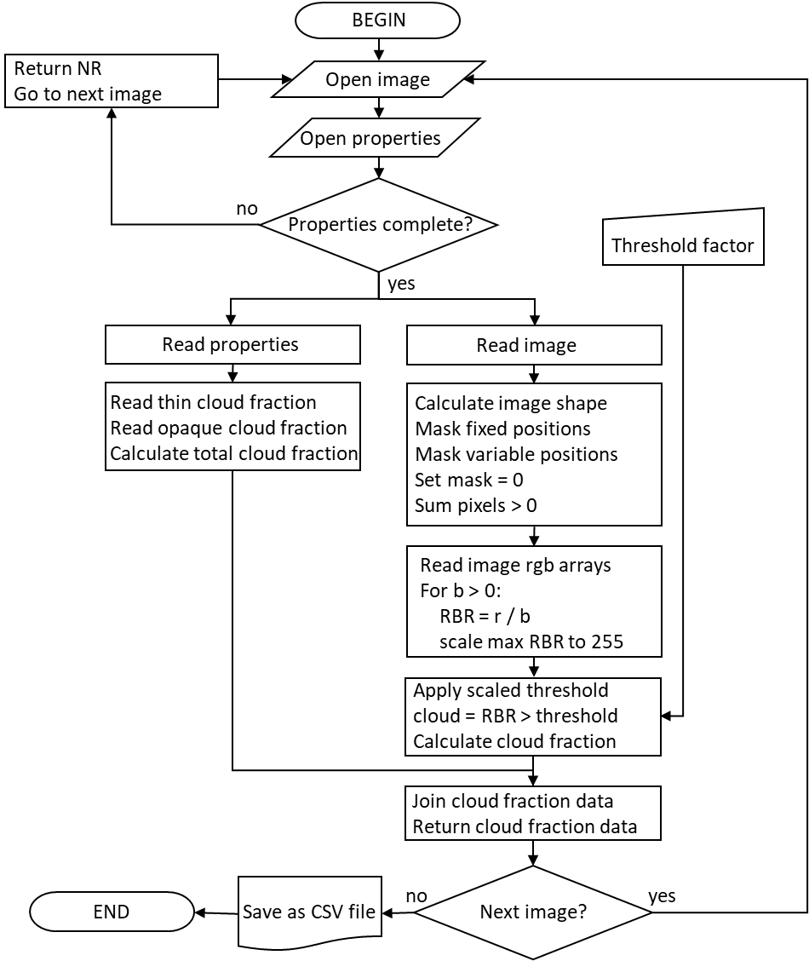
Figure 1: A flowchart demonstrating the order of processes implemented in the proposed Python TSI_Analyser algorithm.

Figure 2: Sample sky image from the TSI440 apparatus, showing all the parts to be masked: A – background, B – camera housing, C – camera-arm and D – sun-shield. The resultant masked image is below.

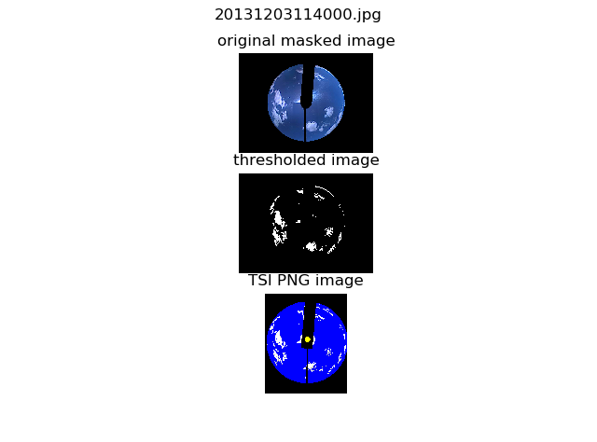
Figure 3: Example of masked whole sky image against the binarised cloud/clear-sky threshold mask, where k = 0.56. The TSI440 png file is included for comparison.

