Love Lies Bleeding
Sarah Ryan & Tiffany Shafran
9 April – 5 May 2021

FLOOR SHEET
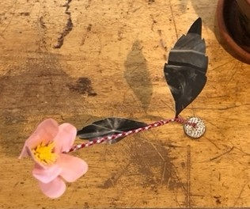
Tiffany Shafran, Peach & red gingham stem, 2021, found paper, fabric, wire and gouache in kenzan, 36 x 20 x 20 cm, $250
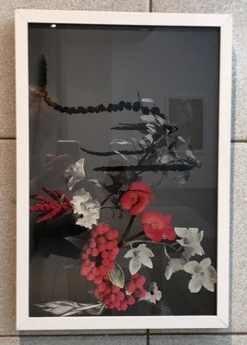
Sarah Ryan and Tiffany Shafran, Love Lies Bleeding #2, 2021, collage on archival print, 48 x 32.5cm,
$1,300
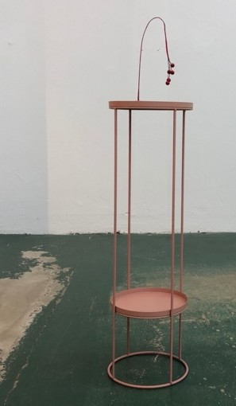
Tiffany Shafran, Red berries, 2021, found paper, berries, and wire in kenzan, 26 x 13 x 5cm, $250

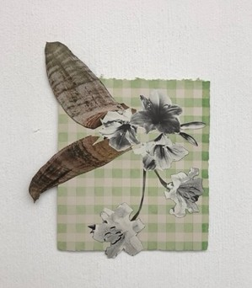
Tiffany Shafran, Rainy day arrangement #2 (green gingham), 2021, collage, gouache and graphite on paper, 25 x 21cm, $450

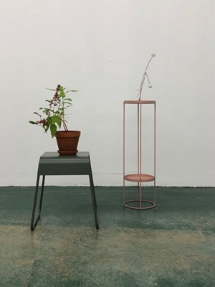
Tiffany Shafran, Dandelions, 2021, found paper, fabric, wire and clay in kenzan, 37 x 16 x 13cm, $250 (plant and stool not for sale)
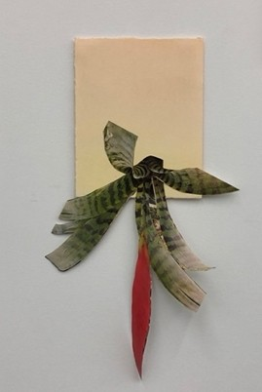
Tiffany Shafran, Yellow bromeliad, 2021, collage and gouache on paper, 46 x 27cm, $450
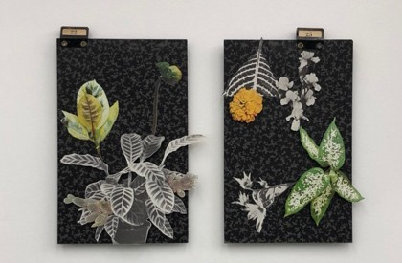

Tiffany Shafran, Dahlia arrangement with cacti from Pinned objects series 2021, collage, pins on found filing card, 26cm x 19cm, $350 (left)

Tiffany Shafran, Marigold from Pinned objects series 2021, collage, pins on found filing card, 26cm x 18cm, $350 (right)

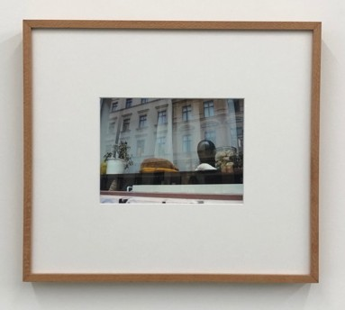
Sarah Ryan, Cat in Window Cat in window 2021, Giclee print framed with native Silky Oak, 41cm x 46cm (framed size), Edition of 3 + 1 Artist proof $1200

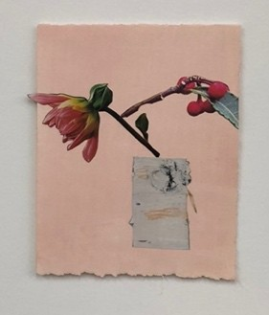
Tiffany Shafran, Rainy day arrangement #1 (dahlia and birch) 2021, collage and gouache on paper, 20 x 18cm, $450
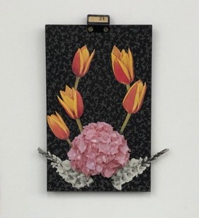
Tiffany Shafran, Coronation arrangement with hydrangeas, gladioli and tulips from Pinned objects series, 2021, collage, pins on found filing card, 26cm x 21cm, $350 SOLD
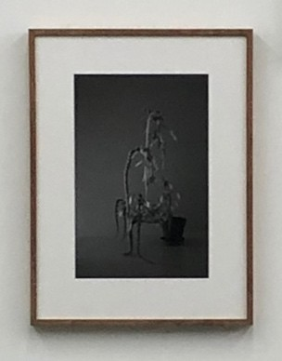
Sarah Ryan, Love Lies Bleeding, 2021, Giclee print framed with native Tasmanian Blackwood, 58 x 43.5cm (framed size), Edition of 3 + 1 Artist proof, $1250

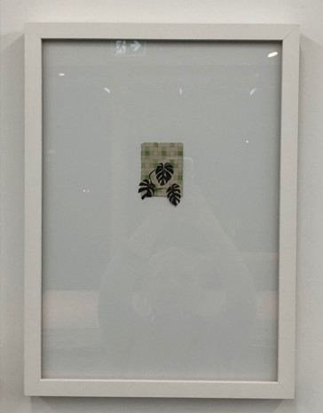
Tiffany Shafran, Monstera deliciosa, 2021, collage, gouache and graphite on paper, 45 x 33cm, $550
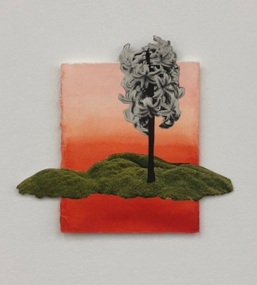
Tiffany Shafran, Islands follow me, 2021, collage and gouache on paper, 15cm x 17cm, $400
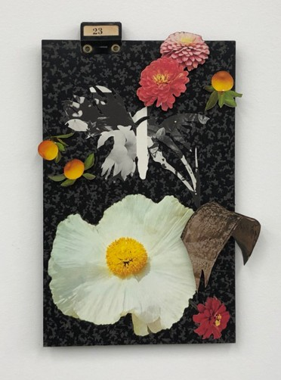
Tiffany Shafran, Poppy arrangement (Fried egg) from Pinned objects series, 2021, collage, pins on found filing card, 26cm x 19cm, $350

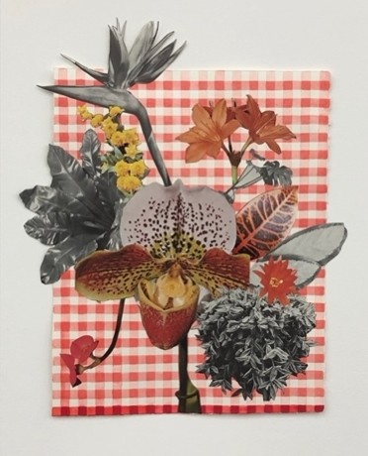
Tiffany Shafran, Riot in the hot house, 2021, collage, gouache and graphite on paper, 46 x 39cm, $650

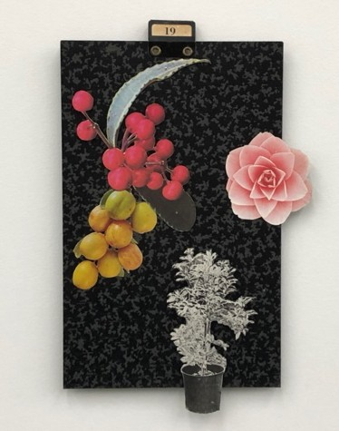
Tiffany Shafran, Camellia, gooseberries and ficus from Pinned objects series, 2021, collage, pins on found filing card, 30cm x 19cm, $350
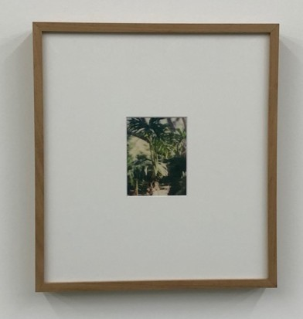
Sarah Ryan, Garden 2021, Lenticular photograph framed with native Tasmanian Blackwood, 37cm x 34cm, unique print, not for sale
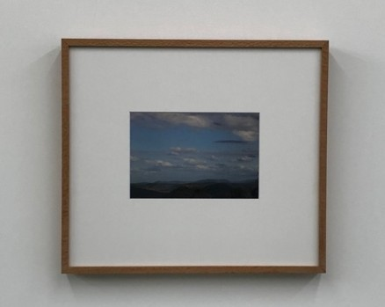
Sarah Ryan, Sky, 2021, Giclee print framed with native Silky Oak, 41cm x 46cm (framed size), Edition of 3 + 1 Artist proof, $1200

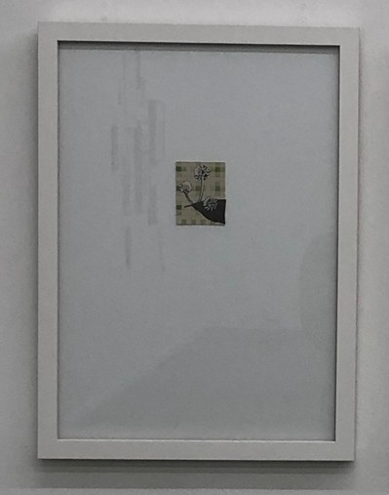
Tiffany Shafran, Fatsia japonica, 2021, collage, gouache and graphite on paper, 46 x 33cm, $550

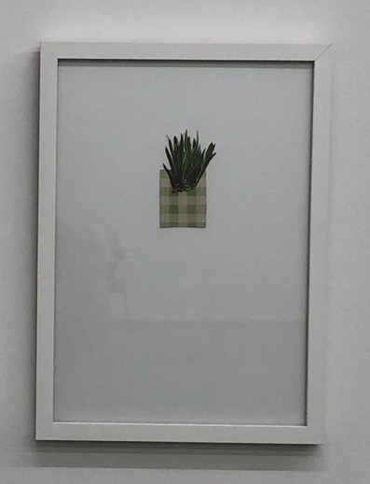
Tiffany Shafran, Iris, 2021, collage, gouache and graphite on paper, 46 x 33cm, $550

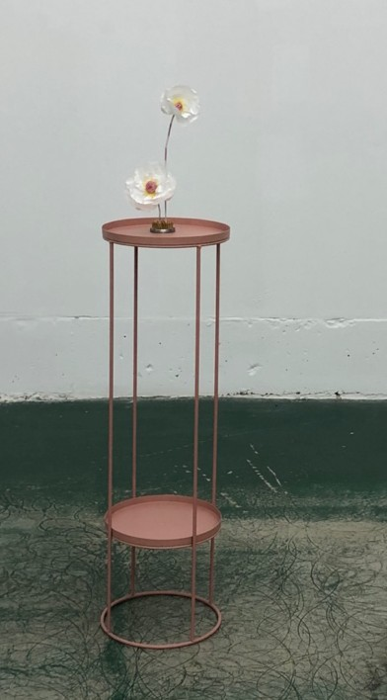
Tiffany Shafran, Poppies, 2021, found paper, fabric, clay, gouache and wire in kenzan, 30 x 15 x 13cm,
$250

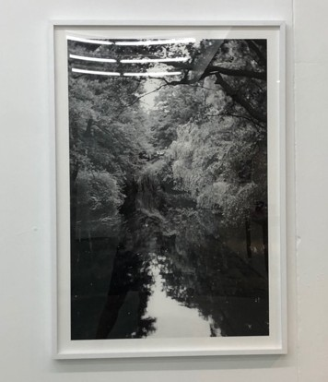
Sarah Ryan, July, 2013, Giclee print , 123cm x 87cm, Edition of 3 + 1 Artist proof $1680

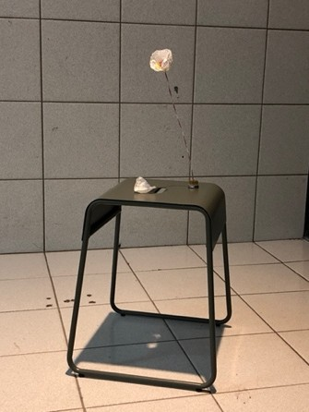
Tiffany Shafran, Falling poppy, 2021, found paper, fabric, clay, gouache and wire in kenzan, dimensions variable, $250

Note: Framing can be organised in consultation with the artist Contact:
Alexandra Lawson www.alexandralawsongallery.com info@alexandralawsongallery.com 0418 603 695
Open Wednesday - Saturday noon-5.30pm

