Online Educative Activities for Solar

Ultraviolet Radiation based on Measurements of

Cloud Amount and Solar Exposures

**A.V. Parisi**a,\***, N. Downs**a**, J. Turner**a**, A. Amar**a

aFaculty of Health, Engineering and Sciences, University of Southern Queensland, Toowoomba, 4350. Australia.

*To whom correspondence is to be addressed. Email: parisi@usq.edu.au

**Abstract**

A set of online activities for children and the community that are based on an integrated real-time solar UV and cloud measurement system are described. These activities use the functionality of the internet to provide an educative tool for school children and the public on the influence of cloud and the angle of the sun above the horizon on the global erythemal UV or sunburning UV, the diffuse erythemal UV, the global UVA (320 – 400 nm) and the vitamin D effective UV. Additionally, the units of UV exposure and UV irradiance are investigated, along with the meaning and calculation of the UV index (UVI). This research will help ensure that children and the general public are better informed about sun safety by improving their personal understanding of the daily and the atmospheric factors that influence solar UV radiation and the solar UV exposures of the various wavebands in the natural environment. The activities may correct common misconceptions of children and the public about UV irradiances and exposure, utilising the widespread reach of the internet to increase the public’s awareness of the factors influencing UV irradiances and exposures in order to provide clear information for minimizing UV exposure, while maintaining healthy, outdoor lifestyles.

Keywords: online; UV; education; real-time; clouds

1. **Introduction**

Skin cancer is a severe public health problem with the number of Australians being treated for skin cancer each year exceeding 750,000 [1]. There is a similar health problem in other countries, for example the American Cancer Society estimates that in 2016 in the USA, approximately 76,380 new cases of skin melanoma will be diagnosed, and approximately 10,180 persons will die [2]. Additionally, there is the incalculable cost of the associated human suffering and disfigurement. This is despite the fact that the risk of a large number of skin cancers can be reduced through the reduction of personal UV exposures [3]. For example, substantial sun damage can and does occur on cool or cloudy days when the majority of people may consider themselves safe. A recent report [4] states that through the increase of sun protection, many skin cancers can be prevented. This report also states that people need clear information about how to reduce their skin cancer risk while maintaining daily healthy, outdoor activities. Consequently, there is a demonstrated need for increased education of both school children and the general public on solar UV in order to raise awareness of the complex solar UV environment affecting the public health of citizens going about their everyday lives. In order to address this need, sound research, aimed at increasing public education on the physical factors influencing solar UV radiation needs to be presented highlighting the important concepts in a manner that can be easily understood and easily accessed through public forums, including the internet.

#### The predicted UV index (UVI) [5] employed in Australia and worldwide has been introduced to increase the awareness of the public to UV radiation. However, the UVI does not take cloud cover into account and so the real-time UVI at any time of the day may be different to the predicted or modelled value. Additionally, most media reports provide the maximum UVI which is only relevant for solar noon under clear sky conditions. Consequently, the problem with current UVI forecasts is that they can be incorrect by a factor of 2 to 4 and thus potentially be very misleading to the general public. Opportunities to promote solar radiation awareness for online users, has the potential to reach an ever growing number of younger aged internet users [6]. This is important because personal behaviour and attitude toward sun safety play a critical role in minimising unnecessary exposure accumulated throughout a lifetime [7] and those exposures that occur due to daily UV variability [8]. The current measured UVI for the Australian capital cities of Adelaide, Brisbane, Darwin, Melbourne, Perth and Sydney and three other major population centres of Kingston (near Hobart), Newcastle and Townsville is available for users with mobile phone Internet access and a web browser [9]. However, it is not available for the large proportion of the population in locations outside of these areas. The UVI forecast is also available via an iPhone app [10], however like the UVI forecast in the media, this does not take into account the local cloud conditions.

#### A variety of educational programs and initiatives for UV prevention are available, The Cancer Council in Australia [11] has information on hats, clothing, sunscreen, sunglasses and shade for UV protection. Similarly, the American Cancer Society [12] provides information on UV protection, along with an online quiz to test general knowledge on sun safety. A series of teaching resources and lesson plans are provided for primary school teachers for the age groups of 6-9 years and 10-12 years [13]. These are based on the three units of the sun, UV radiation and the health risks with teaching objectives and activities provided for each of the units and the age groups. This education on sun protection is targeted at the two age groups of 6-9 years and 10-12 years when the children may be receptive to the messages of sun protection.

#### The online access to data on the solar UV environment has been previously introduced [14] and is extended in this current research to provide educational activities on the physical factors influencing solar UV exposures. These are designed to raise awareness amongst school children and the general public in order to provide clear information to minimize UV exposure, while maintaining healthy, outdoor activities. The project presented in this paper provides scientifically relevant information incorporating actual measured solar and cloud data which can be utilized as teaching resources for educators linking the physical environment, public health and solar UV radiation. This project therefore aims to improve community understanding of solar UV exposure to encourage improved sun safety, through the education of children and the community on the factors influencing solar UV radiation in the day to day environment. This information is provided online enabling children and the community in regional areas with internet availability to access this as readily as anyone in metropolitan areas.

1. **Methods**

This paper reports on six online educational activities on solar UV radiation designed for children, but also applicable for the general public in order to raise awareness of solar UV and improve skin cancer prevention. The specific aims of the activities described in this paper are to:

1. Employ real-time erythemal UV and UVA (320 – 400 nm) data provided via an internet platform to develop an understanding of the daily factors influencing the solar UV radiation;
2. Provide a facility for the analysis of real-time data to develop a knowledge of the atmospheric factors that influence the solar UV radiation;
3. Provide an educative initiative for children in any location with network connectivity on the hazards and benefits of solar UV.

These objectives have been achieved by a series of online activities to investigate:

* Real-time solar UV data;
* Real-time cloud cover amount;
* Influence of cloud on the solar UV;
* Diffuse erythemal and global erythemal UV;
* Vitamin D effective UV;
* Animation on the factors influencing UV exposure.

Each activity will employ data on the solar UV environment from research equipment collected at the University of Southern Queensland's (USQ) online solar radiation network in Toowoomba (27.6 °S, 151.9 °E), Australia. The solar UV is comprised of the direct component which is received in a direct line from the sun and the diffuse component which is the UV scattered by the atmospheric components of clouds, suspended aerosols and the molecules in the atmosphere [15]. These two components make up the global UV radiation. The real-time data employed in this paper comprises of irradiance and exposure data of the global erythemal UV, the global UVA, the diffuse erythemal UV and the cloud amount data as follows:

* Global erythemal UV from a UV Biometer (model 501, Solar Light, Inc., PA. USA) [16]. The instrument is a radiometer with a spectral response that approximates the erythemal action spectrum [17] which is based on the response of human skin to the production of mild reddening 24 hours post exposure to set wavelengths in the UV waveband. The erythemal response is heavily weighted to the UVB (280-320 nm) wavelengths with a response that is of the order of 1000 times higher than in the UVA (320-400 nm). The instrument is temperature stabilised to 25 oC and is connected via a cable to a data logger in the laboratory. The unit of MED employed in this data is the minimum erythemal dose and represents the amount of erythemal UV that will induce barely perceptible erythema in skin type one (most sensitive), 8 to 24 hours post UV exposure [18] and it may be taken that one unit of MED is equivalent to 200 J/m2 of erythemally weighted UV [18]. The UVI is a unitless quantity that is calculated from the erythemally weighted UV by multiplying the erythemal irradiance in units of W/m2 by 40;
* Global UVA from a UVA Biometer (model 501A, Solar Light, Inc., PA. USA) [19]. This instrument is a radiometer with a response from 320-400 nm and is also temperature stabilised to 25 oC and is connected via a cable to a data logger in the laboratory;
* Diffuse erythemal UV from a UV Biometer (model 501, Solar Light, Inc., PA. USA) that is the same as that measuring the global erythemal UV, but with a shadow band to shade the sensor from the direct UV. This shadow band is aligned east-west and the inclination adjusted with the seasons to shade the sensor;
* Cloud fraction from a Total Sky Imager (TSI) (model TSI440, Yankee Environmental Systems, USA) [20]. The cloud fraction is provided as a percentage of cloud by image analysis of a JPEG image taken of a reflective hemispherical dome that images the sky and clouds at a user specified interval of five minutes [21]. The camera with a charge coupled device (CCD) sensor is suspended over the reflective dome on a thin metal arm and there is a black band on the dome to block out the sun, with the dome and band rotating throughout the day.

The data from the first three meters is collected by data loggers and the Internet Data Link (IDL) software (Solar Light Co., Philadelphia, PA. USA) which downloads the data from the data logger and outputs the written data as a graph to a remote server that makes the information available online with a data update provided every 5 minutes. The format of the display and the graphs are user defined and specified by the user. Similarly, the data on the cloud fraction with the raw image and the processed image are uploaded by the Total Sky Imager software every five minutes to a server. The educational activities based on the real-time data are at:

<http://uveducation.usq.edu.au/>

This web page accesses the real-time solar global and diffuse erythemal UV, the real-time UVA data and the cloud data that has been uploaded to the servers for display of the real-time UV and cloud data and for use in the educational activities. Specific data sets have also been employed to produce animations of the influence of cloud and time of day on the erythemal UV exposures, the influence of cloud and time of day on the relative amounts of diffuse and direct UV and the exposure time required at different times of the day to initiate the production of adequate amounts of vitamin D. The animation on the influence of cloud and time of day on the erythemal UV exposures compares the erythemal UV on a cloudy day to that on a cloud free day. The exposures for the cloud free case are actual measured exposures on a cloud free day that is within two days of the cloudy day. The animation on the relative amounts of diffuse and direct erythemal UV has derived the direct UV by the subtraction of the measured erythemal diffuse UV from the measured global erythemal UV. For each of the animations, each frame has been produced in PowerPoint and the saved file converted into a video file using Media Maker, which was then uploaded onto the UVEducation site.

1. **Results and Discussion**

*3.1 Web Site Activity: Real-time Solar UV Data*

The sample snap shot of the real-time solar UV data for Toowoomba with the global erythemal UV exposures over five minutes on each day provided on the web site are shown in Figure 1. In order to explain the terms on this graph and text on the web page and the graphs and text on the subsequent pages, some words and terms in the text have an explanation that appears on a computer when the user hovers over them. This is designed to assist with the understanding of the material.

The information on the page has the maximum UVI encountered so far throughout the day in the top left hand side and the current UVI in the bottom left hand side. The colours on the column for the UVI are according to the UVI categories of low, moderate, high, very high and extreme [22]. As shown, these correspond to the UVI values of 1-2, 3-5, 6-7, 8-10 and 11+ respectively for each of the categories [22]. For a UVI in the low category, sun protection is generally not required unless outside for an extended time. The daily global erythemal UV exposures for each five minutes in units of MED over five minutes as a function of time of day are plotted in the top graph with the current erythemal exposure over the last five minutes in the top left hand corner of the graph. Similarly, the daily global UVA exposures over periods of five minutes in units of J/cm2 over five minutes as a function of time of day are shown on the bottom graph of Figure 1 with the current UVA exposure over the last five minutes in the top left hand corner of the graph.

The real time solar UV data updates every five minutes showing the real-time influence on the global erythemal UV and the UVA with time of day and cloud cover. The real time data clearly shows the influence of cloud which accounts for the observed variability from the smooth clear sky bell shaped curve expected under cloud free conditions. From the current erythemal UV in units of MED/5 min provided under the daily graph, one activity allows calculation of the time taken for an exposure of one MED to a horizontal plane. Other activities can allow the determination for any five minute period of the day, the conversion of MED in the five minutes to J/m2 over those five minutes and the calculation of the average irradiance in W/m2 over the five minutes.

The column on the right providing the cumulative daily UV exposures in units of MED to a horizontal plane represents the area under the curve of the daily erythemal UV graph. Based on this information, another online activity called ‘Influence of cloud on the solar UV’ described in Section 3.3 allows the observation of the changes and influencing factors on the erythemal UV and the manner in which this contributes to the cumulative exposure observed over the day.

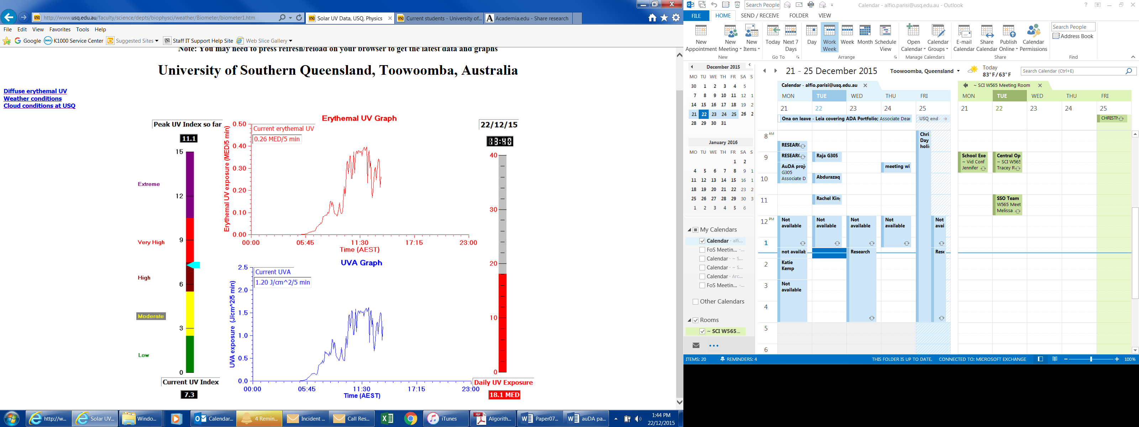

Figure 1 – An example of the real-time solar UV data for Toowoomba with current date and time in the top right hand corner and the global erythemal UV, UVI and UVA that are updated every five minutes during the day.

The real-time diffuse erythemal UV exposures for each five minutes are provided in Figure 2. These exposures account for approximately half of the global UV radiation received during most periods of the day. The current date (dd/mm/yy) and time are provided in the top right hand corner and updates are provided every five minutes. As well as the graph showing the change in the diffuse erythemal UV throughout the day, the current diffuse UV over the last five minutes is in the top left hand corner. The cumulative diffuse erythemal UV received by a horizontal plane throughout the day is shown by the column on the right hand side.

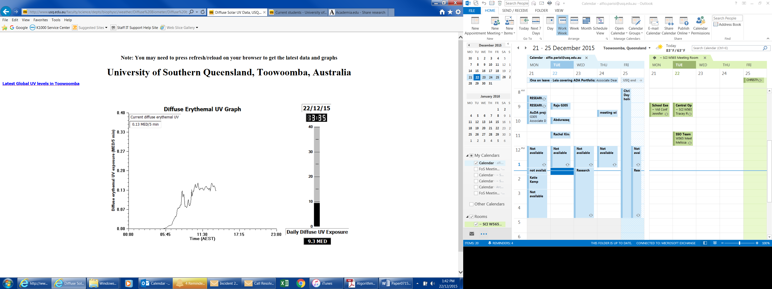

Figure 2 - An example of the real-time diffuse erythemal UV exposure graph for Toowoomba at 13:35 on the 22nd December 2015 for every five minutes in units of MED/5 minutes. The right hand column shows the cumulative diffuse erythemal UV over the day.

*3.2 Web Site Activity: Real-time Cloud Cover Data*

A sample real-time image of the cloud cover showing the raw camera image, the processed image and the amount of cloud cover as a percentage is provided in Figure 3. The thick black band is a black tape on the hemispherical dome with this rotating during the day to obscure the sun from being imaged and saturating the CCD sensor of the camera. The solar disc is represented by the yellow circle on the black band. The very thin line is the rod on which the camera is suspended. The processed image shows the cloud and sky as white and blue respectively. For this example, the image analysis provides the amount of cloud, with the raw and processed images and percentage of cloud cover updated every five minutes.

This activity allows users to evaluate the influence of real-time cloud cover on the global and diffuse erythemal UV and UVA provided in the previous activity. The influence will depend on the amount of cloud, type of cloud, configuration of cloud with respect to the solar disc and distribution of cloud.

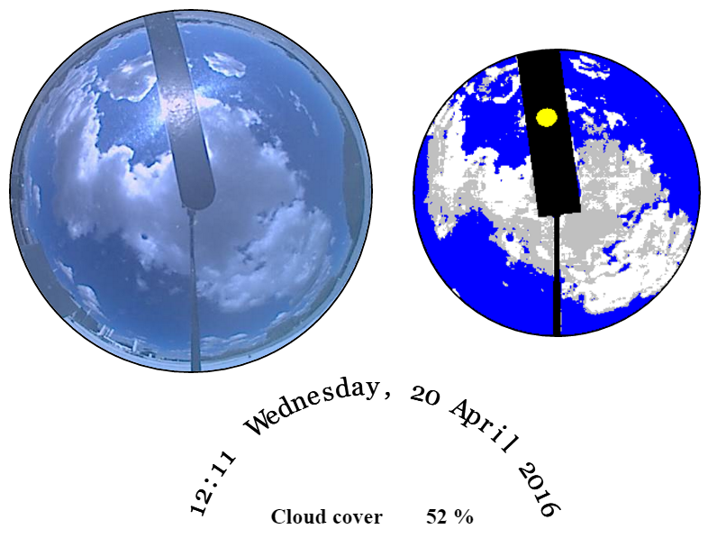

|  |
| --- |
|  |
|  |

Figure 3 – Real-time image example of the cloud cover observed over Toowoomba (left image) with the corresponding processed image shown in the right image and the time, date and percentage of cloud cover shown below these. The black band is the tape on the dome to block the solar disc, with the dome rotating during the day and the thin line is the arm suspending the CCD camera over the dome.

*3.3 Web Site Activity: Influence of Cloud*

For a given solar zenith angle (the angle of the sun with respect to the zenith), cloud is the biggest influence on the UV irradiance. This influence is sensitive to the amount of cloud, cloud type, cloud position relative to the sun and the total sky distribution of the observed cloud [23]. Numerous papers have reported on the influence of cloud on both the erythemal UV and the UVA [24][25][26][27]. The integrated system described here provides the real-time data to enable an informed investigation for educating users of the influence of cloud on the global erythemal UV compared to that of a clear day with the same solar zenith angles.

The main effect of cloud is to convert direct radiation into diffuse UV radiation. Clouds not covering but located in proximity to the sun can produce a UV enhancing effect, increasing the UV above clear sky values [23]. Cloud can therefore result in small enhancements of the UV irradiance above that of a clear day for the same solar angles, or result in near total elimination, particularly under the influence of heavy rain bearing cloud [28].

In this activity the real time influence of cloud on the solar UV to a horizontal plane throughout the day is shown as an animation of the changing cloud cover measured every five minutes for a selected sample day. The corresponding UV exposures are compared to the clear sky exposures. This illustrates the influence of the different types and configurations of cloud on the solar UV.

A sample frame of this animation at 12.50 is shown in Figure 4. This animation has a frame for each of the five minutes of the day. The cloud is shown as the white part in the image and the UV exposures are shown as the black line of the bell shaped curve for the clear sky erythemal UV and the red jagged line for the cloud affected erythemal UV. Generally the UV on the cloudy day is below that on the clear day. However, there are two times in this example when the UV is enhanced above that of the clear day due to the particular configuration of cloud at that time. The amount of cloud as a percentage is given at the bottom of the figure along with the current five minute exposure in units of MED. The cumulative exposures over the day to a horizontal plane for a clear day and a cloudy day are shown as the black and red columns respectively to allow comparison. This activity shows the user that in most cases clouds do not totally block UV radiation and therefore people may still receive a sunburn even on a cloudy day.

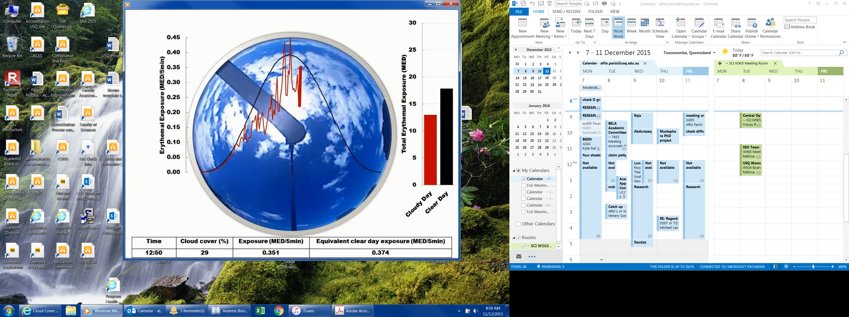

Figure 4 – Sample frame of an animation of the real time effect of cloud throughout the day on the corresponding solar erythemal UV exposures compared to the clear sky exposures.

*3.4 Web Site Activity: Direct and Diffuse UV*

This activity is designed to show the components of the direct erythemal UV and the diffuse erythemal UV that comprise the global UV. The diffuse UV is influenced by the amount of atmospheric scattering which is affected mainly by the solar zenith angle and the amount of cloud cover. A sample frame of an animation showing the amounts of diffuse UV and direct UV influenced by the time of day and by the amount of cloud cover is in Figure 5. Throughout the day, the direct UV is shown as the red part of each column and the diffuse UV is the orange part of each column. The columns on the right hand side show the cumulative exposures of diffuse, direct and global UV. In this example the amount of cloud is higher in the morning resulting in a higher relative amount of diffuse UV. The animation shows the importance of the diffuse component of UV irradiance during cloudy times (most of the global is diffuse) as well as when the sky is clear (at least half of the global is diffuse) and by the end of the day 60% of the total global exposure is diffuse. This shows that even in shade, which blocks the direct UV, it is still possible to obtain a sunburn from the diffuse UV component.

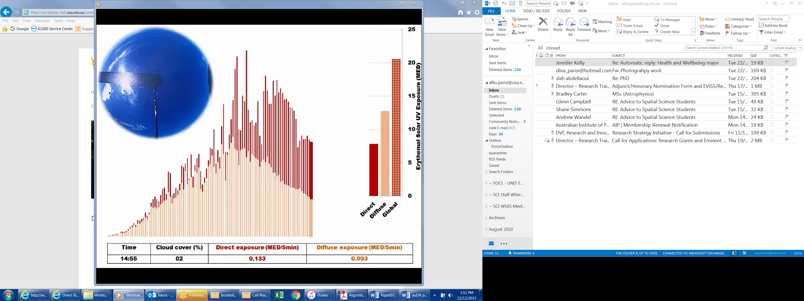

Figure 5 – A sample frame at 14:55 of an animation showing the amounts of diffuse UV and direct UV influenced by the time of day and by the amount of cloud cover. Throughout the day, the direct UV is shown as the red part of each column and the diffuse UV is the orange part of each column. The columns on the right hand side show the cumulative exposures.

*3.5 Web Site Activity: Vitamin D Effective UV*

Small amounts of the shorter UV wavelengths can have a beneficial impact on human health, with these exposures required for the initiation of the production of pre-vitamin D3. The production of pre-vitamin D3 in human skin is necessary for maintaining adequate vitamin D levels [29]. Approximately 90-95% of the human body’s vitamin D levels are obtained from exposure to solar UV radiation [30]. Consequently, it is necessary to optimize exposures to solar UV to minimize skin and sun-related eye damage and yet allow the formation of vitamin D. A position statement issued by the Working Group of the Australian and New Zealand Bone and Mineral Society, Endocrine Society, Osteoporosis Australia, Australian College of Dermatologists and the Cancer Council Australia recommends exposures in Australia of five minutes solar UV exposure either side of the peak UV periods on most days of the week in summer and approximately 2-3 hours solar UV exposure over a week in winter.

The Cancer Council [31] recommends enough sun can be obtained in summer to maintain adequate vitamin D levels from a few minutes of exposure to sunlight on the face, arms and hands or the equivalent area of skin in the morning or in the afternoon, provided the exposure is received before or after the peak UV periods on most days of the week. For southern parts of Australia, this is a few minutes on most summer days and two to three hours per week in winter, whereas in the northern parts of Australia in winter, adequate vitamin D levels can be maintained by people going about their normal daily activities. Specifically, the time of exposure to the sun required to produce adequate amounts of vitamin D varies with the amount of UV levels which varies with location, season, time of day and atmospheric conditions, skin type, age and outdoor activities [31]. Webb and Engelsen [29] recommend 1/6 to 1/3 MED exposure to the arms, hands and face as being sufficient for the production of adequate amounts of vitamin D. This activity illustrates how the time for a moderate exposure to UV radiation sufficient to produce an adequate amount of vitamin D varies over the day and with cloud cover.

A sample frame at 14.50 from an animation shows the exposure time required at different times of the day for an exposure of 1/6 MED as calculated by Turnbull et al. [32] to produce an adequate amount of vitamin D. These times are along the *x*-axis for different periods of the day, showing that three minutes solar UV exposure either side of the middle part of a summer’s day on 1st February 2015 at a sub-tropical site provides the 1/6 MED required for vitamin D production. The presentation also shows that longer times (up to 25 minutes) are required during other parts of the day to accumulate 1/6 MED while only two minutes was required at midday. These times will change at different latitudes [33]. In terms of educational benefit, this activity illustrates that even very short times of exposure to solar radiation are enough for healthy vitamin D production in most individuals.

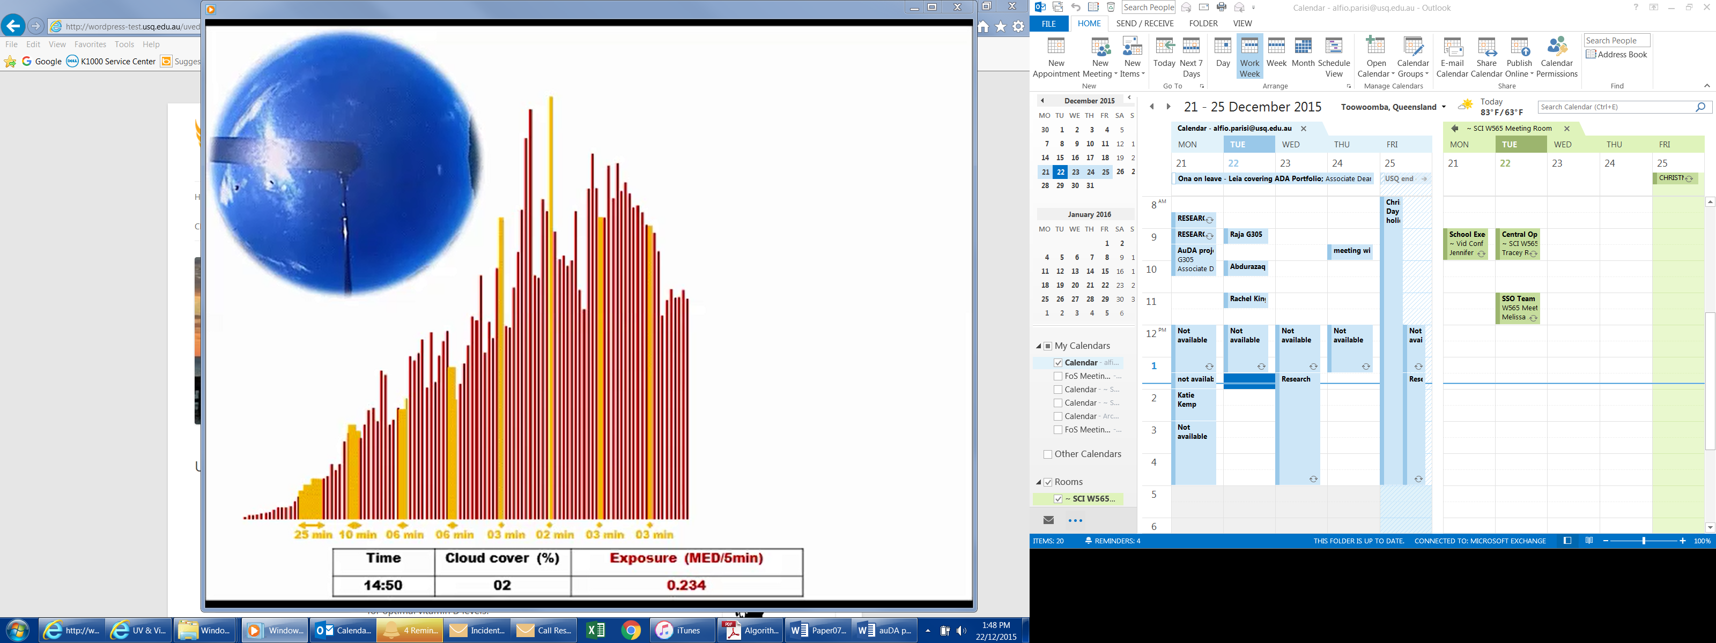

Figure 6 – A sample frame at 14.50 from an animation showing the exposure time required at different times of a summer’s day for an exposure of 1/6 MED at a sub-tropical site. These times are shown along the *x*-axis.

*3.6 Web Site Activity: UV and U animation*

This activity is based on the user design of an avatar with the user controlling gender, age, eye colour, skin tone, hair and clothing. The next part of the animation is based on the user’s selection of clothing, sunglasses, cosmetics, and sunscreen. Personal protection is discussed in terms of solar UV and UV from artificial light sources. Here the aim is to dress an avatar based upon an individual’s usual habits and then redesign the avatar to reflect better sun safe practices. The animation is interactive, so users selecting different forms of personal protection are prompted on use and best practice. This activity emphasises the genetic factors and the personal UV protection methods that govern or control personal exposure to UV radiation. The activity also provides a useful mechanism to allow the animation user to apply new or renewed knowledge about UV radiation and exposures to guide their choices within the interactive animation.

1. **Summary and Conclusion**

This research has provided six online educational activities based on real-time data, for use by children and the public in any location with internet connectivity. The integrated system described incorporates global erythemal UV exposures, global UVA exposures, diffuse erythemal UV exposures and real-time cloud amount data for the educational activities. These activities present scientific information which can be evaluated to educate users about the physical factors influencing UV exposures and the hazards of solar UV. They investigate important concepts that contribute toward better understanding of the solar UV environment, including, the influence of cloud and time of day on the global and the diffuse erythemal UV, and the global UVA. The web site also provides the flexibility of being able to add new online activities in the future.

There are beneficial social and environmental outcomes that can arise from the educational aspects of this project. This is because skin cancer is so widespread in Australia and worldwide and a lack of UV awareness and the resulting community behaviour are significant contributors to national disease burdens. The educative aspects of this project will improve the understanding of factors influencing solar UV and in the process promote improved sun safety. The activities may correct common misconceptions about UV exposure, such as; “There is no exposure risk when the sky is cloudy”, “The UV index is always very high”, “High UV exposures are dependent on temperature” or “Long exposure times are required for vitamin D production”. These issues have been directly addressed by this project which utilises the widespread reach of the internet to increase the public’s awareness of the factors influencing UV exposures in order to provide clear information for minimizing UV exposure, while maintaining healthy, outdoor lifestyles. An assessment of the utilisation of the information on the web site can be obtained through web analytics on the use of the web site as well as ‘indirect effectiveness assessment’ though email contact from schools, users and other Public Health researchers that may reference the site in the future literature.

**Acknowledgements**

The authors acknowledge the funding support provided by the auDA Foundation, grant no. 14070. The authors also acknowledge the USQ Media Services for the production of the UV&U animation.

#### References

1. SunSmart®. Skin cancer facts & stats. (2015) <http://www.sunsmart.com.au/about/skin-cancer-facts-stats> accessed: 11, 2015.
2. American Cancer Society. Cancer facts and figures. (2016). <http://www.cancer.org/research/cancerfactsstatistics/cancerfactsfigures2016/index> accessed: 04, 2016.
3. C.M. Olsen, L.F. Wilson, A.C. Green, C.J. Bain, L. Fritschi, R.E. Neale, D.C. Whiteman, Cancers in Australia attributable to exposure to solar ultraviolet radiation and prevented by regular sunscreen use, Aust. NZ. J. Public Health, 39 (2015) 471-476.
4. US Department of Health and Human Services. The Surgeon General's call to action to prevent skin cancer. Washington, DC, Office of the Surgeon General. (2014) <http://www.surgeongeneral.gov/library/calls/prevent-skin-cancer/index.html> accessed: 11, 2015.
5. WMO (World Meteorological Organization), Report of the WMO meeting of experts on UV-B measurements, data quality and standardization of UV indices, Les Diablerets, Switzerland, WMO/TD-NO. 625, 25-28 July 1994.
6. D. Holloway, L. Green, S. Livingstone, Zero to eight: Young children and their internet use. The London School of Economics and Political Science (LSE), London: EU Kids (2013), [http://eprints.lse.ac.uk/52630/1/Zero_to_eight.pdf accessed 05](http://eprints.lse.ac.uk/52630/1/Zero_to_eight.pdf%20accessed%2005), 2016.
7. D.T. Donavan, S.N. Singh, Sun-safety behaviour among elementary school children: the role of knowledge, social norms, and parental involvement, Psychological Reps. 84 (1999) 831-836.
8. O.B.J. Carter, R.J. Donovan, Public (Mis)understanding of the UV index, J. Health Comm*.* 12 (2007) 41-52.
9. ARPNSA (Australian Radiation Protection and Nuclear Safety Agency). Australian UV levels for mobile phones. (2014). <http://www.arpansa.gov.au/uvindex/realtime/cellrt.htm> accessed: 11, 2015.
10. Bureau of Meteorology. SunSmart app for iPhone and Android. (2015). <http://www.bom.gov.au/uv/iphoneapp.shtm> accessed: 11, 2015.
11. Cancer Council. SunSmart. (2015). [http://www.sunsmart.com.au/uv-sun-protection accessed: 10, 2015](http://www.sunsmart.com.au/uv-sun-protection%20accessed%20October%202015).
12. American Cancer Society. Be safe in the sun. (2015). <http://www.cancer.org/healthy/besafeinthesun/index> accessed: 10, 2015.
13. World Health Organization (WHO). Sun protection and schools: How to make a difference. (2003) <http://www.who.int/uv/publications/en/sunprotschools.pdf?ua=1> accessed 10, 2015.
14. A.V. Parisi, Physics concepts of solar ultraviolet radiation by distance education, *Eur. J. Phys.* 26 (2005) 313-320.
15. M. Blumthaler, W. Ambach, Spectral measurements of global and diffuse solar ultraviolet-B radiant exposure and ozone variations, Photochem. Photobiol. 54 (1991) 429-432.
16. Solar Light. UVB Biometer model 501 radiometer. (2013). <http://solarlight.com/product/uvb-biometer-model-501-radiometer/> accessed: 11, 2015.
17. CIE (International Commission on Illumination) (1998). Erythema reference action spectrum and standard erythema dose*.* *CIE S007E-1998,* CIE Central Bureau, Vienna, Austria.
18. B.L. Diffey, Stratospheric ozone depletion and the risk of non-melanoma skin cancer in a British population, Phys. Med. Biol. 137 (1992) 2267-2279.
19. Solar Light. UVA model 501 radiometer. (2013) <http://solarlight.com/product/uva-uvb-sensor-non-weighted-pma-1107/> accessed: 11, 2015.
20. YES® (Yankee Environmental Systems, Inc.). TSI-440 Total Sky Imager. (2006). <http://www.yesinc.com/products/data/tsi440/> accessed: 11, 2015.
21. J. Sabburg, C.N. Long, Improved sky imaging for studies of enhanced UV irradiance, Atmos. Chem. Phys*.* 4 (2004) 2543-2552.
22. Bureau of Meteorology. National UV Index forecast map. (2015). <http://www.bom.gov.au/australia/charts/UV.shtml> accessed: 11, 2015.
23. J. Sabburg, J. Wong, The effect of clouds on enhancing UVB irradiance at the earth's surface: a one year study. Geophys. Res. Lett*.* 27 (2000) 3337-3340.
24. J. Calbo, D. Pages, J. Gonzalez, Empirical studies of cloud effects on UV radiation: a review, *Rev. Geophys.* 43 (2005) RG2002, doi:10.1029/2004RG000155.
25. I. Foyo-Moreno, I. Alados, F.J. Olmo, L. Alados-Arboledas, The influence of cloudiness on UV global irradiance (295-385 nm), Agr. For. Meteorol*.* 120 (2003) 101-111.
26. A.V. Parisi, N. Downs, J. Turner, Evaluation of the cloudy sky solar UVA radiation exposures, J. Photochem. Photobiol. B: Biol.138 (2014) 141-145.
27. D.J. Turnbull, A.V. Parisi, P. Schouten, Empirical evaluation of global vitamin D effective ultraviolet irradiances under cloudy conditions for a sub-tropical southern hemisphere site, Rad. Res. 173 (2010a) 703-708.
28. C. Kuchinke, M. Nunez, Cloud transmission estimates of UV-B erythemal irradiance, Theor. Appl. Climatol. 63 (1999) 149-161.
29. A.R. Webb, O. Engelsen, Calculated ultraviolet exposure levels for a healthy vitamin D status, Photochem. Photobiol. 82 (2006) 1697-1703.
30. M.F. Holick, Sunlight and vitamin D for bone health and prevention of autoimmune diseases, cancers, and cardiovascular disease, Am. J. Clin. Nutrit.80 (2004) 1678S–1688S.
31. Cancer Council. How much sun is enough? (2015). <http://www.cancer.org.au/preventing-cancer/sun-protection/vitamin-d/how-much-sun-is-enough.html> accessed: 12, 2015.
32. D.J. Turnbull, A.V. Parisi, N. Downs, Sun exposure, shade and vitamin D: a practical activity for the Australian climate and curriculum, Teaching Sci.56 (2010) 43-45.
33. D.J. Turnbull, A.V. Parisi, Latitudinal variations over Australia of the solar UV exposures for vitamin D3 in shade compared to full sun, Rad. Res. 173 (2010) 373-379.