Factors Affecting the Infant Mortality and Low Birth Weight of Children in Bangladesh: Evidence from Cox PH and Logistic Regression Models
Md. Johurul Islam and Mashfiqul Huq Chowdhury
Mohammad Mafizur Rahman
Zubaidur Rahman
Abstract
Background: Low birth weight and infant mortality are crucial health components as they have detrimental effects on overall health progress of a country. Although Bangladesh has made a commendable progress in several public health indicators, median age at first birth is still below 19 years and more than 10 percent mothers gave birth within two years of preceding birth. The consequences of early age at first marriage, teenage childbearing and short birth intervals account negative health outcomes for both newborn babies and their mothers. Thus, this study attempts to explore the contributing factors that influences infant mortality and child’s low birth weight in Bangladesh.
Methods: The data utilized for this study has been extracted from Bangladesh Demographic and Health Survey (BDHS), 2014. The response variables are time-to-event data (infant mortality) and categorical (low birth weight). Log-rank test and Chi-square test of independence have been carried out in bivariate analysis whereas cox proportional hazard survival model and binary logistic regression model are utilized to obtain the net effect of each significant determinants on infant mortality and child’s low birth weight, respectively, in Bangladesh.
Results: The findings reveal that wealth index, division, partner’s education, child twin status, media exposure, child birth order, respondents antenatal care visit and prenatal care assistance have significant impact on infant mortality and child’s low birth weight in Bangladesh. Government policy makers may focus on community health based educational programs and maternal health care awareness program to improve child and their mother’s health outcomes as well as to tackle the future public health challenges in Bangladesh.
Conclusions: Education has been proven as a key element for explaining low birth weight and infant mortality in Bangladesh. So, parents might be encouraged to receive health-based knowledge about pregnancy and afterwards.
Keywords: Chi-square test, Cox PH model, infant mortality, log-rank test, low birth weight, logistic model.

- Introduction
Child birth weight is considered as one of the key components of childhood development and low birth size causes serous vulnerability of childhood illness and survival. Infant mortality rate is the probability of dying before first birthday and also regarded as another major health problem since it guides the overall quality of the healthcare and nutrition program towards children and their mothers in any country (NIPORT et al. 2019). In addition, this indicator also impedes the overall health progress of a society. Higher child mortality refers to negative impact on the economic and health situation of a country (Rahman and Alam, 2021).
Low birth weight (LBW) is identified as one of the leading causes of infant deaths, neonatal deaths, under-five mortality and a number of subsequent disorders in developing world (Islam et al. 2022). LBW has both short-term and long-term consequences such as infection, malnourishment, handicapped situations, mental growth deficiencies, behavioral problems, learning disabilities during and after childhood. A number of studies show that infants with low birth weight have a higher risk of development disabilities such as cerebral palsy and retinopathy of prematurity. In addition, LBW increases the risk of non-communicable diseases including obesity, diabetes, and cardiovascular disease later in life (Risnes et al. 2011; Larroque et al. 2001). Each year, LBW causes approximately 60 percent to 80 percent neonatal deaths globally (Mediani, 2020). It is found that 15% babies experiences LBW worldwide and more than half were born with LBW in Asia among them (WHO, 2019). The incidence of LBW varies widely across regions and usually the proportion of the LBW is more prevalent in low and middle-income nations, particularly in the most vulnerable populations (Kim and Saada, 2013; Muglia and Katz, 2010). Regional estimates of child size at birth indicates that the prevalence of LBW is 28% in South Asia, 13% in Sub-Saharan Africa and least developed countries, 9% in Latin America (World Health Organization, 2015). The LBW rate in Bangladesh indicates constant presence in the last decades; the rate was 17.7% in 2011, 20% in 2014 and 16% in 2017-18 (NIPORT et al. 2011; NIPORT et al. 2014; NIPORT et al. 2019). Though the LBW rate has decreased in Bangladesh between 2011 and 2017, it is still higher in comparison to most developing countries. World Health Organization (2018) reported that about 4 million deaths occurred globally before completing the first birthday of infants. The infant mortality rate was found more prevalent in the African subcontinent (52 per 1000 live births) in 2018 (WHO, 2018). In Bangladesh, though infant mortality rate is declining, it was still 23 per 1000 live birth in 2022 (BER, 2023). Life expectancy at birth is negatively associated with infant mortality (Rabbi, 2013). Birth defects, birth asphyxia, pneumonia, protracted labor, diarrhea, malaria, measles, malnutrition, congenital disorders, low birth weight and smoking during pregnancy are identified as the main causes of infant mortality (Hall et al. 2016; Yunida, 2022).
The issue of low birth weight and infant mortality has been prioritized in various national and international discussions. The indicator 3.2.1 of sustainable development goals (SDGs) states the reduction of the child mortality rate to fewer than 25 deaths per 1,000 live births per year across all countries by 2030 which has close connection with this research topic (Indicator 3.2.1 of SDGs, United Nations Development Program, 2015; World Health Organization, 2015). Similarly, the issue of child mortality has focused in goal no 4 of Millennium Development Goals which targeted in reducing two-thirds of mortality between 1990 to 2015 (Target 4A, Goal no 4, Millennium Development Goals). The eighth five-year plan of Bangladesh centers on six core themes. Among them, one theme (number six) has close link with infant mortality and low birth weight (Eight five-year plan, Bangladesh). In the perspective plan, the government is committed to achieve universal health care by 2030 in line with SDGs which has relationship with infant mortality and low birth weight (Perspective Plan: 2021-2041, Bangladesh). In this regard, keeping low prevalence of infant mortality and low birth weight is indispensible not only for newborn and their mothers but also for tackling new health challenges in Bangladesh.
The prime objective of the present study is to determine the impact of contributing factors on child size at birth and infant mortality in Bangladesh by using statistical regression models. To achieve the general objective, the following specific objectives are set for this study:
- To give an overview of low birth weight and infant mortality in Bangladesh.
- To identify the mother’s socio-economic, bio-demographic, socio-cultural and maternal health related triggering factors that are associated with child’s low birth weight and infant mortality in Bangladesh.
- To suggest feasible strategies for the government to increase the momentum of maternal and child health care utilizations in Bangladesh.

The contributions of this paper are threefold: First of all, most of the previous studies are conducted in this topic based on limited variables, but this study considers biodemographic, socio-cultural, maternal health, fertility and child health related covariate to explore the potential risk factors. These determinants may carry more policy implication than those of previous studies. Secondly, the present study uses survival regression model for time to event data (infant mortality) and binary logistic regression model for categorical responses (child size at birth). Thirdly, the expected outcome of this study would assist policymakers not only in Bangladesh, but also in other developing countries, for tackling future child survival and vulnerability challenges.
The paper is articulated into five sections. After introducing the issue in the first section, review of literatures is presented in section 2. Methodology of the study is presented in section 3. Section 4 discusses the results of the study. Finally, section 5 concludes the paper with some policy recommendations.
- Review of Literatures
A number of studies carried out separately to analyze the potential determinants of child size at birth and infant mortality across countries in Middle East, Africa, Southeast Asia especially in Bangladesh. The outcomes of the previous studies substantially vary because of differences in used methodological tools, data periods and selection of variables. Past literatures are discussed under two strands as follows:

2.1 Infant Mortality
Asif et al. (2022) explored the socio-economic determinants of child mortality in Pakistan using the dataset of 2017-18 Pakistan Demographic and Health Survey. The findings of the study explored the negative association between the likelihood of child mortality and an increase in women’s education, empowerment, husband’s education, the wealth status of their households, access to clean drinking water, access to toilet facilities, and exposure to mass media. The unmet demand for family planning, on the other hand, raises the chance of child mortality. McFadden et al. (2022) investigated the relationship among infant-juvenile age-at-death proportions, fertility rates, and a range of gestational and early childhood mortality measures in Australia. The study showed the correlation between fertility rates and infant-juvenile proportions which was stronger in comparison to any mortality related variables. Rachmawati et al. (2022) analyzed the determinants of under-five mortality in Indonesia using 2017 Indonesian Demographic and Health Survey (IDHS) and showed that birth weight is the more likely cause for under-five mortality in Indonesia. The findings of Rehman et al. (2022) suggested that parent’s high level of education was negatively associated with the infant mortality in Pakistan. Mbitto and Mzingula (2022) explored the determinants of infant mortality in Tanzania using binary logistic regression model and found that delivery at home increases chances of infant deaths while infant mortality is reduced when newborn has access to adequate breast feeding. Kousar et al. (2022) examined the relationship between socio-economic factors and child mortality in South Asia by utilizing panel data from World Development Indicators covering the period from 1990 to 2017. Their study used cointegration test to investigate the long-run relationship between variables and Granger causality test to determine the direction of the relationship. The findings showed that education, unemployment, health expenditure, access to improved water and sanitation facilities were associated with child mortality. Eke and Ewere (2022) analyzed the levels, trends and determinants of infant mortality in Nigeria and revealed that mothers age, educational level, access to pure water and toilet facilities were statistically significant determinants of infant mortality in Nigeria. Shabbir et al. (2022) conducted a study in order to uncover the trend of infant mortality using time series data from 1960 to 2017. The result showed the decreasing trend in the infant mortality rate in Pakistan. Ahamad et al. (2010) showed that infant immunization is the most effective factor that reduces infant mortality especially at lower quantile districts. Ijdi et al. (2022) explored the impact of place of delivery and newborn care on early neonatal mortality in Bangladesh. The study found that newborns who had received any postnatal care were 68% less likely to die in the early neonatal period than those who had not received any PNC. Anney et al. (2020) investigated the risk factors of under-five child mortality in Bangladesh. The findings of the study showed that multiplicity of birth, preceding birth interval, number of antenatal care visits, place of delivery, child-size at birth, total children ever born and number of living children were the significant determinants of under-five child mortality. Ara et al. (2023) investigated the sociodemographic determinants of child mortality in Bangladesh and found that the prevalence of child mortality was higher among those who thought that IPV is acceptable. Khan et al. (2023) assessed the impact of socio-demographic factors on under-five child mortality in Bangladesh and found that mother’s education level, mother’s age, wealth index, source of drinking water and division were the significant predictors of child mortality.

2.2 Low Birth Weight
Mondal (2000) used the multiple logistic regression analysis for Nepal in order to analyze the risk indicators of low birth weight of Nepali infants and noted that sex, maternal age, parity, gestation period, economic condition and maternal education were significantly related to the incidence of LBW. Sharma et al. (2015) revealed that premature delivery history, hard physical work during pregnancy, younger age of mother, mothers with low hemoglobin level and lack of consumption of nutritious food during pregnancy were significantly associated with the LBW babies in Nepal. Khan et al. (2020) estimated the change in the prevalence of LBW in India over the last decades using the data from the National Family Health Survey of 2005-2006 (NFHS-3) and 2015-2016 (NFHS-4). The outcome of the study revealed that the prevalence of LBW declined among second or higher birth order child, whose mothers educated up to secondary level and above, belonged to rich wealth quintiles, were from rural area, received better nutrition and adequate antenatal care and were from eastern, northeastern, and southern regions of India. Ahammed et al. (2020) estimated the prevalence of the LBW among Nepalese children and showed that twin children and female children had a higher risk of LBW. Safitri et al. (2022) analyzed the determinants of child size at birth in Indonesia and concluded that the frequency of antenatal care visits was a key factor for the incidence of LBW. Panda et al. (2022) investigated the determinants of low birth weight in Eastern India and found that preterm delivery, mothers with hypothyroidism increased the possibility of low birth weight babies whereas mothers with regular antenatal check-up and mothers with primary and secondary education have a lesser possibility of having low birth weight babies. Samsury et al. (2022) utilized logistic regression model to analyze the factors associated with teenage mother’s child size at birth. The study showed that teenage husband and a mother with a low level of education were responsible for low-birth-weight infants. Thapa et al. (2022) assessed the prevalence and risk factors associated with child’s LBW in Nepal. The findings showed that mothers belonged to Dalit ethnic, frequent antenatal care visits and did not comply with Iron and folic acid supplementation was significantly associated with LBW in Nepalese babies. Carpenter et al. (2023) established a linkage between maternal hemoglobin level (Hgb) and the risk of child’s LBW. The study identified a U-shaped relationship where the highest risk of LBW was seen at very low and high Hgb levels. Axame et al. (2023) showed that the prevalence of low birth weight and preterm delivery were 12.9% and 14.1%, respectively. It was also found that caesarean section and hypertension significantly increased the possibility of low birth weight. Khatun and Rahman (2008) identified the determinants for low birth weight. They found that mother's age, education, occupation, yearly income, gravid status, gestational age at first visit, number of antenatal care visit attended, quality of antenatal care received and pre-delivery body mass index had significant impact on child LBW. Hosain et al. (2005) identified the determinants of low birth weight in rural Bangladesh. Results of the study showed that gestational age, hemoglobin levels at first visit and weight gain during pregnancy were the significant determinants of LBW. Yasmin et al. (2001) examined the effects of low birth weight in neonatal mortality in a periurban setting in Bangladesh and found that the neonatal mortality rate for these infants was 133 per 1000 live births.

- Materials and Methods
  - Data and Variables
This study utilizes nationally representative dataset from Bangladesh Demographic and Health Survey (BDHS), 2014. This dataset consists of more responses about the intended response variables considered in this study comparing to the 2017-18 BDHS dataset. It is noted that only 2408 responses about child’s LBW are recorded in 2017-18 BDHS dataset whereas the reported percentage about child’s LBW is almost twice in 2014 BDHS (4904 responses). The sample consists of 7886 women who gave birth in three years prior to 2014 BDHS. This dataset provides entire history of mother’s health status during and after pregnancy, socio-demographic characteristics and their under-5 years children’s survival status etc.

  - Response Variables
The response variables included in our study are child size at birth and infant mortality. Mother’s perceptions about their child’s birth size are recorded as “very large, larger than average, average, smaller than average, and very small”. Childs birth size is recoded in binary scale whereas LBW is defined with the babies reported birth size are smaller than average and very small. The rest of the categories such as larger than average, average and very large were considered as normal birth size. Another response variable is time to death or alive status within first year of their birth. The censoring indicator is created for each child after observing the survival or death status at the end of first year. The survival time is calculated after taking the differences between date of birth and the event time (death event) whereas the survival time is the difference between current age at child (month) and date of birth (CMC) for censored observations.

  - Predictor Variables
This research considers biodemographic, socio-cultural, economic, fertility, maternal and child health related predictor variables. Wealth index, religion, division, place of residence and education are regarded as respondent’s fundamental background characteristics. Wealth index is categorized into poorest, poorer, middle, richer and richest. Respondent’s religion is categorized as Muslim and non-muslim. The present study considers mothers seven administrative zones including Dhaka, Khulna, Chattogram, Rangpur, Sylhet, Barisal and Rajshahi. Residence type, in this study, is split into rural and urban. Respondent’s and their partner’s education level is recoded into illiterate, primary, secondary and higher-level education. Media exposure (yes, no) is created by combining the responses if the respondent’s had access to TV, newspaper or radio. Demographic variable respondent’s age is recoded as 15-19, 20-24, 25-29, 30-34, 35-39, 40-44, 45-49 years; age at first marriage is categorized 18 years or less and 19 or more; childbearing age is reported into three categories: 14 years or less, 15 to 19 years and 20 years or more. Employment status is recorded into currently working or not. Maternal and child health indicators are important for explaining the child size at birth and infant mortality in Bangladesh. Childs birth order is recoded into first order, second order and third to higher order birth; twin status is categorized into single birth, multiple birth; ANC visits reported as no visits, 1 visit and 2 or more visits; body mass index (BMI) is constructed according to WHO definition: underweight (BMI <18.5), normal weight (BMI: 18.5-24.9) and overweight (BMI> 25); caesarean section delivery is reported yes or no; delivery assistance and prenatal care after delivery is recoded by non-health professional and health professional, postnatal checkup within two months is recorded as yes or no and preceding birth interval is categorized as first birth, 2 years or less and more than 2 years.
  - Study Population Size
The study population varies as this study deals with two different response variables. The 2014 dataset only reports 4904 mother’s perception on child birth. After discarding all missing responses, 4439 respondent’s information are utilized to analyze children’s size at birth. On the other hand, two sub-populations are created for analyzing infant mortality based on the presence of missing information in the corresponding predictor variables. It is noted that, among 7886 children, 290 children deaths (event) are reported before reaching their first birthday. After removing all missing cases, the size of the population consists of 7869 and 4481 respondents. Table 2 illustrates the descriptions of study population for analyzing infant mortality in Bangladesh.
Table 1: Missing Cases of Study Population for Infant Mortality
Sub-populations | No. of missing cases | Population size  (after removing missing cases) | Variables considered
Case: I | 1-20 | 7869 | Wealth index, division, media exposure, child birth order, twin child, preceding birth interval, respondent’s and partners education.
Case: II | More than 3000 | 4481 | Number of ANC visits, prenatal care assistance, baby postnatal check within two months, child size at birth.

  - Model Specification
The response variable, child size at birth, is a dichotomous variable. So, binary logistic regression model is applied to examine the net effect of each category of the predictor variables holding other variables constant. The general form of the logit linear model is:
$$\text{log}\text{it}(π_{i})=\text{ln}(\frac{π_{i}}{1−π_{i}})=β_{0}+β_{1}X_{1i}+\text{.}\text{.}\text{.}\text{.}\text{.}\text{.}\text{.}\text{.}\text{.}\text{.}+β_{m}X_{\text{mi}}$$
The maximum likelihood of the estimates of parameter implies as follows

$${\hat{π}}_{i}=\frac{\text{exp}({\hat{β}}_{0}+{\hat{β}}_{1}X_{1i}+\text{.}\text{.}\text{.}\text{.}\text{.}\text{.}\text{.}\text{.}\text{.}\text{.}+{\hat{β}}_{m}X_{\text{mi}})}{(1+{\hat{β}}_{0}+{\hat{β}}_{1}X_{1i}+\text{.}\text{.}\text{.}\text{.}\text{.}\text{.}\text{.}\text{.}\text{.}\text{.}+{\hat{β}}_{m}X_{\text{mi}})}$$
The semi-parametric and robust Cox proportional hazard (PH) model is suitable for understanding the effect of various covariates on survival based on hazard function. The well-known form of Cox PH model for the life time random variable $T$ is
$$h(t)=h_{0}(t)C(x,β)$$
where, $C(x,β)=e^{β^{'}x}$ and $h_{0}(t)$ is left as an arbitrary function.

- Discussion of Results
  - Bivariate Analysis: Association between Child Size at Birth and Covariates
Table 2 examines the association between respondent’s child size at birth and predictor variables with the chi-square test of independence and reveals significant association between the child size at birth and variables like wealth index, division, respondents and partners education, media exposure, child is twin, number of ANC visit, BMI and child sex ($P$-value < 0.05). In contrast, variables like respondent’s age group, religion, age at first marriage, respondent’s current employment, age at first birth, preceding birth interval are not found as significant associated with the child size at birth ($P$-value > 0.05). It can be seen that as the respondent’s wealth index increases from poorest to richest, the percentage of child’s LBW decreases. It can be observed that the lowest percentage of LBW occurs in Rajshahi division and the highest percentage found in Sylhet division mothers. Table 2 suggests that the percentage of LBW from urban to rural area increases. It can be observed that the respondents who are underweight, the percentage of their child’s LBW shows higher than the respondents whose BMI are normal and overweight. It is also noticed that higher educated parent’s child shows less LBW proportion, mothers no media access are seen more vulnerable to have LBW child than mothers who had access to media, twin children are found more prevalent to LBW comparing to single birth, mothers with more ANC visits during pregnancy gave less LBW child birth and female birth child are found more risk to be LBW than male child. The significant variables are going to be used as predictors in binary logistic regression model for analyzing child size at birth in Bangladesh.
Table 2: Association between child size at birth and predictors
Predictors | Categories | Child size at birth (%) |  |  | -value
Predictors | Categories | Low birth weight | Normal weight
Age Group | 15-19  20-24  25-29  30-34  35-39  40-44  45-49 | 21.5  18.6  18.3  19.4  21.2  17.8  42.9 | 78.5  81.4  81.7  80.6  78.8  82.2  57.1 | 9.65 | 0.14
Wealth Index | Poorest  Poorer  Middle  Richer  Richest | 24.4  20.3  20.1  17.1  15.1 | 75.6  79.7  79.9  82.9  84.9 | 28.93 | 0.00
Division | Dhaka  Chittagong  Barisal  Khulna  Rajshahi  Rangpur  Sylhet | 21.9  20.6  16.1  17.8  14.2  14.7  27.0 | 78.1  79.4  83.9  82.2  85.8  85.3  73.0 | 49.69 | 0.00
Residence | Urban  Rural | 17.3  20.5 | 82.7  79.5 | 6.18 | 0.01
Religion | Muslim  Non-Muslim | 19.3  20.8 | 80.7  79.2 | 0.44 | 0.50
Respondent’s education | No Education  Primary  Secondary  Higher | 27.0  20.8  17.9  13.6 | 73.0  79.2  82.1  86.4 | 37.75 | 0.00
Media exposure | No  Yes | 22.5  17.6 | 77.5  82.4 | 16.39 | 0.00
Age at first marriage | 10-18  19-49 | 19.8  17.7 | 80.2  82.3 | 1.66 | 0.20
Partner’s education | No Education  Primary  Secondary  Higher | 24.7  20.5  16.9  14.7 | 75.3  79.5  83.1  85.3 | 34.96 | 0.00
Currently employment | No  Yes | 19.4  19.5 | 80.6  80.5 | 0.00 | 0.93
Twin child | Single birth  Multiple birth | 19.3  46.4 | 80.7  53.6 | 13.10 | 0.00
Respondent’s age at first birth | 10-14  15-19  20-49 | 23.5  18.9  19.6 | 76.5  81.1  80.4 | 4.28 | 0.11
Preceding Birth Interval | First birth  10-23 (Months)  24-267 (Months) | 20.4  18.9  18.7 | 79.6  81.1  81.3 | 1.96 | 0.37
Number of ANC Visit | No  1  More than 2 | 24.4  20.9  17.3 | 75.6  79.1  82.7 | 23.66 | 0.00
BMI | Underweight  Normal  Overweight | 24.5  18.4  15.6 | 75.5  81.6  84.4 | 26.87 | 0.00
Child Sex | Male  Female | 17.9  21.1 | 82.1  78.9 | 7.29 | 0.00

  - Binary Logistic Regression Model: Child Size at Birth and Predictors
Table 3 shows the regression parameter estimates, corresponding with $P$-value, odds ratio (OR) and 95% confidence interval (C.I) of OR for each category of the predictor variables obtained by binary logistic regression model on the response variable child size at birth. It can be seen that respondent’s education, child birth order, twin status of child, respondents BMI and child sex are found to have significant effect on child size at birth. OR indicates that respondents who have completed higher education, secondary education and primary education are 38%, 26% and 25% less likely to have small sized children at birth compared to children whose mothers have no education ($P$-value <0.05). Child birth order shows significant association with child size at birth. The coefficient of 3rd-13th and 2nd birth order shows 27% and 20% less chance to give low weight baby than first birth order child ($P$-value <0.05). Mothers with good BMI gave less LBW children compared to underweight mothers and the results are also found highly significant ($P$-value = 0.00). From the analysis, female child is found 1.22 times more likely to have low weight at birth compared to male children value = 0.01). Richer and richest respondent’s child size shows 25% and 33% less likelihood to be low weight at birth compared to poorest respondents’ child. Among divisions, Dhaka division respondents are considered as reference population and the coefficient of each category are found all negative except Sylhet division. OR indicates that Barisal, Khulna, Rajshahi and Rangpur division mother’s child shows 38%, 24%, 48% and 46% less likelihood to have LBW birth compared to Dhaka division mother’s child value < 0.05). Chittagong and Sylhet division respondent’s child are found more prone to give more LBW babies, however the results are not found significant value > 0.05). The coefficient of partner’s education, residence, ANC visits and media access results are not found statistically significant value > 0.05).

Table 3: Regression Parameters Estimates ($β$) of Logistic Regression Model
Covariates |  | Category | $$β$$ | Wald Statistic | df | $P$-Value | OR | 95% C.I of OR
Wealth Index |  | Poorest (Reference)
 |  | Poorer  Middle  Richer  Richest | -0.16  -0.10  -0.27  -0.38 | 1.78  0.58  3.67  5.01 | 1  1  1  1 | 0.18  0.44  0.05  0.02 | 0.85  0.90  0.75  0.67 | [0.67, 1.07]  [0.70, 1.16]  [0.57, 1.00]  [0.48, 0.95]
Division | Dhaka (Reference)
Division | Chittagong  Barisal  Khulna  Rajshahi  Rangpur  Sylhet |  | -0.11  -0.46  -0.26  -0.63  -0.61  0.09 | 0.84  9.25  3.34  16.99  15.76  0.49 | 1  1  1  1  1  1 | 0.35  0.00  0.06  0.00  0.00  0.48 | 0.89  0.62  0.76  0.52  0.54  1.09 | [0.70, 1.13]  [0.46, 0.84]  [0.57, 1.01]  [0.39, 0.71]  [0.40, 0.73]  [0.85, 1.40]
Residence | Urban (Reference)
Residence | Rural |  | 0.02 | 0.07 | 1 | 0.78 | 1.02 | [0.85, 1.23]
Respondent’s Education | No Education (Reference)
Respondent’s Education | Primary  Secondary  Higher |  | -0.28  -0.29  -0.46 | 5.34  4.87  4.92 | 1  1  1 | 0.02  0.02  0.02 | 0.75  0.74  0.62 | [0.58, 0.95]  [0.57, 0.96]  [0.41, 0.94]
Media Exposure | No (Reference)
Media Exposure | Yes |  | 0.01 | 0.01 | 1 | 0.89 | 1.01 | [0.83, 1.23]
Partner’s Education | No Education (Reference)
Partner’s Education | Primary  Secondary  Higher |  | -0.09  -0.20  -0.16 | 0.82  2.80  0.92 | 1  1  1 | 0.36  0.09  0.33 | 0.90  0.81  0.84 | [0.73, 1.12]  [0.63, 1.03]  [0.59, 1.19]
Child Birth Order | 1st (Reference)
Child Birth Order | 2nd  3rd -13th |  | -0.22  -0.31 | 5.40  9.34 | 1  1 | 0.02  0.00 | 0.80  0.73 | [0.66, 0.96]  [0.59, 0.89]
Child is Twin | Single Birth (Reference)
Child is Twin | Multiple Birth |  | 1.43 | 13.32 | 1 | 0.00 | 4.20 | [1.19, 9.07]
BMI of the Respondents | Underweight (Reference)
BMI of the Respondents | Normal  Overweight |  | -0.24  -0.28 | 7.60  4.59 | 1  1 | 0.00  0.03 | 0.78  0.74 | [0.65, 0.93]  [0.57, 0.97]
ANC visits | No ANC Visit (Reference)
ANC visits | 1 visit  2 or more |  | -0.07  -0.15 | 0.38  2.19 | 1  1 | 0.53  0.13 | 0.92  0.85 | [0.72, 1.18]  [0.69, 1.05]
Child sex | Male (Reference)
Child sex | Female |  | 0.20 | 6.70 | 1 | 0.01 | 1.22 | [1.05, 1.42]
Intercept |  |  | -0.32 | 2.82 | 1 | 0.09 | 0.72 | [0.49, 1.05]

  - Bivariate Analysis: Association between Infant Mortality and Covariates
Table 4 presents the association between infant mortality and covariates using Mantel-Cox log rank test. The chi-square test indicates that wealth index, division, respondents and partners education, media exposure, twin child, ANC visit, postnatal care assistance, postnatal checkup and child size at birth have significant association with child survival in Bangladesh. Figures 1 to 12 shows the hazard plot of infant mortality regarding different covariates.
Table 4: Log Rank (Mantel-Cox) Results of Covariates on Child Survival
Covariates | Chi-square | Degrees of freedom | value
Age group | 5.24 | 6 | 0.51
Wealth index | 11.24 | 4 | 0.02
Employment status | 2.24 | 1 | 0.13
Division | 15.16 | 6 | 0.01
Residence | 0.50 | 1 | 0.47
Respondent education | 12.40 | 3 | 0.00
Religion | 0.29 | 1 | 0.59
Media exposure | 4.60 | 1 | 0.03
Age at first marriage | 0.15 | 1 | 0.69
Parents education | 18.71 | 3 | 0.00
Child sex | 0.47 | 1 | 0.49
Age at first birth | 0.28 | 2 | 0.86
Birth order | 5.35 | 2 | 0.06
Twin child | 179.88 | 1 | 0.00
Preceding birth interval | 5.42 | 2 | 0.06
Caesarean Section | 0.37 | 1 | 0.54
Number of ANC visit | 9.28 | 2 | 0.01
Delivery assistance | 0.11 | 1 | 0.74
Prenatal care assistance | 5.52 | 1 | 0.01
Postnatal checkup | 12.14 | 1 | 0.00
Child size at birth | 4.34 | 1 | 0.03

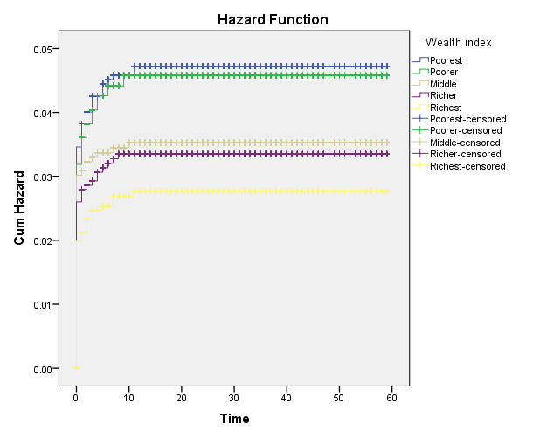 | 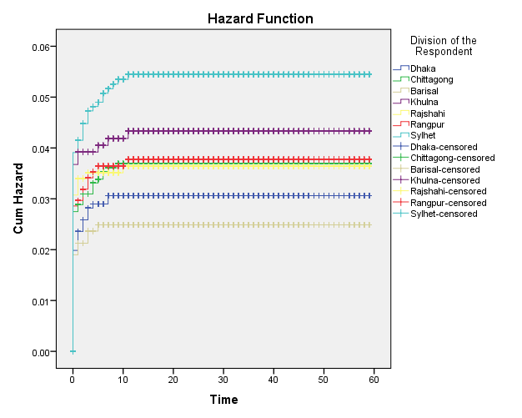
Figure 1: Wealth index | Figure 2: Division
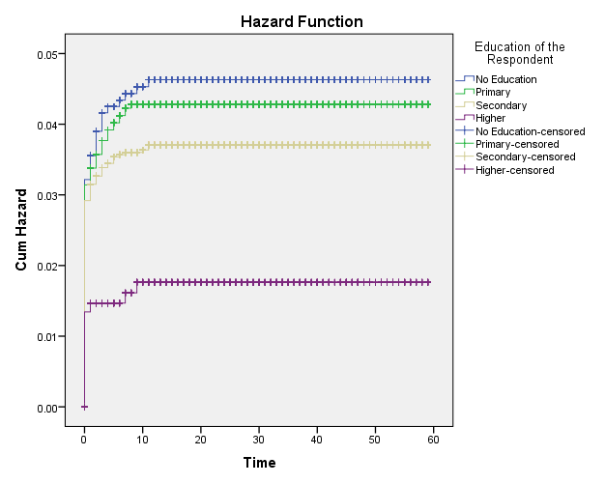 | 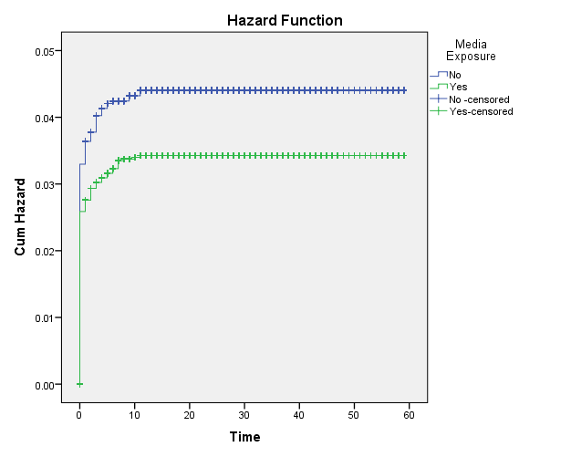
Figure 3: Respondents Education | Figure 4: Media Exposure
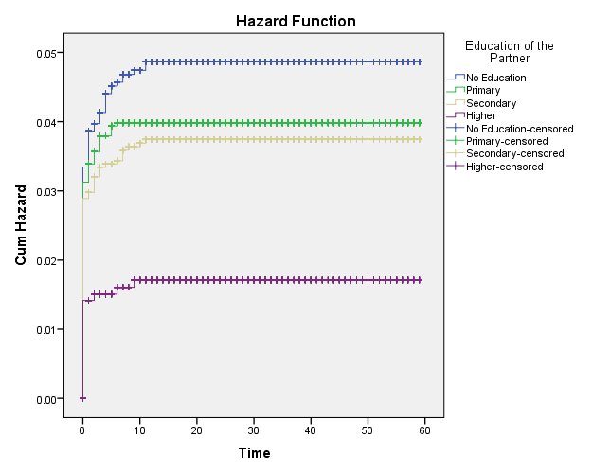 | 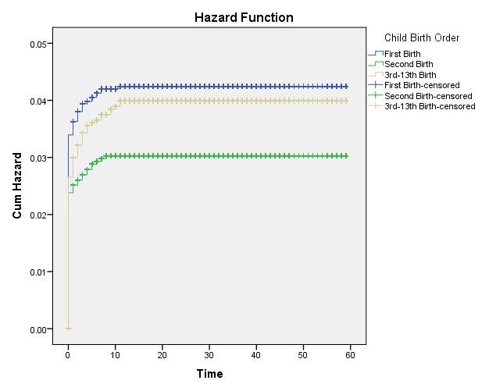
Figure 5: Partners Education | Figure 7.6: Child Birth Order
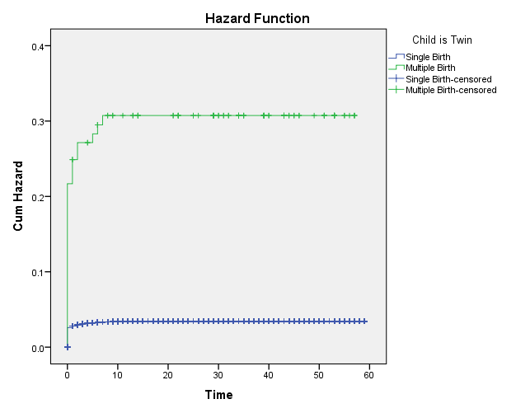 | 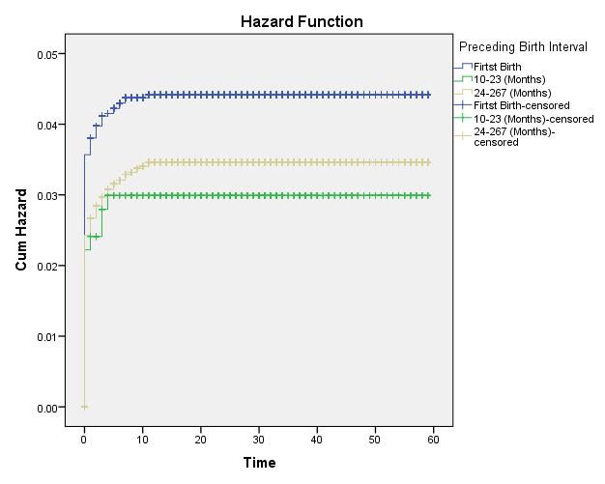
Figure 7: Twin Child | Figure 8: Preceding Birth Interval
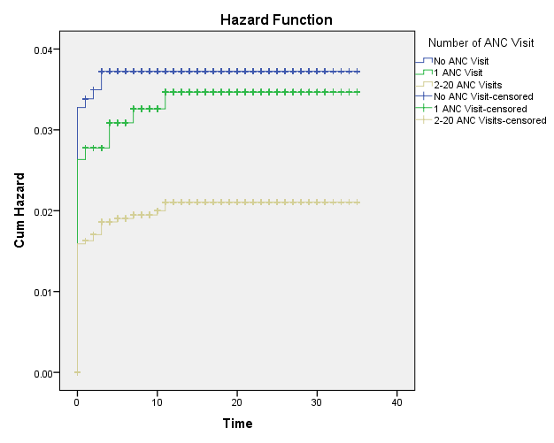 | 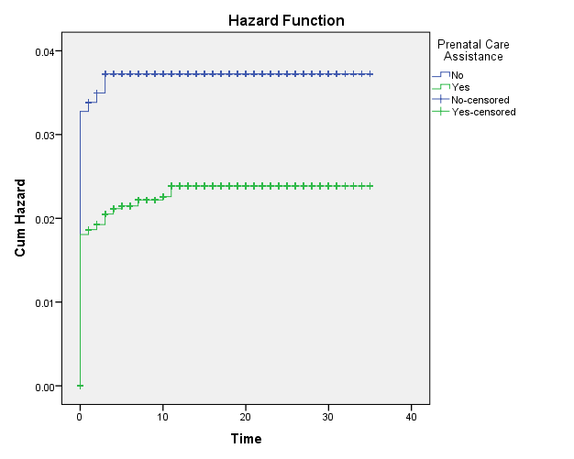
Figure 9: Number of ANC Visits | Figure 10: Prenatal Care Assistance
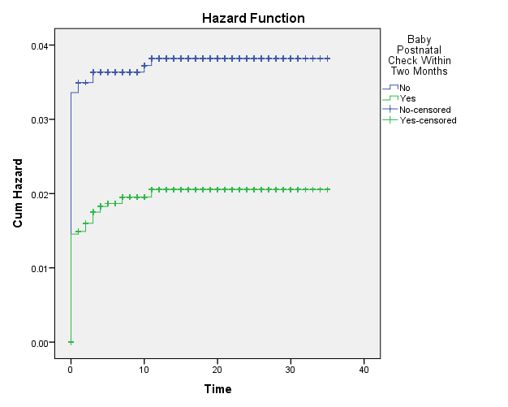 | 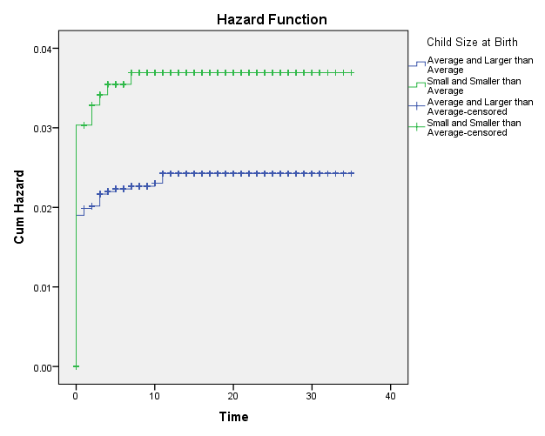
Figure 11: Baby Postnatal Checkup | Figure 12: Child Size at Birth
From figure 1, it is seen that the poorest group respondent’s child shows the highest rate of hazard on mortality compared to other wealth indices while the richest class respondents’ child shows the lowest hazard rate. Child of the respondents who belongs to Sylhet division shows the highest rate of hazard on mortality compared to other divisions whereas Barisal division child shows lowest hazard rate (Figure 2). No educated respondent’s child shows the higher mortality compared to other education groups. It can be noticed that respondents first ordered birth shows uppermost mortality hazard rate compared to other preceding birth interval categories. Respondents who did not receive any ANC facilities, their child shows the highest mortality hazard rate compared to other ANC visit groups. In terms of the hazard plot of respondent’s prenatal care assistance, children who did not receive prenatal care services shows uppermost hazard compared to their counterparts. From the Figure 12, it can be noticed that children born with LBW shows the highest mortality hazard rate compared to the average size baby.

  - Cox PH Results for Model 1 Covariates
Table 5 presents Cox PH results for model 1 (hazard ratio and 95% C.I of HR). Cox PH model shows that children from poorer, middle, richer and richest family have 4%, 25%, 29%, and 42% less hazard of dying before the first birthday compared to the children from the poorest family. Hazard ratio indicates that Rajshahi, Chittagong, Rangpur, Khulna and Sylhet division respondent’s child show 1.19, 1.20, 1.22, 1.41 and 1.75 times higher likelihood of experiencing infant mortality compared to Dhaka division respondent’s child. Barisal division respondent’s child shows 19% less vulnerability of infant mortality compared to Dhaka division respondent’s child. Only Sylhet division shows the significant result. It is noticeable that respondent’s higher education plays a significant role in experiencing infant mortality event. Higher educated mother’s child shows 62% less risk of dying before first birthday compared to uneducated mothers’ child. The result is almost similar for partners’ education as well ($P$-value < 0.05). The fact is educated parents usually utilize more maternal health care during pregnancy and aware about the quality child health care. The negative coefficient of media access respondents indicates that mothers are experienced 23% less risk of infant mortality compared to their counterparts ($P$-value = 0.03). Second ordered birth is found to have less risk of infant mortality event compared to the first birth of the mother’s child. Twin birth is found another potential risk factor of infant death as hazard ratio indicates that multiple birth child is 8.23 times more likely to experience infant death ($P$-value = 0.00). The results reflect that children who were born after 2 years preceding birth interval of his/her mother shows significantly 23% less risk of infant mortality compared to the first birth children ($P$-value = 0.03).
Table 5: Cox PH Results of Model 1
Variables | Category | $$β$$ | df | $P$-value | HR | 95% C.I of HR
Wealth index | Poorest (Reference)
Wealth index | Poorer  Middle  Richer  Richest | -0.03  -0.28  -0.33  -0.53 | 1  1  1  1 | 0.85  0.11  0.05  0.00 | 0.96  0.75  0.71  0.58 | [0.69, 1.34]  [0.53, 1.07]  [0.50, 1.01]  [0.40, 0.85]
Division | Dhaka (Reference)
Division | Chittagong  Barisal  Khulna  Rajshahi  Rangpur  Sylhet | 0.18  -0.20  0.34  0.17  0.20  0.56 | 1  1  1  1  1  1 | 0.37  0.44  0.13  0.44  0.37  0.00 | 1.20  0.81  1.41  1.19  1.22  1.75 | [0.79, 1.80]  [0.48, 1.37]  [0.90, 2.20]  [0.75, 1.87]  [0.78, 1.92]  [1.19, 2.58]
Respondent’s education | No Education (Reference)
Respondent’s education | Primary  Secondary  Higher | -0.07  -0.21  -0.96 | 1  1  1 | 0.66  0.18  0.00 | 0.92  0.80  0.38 | [0.66, 1.29]  [0.58, 1.10]  [0.21, 0.68]
Media exposure | No (Reference)
Media exposure | Yes | -0.25 | 1 | 0.03 | 0.77 | [0.61, 0.98]
Partner’s education | No Education (Reference)
Partner’s education | Primary  Secondary  Higher | -0.18  -0.25  -1.03 | 1  1  1 | 0.20  0.08  0.00 | 0.82  0.77  0.35 | [0.62, 1.10]  [0.57, 1.03]  [0.21, 0.58]
Child birth order | First Birth (Reference)
Child birth order | Second birth  3rd-13th birth | -0.33  -0.07 | 1  1 | 0.02  0.60 | 0.71  0.93 | [0.53, 0.95]  [0.71, 1.21]
Twin child | Single Birth (Reference)
Twin child | Multiple birth | 2.10 | 1 | 0.00 | 8.23 | [5.67, 11.9]
Preceding birth interval | First Birth (Reference)
Preceding birth interval | 10-23 (Months)  24-  267(Months) | -0.38  -0.25 | 1  1 | 0.14  0.03 | 0.68  0.77 | [0.40, 1.14]  [0.61, 0.98]

  - Cox PH Results for Model 2 Covariates
This section presents the results obtained from the Cox PH model 2 (Table 6). From Table 6, respondents who receive 1 ANC visit shows 10% less risk of infant mortality and respondents who received 2 or more ANC visit found to have 45% less risk of infant mortality compared to the respondents who did not receive any ANC visit during pregnancy ($P$-value = 0.00). It is found that the respondents who took prenatal care assistance from health professionals experienced 38% significantly less risk of infant mortality compared to their counterparts ($P$-value = 0.00). Postnatal checkup for baby is found another key risk factor of infant mortality. Mothers who receive postnatal checkup for their babies are found 47% less chance of dying before their first birthday ($P$-value = 0.00). It is noted that low birth weight child is found 1.53 times more vulnerable to experience infant mortality than normal weight baby. The results also identified as significant since $P$-value = 0.00.

Table 6: Cox PH Results of Model 2
Variables | Category | $$β$$ | df | $P$-value | HR | 95% C.I of HR
ANC visit | No ANC visit (Reference)
ANC visit | 1 visit  2-20 visit | -0.09  -0.59 | 1  1 | 0.70  0.00 | 0.90  0.55 | [0.53, 1.52]  [0.36, 0.84]
Prenatal care assistance | Non-health professional (Reference)
Prenatal care assistance | Health professional | -0.46 | 1 | 0.02 | 0.62 | [0.42, 0.93]
Baby postnatal check | No (Reference)
Baby postnatal check | Yes | -0.63 | 1 | 0.00 | 0.53 | [0.36, 0.76]
Child size at birth | Normal weight (Reference)
Child size at birth | Low birth weight | 0.43 | 1 | 0.04 | 1.53 | [1.01, 2.32]

5. Conclusion and Policy Recommendations
This research identifies the contributing factors influencing low birth weight and infant mortality in Bangladesh by using nationally representative 2014 BDHS data. To obtain the desired outcome of the study, the present study uses some statistical tools such as log-rank test, Chi-square test, logistic model and Cox proportional hazard regression model. Among all explanatory variables, respondent’s education plays a vital role on explaining child’s low birth weight in Bangladesh. The study also found that higher educated mother has lower risk of low birth weight compared to lower educated mother. Hence, education is being the prime catalyst in this process because increase in educational attainment is likely to have significant effect on low birth weight. Further, it is identified that if a child is a multiple birth, the chance of having low birth weight baby is more likely than the single birth. Underweight mother is likely to give low weight birth than other BMI indicators. Female child is found more likely to have of low birth weight than male child. Odds ratio indicates that Rangpur, Rajshahi, Khulna and Barisal division respondents’ child have lower risk of low birth weight. It is also notable that as partners’ education increases, the chance of risk for low weight baby decreases. $P−$value indicates that partners secondary education has significant lower chance of giving birth to low weight baby. The coefficients of wealth indices are also found decreasing trend and indicates that as wealth increases the chance of giving birth to low weight baby decreases. $P−$value indicates significant association for richest and richer respondents compared to the poorest respondents. The results of LBW indicates that increasing maternal education and maternal health care utilization should be a key indicator for further reduction of current prevalence of LBW in Bangladesh. In relation to infant mortality rate, it is found that wealth index, division, respondents’ education, partners’ education and twin child are found significant at 1% significance level. On the other hand, media exposure is found significant at 5% level of significance. Furthermore, antenatal care visit, prenatal care assistance, baby postnatal check within two months and child size at birth are also found significant at 1% significance level. Wealth index is found significant for richer and richest respondents and shows potential impact on infant mortality. It is identified that Sylhet division respondents’ child is more likely to experience infant deaths. Respondents with media access shows less risk of infant mortality. The results indicate that higher educated mother is found less likely to experience infant mortality compared to uneducated respondents. Higher educated partners’ child also shows the similar results. Multiple birth child is more vulnerable to experience infant deaths. Mothers preceding birth interval two or more years shows significant impact on infant mortality and proved that more preceding birth interval causes less likely chance of experiencing infant mortality. It is noticed that more ANC visit reduces the risk of infant mortality in Bangladesh. Like ANC visits during pregnancy, prenatal care assistance from medical health professionals also increases the likelihood of infant survival. Baby postnatal check result indicates that the mothers who are conscious and take the baby for postnatal check after birth are found less likely to have risk on infant mortality. More significantly, low weight baby at birth increases the likelihood of experiencing infant deaths in Bangladesh. Based on the findings above, the following policy recommendations are worthy to note for the policy makers:
- Education has been proven as a key element for explaining low birth weight and infant mortality in Bangladesh. So, parents might be encouraged to receive health-based knowledge about pregnancy and afterwards.
- Every pregnant woman should be encouraged to receive prenatal care assistance from medical health professionals. It may help to reduce the chance of infant mortality. Baby postnatal check within two months is also required to reduce infant mortality in Bangladesh. Furthermore, frequent ANC visit is needed for close monitoring for the upcoming child and the mothers.
Authors’ Contributions:
MHC: Study plan; writing abstract; variable selection; result analysis; closely supervising.
MJI: Data collection; writing main sections of the paper; econometric estimation, and data and result analysis.
ZR: Literature review, polishing and editing, improving the quality of the manuscript, undertaking the responsibility of corresponding author of this paper.
MMR: Conceptual and methodological development.
Declaration of Conflicting Interests
The author(s) declared no potential conflicts of interest with respect to the research, authorship, and/or publication of this article.
Funding
The author(s) received no financial support for the research, authorship, and/or publication of this article.

References
Ahammed, B., Maniruzzaman, M., Ferdausi, F., Abedin, M. M., & Hossain, M. T. (2020). Socioeconomic and demographic factors associated with low birth weight in Nepal: Data from 2016 Nepal demographic and health survey. Social Health and Behavior, 3(4), 158.
Ahamad, M. G., Tasnima, K., Khaled, N., Bairagi, S. K., & Deb, U. K. (2010). Infant mortality situation in Bangladesh in 2007: a district level analysis.
Ara, F., Sultana, M. M., Naoshin, S., Sultana, I., Hoq, M. N., & Hossain, M. E. (2023). Sociodemographic determinants of child mortality based on mothers’ attitudes toward partner violence: Evidence from Bangladesh. Heliyon, 9(2023), 1-11.
Anney, A.S, Rudra, S. & Biswas, S.C. (2020). Factors affecting under-five child mortality in Bangladesh: Cox proportional hazard model and cox frailty model. International Journal of Biomedicine and Public Health, 3(1), 15-24.
Asif, M. F., Pervaiz, Z., Afridi, J. R., Safdar, R., Abid, G., & Lassi, Z. S. (2022). Socio-economic determinants of child mortality in Pakistan and the moderating role of household’s wealth index. BMC pediatrics, 22, 1-8.
Adhikari, N. (2022). Prevalence of low birth weight and its associated factors: Hospital based cross sectional study in Nepal. PLOS Global Public Health, 2(11), e0001220.
Axame, W. K., Binka, F. N., & Kweku, M. (2022). Prevalence and factors associated with low birth weight and preterm delivery in the ho municipality of Ghana. Advances in Public Health, 2022.
Blencowe, H., Cousens, S., Oestergaard, M. Z., Chou, D., Moller, A. B., Narwal, R., ... & Lawn, J. E. (2012). National, regional, and worldwide estimates of preterm birth rates in the year 2010 with time trends since 1990 for selected countries: a systematic analysis and implications. The lancet, 379(9832), 2162-2172.
Carpenter, R. M., Billah, S. M., Lyons, G. R., Siraj, M. S., Rahman, Q. S., Thorsten, V., ... & Petri, W. A. (2022). U-Shaped association between maternal hemoglobin and low birth weight in rural Bangladesh. The American Journal of Tropical Medicine and Hygiene, 106(2), 424.
Government of Bangladesh. Bangladesh Economic Review 2023. Economic Advisory Wings, Finance Division, Dhaka: Ministry of Finance, Dhaka
Hosain, G. M.M, Chatterjee, N., Begum, A., & Saha, S. C. (2005). Factors associated with low birthweight in rural Bangladesh. Journal of tropical pediatrics, 52(2), 87-91.
Hall, E. S., Venkatesh, M., & Greenberg, J. M. (2016). A population study of first and subsequent pregnancy smoking behaviors in Ohio. Journal of perinatology : official journal of the California Perinatal Association, 36(11), 948–953. https://doi.org/10.1038/jp.2016.119
Ijdi, R. E., Tumlinson, K., & Curtis, S. L. (2022). Exploring association between place of delivery and newborn care with early-neonatal mortality in Bangladesh. Plos one, 17(1), e0262408.
Islam Pollob, S. A., Abedin, M. M., Islam, M. T., Islam, M. M., & Maniruzzaman, M. (2022). Predicting risks of low birth weight in Bangladesh with machine learning. PloS one, 17(5), e0267190.
Eke, D. O., & Ewere, F. (2022). Levels, trends and determinants of infant mortality in Nigeria: An analysis using the logistic regression model. Earthline Journal of Mathematical Sciences, 8(1), 17-40.
Kim D, Saada A. The social determinants of infant mortality and birth outcomes in western developed nations: a cross-country systematic review. Int J Environ Res Public Health. 2013;10(6):2296–335. doi:10.3390/ ijerph10062296.
Khan, N., Mozumdar, A., & Kaur, S. (2020). Determinants of low birth weight in India: An investigation from the National Family Health Survey. American Journal of Human Biology, 32(3), e23355.
Khatun, S., & Rahman, M. (2008). Socio-economic determinants of low birth weight in Bangladesh: a multivariate approach. Bangladesh Medical Research Council Bulletin, 34(3), 81-86.
Khan, G. R., Baten, A., Azad, M., & Kalam, A. (2023). Influence of contraceptive use and other socio-demographic factors on under-five child mortality in Bangladesh: semi-parametric and parametric approaches. Contraception and Reproductive Medicine, 8(1), 1-11.
Kousar, S., Shabbir, A., & Shafqat, R. (2022). Investigation of socioeconomic determinants on child death in south Asian countries: a panel Cointegration analysis. OMEGA-Journal of Death and Dying, 84(3), 811-836.
Larroque B, Bertrais S, Czernichow P, Leger J. School difficulties in 20-yearolds who were born small for gestational age at term in a regional cohort study. Pediatrics. 2001;108:111–15.
Mahumud, R. A., Sultana, M., & Sarker, A. R. (2017). Distribution and determinants of low birth weight in developing countries. Journal of preventive medicine and public health, 50(1), 18.
Mbitto, W. D., & Mzingula, E. P. (2022). Determinants of infant mortality in Kisarawe district Tanzania. In SPR (Vol. 2, No. 2, pp. 476-481).
Ministry of Planning, Government of Bangladesh. https://plandiv.gov.bd/site/files/3306e77a-62bc-4a12-b76e-91ac5e56a821/Perspective-Plan-(2021-2041)
Mondal, B. (2000). Risk factors for low birth weight in Nepali infants. The Indian Journal of Pediatrics, 67, 477-482.
Muglia LJ, Katz M. The enigma of spontaneous preterm birth. N Engl J Med. 2010;362(6):529–35.
Mediani, H.S. Predictors of Stunting Among Children Under Five Year of Age in Indonesia: A Scoping Review. Glob. J. Health Sci. 2020, 12, 83.
McFadden, C., Muir, B., & Oxenham, M. F. (2022). Determinants of infant mortality and representation in bioarchaeological samples: A review. American Journal of Biological Anthropology, 177(2), 196-206.
National Institute of Population Research and Training (NIPORT), Mitra and Associates, and ICF International. Bangladesh Demographic and Health Survey 2011. Dhaka, Bangladesh and Calverton, Maryland, USA: NIPORT, Mitra and Associates, and ICF International.
National Institute of Population Research and Training (NIPORT), Mitra and Associates, and ICF International. 2016. Bangladesh Demographic and Health Survey 2014. Dhaka, Bangladesh, and Rockville, Maryland, USA: NIPORT, Mitra and Associates, and ICF International.
National Institute of Population Research and Training (NIPORT), and ICF. 2019. Bangladesh Demographic and Health Survey 2017–18: Key Indicators. Dhaka, Bangladesh, and Rockville, Maryland, USA: NIPORT, and ICF.
Panda, R., Jena, P., Chanania, K., & Kar, D. (2022). Determinants of Low Birth Weight in a Tertiary Care Hospital in Eastern India. National Journal of Community Medicine, 13(01), 37-42.
Perspective Plan: 2021-2041, Bangladesh
Rabbi, A. F. (2013). Imbalance in life table: Effect of infant mortality on lower life expectancy at birth. Journal of Scientific Research, 5(3), 479-488.
Rahman, M. M., & Alam, K. (2021). The role of socio-economic and female indicators on child mortality rate in Bangladesh: a time series analysis. OMEGA-Journal of Death and Dying, 0030222821993616. https://doi.org/10.1371/journal.pone.0267190
Risnes KR, Vatten LJ, Baker JL, Jameson K, Sovio U, Kajantie E et al. Birthweight and mortality in adulthood: a systematic review and metaanalysis. Int J Epidemiol. 2011;40:647–61. doi:10.1093/ije/dyq267.
Rachmawati, P. D., Kurnia, I. D., Asih, M. N., Kurniawati, T. W., Krisnana, I., Arief, Y. S., ... & Arifin, H. (2022). Determinants of under-five mortality in Indonesia: A nationwide study. Journal of Pediatric Nursing, 65, e43-e48.
Rehman, A., Shah, M. I., Manan, A., Sadiqa, A., & Saadat, U. R. (2022). Impact of Socioeconomic Determinants on Infant Mortality in Pakistan. Journal of Economic Impact, 4(3), 265-277.
Rahman, M. M., & Alam, K. (2023). The role of socio-economic and female indicators on child mortality rate in Bangladesh: a time series analysis. OMEGA-Journal of Death and Dying, 86(3), 889-912.
Shaheen, R., Roy, M., Anny, A., Shova, N. Y., & Hema, T. (2020). Prevalence of low birth weight in urban Dhaka and its association with maternal age and socioeconomic status. Dr. Sulaiman Al Habib Medical Journal, 2(4), 162-166.
Shrestha, S.; Shrestha, S.; Shakya Shrestha, U.; Gyawali, K. Predictors of Low Birth Weight at Lumbini Provincial Hospital, Nepal: A Hospital-Based Unmatched Case Control Study. Adv. Prev. Med. 2020, 2020, 8459694
Shabbir, Z., Riaz, A., & Ahmad, F. (2022). Trend and future of infant mortality in Pakistan. Journal of University Medical & Dental College, 13(4), 518-523.
Safitri, H. O., Fauziningtyas, R., Indarwati, R., Efendi, F., & McKenna, L. (2022). Determinant factors of low birth weight in Indonesia: Findings from the 2017 Indonesian demographic and health survey. Journal of Pediatric Nursing, 63, e102-e106.
Samsury, S. F., Ismail, T. A. T., & Hassan, R. (2022). Low birth weight infant among teenage pregnancy in Terengganu, Malaysia: A cross-sectional study. Malaysian Family Physician: the Official Journal of the Academy of Family Physicians of Malaysia, 17(1), 44.
Sharma, S. R., Giri, S., Timalsina, U., Bhandari, S. S., Basyal, B., Wagle, K., & Shrestha, L. (2015). Low birth weight at term and its determinants in a tertiary hospital of Nepal: a case-control study. PloS one, 10(4), e0123962.
Thapa, P., Poudyal, A., Poudel, R., Upadhyaya, D. P., Timalsina, A., Bhandari, R., ... & Adhikari, N. (2022). Prevalence of low birth weight and its associated factors: Hospital based cross sectional study in Nepal. PLOS Global Public Health, 2(11), e0001220.
United Nations Children’s Fund; World Health Organization. UNICEF-WHO Low Birthweight Estimates: Levels and Trends 2000–2015; World Health Organization: Geneva, Switzerland, 2019; Available online: https://apps.who.int/iris/bitstream/handle/10665/324783/WHO-NMH-NHD-19.21-eng.pdf?ua=1
United Nations Development Program. (2015). Sustainable development goals (goal 3: Good health and well-being). https://www.undp.org/content/undp/en/home/sustainable-development-goals/goal-3-good-health-and-well-being.html
World Health Organization. (2015). Sustainable development goal 3: Health. https://www.who.int/topics/sustainable-development-goals/targets/en/
World Health Organization. (2015). Sustainable development goal 3: Health. https://www. who.int/topics/sustainable-development-goals/targets/en/
World Health Organization. (2015). Global Nutrition Targets 2025: Low birth weight policy brief. 2014. World Health Organization, Geneva, Switzerland.
Yadav, D. K., Chaudhary, U., & Shrestha, N. (2011). Risk factors associated with low birth weight. Journal of Nepal Health Research Council,9(19),159-64
Yunida, H. (2022). Factors Related to Maternal Death and Infant Death in Indonesia. Journal of Innovation Research and Knowledge, 2(4), 1039-1046.
Yasmin, S., Osrin, D., Paul, E., & Costello, A. (2001). Neonatal mortality of low-birth-weight infants in Bangladesh. Bulletin of the World Health Organization, 79(7), 608-614.

Department of Statistics, Mawlana Bhashani Science and Technology University, Santash, Tangail, Bangladesh.
School of Business, University of Southern Queensland, Toowoomba QLD 4350, Australia.
Department of Economics, Bangabandhu Sheikh Mujibur Rahman Science and Technology University, Gopalganj, Bangladesh. (Corresponding author)

