METABODY – full report on event
http://people.brunel.ac.uk/dap/MetabodyForumResearch.html

Provocation 7 April – Lecture delivered to audience
Workshop 8 April – photograph shown of work in progress
Performance 9 April – installation created by the artist (Janice Jones) using earth, paper, flowers, feathers, ashes and one pomegranate.
ABSTRACT
Janice Jones (University of Southern Queensland): 13 Moons: A Story of Ashes, Blood, Light (provocation)
Abstract: (291 Words)
An artist-performer and arts educator draws upon the complex and layered Third Space to explore her experience of creative destruction. Movement, spoken word and digital representations articulate and question her deep journey through nine months of grief, disruption and renewal. Nine paintings were created by the artist under the light of a full moon over as many months: these form a digital backdrop to the embodied narrative of her ongoing journey commencing with the loss of her life partner, whose final breath was drawn with the rising of a rare blue moon on 31 July 2015. Engaging her audience in this visceral narrative of loss and regeneration the artist uses ashes, blood and light, words and movements as codified representations of the ebb and flow of grief, and of the power of time as a creative Third Space for intellectual, physical and spiritual growth. After the performance, audience members are invited to ‘walk into’ the final painting, or to remain silent, being and becoming part of the personal, professional and critical understandings generated by the shared experience. The performance may be filmed and shared under a Creative Commons Share-alike license, and it is intended that both film and artworks will be shared as Open Education resources. Note: Human ashes and blood will not be used in the performance: issues around authenticity and representation-embodiment are therefore presented as a point of critical concern: they act both a raw nerve, and also as a thread of illumination along which we may explore points of connections regarding ethics, respect and space arising from the performance-presentation. Artworks yet to be created will be presented in an exhibition and performance piece: 13 Moons – Ashes, Blood, Light in a regional Australian art gallery in in October 2016.
Keywords:
Third space, grief, the moon, Narrative, Embodiment, symbolic representation, Open Education, digital art, dance

DETAILS FOR RESEARCH REPORTING
Janice Jones building upon her successful (20K) 2015 USQ Excellence in Learning and Teaching Grant Janice designed and curated a Creative Commons Open Education Arts site (ArtsSpace) where all works may be freely used or adapted by teachers, students and artists. Students in two USQ undergraduate courses are co- curating the site in S2 2016.
Funded by that grant Janice was invited to work in the UK with artist-performers using body-technologies for the arts at the International Metabody Forum, “Performance Architectures, Wearables and Gestures of Participation” at Brunel University London in April. During her week there she presented a provocation on the architecture of grief and renewal, followed by two public dance performance/installations of “13 Moons: A Story of Ashes, Blood, Light”. The installation for the performance included a huge circle of white paper, covered by dry earth. Janice used dance to carve powerful visual representations of love, grief, and rebirth in the earth. A Makey Makey allowed Janice to trigger a digital backdrop to play by touch. Janice created all music, artworks and photographs for the film backdrop which is available at https://youtu.be/GvWL_JjB6sE. USQ Media assisted by capturing film for the project. Janice comments: “Taking part in creating the Metakinosphere - a warehouse-sized installation of body-technology activated sound, light, performance and sculpture was an amazing and inspiring experience of collaborative art making.”
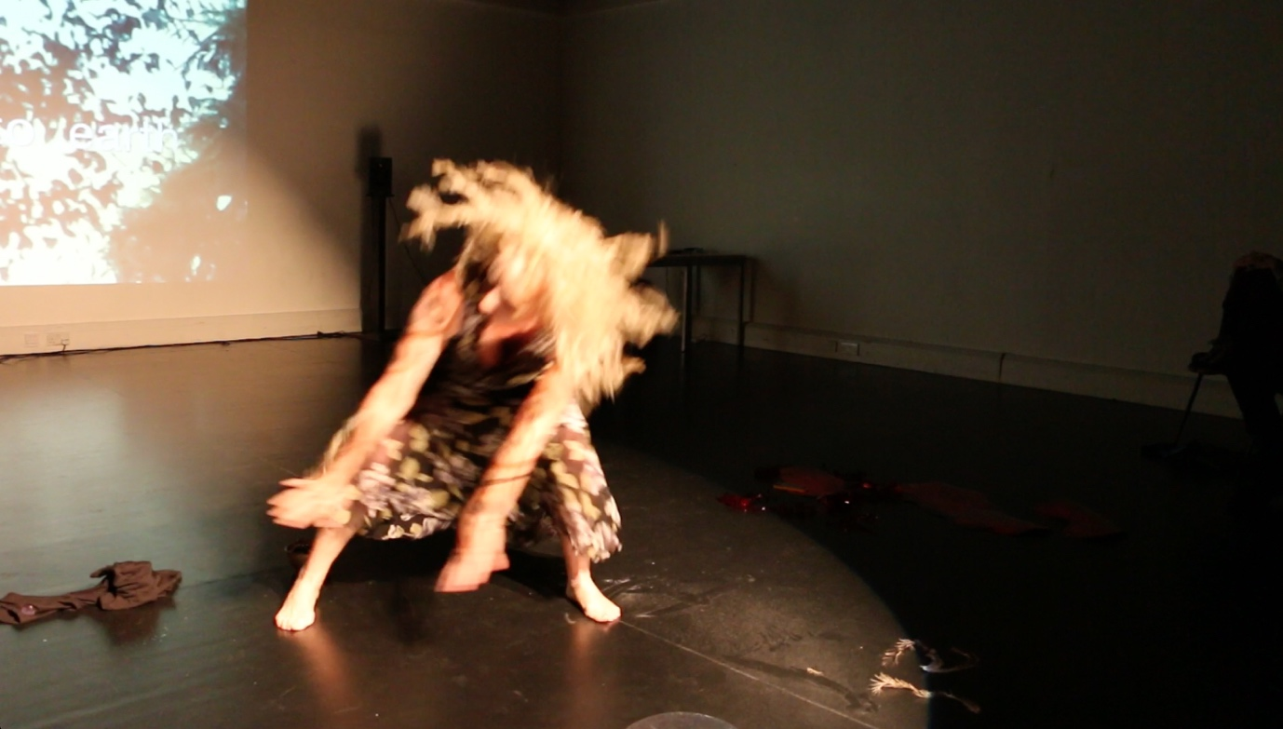
Rehearsal for Performance “13 Moons: A Story of Ashes, Blood, Light”. Photo by Michele D’Anjou.

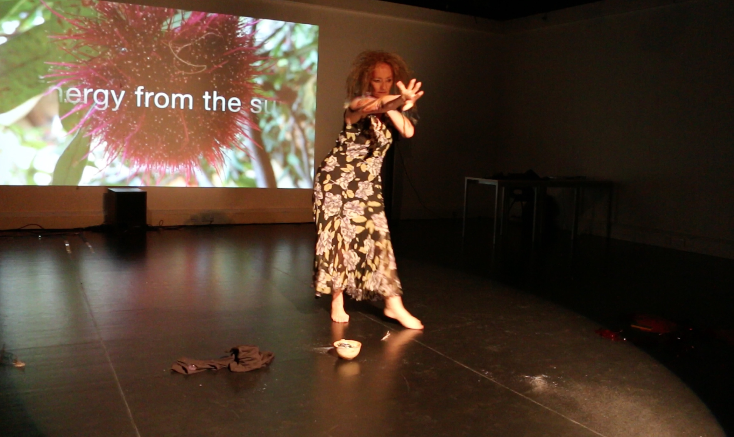
Image captured during workshop

VIDEO Backdrop to dance performance and installation of Asheds Blood Light: https://youtu.be/GvWL_JjB6sE
Art works, music and performance created by Janice Jones. Film created and edited by Janice Jones
Film captured provided by USQ media (live film captured in Japanese Gardens).

