Impact analysis of Smart Assistive Technologies for people with dementia

Trudy Yuginovich1, Jeffrey Soar² and Ying Su³

1 Faculty of Sciences, University of Southern Queensland, AUSTRALIA 4350
2 Faculty of Business & Law,
University of Southern Queensland
AUSTRALIA 4350
3 Institute of Scientific and Technical Information of China,
15 Fu Xing Rd, Beijing 100038, CHINA

Abstract

Aims: To trial the use of a range of available Smart Assistive Technologies for people with dementia and their families.

Methodology: Participants in the project were selected on the basis of having a diagnosis or suspected diagnosis of dementia; living at home and eligible for government funding for care in their own homes. All participants were assessed by an Occupational Therapist, and then based on this assessment of individual need and functional capacity, were prescribed individual items of AT.

Findings: The results found a range of benefits including a significant reduction in the extent to which carers were worried about the client getting out of bed at night and falling following the implementation of AT. No difference was found in the ability of carers to leave the client alone at home as a result of the AT, nor any indication that AT made the clients feel safer. AT did not reduce their need for external support services (respite), in-home care (housework and /or meals). Contrary to expectations results also found that neither the levels of stress nor the frequency of stress reported by carers decreased significantly secondary to the introduction of AT. Finally carers had perceived that using the AT would enable the client to remain home longer, however this was not supported by the post AT survey.

Summary: The disability support and aged care sectors have not to date taken full advantage of assistive and other relevant technologies; there is a massive unmet need for greater support and a significant level of issues that are not addressed. There are a range of potential benefits of Smart Assistive Technologies for people with dementia, their families and carers. This small study confirmed some of these whilst confirmation of other potential benefits will require more research.

Key Words: information technology, assistive technology, disability support, independent living, aged care, seniors, dementia

1. Introduction

Life expectancy of people in developed countries worldwide is continuing to increase⁽¹⁾, creating health implications, and places greater pressure on the community and residential facilities⁽¹⁻³⁾. As well as an ageing population, the incidences of people diagnosed with dementia have increased over the last decade and is predicted to continue to increase. The needs of this group of clients’ places increased pressure in relation to care and financial costs on the aged care sector. As a result clients, carers and the government want older people to stay in their own home as long as possible^{(1, 2, 4)}. One possible way to achieve this is through the use of assistive technology (AT) ^{(5, 6)}.

Assistive technologies (ATs) are potential enablers for change in community aged care, by reducing the risks of adverse events for consumers and ultimately, enabling persons to remain in their own homes longer, reduce costs and improve outcomes⁽⁵⁾. They also have a role in promoting and maintaining a person's dignity, respect and independence ^{(7, 8)}. There is some evidence emerging internationally to suggest AT can provide care at lower cost, deliver consumer satisfaction, improve work-force productivity, better assist consumers in self-care, and decrease hospital admissions⁽⁹⁾. This is important in view of figures suggesting that in Australia 9% or 552,000 hospital admissions were found to be potentially avoidable, with almost one third of those occurring in the 75 years and over age bracket⁽⁹⁾.

Limited information or research exists in relation to how smart assistive technology can assist clients with dementia to remain independent at home for longer. This literature review considered all primary studies that explored the lived experiences of consumers and health professionals in relation to use of assistive technologies in the community. Previous research⁽¹⁰⁾ found that the aged and community sector particularly those in rural and remote communities often do not have access to suitable internet infrastructure, support and training to assist them in their work.
Health professionals such as Registered Nurses, Occupational Therapists, Social Workers, carers and Physiotherapists work in a field where there is a likelihood of a high level of adverse events, conditions and unmet needs of the frail aged needing support in the community ⁽¹¹⁾. These adverse events include falls, difficulties in managing medications, incontinence, social isolation, fear of crime, depression, cognitive decline and associated challenges such as wandering and safety⁽¹¹⁾. Such issues are similarly highlighted by other researchers⁽¹²⁾ who identified that the relationship between the approach that people take to their illness and the acceptance of using AT needs further study.

AT has been described as ‘any device or system that allows an individual to perform a task that they would otherwise be unable to do, or increases the ease and safety with which the task can be performed ^{(5, 6)}. The terminology around AT can vary greatly and encompass a variety of specific equipment. Telecare for instance is assistive technology that uses a combination of alarms, sensors and other equipment, connected to a response centre to support functional independence^{(13, 14)}.
An example of AT is a bed occupancy sensor that can be used to monitor when a person gets out of bed at night and if they do not return within a certain period. Bed sensors can be linked with an automatic light sensor so that when the person gets out of bed the light turns on. Similarly door exit sensors will detect if someone opens the front door and movement detectors will provide an alert if the person then leaves their home at a time that might be inappropriate^{(13, 14)}.
The power of AT is still under-recognised by physicians and other health providers ⁽¹⁵⁻¹⁷⁾ and its potential as an aid to clients is under-exploited. There are limits to the extent to which rehabilitation professionals can help to improve the skills of impaired people and the broader environments in which they live, and AT provides powerful means to overcome those limitations. In the USA, the effectiveness of Telecare has been demonstrated⁽⁴⁾ by the implementation of home Telecare which reduced hospital admissions by 19%, hospital bed days by 25% and re-admissions by 25%.

With, nearly 14% of people over age 71 diagnosed with some form of dementia, and prevalence increasing to nearly 40% of those over age 90⁽¹⁷⁾ , cognitive impairment is an important issue when considering supporting people living at home. As dementia progresses, it impacts a person's independent functions and can increase the burden on caregivers. Use of assistive devices can help individuals with dementia live more independently and safely. However, older individuals with cognitive impairment, visual, auditory or speech disabilities may have difficulties using AT because the devices are not designed to address their specific needs. The development of "smart devices" has potential in assisting older adults with cognitive impairment⁽¹⁷⁾.

The application of AT for use in the home should be directed by the client as the key stakeholders, collectively and individually rather than the developers⁽¹⁸⁾. It is important to gain an insight into the experiences of the end user of AT in order to design technology which meets carer needs ⁽¹⁹⁾. It must be noted that not everyone will benefit from or accept the new technological aids and devices and each individual’s situation must be carefully assessed ^{(20, 21)}.

AT is most effective when provided early in the disease process and after careful assessment, the correct prescription and home-based follow-up training in how to use it. Research⁽²²⁾ also suggests that families and carers have an improved sense of confidence about older peoples’ quality of life when they are provided with comprehensive telecare and/or ‘smart’ technology. Overall the technology can improve ‘peace of mind’ for older people and carers and may also improve safety, reduce hospitalisation, improve quality of life and enhance opportunities to remain at home thereby deferring the need to move into residential care.

Despite current advances in the range of technology and networking capabilities in the home, AT and telecare solutions have not been taken up as eagerly as might have been anticipated ⁽²³⁻²⁵⁾. These barriers include: lack of clear access and information points for people to learn about AT and be properly assessed; lack of follow-up home-based training and basic maintenance of technologies. Other barriers include poor design and unattractive appearance of aids and devices, compounding concerns related to self-image, feelings of stigma and denial about disability and ageing⁽²²⁾. Many stakeholders emphasised that the design of technologies often lacks consideration of older people’s views, attitudes and tastes. Another significant barrier for older people is apprehension about the cost and affordability of assistive technologies.

Evaluating AT services to demonstrate quality or measure outcomes requires ethical obligation⁽²⁹⁾. The ethics involved in providing AT is not widely discussed⁽³⁰⁾. However, recommendations were made that partnerships between industry, consumers and purchasers of the technology must be established and be long term commitments (3-5- years at least)⁽³¹⁾. Partnership and long term commitment will assist in developing AT which is user friendly, easy to manage, improve client outcomes and reduce carer burnout. Decision making about AT must respect the rights of individuals.

2. Aims

The primary objective of this project was to demonstrate the usability of smart assistive technologies for clients who have dementia and/or who are frail aged. The study aimed to identify evidence in relation to the experiences of carers of a person with dementia, over 65, living at home with AT. Alzheimer’s Queensland, (AQ) aim for the project was to determine how using smart assistive technology might be of benefit (or detriment) to clients, their carers and families and what factors influence this. Smart assistive technology uptake was determined using a client focused approach, in line with AQ’s philosophy. Evaluation criteria included assessing the incidence of:
- Increased safety in the home whether living independently or with carers.
- Decreased carer burden and anxiety
- Reduced need for in home, residential or community care
- Reduced wandering
- Earlier reporting of falls and/or injuries

3. Methods
The impact of Smart assistive technology uptake was determined using a client focused approach based on Fourth Generation Evaluation (FGE) as the theoretic framework and methodology to answer the research questions posed. This involved the development, implementation and review of rigorous screening and assessment tools to ensure that clients are prescribed smart assistive technology that is appropriate to their individual needs and promotes the client’s functional independence. FGE identifies stakeholders’ claims and issues and then reaches a consensus about the phenomena (in this case assistive devices and consumer satisfaction with outcomes)⁽³³⁾. It encourages the use of multiple methods (in this case focus groups, in-depth interviews and surveys) to accomplish the facilitation of stakeholder views by focus groups, semi structured interviews or satisfaction surveys. It uses a constructivist inquiry method that is outcome oriented and includes the dynamic, human, political social, cultural and contextual elements⁽³⁴⁾. It also contributes to the philosophy of community development and empowerment that underpins practice such as in the current study ⁽³⁵⁾.
The study involved 5 phases; 1) AQ staff managed the project; 2) USQ developed the surveys whilst AQ utilised their current tools; 3) Tunstall provided a 2 day workshop to AQ staff and management; 4) Ongoing service provision including screening and assessment of the appropriateness of using smart assistive technology for individual Home and Community Care (HACC) clients was provided throughout the study; 5) USQ collected data via focus groups (lasting about two hours), surveys and in-depth interviews. Participants were invited to discuss issues and benefits or otherwise of the assistive devices they were using. Interviews were digitally recorded and transcribed with participant permission. The assessment process used ensured that the participant was looked at holistically (including all activities) which involved the technology and how it will impact within the context that the person lives.

4. Selection and recruitment

Carers and people with dementia, living at home were invited to participate in the study. Clients and carers were selected by the Occupational Therapists (OTs) in the two centres. To ensure the quality of the service developed under the Smart Assistive Technology project the client must fall within the following criteria;

- Clients must live in the Brisbane North or Darling Downs regions.
- Must have a diagnosis or suspected diagnosis of Dementia
- Live at home
- Must be eligible for government funding for care at home

Approximately 60+ clients with carers were screened and assessed as being suitable to trial the smart assistive technology. The final number that agreed to be involved in the project and provide feedback was 39 carers.

5. Data collection

Two surveys were developed (pre-test, post-test) and were delivered to carers in each of the two locations. The second survey tool was delivered 1-11 months after the AT was provided. Data collected via the surveys was analysed using SPSS.

39 participants over the 12months were involved in the project. Data was collected in various formats, in two different locations and at three different periods in time. The results cannot be generalized across populations, based on the small sample and study findings. Researchers contacted each of these carers individually and offered them the opportunity to participate in an in-depth phone interview. This resulted in 15 people expressing willingness to be interviewed. (Interviews lasted about 45-70 minutes each). An additional four carers participated in a focus group.

Ethics approval was obtained from the University of southern Queensland ethics committee prior to commencing the study (Approval number H11REA111). Prior to commencement each participant was provided with a plain language statement outlining the purpose of the study and a consent form.

6. Findings
Participants were surveyed 1-11 months after commencement of using the AT, to determine what the impact of the AT had been for them. The two samples yielded low response rates (survey 1 n-39; Site 1 (n-13) and site 2 (n-26). Survey 2 yielded n-34; (site 1 n-13, site2 n-21). As a result the samples were joined to provide an overall sample of 39 respondents for survey 1 and 34 for survey 2. 59% of carers identified as being the spouse of the client, 87.2% of carers are female, and the mean age of respondents is 65.5 years, ranging from 26-92 years. 84.6% of respondents identified as being the main carer and 66.7% stated they were the only carer. 56.4% identified that they are unable to leave the client alone (figure 1). The types of AT used by carers included sensor mats, hearing devices, robotic vacuum cleaners and GPS watches. This AT had varying levels of success. 96.4% of respondents stated that they received adequate information and preparation prior to using the AT and 89.3% stated that they had experienced positive outcomes by using the AT during the last 6 months. 78.6% of respondents indicated that they felt comfortable troubleshooting the AT if problems arose.

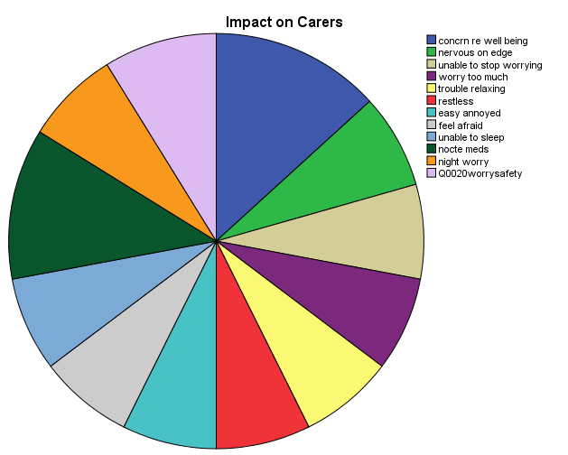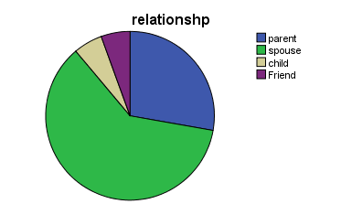
Figure 1. Impact on carers Figure 2. Relationship between carer & client

IMPACT OF CARING FOR A PERSON WITH DEMENTIA
The impacts of caring for a person with dementia were identified by participants as being primarily; unable to stop worrying, feeling afraid all the time, inability to sleep and inability to relax (see figure 1). The main carer concerns about clients were perceived as being the clients falling, risk of fire and their inability to be left alone (see figure 4). One carer expressed that the major risk for them was flooding as a result of the client leaving taps running. 86% of respondents (n-39) indicated high to very high levels of concern for the client, 61% expressed very high concern for the safety of the client, 74.4% indicated they are nervous and on edge, 33.3% of respondents identified that they are unable to stop worrying, 48.7% indicated they believe that they worry too much, 48.7% have trouble relaxing, 25.6% stated they are restless, 61.5% responded that they are easily annoyed, 30.8% feel afraid, 56.4% are unable to sleep, 69.2% worry about the client getting out of bed at night, while 20.5% indicate that they have been prescribed sleeping medications. Participants indicated that improvements as a result of using AT were of direct benefit for the carer and had little impact on the quality of life of the client with 59.3% of respondents indicating they did not believe the client was really aware of or felt any safer as a result of AT being used.

7. Analysis and discussion
38.5% of respondents indicated in survey 1 that they are able to leave the client alone at home 63.9% indicate that the client falls regularly, 47.2% state the client wanders, 50% indicate that the client gets lost, 27.8% indicated the client is unaware of dangers such as fire. There was no statistical difference (t=0.29) in the ability of carers to leave client alone at home as a result of AT. Likewise there was no significant increase in carer perceptions in the post AT survey that using the AT would enable to client to feel safer. Additionally 30% indicated that they experienced nervousness for the person they cared for each day.

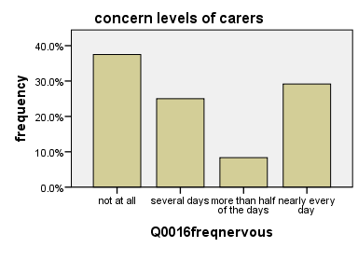

Figure 3: Frequency of carer nervousness
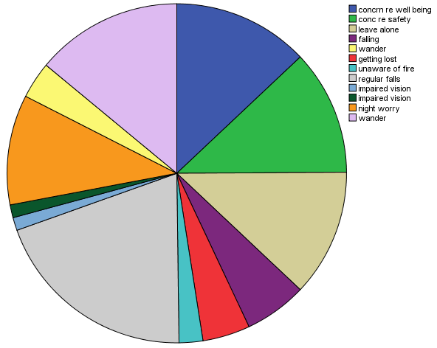
Figure 4: Client Issues
There was no significant impact on carer need for sleeping medications as a result of using the AT with 20.8% of respondents indicating that they continued to take sleeping medications compared with 21.1% at survey 1.
Respondents were asked to rank their stress levels on a scale from 1 to 10 with 1 being no stress and 10 being maximum stress. No significant difference in carer identified stress levels was noted between pre AT and post AT usage. These remained high with more than 50% indicating they were experiencing high or very high levels of stress most of the time. This may be related to the disease progression and different stressors being placed on the carer.
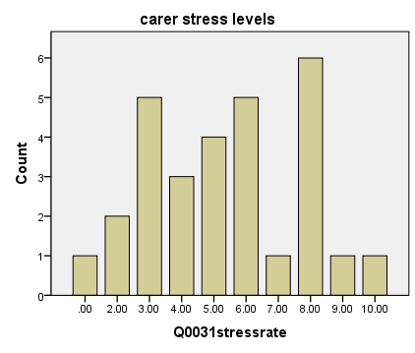

Figure 5. Carer stress levels
More than 30% of carers indicated that they experience nervousness every day about the person they care for.

At survey 1, 80.5% of respondents believed that using AT would enable them to feel less anxious, 73.1 % believe that using AT will let the client feel safer, while 88.5% believe that using AT will enable the client to remain at home longer. On the other hand, 61.5% of respondents do not believe that using AT will mean that the client will require less external support and care and 57.7% do not believe that the use of AT will assist them with current issues.

Carers indicated that since using AT they are less worried about the client getting out of bed at night and falling. Paired samples t-test indicated a statistically significant decrease in carer concern at night from survey 1 (-1.10, SD.89) to survey 2 (M-.47,SD.89), t=-5.06,p<.000 2 tailed. This was attributed to the use of the sensor mats beside the beds. This also contributed to their improved sleep patterns at night as evidenced by comments provided during focus groups and in-depth interviews (see section 5).
Finally, significant correlation (0.05 one-tailed) was noted between participants who believed that AT would assist them with their issues and that they would feel less anxious in survey 1. However, this was not identified in survey 2. Likewise, no correlation was noted between the use of AT and the ability to leave clients alone for a longer period of time. High correlation (Pearson’s) was evident between the need to remind clients about medications and all forms of dementia was noted as was the need for the client to be reminded to go to toilet and requiring help getting out of chairs.

8. Conclusion

The nature of this study (i.e. survey in depth interviews, focus group of carers and staff) has provided a useful cross sectional, triangulated view of perceptions of the effectiveness of AT to help in the care of people with dementia or other cognitive impairment. Carers indicated that they expected that the technology was going to reduce their burdens and stress levels and improve the quality of their own and their loved ones’ life. This proved not to be the case for some. While most indicated that they are sleeping better now this appears not to have reduced the level or frequency of their stress nor the need for sleeping medications on the part of carers. The stress appears to be a direct consequence of carer fear for the person they care for rather than the burden of their load. Post AT, burdens were identified by carers in some cases as actually being caused by needs in relation to activities of daily living as well as the risks of clients falling, becoming lost, wandering rather than inconveniences for themselves (i.e. sheer workload imposed by client physical and cognitive condition of their loved one). Some carers also identified fear of what should happen should the carer become too frail.

Involvement in the selection of the type of AT to be used was important for carers who stated that they appreciated being able to identify their particular needs, to be listened to and to be provided with adequate and appropriate education upon receipt of the AT. Timing of the introduction of the AT for carers was noted as being an important factor in regards to the usefulness for carers. Despite this, carers expressed appreciation for the security that the AT presented for them. This was primarily related to the fact that if they needed to use it they were able to do so and contact a service provider for help and it was seen as a backup for them.

The most useful and successful types of AT were identified by respondents as being sensor mat with remote pager. The bed exit sensor with interval timer and pager were also identified as being beneficial, as was the robotic vacuum cleaner and the hearing devices. Mats were significant in enabling carers to obtain a better quality of rest at night and be better able to cope with demands during the days. Some carers indicated that the high level of sensitivity to movement by the mats caused them to buzz non-stop even if the client was only to change their position in the chair. In some cases this distressed carers to the point that they removed the batteries and only used the mats at night, with the result that there was a continued risk of daytime falls whilst ever the client was able to independently mobilise. Hearing devices and vacuum cleaners were seen as increasing independence and communication in the case of the hearing devices.

The small size of the sample limits the usability of these findings for the general target population. Having said this, the findings do reflect those in the wider literature in relation to carers and staff. The technology was seen by all as being relevant and useful even though the poor design of some technology caused more frustrations than actual help. While this twelve month study has confirmed findings of the literature review, that AT is seen as an acceptable and useful strategy to assist with caring for clients with various stages of dementia, it has also raised some issues that provide opportunity for further exploration.
Early in the project it was anticipated that integrated Tunstall monitored emergency call systems with automated/passive peripherals i.e. door exit sensors and PIR sensors would be heavily prescribed however there was very limited uptake of this equipment by clients and client families with dementia. Several possible explanations for this were put forward by the Occupational Therapists based on their observations and discussion with carers around the technologies. One explanation revolved around the nature of the system, specifically, to be effective the automated/passive systems (i.e. not reliant on the person pressing a personal alarm button to trigger an alert) required windows of time at least 4-5 hours long i.e. PIR movement sensors could trigger an alarm if a person did not move past the sensor between the hours of 7.30-12.30am. Creating alarms for shorter windows was likely to result in too many false alarms i.e. if the window was set to trigger an alert if the person did not move past the PIR sensor between the hours of 7.30-8.30 the client choosing to spend an extra long time doing their hair was likely to set off an alarm. Additionally, feedback from carers indicated that even with the telecare technologies in place such as monitoring for lack of activity, flooding, fire, and falls, they didn’t feel confident leaving the person with dementia alone for the longer periods of time. They advised the numerous risks which couldn’t be controlled with technologies e.g. person would become hungry but wouldn’t be able to prepare food or person might sit in a low chair and not be able to get up etc. Additionally many carers of clients with advanced dementia did not feel they could leave the person unsupervised even momentarily, let alone for extended periods, for these carers' simple unmonitored sensor mats were the best choice of technology.
Another explanation for the low levels of adoption of the Tunstall systems was that few clients living alone with dementia were referred to the program. Those who were identified and approached refused to accept the technologies as they saw them as unnecessary. From their perspective they viewed themselves as at no particular risk for the kind of misadventure which would require such monitoring or assistance. The Occupational Therapists thought this may be due to a lack of insight into their own symptoms and thus their vulnerabilities, a common hallmark of the disease. For example a client with dementia who was living alone and whose family were very concerned about her vulnerability to crime or becoming lost when leaving her unit. A Tunstall system would have allowed the family to be informed when the client exited the house and if she didn’t return within a short period of time i.e. longer than it would take for her to go to the mailbox. From such an alert a family member could then travel to the local area to pick her up. However, the client refused on the grounds that she was in no way vulnerable and required no such assistance. The family determined it was not worth ‘forcing it upon her’.
Potentially the window for client acceptance of such technologies is small, and must occur before clients have lost their insight into the disease. Alternatively, for people living alone with dementia, systems with a less obvious physical presence in the home to which the person could object may be the answer. There are several such activity monitoring systems available overseas but not yet released in Australia. For example NEC is releasing a system which works via a network of small unobtrusive sensors attached to electrical devices and doors. The sensors detect if appliances have been turned on and if doors on cupboards and fridges have been opened et cetera, if patterns of use deviate from normal patterns this information is transmitted via Wi-Fi to formal or informal carers. Where such monitoring technology is installed covertly and/or continued to be used covertly ethical issues of privacy must be considered.

The Occupational Therapists involved in the study noted high rates of AT abandonment, even in cases where the equipment was initially suitable and well accepted by the carer and or client. They advised that this was not surprising given the progressive nature of dementia, emphasising that carers often spoke about different “phases” and that as symptoms changed AT needs changed. For example, sensor mats used to manage the risk of wandering may be very useful for a client who is highly mobile, but as their mobility deteriorates this equipment may no longer be required. This suggests that an equipment loan scheme where equipment could be issued returned and new equipment issued could be a good approach.

Results found that carers perceptions of concern for the person’s safety and wellbeing remained high despite the implementation of AT. The Occupational Therapists postulated that this too might be a product of the progressive nature of dementia with deterioration in multiple areas of functioning e.g. language, social skills, ability to independently attend to self care tasks, continence, mobility and dexterity typical over the course of the project. Such deterioration generally increases the carer burden in terms of the level of assistance they must provide thus resulting in an increase rather than decrease in the level of concern for safety and wellbeing. It may not be realistic to expect that AT can compensate for these types of decline.

Similarly, the progressive nature of the disease may explain why the carer’s reported no measurable decrease in stress after the implementation of the AT. The Occupational Therapists’ impression was that the progression nature of dementia meant increasing levels of stress as the carers struggled to cope with the increasing demands for support, as well as trying to manage the grief and loss reactions normal for a person watching the decline of a loved one.

The survey used in this study was not subjected to any validity or reliability testing, and as such has undetermined psychometric properties. The lack of measurable outcomes in several key area of study may be a result of flaws in the survey design. Consideration should be given to adopting a valid and reliable standardised assessment tool in future research.

The small size of the sample limits the usability of these findings for the general target population. Having said this, the findings do reflect those in the wider literature in relation to carers and staff. The technology was seen by all as being relevant and useful even though the poor design of some technology caused more frustrations than actual help. While this twelve month study has confirmed findings of the literature review, that AT is seen as an acceptable and useful strategy to assist with caring for clients with various stages of dementia, it has also raised some issues that provide opportunity for further exploration.

