South West Queensland Regional Drought Resilience Plan 2022–2030

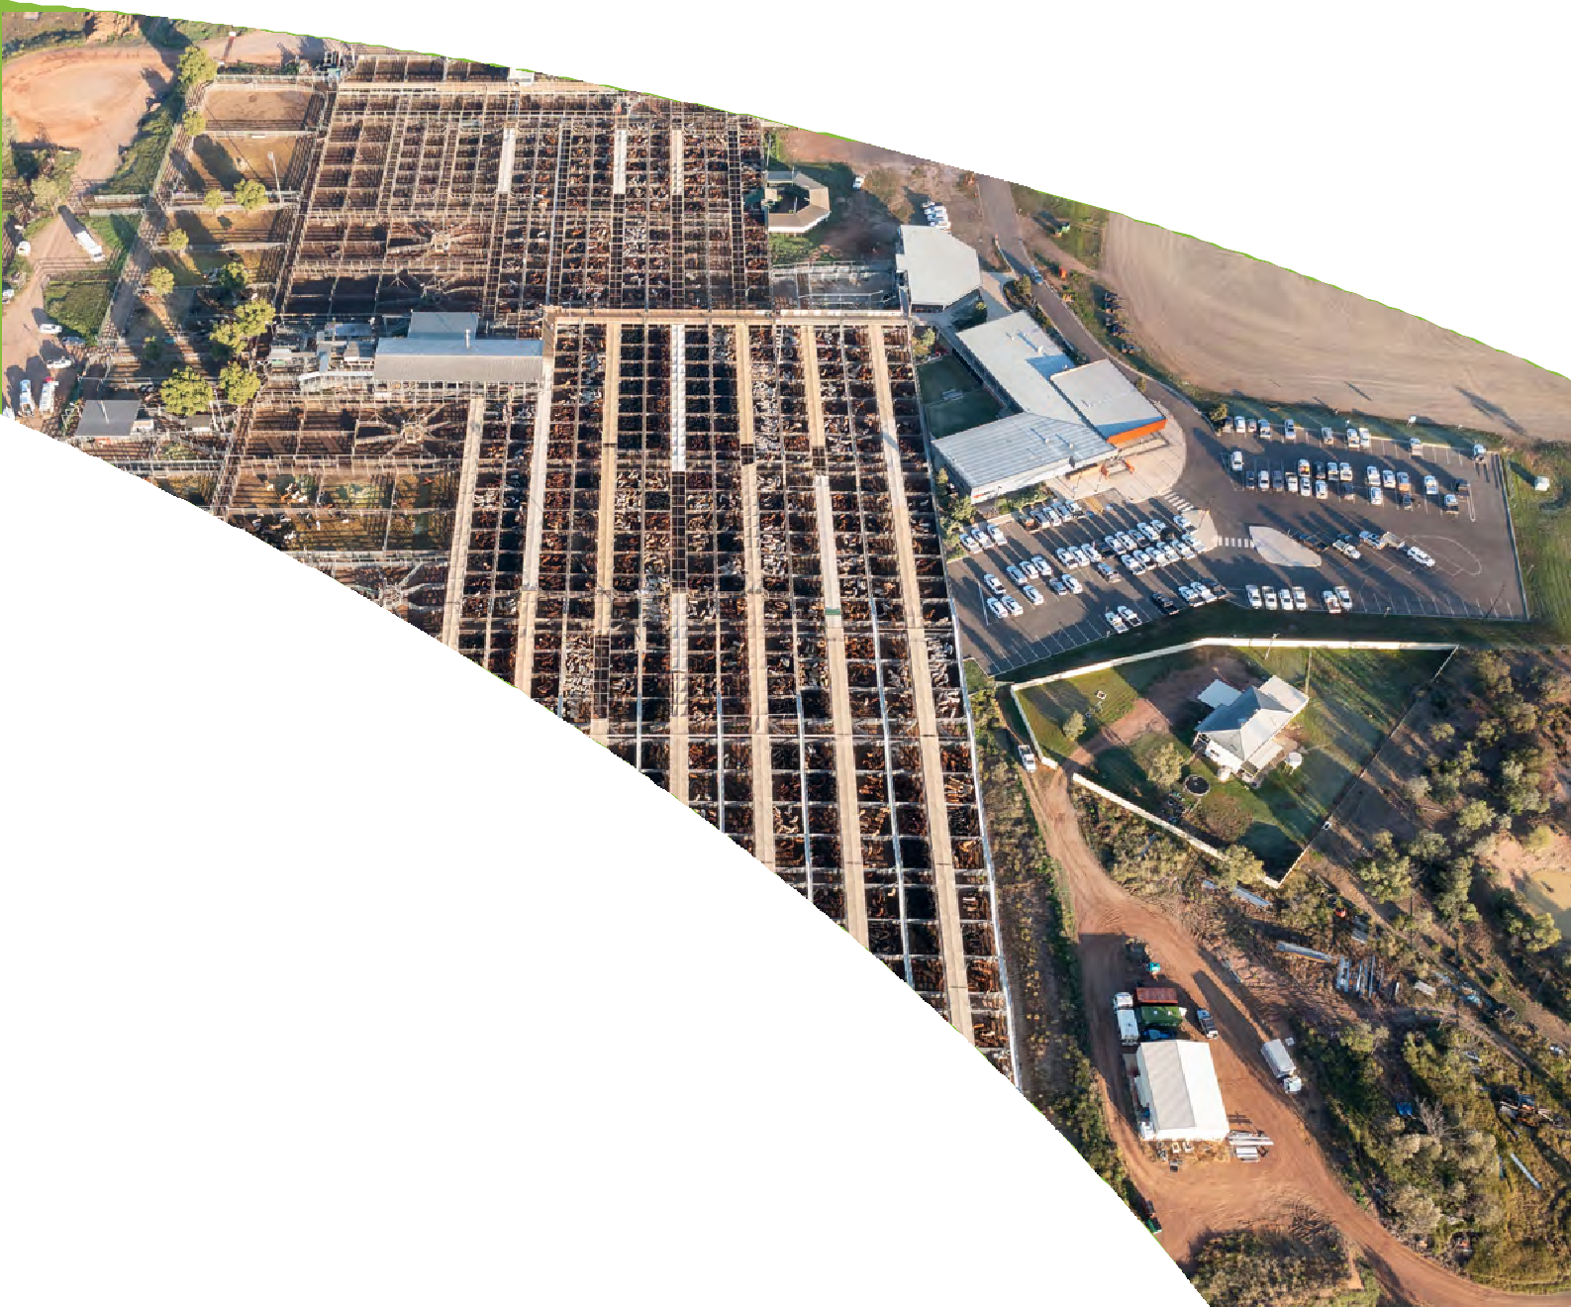
•
;;: : ,,::!
Australian Government
f Agriculture, Fisheries and Forestry

Future Drought Fund

Queensland Government
....,.
Rural Economies
Centre of Excellence

South West Queensland

The South West Queensland Regional Drought Resilience Plan has been developed as a partnership between the Rural Economies Centre of Excellence and the following organisations who will lead implementation of any actions: Regional Development Australia – Darling Downs and South West, Balonne Regional Council, Bulloo Shire Council, Maranoa Regional Council, Murweh Shire Council, Paroo Shire Council and Quilpie Shire Council.
The Regional Drought Resilience Planning program is jointly funded through the Australian Government’s Future Drought Fund and the Queensland Government. Development of the plan has been supported by the Australian Government (Department of Agriculture, Fisheries and Forestry) and the Queensland Government (Department of Agriculture and Fisheries).
While every care has been taken in preparing this publication, neither the Australian Government nor the Queensland Government accepts responsibility for the decisions or actions contained herein, or any decisions or actions taken as a result of any data, information, statement or advice, expressed or implied.
Acknowledgement
We pay our respects to the Aboriginal and Torres Strait Islander ancestors of this land, their spirits and their legacy. The foundations laid by these ancestors – our first Australians – give strength, inspiration and courage to current and future generations, both Indigenous and non-Indigenous, towards creating a better Queensland.
We recognise it is our collective efforts and responsibility
as individuals, communities and governments to ensure equality, recognition and advancement of Aboriginal and Torres Strait Islander Queenslanders across all aspects of society and everyday life.
On behalf of the Queensland Government, we offer a genuine commitment to fearlessly represent, advocate for, and promote, the needs of Aboriginal and Torres Strait Islander Queenslanders with unwavering determination, passion and persistence.
As we reflect on the past and give hope for the future, we walk together on our shared journey to reconciliation where
all Queenslanders are equal.
Contact us
drought@daf.qld.gov.au
Call
13 25 23 (Queensland callers only)
(07) 3404 6999 (outside Queensland)
Monday, Tuesday, Wednesday and Friday: 8am to 5pm Thursday: 9am to 5pm
Post
Department of Agriculture and Fisheries GPO Box 46 Brisbane QLD 4001 Australia
Interpreter statement
The Queensland Government is committed to providing accessible services to Queenslanders from all culturally and linguistically diverse
backgrounds. If you have difficulty in understanding the regional drought resilience plan, you can contact us for assistance and we will arrange an interpreter to effectively communicate the plan to you.
© State of Queensland, 2021
The Queensland Government supports and encourages the dissemination and exchange of its information. The copyright in this publication is licensed under a Creative Commons Attribution 4.0 International (CC BY 4.0) licence. Under this licence you are free, without having to seek our permission, to use this publication in accordance with the licence terms. You must keep intact the copyright notice and attribute the State of Queensland as the source of the publication. For more information on this licence, visit creativecommons.org/licenses/by/4.0/.

The information contained herein is subject to change without notice. The Queensland Government shall not be liable for technical or other errors or omissions contained herein. The reader/user accepts all risks and responsibility for losses, damages, costs and other consequences resulting directly or indirectly from using this information.

Contents
Regional Drought Resilience Plan 2022–2030

Foreword and acknowledgements 2
Introduction 4
How to use this plan 8
Regional profile 10
History of drought in this region 18
Past impacts of drought in this region 20
Likely future impacts (risks) of drought in this region 40
Building drought resilience in our region 46
RDRP conceptual framework 50
Regional Strategy: actions and initiatives 52
Monitoring, evaluation and learning (MEL) 62
References 68

1

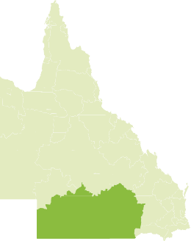
South West Queensland

Foreword and acknowledgements

Regional Development Australia Darling Downs and South West (RDA-DDSW), along with our partner LGAs, proudly acknowledges the Aboriginal peoples and Torres Strait Islander peoples as the Traditional Owners and Custodians of this Country. We recognise and honour their ancient cultures and connection to country and community.
We pay our respect to them, their cultures, and to their Elders, past, present and emerging.

Disruptions and uncertainty in our world have become the norm in our ever-changing environment. Recent climatic events have reinforced the significance of building sustainability and resilience in our communities. Preparedness has never been more important for our communities to continue to thrive. We believe preparation is critical to investment and employment attraction, the wellbeing of our people and the liveability
of our region.
With this plan we aim to strengthen, advance and transform the South West Queensland region during the dry times. This plan has been built through engagement across the region with key stakeholders and the wider community. Their advice and expressions of lived experience, along with the best of resilience, science and practice, have been combined to create this shared plan for the region.

2

Regional Drought Resilience Plan 2022–2030

The South West region and our communities are no strangers to hardship, shocks and natural disasters. Floods, droughts and economic shifts have been regular events throughout our history and have served to create a resilient and adaptable culture. We have always worked together in our community and alongside our neighbours to prepare for and overcome such adversity. Drought has been an especially focused topic for our region, with recent droughts exacting a heavy toll
on many of our rural communities. The Regional Drought Resilience Plan (RDRP) for the South West acknowledges the potential for longer, hotter, and drier seasons and the need to proactively nurture resilience to drought – economically, socially, and environmentally.
The South West RDRP has been developed through
a partnership between RDA-DDSW and the following local government areas: Balonne Regional Council, Bulloo Shire Council, Maranoa Regional Council, Murweh Shire Council, Paroo Shire Council and Quilpie Shire Council. Our local governments are connected by history and commerce,
as well as their wealth of social capital. This plan further illustrates our shared values and partnership.
The South West region is a unique and diverse area that extends over 320,000 square kilometres and includes the townships of Cunnamulla, Charleville, Quilpie, Roma, St George and Thargomindah. While traditionally known for its livestock production, the region also boasts horticulture, broad acre cereal cropping and meat processing (beef, lamb and
goat meat).
Our region’s ability to deliver and utilise significant private and public investment includes the iconic Warrego highway connecting the largest saleyards in Australia at Roma, transporting over $500 million in agricultural value, producing over $1 billion dollars in resources and carrying a burgeoning tourist industry to some of Australia’s most pristine outback
landscapes. We are a remote outback region that extends to the far western border with both traditional and renewable energy generation, exhibiting an unparalleled diversity on the national landscape. A reliable and consistent supply of artesian water, along with building resilience to drought, is critical to our future.
The immense potential of our region is inspiring. We share a future vision where our region is proud of its vibrant economy and enabling infrastructure, its strong and resilient community, and its stunning natural landscapes.
We are committed to working collaboratively with the Department of Agriculture and Fisheries, other tiers of government, and our industry and community partners in the development and implementation of this Regional Drought Resilience Plan.
We thank the people, partners and organisations who have invested time and knowledge in contributing to development of this plan. Their support of our region and its resilience is what paves the way forward to our shared future, and a vibrant thriving legacy for future generations.

Fiona Gaske
Chair
Regional Development Australia – Darling Downs and South West

Regional Drought Resilience Planning
South West Queensland
Introduction
Australia, and particularly the State of Queensland, is no stranger to drought. First Nations traditional stories of drought go back thousands of years and European settlers have officially recorded drought in Australia since the late 1700s. Droughts have been officially ‘declared’ in Queensland since 1897.1
The economic, social and environmental costs of drought in Queensland are immeasurable. The toll taken on regions and their communities is high and the impacts often linger for decades. So, in recent years there has been a growing emphasis on the importance of drought resilience planning. This means planning now for the next drought and considering how to do things better or differently to make our communities more resilient.

Alignment with the Queensland Strategy for Disaster Resilience and Regional Resilience Strategies
Queensland is the most disaster impacted state in Australia, and Queenslanders are susceptible to a variety of hazards. We are facing unprecedented change in both our current and future operating environment with a dynamic political, social, economic and policy landscape surrounding disaster risk reduction and resilience. This is being amplified by natural
hazards becoming more frequent and intense due to a changing climate.
The Queensland Strategy for Disaster Resilience 2022–2027 (QSDR) promotes a systems approach to resilience that connects with a range of agencies and sectors to deliver improved outcomes for Queensland.
Queensland’s suite of Regional Resilience Strategies ensure every region across Queensland is now part of a locally-led, regionally-coordinated and state-facilitated blueprint to strengthen disaster resilience.

It is often agreed that resilience planning for disasters and resilience planning for drought should be aligned. The Queensland RDRP program builds on the work completed under the QSDR, led by the Queensland Reconstruction Authority (QRA). The RDRP program provides the opportunity to have a clear focus on drought risk in the context of regional resilience, addressing the unique challenges it poses and the need for setting out drought-specific priorities and actions at a regional and local level.

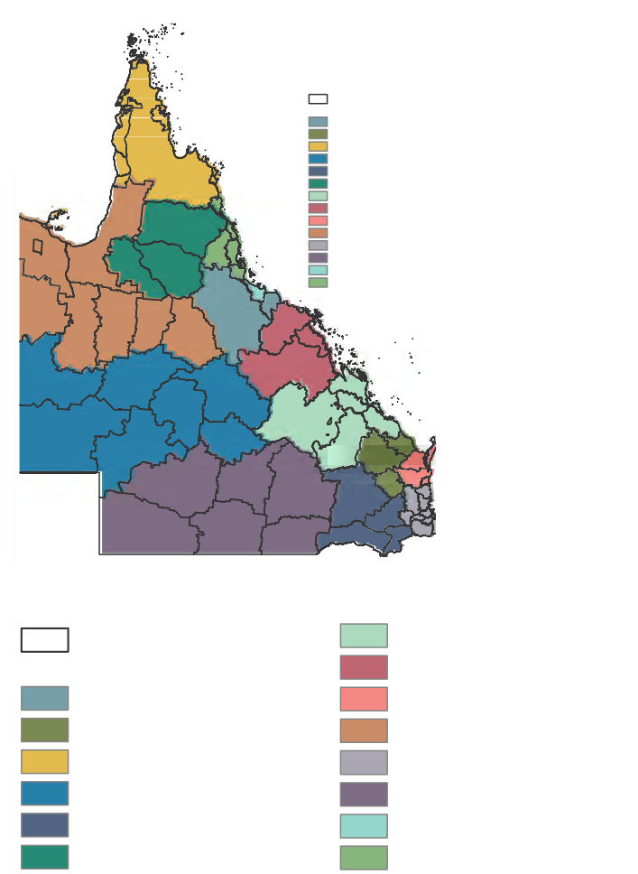
Figure 1: Queensland’s Regional Resilience Strategies (Regions and Local Government Areas), Queensland Strategy for Disaster Resilience 2022–2027. Source: Queensland Reconstruction Authority.
Legend
Local Government Areas
Resilience Strategy Regions
Burdekin and Charters Towers Region
Fitzroy and Capricornia Region Mackay, Isaac and Whitsunday Region
Mary Region
Burnett Region North West Region

Cape York and Torres Strait Region South East Region

Central West Region South West Region

Darling Downs Region Townsville and Palm Island Region

Far North Hinterland to Gulf Region Wet Tropics Region

Legend

Local Government Areas
Resilience Strategy Regions
Burdekin and Charters Towers Region Burnett Region
Cape York and Torres Strait Region Central West Region
Darling Downs Region

Far North Hinterland to Gulf Region Fitzroy and Capricornia Region Mackay, Isaac and Whitsunday Region Mary Region
North West Region South East Region South West Region
Townsville and Palm Island Region Wet Tropics Region

Regional planning and approach
Regional Drought Resilience Plan 2022–2030
This plan was developed and produced through a collaborative partnership between DAF, RECoE, QRA, Regional Development Australia – Darling Downs and South West, and its member LGAs, the local facilitator (Julia Spicer), local advisor (Andrew Drysdale) and key regional, community and industry partners and stakeholders. The regional engagement model was developed from earlier work undertaken by RECoE, Red Cross Queensland2, the Queensland Reconstruction Authority (QRA)3, and was informed by international best practice from the World Bank and the UNDRR4, as well as recent work by CSIRO.5
The plan has been reviewed by an independent assessor appointed by the Australian Government, and their feedback has been incorporated in the final plan.
The plan was co-designed with local stakeholders, using an approach that emphasised: initial trust-building; building on existing networks; local co-design of process; commitment and agreement; risk-informed adaptation of processes; place-based and regional strategies; locally led and coordinated solutions and integrated multi-objective responses. The approach was sensitive to the high levels of well-recognised ‘engagement fatigue’ in many of the drought-affected communities of
the region; large physical distances between key locations; constraints on time for all stakeholders and participants and maximising opportunities to ‘piggyback’ with important regional events. Hence the plan was developed through practical and effective processes that maximised active participation, recognised and respected a diverse range
of knowledge, values and views, and above all, were ethical and fair.

Regional engagement process
The RDRP engagement process was reiterative and involved
a systems approach that highlighted local voices and ownership and encouraged people to describe important information in their own words. It also combined both subjective and objective perspectives by using local, traditional (including First Nations) as well as ‘scientific’ knowledge.
The plan was co-designed with a wide range of local partners and stakeholders that included: agricultural businesses and associations; RDA members; NRM groups; First Nations groups and elders; QLD state government agencies; QFES; local government (councils, mayors, staff and groups); CSOs, NFPs and charities; local (town) businesses; educational providers; young people; health providers; banks and finance advisers; religious leaders; and consultants and advisers.

Key principles and concepts: drought and resilience
Whilst there is no universally accepted definition of drought,
in Australia, the Bureau of Meteorology (BOM) states, “drought, in general, means acute water shortage”.6
In Queensland, drought is ‘declared’ for a local drought area and/or individual properties. Local drought areas are drought declared “when the rainfall recorded during the previous
12 months (minimum) is in the lowest (or driest) decile or below the 10th percentile when compared to the long-term historical rainfall”.7 This is the technical definition of drought utilised
in this plan.
‘Resilience’ is harder to define. The World Bank has defined resilience as the ability “… to anticipate, absorb, accommodate or recover from the effects of a hazardous event in a timely
and efficient manner” .8

South West Queensland

Australia’s CSIRO perhaps more specifically states:

“drought resilience will result in a regional Australia that can endure deeper,
longer droughts, and recover from them sooner. This will allow our food and agribusinesses to boost national farm income, increase food security, and protect the regional jobs that rely on agriculture. It will increase the resilience of rural and regional communities that depend on agriculture and improve environmental outcomes”.9
This plan utilises drought resilience objectives that broadly align with the four key objectives underpinning the Queensland Strategy for Disaster Resilience.
Figure 2: Four key objectives of the Queensland Strategy for Disaster Resilience 2022–2027. Source: Queensland Reconstruction Authority.
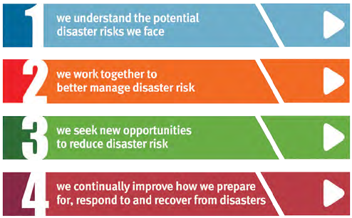

Experience from earlier works on resilience has highlighted the crucial importance of community and regional resilience, sometimes referred to as ‘societal’ resilience. For instance,
work by QRA has revealed that community stakeholders report that their ‘societal resilience’ is significantly affected by chronic and enduring stresses (long-term megatrends such as ageing populations, fluctuating commodity prices), periodic stresses (such as drought) that are often cyclical, acute shocks (such
as rapid-onset disasters), cumulative shocks (often a rapid succession of shocks or the increased impacts of the combined stresses and shocks).

Introduction Regional Drought Resilience Plan 2022–2030

Figure 3: How resilience is affected by stresses and shocks. Source: Queensland Reconstruction Authority.
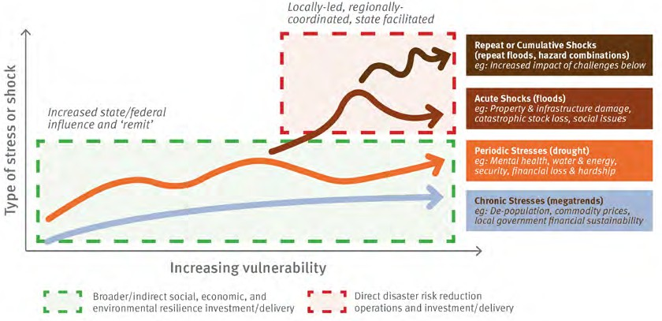

Whilst drought has been often referred to as “an enduring feature of the Australian landscape”, when viewed in this context of community resilience, drought is also understood as a periodic stress that comes and goes. However, it is now evident that the warming caused by climate change has added to the variability in Queensland’s weather and “increased the
e
n
t
severity of drought conditions during periods of below-average rainfall”.10
p
l
e
,
c
u
l
t
u
Importantly, our approach and engagement processes encouraged community and regional stakeholders to express their own observations of ‘drought’ and ‘resilience’. We have combined the ‘local’ with ‘outside’ definitions to produce the regional understanding that underpins this plan and identifies drought impacts, risks and pathways to resilience.
t
n
e
m
n
o
r
i
v
n
e
l
a
r
u
t
a
n
d
n
a
e
p
a
c
s
d
n
a
L
P
e
o
y
m
o
n
o
c
E
Figure 4: Queensland RDRP elements of drought resilience.
Source: Queensland Regional Drought Resilience Planning.
r

r
Drought impacts
t
e
s
m
a
i
l
i
t
I
a
e
n
i
t
f
n
i
r
o
a
c
o
s
e
t
r
n
n
u
c
t
u
r
e
a
n
d
b
u
i
l
t
e
n
v
i
r
o
n
m
r
e
a
n
d
c
o
m
m
A
T
u
D
r
n
i
r
d
a
t
y
o
n
u
a
g
s
h
f
p
t
o

South West Queensland
How to use this plan

The purpose of the plan
The South West Queensland Regional Drought Resilience Plan (RDRP) has been developed in accordance with the guidelines distributed by the Australian Government’s Future Drought Fund (FDF) program. It also has been shaped by the inputs from key stakeholders along with the voices and experiences of the region’s people.
Accordingly, the purpose of this RDRP is to contribute towards the following objectives:
- Growing the self-reliance and performance (productivity and profitability) of the agricultural sector.
- Improving the natural capital of the agricultural landscape for better environmental outcomes.
- Strengthen the wellbeing and social capital of rural, regional and remote communities.
- Specify key actions (regional and local) that can be implemented to build drought resilience in the region.
The RDRP process is intended to be practical, implementable and ongoing. As the region undertakes the specified actions, this plan will assist with monitoring progress and future learning.

Key inputs
Regional Drought Resilience Plan 2022–2030
This plan draws from, complements and builds upon many important works, such as:
- Queensland Strategy for Disaster Resilience
- Resilient Queensland
- Darling Downs Regional Resilience Strategy
- South Queensland Landscapes NRM Strategy
- Murray Darling Basin Plan and associated documents
- Rural and Remote Health and Wellbeing Strategy 2022–2027 (Queensland Government)
- University of Canberra Wellbeing Survey 2013–20
- Native Fish Management and Recovery Strategy
- Drought Resilience, Adaptation and Management Policy Framework 2018
- Infrastructure Australia’s Regional Strengths and Infrastructure Gaps Regional Analysis Queensland Report 2022
- Stocktake of Megatrends Shaping Australian Agriculture (ABARES 2021)
- State Heatwave Risk Assessment (Queensland Government)
- Australian Government Natural Resource Management Monitoring, Evaluation, Reporting and Improvement Framework Guidelines.
The most critical input was gained from talking to a cross section of individuals and organisational representatives from across the South West Queensland region.

Other important linkages
It is the intention of this Plan that it is considered and factored into a range of other strategies and plans – including (but not limited to) the following list. We also hope it will be closely considered by charities; non-government organisations;
not-for-profits; businesses; and government agencies with an interest in the region.
- regional plans
- regional economic development strategies
- regional transport and infrastructure plans
- natural resource management plans
- water resource plans
- local and district disaster management plans
- local asset management and capital works plans
- local corporate and community development plans
- land use planning schemes
- local and regional health strategies.

South West Queensland
Regional profile

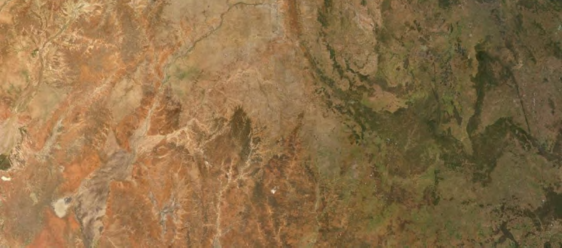
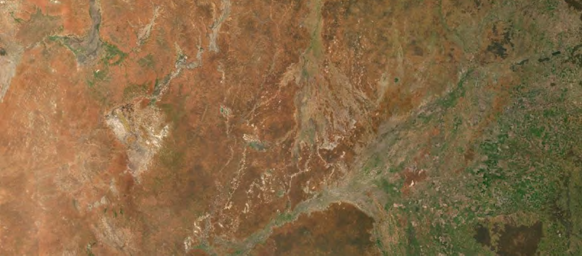
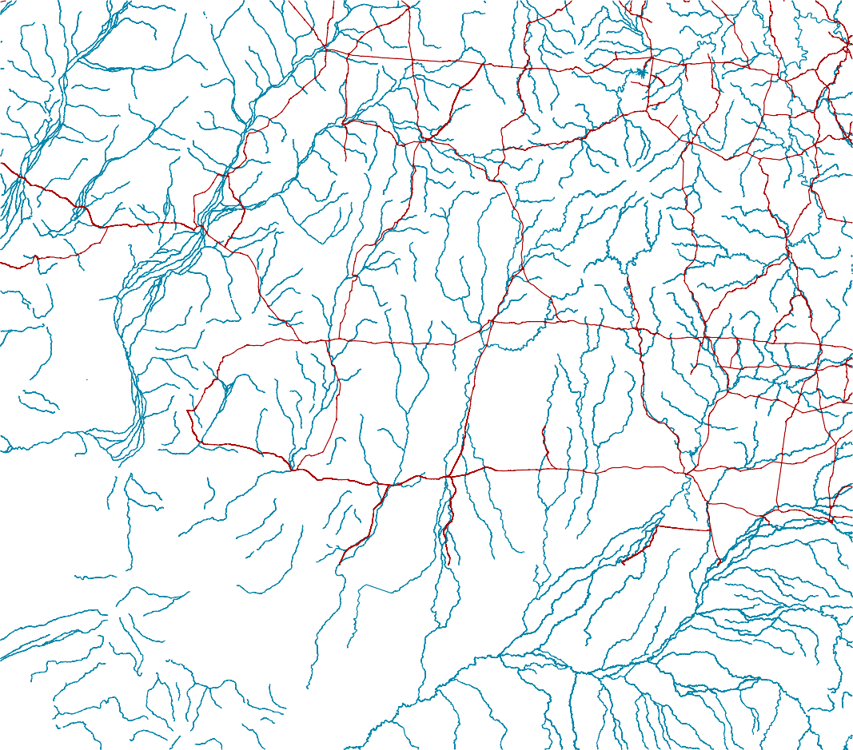
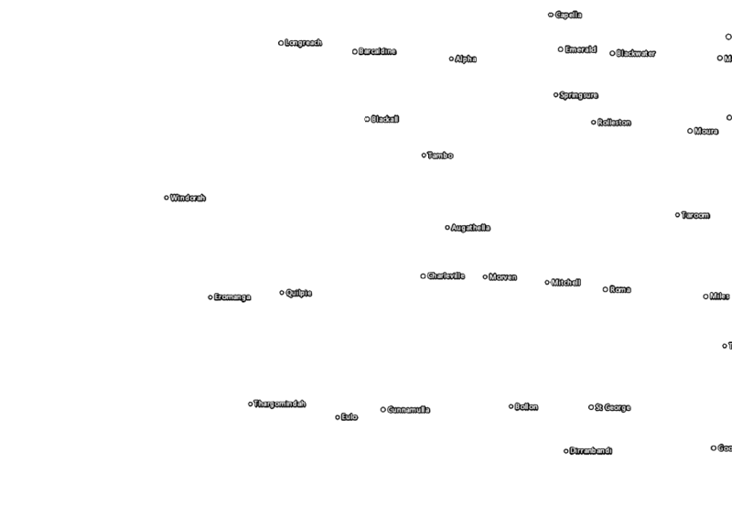
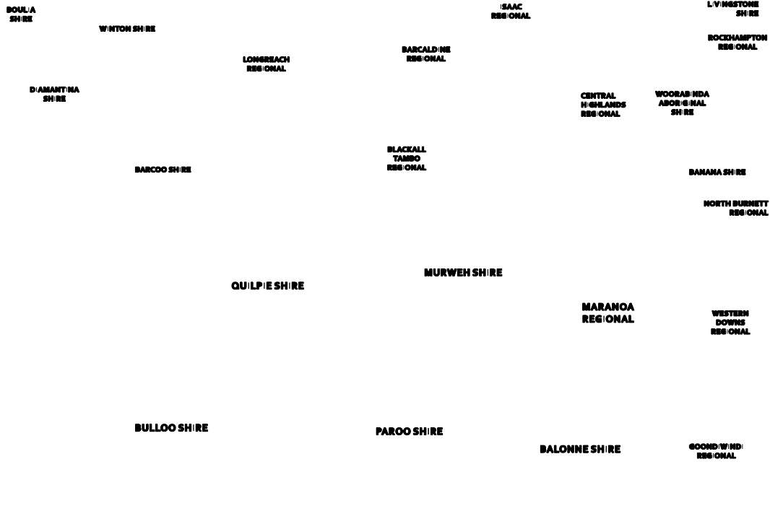
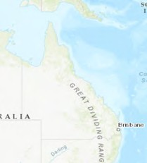
Figure 5: South West Queensland regional map. Source: Department of Agriculture and Fisheries, Queensland Government.
BOULIA
SHIRE
ISAAC
REGIONAL
LIVINGSTONE
SHIRE
WINTON SHIRE
ROCKHAMPTON
LONGREACH
REGIONAL
BARCALDINE
REGIONAL
REGIONAL
¹
DIAMANTINA
SHIRE
CENTRAL
HIGHLANDS REGIONAL
WOORABINDA
ABORIGINAL SHIRE
South West Region
Cities and Towns
Major Roads in Queensland Major Watercourses Queensland Dams and Lakes Region Boundary
Local Government Areas
BARCOO SHIRE
BLACKALL
TAMBO REGIONAL
BANANA SHIRE
NORTH BURNETT
REGIONAL
MURWEH SHIRE
QUILPIE SHIRE
MARANOA
REGIONAL
WESTERN
DOWNS REGIONAL
BULLOO SHIRE
PAROO SHIRE
BALONNE SHIRE
GOONDIWINDI
REGIONAL
1:3,500,000
at A3
0 20 40 80 120 160
Km

© State of Queensland (Department of Resources) 2021, Earthstar Geographics, Esri, HERE, Garmin, FAO, NOAA, USGS
© The State of Queensland 2022

COORDINATE SYSTEM:
PROJECTION: Mercator Auxiliary Sphere HORIZONTAL DATUM: WGS 1984

MAP PRODUCTION
26 April 2022
Produced by the Natural Assets Policy and Planning GIS team from information provided by officers of DAF and other Queensland Government agencies.

DISCLAIMER: This map is compiled from information supplied to the Department of Agriculture and Fisheries (DAF). Whilst all care is taken in the preparation of this map, neither DAF nor its officers or staff accept any responsibility for any loss or damage which may result from inaccuracy or omission in the map from the use of the information contained therein.

RDRP_20220426 (HoolihD)

Regional Drought Resilience Plan 2022–2030

Figure 6: Regional socioeconomic profile.

Balonne
Bulloo
Maranoa
Murweh
Paroo
Quilpie Queensland

Population Australian Digital Inclusion Index

4,286

4,150
322

1,544

4,476,778
Insufficient sample
67%
66%

65%

71%

Projected population as at 30/06/2041
4.9%

8.6%
12,944

553
65%

66%
12,706

769

Unemployment rate

3,808

3,597
291

1,083

7,161,661
6.2%

5.6%
8.4%

8.5%

5.5%

Median age
SEIFA 2016 Socio Economic Index of Social Disadvantage

38.7 yrs

38.9 yrs
44.3 yrs

42.4 yrs

36.4 yrs
973

943
1,003

891

996

% Aboriginal or Torres Strait Islander Peoples
2,539

207
7.2%

16.5%
996

962
37.1 yrs

39.4 yrs

Number of local businesses

15.9%

12.7%
11.6%

27.9%

4.0%
905

653
43

262

460,807

% people who speak a language other than English at home
4.2%

4.6%
4.0%

1.5%
Population that need assistance due to disability

3.4%

4.5%
2.5%

1.7%

12%
4.4%

4.6%
2.0%

5.6%

5.2%

Median total personal income
$/year

Protected area (km2)

$47,545

$48,358
$67,844

$41,902
$55,246
$50,901
$46,020
741 km2

839 km2
3,205 km2

736 km2
4,186 km2

1,416 km2

130,322
km2

Source: Australian Bureau of Statistics – Data by region.

Figure 7: Bioregions of South West Queensland. Source: Department of Environment and Science, Queensland Government.
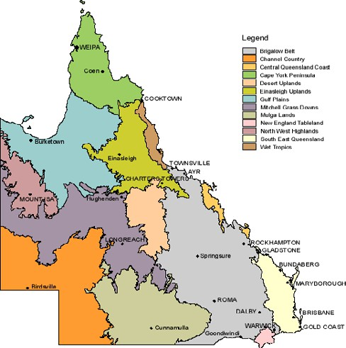

What makes the South West Queensland region unique?
The First Nations history of the South-West Queensland region is as rich as it is diverse. The region is crisscrossed by traditional trading routes and story lines. Many of the region’s
major roads and highways now follow these trading routes. The South West forms the Country of the Wangkumarra, Bidjara, Boonthamurra, Kunja, Mardigan, Budjiti, Kooma and Kullilli Aboriginal Traditional Owner groups and there are three major languages which continue to be spoken by people across the region.11 The First Nations history and strong connection to Country in the region has led to the development of the popular South West Queensland Indigenous Cultural Trail.12 In 1845, Thomas Mitchell navigated the upper reaches of the Warrego River in the eastern part of the region, and tales of Burke and Wills’ fateful journey inspired others to explore. After William Landsborough’s exploration in 1862 the area began to open
up with pastoral runs. Discovery and development of artesian
water led to rapid agricultural development and by 1890s the region was serviced by regular Cobb & Co coach runs from the coast. QANTAS – Australia’s national airline – began its flights from Charleville in 1922.
These days, the South West Queensland region is often referred to as the ‘Cornerstone’ of Queensland. The region’s area is 319,808km² – almost one fifth of the area of the state – and is home to 23,777 residents (ABS 2021). This population density of 0.074 people per km², makes it one of the least populated areas in Queensland. It comprises the Local Government Areas of Maranoa Region, Murweh, Shire of Balonne, Shire of Paroo, Shire of Bulloo and Shire of Quilpie. The region is noted for its beef, sheep meat and wool grazing, extensive farming, opal mining and oil and gas deposits with regional tourism also growing as an important industry. Roma Cattle saleyards are the largest in the country. This part of the state is well serviced
for transport with “over 3,000kms of sealed roads”, six ‘principal airports’, and significant road connections to SA, NT and NSW (SQROC, 2021).
With over $2.7b Gross Regional Product (SWQROC,2021) regional employment is largely derived from agriculture, mining/gas and health care. Employment in Agriculture (and agricultural supply-chain) businesses ranges from 18–35% of total local employment. ‘Public Health and
Administration Services’ accounts for approximately 10% and 9% of employment respectively. Mining, despite large income streams, creates relatively few local jobs (2.7–3%). Despite early predictions of a regional “jobs boom” from gas production,
the Maranoa LGA has seen a 10% reduction of gas-related employment 2011–2016 and, on average, the industry further cut 10.5% of jobs in 2019. Even with recent media of new gas projects, agriculture remains the most consistent employer in the region. Whilst the SWQ regional economy is still so heavily reliant on agriculture, rainfall, drought and seasonal conditions, along with market fluctuations, all have a significant impact.
The region’s climate ranges from arid to semi-arid and has average annual daily temperatures range from 13.5°C to 29.1°C. Temperatures are known to be variable (49 °C recorded in Thargomindah and -5 °C recorded in Charleville). The region also has highly variable rainfall (500mm in the eastern zones, down to 150mm in the west). This is reflected in the large transition zone from farming to extensive animal production

Figure 8: Regional employment by category 2021. Source: economy.id.com.au (2022).

45

40

35

30

25
(%)

20

15

10

5

0

Balonne Bulloo Maranoa Murweh Paroo
Quilpie

Agriculture Mining Goods Related Household
Services
Public Admin Other

systems. Whilst contemporary farming systems allow for cropping to occur on less rainfall, there is very little farming occurring west of the Maranoa and Balonne rivers. An exception is some irrigated small crop enterprises around Cunnamulla.
The majority of irrigation occurs along the Balonne River with Cubbie Station, south of Dirranbandi, being one of the largest cotton farms in Australia. The only major water infrastructure in the region is the Beardmore Dam, upstream from St George. The Bulloo River system is the only closed river system in Australia.13
The South West contains three bioregions (Figure 7) – the Brigalow, the Mulga Lands and the Channel Country – and these different bioregions support different land uses. The eastern portion of the SWQ region largely sits in the fertile Brigalow bioregion that been extensively developed for farming and beef production on buffel grass pastures. The gas industry is also prominent in the northeastern zone of this area. The middle portion of the region, known as the Mulga Lands, has less fertile soils but extensive areas of mulga that is harvested for fodder
in both good and dry times. However, declining viability of properties in this bioregion – a result of small property sizes and land degradation caused by an over reliance on mulga as a fodder source – has seen property amalgamations and the exit of some producers. The western portion sits in the iconic Channel Country with its unique landscape of intertwining creeks, supporting large beef enterprises as well as oil and gas reserves. Channel floods, resulting from good rain in the head waters, have often provided relief from drought conditions
in the lower reaches of the Bulloo and Cooper Creek systems without significant (or any) rain falling in the area.
As can be seen from figures 9 and 10, the Gross Value of Products (GVP) from agriculture in the South West is significant, with ‘livestock disposals’ and ‘crops’ yielding the highest percentage of returns. The region boasts that it produces
“half of Queensland’s wool, sheep and lambs” and “a fifth of Queensland’s cereal crops”.

Figures 9 and 10: Queensland Department of Agriculture and Forestry forecasts for agricultural production (excluding forestry and fisheries) and Australian Bureau of Statistics 2015/2016 data at the Statistical Area 2 level to estimate the gross value of production (GVP) for Queensland’s regions. The value is attributed to production of businesses that have their postal address in the region. They may have other production units outside the region.

Figures 9: LGA Local Value of Product 2020–2021

$450,000,000

$400,000,000

$350,000,000

$300,000,000

$250,000,000

$200,000,000

$150,000,000

$100,000,000

$50,000,000

$0

Balonne Bulloo Maranoa Murweh Paroo Quilpie

Crops Fruits & nuts Nurseries Livestock
disposals
Livestock products
Vegetables

Figures 10: Regional Gross Value of Production 2020–2021

$900,000,000

$800,000,000

$700,000,000

$600,000,000

$500,000,000

$400,000,000

$300,000,000

$200,000,000

$100,000,000

$0

Crops Fruits & nuts Nurseries Livestock
disposals
Livestock products
Vegetables

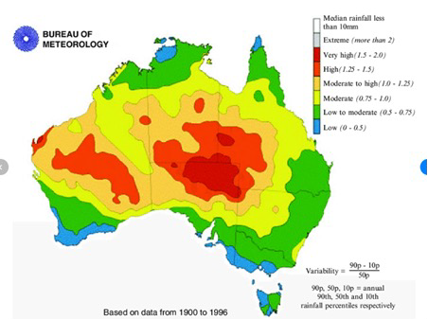
Figure 11: Annual Rainfall Variation. Source: Bureau of Meteorology.

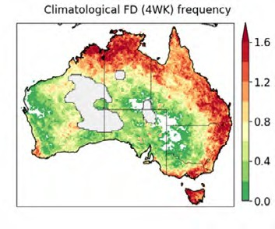
The predominance of agriculture (and agricultural supply-chain industries) as a major source of income and employment, makes the region highly vulnerable to the impacts of unseasonal dry periods and droughts. The records for the region indicate that the South West Queensland region is one of the most likely regions in Australia to experience both prolonged droughts
and flash droughts in the eastern portion of the region. Whilst prolonged droughts can last as long as 12–13 years (e.g. the ‘Millennium Drought’), a flash drought typically lasts for as little as a month or as long as six months. The western portion of the region has some of the most variable rainfall in the country.14
Figure 12: Annual Frequency of Flash Droughts. Source: Northern Australia Climate Program.

Figure 13 shows the climatic conditions and soil and plant responses to those conditions which cause a flash drought. Blue arrows from the surface indicate evapotranspiration and the red arrows indicate heat. The larger the arrow the bigger the flux from the surface to the lower atmosphere.
Figure 13: Climatic Conditions and soil and plant responses which cause flash droughts. Source: Earth Systems and Climate Change Hub, National Environmental Science Program.

Low precipitation

Low evaporative demand
Clear skies and more sunshine
Heating from surface moderated by soil moisture
availability
Dry lower atmosphere

High evaporative demand

Dry and hot surface conditions + lack of soil moisture
devastate crops

Lack of precipitation cuts off moisture supply
Extreme heat increases evapo- transpiration

Soil moisture depletes rapidly

Low evapo- transpiration

Increase in heating from the surface

Figure 14: South West Queensland regional 2000–2021 rainfall compared to 1888–2021 average. Source: Long Paddock – (AussieGrass), Queensland Government.

1,200

1,000
Annual Total Rainfall (mm)

800

600

400

200

0
2000
2001
2002
2003
2004
2005
2006
2007
2008
2009
2010
2011
2012
2013
2014
2015
2016
2017
2018
2019
2020
2021
Balonne Bulloo Maranoa Murweh Paroo Quilpie

Year
1888–2021

South West Queensland
History of drought in this region

The rivers and creeks of the region were important in sustaining the lives of First Nations people in the past and still play an important role in maintaining cultural links to country for existing First Nations people. As with most of Australia, there is a strong link between water – the waterways, waterholes and the patterns of rain and flood on Country – in this region and the cultural history and practices of the Aboriginal/First Nations people. The eastern part of the region was first settled in the mid
to late 1860s and the impacts of droughts (due to the reliance on surface water) restricted early pastoralism. It wasn’t until artesian bore water was discovered (1887 at Cunnamulla) that pastoralism was fully established along with many of the communities.15
Evaporation significantly exceeds precipitation throughout the region.16 Droughts have occurred regularly and floods play a major role in maintaining the ecosystems of the major river systems, particularly in the Channel Country. However, these
conditions are predicted to be more variable in intensity and to occur more frequently under future climate change forecasts.
Weather and climate characteristics in the Balonne sub-basin in the last 30 years (1989–2018):
- Annual rainfall has been relatively stable, with summer rainfall being reliable, and rainfall in winter decreasing. The region averages an annual rainfall of 550mm over the past 30 years (1989–2018) however, average annual rainfall does fluctuate from year to year with natural variability.
- Dry years have occurred 10 times and wet years have occurred eight times. It is noted that the Millennium drought accounted for three of these dry years. Hot days have become more frequent with more consecutive days above 38°C.

- Summer rainfall (November to March) in St George has decreased by 17mm from the 308mm experienced between 1959–1988 to 291mm during the period between 1989–2018. Spring frosts have also become
more common and have been occurring later. More frosty nights have tended to occur during through dry winter and springs, when soil moisture is low and cloud cover
is infrequent.
Weather and climate characteristics in the Bulloo, Paroo and Warrego River catchments in the last 30 years (1989–2018):
- The South West has averaged around 400mm of rainfall per year in both the past 30 years (1989–2018) and previous 30 years (1959–1988) around Charleville and Thargomindah. Summer rainfall is noted to be more reliable than other seasons however, rainfall is unreliable across all seasons from year to year.
- Rainfall around the north-east of the region near Charleville has received moderately reliable rainfall in summer which is in contrast to winter and spring. This is particularly relevant to the south-west of the region. Winter and spring rainfall averages for Quilpie and
Thargomindah are decreasing but are offset by increases in summer monthly rainfall averages.
- Dry years have occurred eight times and wet years have occurred 10 times with the remaining years in the average range. It is noted that four of these years were during the Millennium drought years.
- Hot days have become more frequent with more consecutive days above 42°C with Thargomindah experiencing an average of 11 days above this temperature between 1989–2018.
(Data extracted from Longpaddock – AussieGrass)

Figure 15: Percentage of time drought declared since 1964 as of 1 June 2022. Source: Long Paddock.
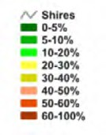
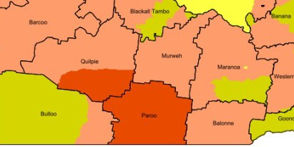
Note: the map reflects partial shire declaration and changes of local government area. The map may not represent "current" drought declaration procedure and policy.

People, culture and community
Having strong, ‘healthy’ and ‘vital’ communities is central to building drought resilience in regional Queensland.
The strength and health of the economy and landscape is intrinsically linked to that of the people and their communities. Community feedback, government reports and statistical evidence all point to a decline in the health and vitality of people and their communities during times of drought.
In a 2012 report (2012) to the Murray-Darling Basin Authority,
ABARES proposed the following framework as a useful way
to understand community drought vulnerability – and drought resilience.

Figure 16: Drought Vulnerability Framework. Source: Allen Consulting Group 2005, based on Schröter & ATEAM consortium 2004.

Exposure

Sensitivity

The exposure is the level of stress or change that may be faced by a community (such as a drought) and their sensitivity relates to their dependence on the factor that is changing (e.g. rainfall or water supplies) – these combined determine the
level of impact. However, the community’s adaptive capacity or resilience can mitigate some of the impacts and hence reduce their level of vulnerability. Community feedback, government reports and statistical evidence all suggest the ‘vitality’ of the community is a critical factor in their capacity for local drought resilience.
Whilst there is no definitive list of the factors that contribute to ‘Community Vitality’, there is general consensus that it includes such indicators as: growth/decline in population; availability/diversity of local employment; ‘connectedness’ and participation in community groups/events; access to knowledge, ideas and advice; evidence of community ‘pride; community health (physical/mental); local investment;
availability of affordable housing; ‘livability’ and ‘local amenity’; community governance and leadership’; cultural identity; subjective levels of ‘wellbeing’; and levels of security crime
and conflict. The McConnell Foundation (2017) summarises community vitality as: “Creative Placemaking; Fostering ‘Local’; Future Readiness; Active Lifestyles and Civic Engagement”.17

South West Queensland
Past impacts of drought in this region

Potential impact

Adaptive capacity

Vulnerability

All of these factors affect the ‘adaptive capacity’ of communities and hence their drought resilience. Many of these factors were
Figure 17: Annual population change 2001–2021. Source: economy. id.com.au (2022).

highlighted through our review of outside ‘expert’ knowledge (data and reports) and through our engagement in the region (interviews, meetings and comments). Some may be considered ‘chronic stresses’ that increase the impacts of drought, and
in turn, there is clear evidence that drought has had a negative effect on many of these factors. Hence, strong action should be taken to address factors and build drought resilience
for the future.
Broad findings from the Regional Wellbeing Survey 18 undertaken for the MDBA19 (Schirmer et al, 2019), revealed, that for Murray-Darling Basin communities (including South West Queensland), the top issues that had a negative impact
on their “wellbeing or quality of life” were: poor quality services and infrastructure (13%); the negative impacts of drought (13%); poor quality governance and institutions (12%); high
5.0

0.0

-5.0

-10.0
(%)

-15.0

-20.0

-25.0

-30.0

-35.0
Balonne Bulloo Maranoa Murweh Paroo
Quilpie

cost of living (12%); poor work conditions and employment opportunities outside agriculture (8%); anti-social behavior, security and safety (7%), lack of social connection (5%);
and poor work conditions in agriculture/farming (5%). Our engagements in this region clearly support the suggestion that these issues were exacerbated during periods of drought.
During the most recent drought, population figures in the SWQ region, have declined – however, it is not possible to directly attribute these figures to the impacts and effects of drought.
It should also be noted that whilst the percentages of population decline may look high it must also be noted
(as mentioned earlier) that the region is very sparsely populated – so identified declines of even small numbers of individuals can show as relatively high when portrayed as percentages.
The South West Queensland region has been drought-declared for 19 years of the twenty years from 2001–2021. In this time the population of the region has fallen from 15–30%
in various LGAs. Only Maranoa has experienced an overall rise in population during this period – the Maranoa region received a small increase in residents due to the number of gas-related projects in the area. Whilst there is no official data that can attribute this population decline specifically to drought… anecdotally, people consistently say that the impacts
of drought made people leave.

“It’s hard to say exactly why people left during the drought… but they did.”

Community member

Figure 18: Estimated resident population by LGA – South West Region and Queensland. Source: ABS 3218.0 Regional Population Growth, Australia.

Custom region / LGA / State | As at 30 June |  |  |  |  | Average annual growth rate
 | 2001 | 2006 | 2011 | 2016 | 2021p | 2001–2021p | 2016–2021p
 | Number |  |  |  |  | %
South west region | 26,485 | 25,441 | 26,392 | 24,622 | 23,777 | -0.5 | -0.7
Balonne (S) | 5,473 | 4,754 | 4,862 | 4,461 | 4,286 | -1.2 | -0.8
Bulloo (S) | 450 | 380 | 418 | 356 | 322 | -1.7 | -2.0
Maranoa (R) | 12,368 | 12,612 | 13,437 | 12,926 | 12,706 | 0.1 | -0.3
Murweh (S) | 4,936 | 4,692 | 4,731 | 4,386 | 4,150 | -0.9 | -1.1
Paroo (S) | 2,172 | 1,991 | 1,937 | 1,668 | 1,544 | -1.7 | -1.5
Quilpie (S) | 1,086 | 1,012 | 1,007 | 825 | 769 | -1.7 | -1.4
Queensland | 3,571,469 | 4,007,992 | 4,476,778 | 4,845,152 | 5,221,233 | 1.9 | 1.5

The official figures20 do reveal that it is ‘younger’ people
(15–44 years old) who are leaving, and this is undoubtedly the reason for the increasingly ageing population. Unlike some neighbouring regions to the east, South West Queensland has not reported the domestic migration of older ‘Treechangers’ into the region, hence the higher proportion of older residents is due to younger people leaving. Our engagements have revealed that the main reasons for younger people leaving are typically given as; (a) seeking or taking up employment in other region(s); (b) educational opportunities; (c) ‘Lifestyle’ factors.

Whilst young people (25–34) typically return from education in other regions, there is still a net departure of people in this age group and the numbers of departures in the (35–44) age group is even higher (ABS 2016). Interestingly, whilst ‘Agriculture, Forestry and Fishing’ is the largest regional sector for self- reported employment (23.7% of the region’s residents) nearly
75% of those workers report themselves as ‘white collar’ workers: i.e. owners, managers, or skilled professionals… not ‘farm labourers’ (ABS 2016). In some cases, people say this is because the nature of regional farm work has become less labour intensive, farms use more ‘AgTech’, and fruit and horticulture properties often use short-term contract labour. Others more bluntly, say things like “young people are simply leaving the land and leaving the region”.
The unemployment rate for the South West Queensland region generally increased for the 2010–20 drought period.
Numerous reports, media stories and anecdotal evidence, all link drought with an increase in mental health issues in rural communities. In recent years, there has been increased attention paid to the provision of rural mental health and
‘wellbeing’ services by both government and non-government agencies.

Figure 19: South West Queensland Region’s 2007–2020 Unemployment Rate. Source: economy.id.com.au (2022).

12

10

8

6
%

4

2

0
2011
2012
2013
2014
2015
2016
2017
2018
2019
2020
2021

Balonne Bulloo Maranoa Murweh Paroo Quilpie Queensland

Year

Whilst not specifically drawing on data from South West Queensland, recent research21 not only supports the claim that drought has a direct causal effect on increased levels of suicide but goes so far as to claim that these figures will persist (and perhaps even increase) with ongoing climate change and future droughts. The authors state:
We estimated the numbers of suicides attributable to drought under possible climate change scenarios for the future years until 2099, based on the historical baseline period 1970–2007. Drought and rural suicide data from the Australian state of New South Wales (NSW) were analysed for the baseline data period. Three global climate models and two representative concentration pathways were used to assess the range of potential future outcomes. Drought-related suicides increased among rural men aged 10–29 years and 30–49 years in all modelled climate change scenarios (Hannigan & Chaston, 2022).
The Queensland Government’s Rural and Remote Health & Wellbeing Strategy 2022–2027 identified harsh natural environment (drought, flood, fires and tropical cyclones)
causing economic stress as a major challenge, threat and risk to the health and wellbeing of rural and remote Queenslanders. Specifically, the University of Canberra Wellbeing Survey
2013–20: Drought found that 85.4% of people surveyed in the South West Queensland reported the level of drought impact on their wellbeing, as ‘5’ or higher on a scale of 1–7.
This is significantly more than the 77.7% for rural and regional Queensland overall.
Whilst there is continued debate around the true extent of the link between drought and suicides, there is little argument that the health and wellbeing of people in rural and regional Australia is certainly more “at risk” during drought periods.
The facts reported for Western Queensland, which includes the South West region, almost speak for themselves:
- 1.6 times more people from the region (compared to the rest of Queensland) present to hospital emergency departments with mental health issues.
- In South West Queensland, risky alcohol consumption is 1.4 times more common than in other parts of Queensland.
- Suicide and self-inflicted injury rates are twice as high in South West Queensland than the rest of Australia.
Source: Western Queensland PHN, South West HHS, 2021.22
The Centre for Rural and Remote Mental Health – Queensland reported in 2008 that, “Due to the reliance on primary industries in rural and remote areas, climate variability is the factor that has the greatest influence on the stress levels of individuals in rural and remote areas”. Drought exacerbates chronic stresses and underlying issues such as: legal and financial problems; medical and health problems; alcohol and substance abuse; isolation and social withdrawal; breakdown of relationships and in the worse cases, self-harm and suicide. This has been indicated
by suicide statistics where 21.8 suicide deaths per 100,000 people occurred in the South-West region in 2020, compared to the national average of just above 10. Whilst the uptake on government support services such as the Rural Financial Counsellors has been very positive, the uptake on mental health services still suffers due to a community stigma
– mostly amongst men.

“Suicide is the 4th highest cause of death amongst Western Queensland males – males [in this region] had the highest rate of death from suicide compared
to all PHNs (2.18 times the rate compared to Australia-wide).”

Western Queensland Public Health Network (2020)

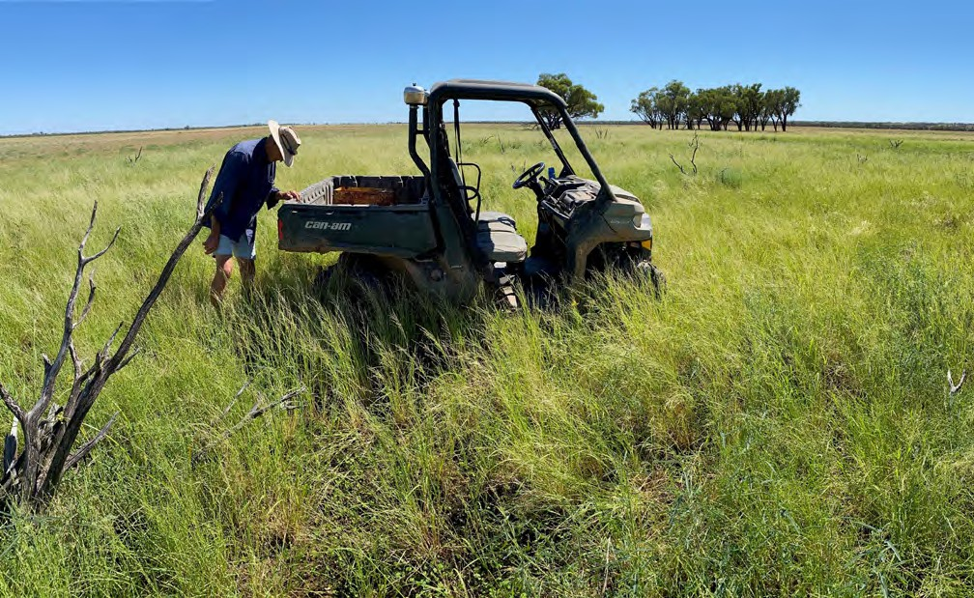
Image: Quilpie grazier inspecting pasture response. Source: Southern Queensland Landscapes.

Economy

“Rather than clinging to the idea that rural inhabitants need to be taught,
a lesson could be learnt from rurality: there is much to learn from country dwellers and their capacity for innovation and creativity. They are continually formulating novel organisational or institutional arrangements to meet the challenges of adapting to a new economy, to adjust local governance or to maintain basic services in small communities spread over a vast territory.”

Jean (2014)

At present, the RDRP region of South West Queensland comprises the shires of Balonne, Bulloo, Maranoa, Murweh, Paroo and Quilpie and is home to approximately 24,000 people. The European history of the region has been traditionally focused on the economics of agriculture and hence the impacts of drought on farming and agricultural supply-chain businesses have been significant.
The Murray-Darling Basin Authority (MDBA) conducted
an assessment of social and economic conditions throughout in the Murry-Darling basin in 2020. Their map (FIgure 20), represents the economic vulnerability of communities resulting from both climate and policy-induced reductions of available water. The map clearly shows that the eastern zone of the South West Queensland region has two out of 10 of most economically vulnerable survey districts in the Murray-Darling basin. ‘Vulnerability’ in this context, inversely implies a lack of resilience, and reflects both the severity of drought impacts and lower levels of adaptive capacity in these communities.

In 2021, ABARES conducted a nationwide survey 23 of farm practices related to natural resource management (NRM) and drought resilience and preparedness. The survey included questions on management practices relating to farm financial diversification, farm planning and management, and the use of NRM and other farming practices. From 478 farms surveyed in Queensland (including from the region) the results indicate that recent drought has driven financial and land management practice change in many farming enterprises. Many farms and properties have been forced to decrease their reliance on a single source of agricultural income through the diversification of income streams. This is being achieved through seeking
off-farm income as well as introducing a wider range of agricultural activities on farm. The ABARES 2021 survey found:
- “Over the last 3 years, an estimated 34% of farms diversified their agricultural enterprises to increase their resilience to drought, while 38% increased their non-farm income.
- Around 64% of farms had some non-farm income, on average over the last 3 years. Of those farms, the
average proportion of household income from non-farm sources was 41%, making many farms well placed to deal with a short-term downturn in farm income.
- Approximately 4% of farms received payments for environmental services.
- However, only an estimated 36% of farmers had a written farm plan with business objectives. Of those plans 79% included drought strategies and 88% included other farm risks.”

“I think planning [for drought resilience] is important... but what it looks like
is another thing. Just because it is documented doesn't mean it is any good.”

NRM advisor

Figure 20: Sensitivity of the Goondiwindi Regional Council and Parts of the BROC Region
to a Reduction in Water Availability. Source: Institute for Rural Futures, University of New England; and Tim Cummins and Associates, Armidale and Rosebank.
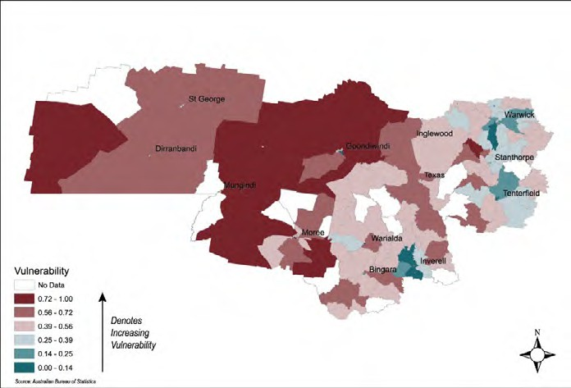

In this region, the relationship between agriculture and other sectors such as mining, CSM as well as (increasingly) Carbon Sequestration and renewable energy projects (solar and wind farms) is complex. While the impacts on local economies are often contested, it does offer many opportunities for drought resilience. Not only do these other sectors bring investment, professional services and employment into regional and
rural towns and communities, but they also offer important opportunities for off-farm income to help ameliorate drought impacts and build drought resilience (both individual agricultural businesses and ‘agricultural’ communities and townships). Increasingly they are also showing more potential for diversified ‘on-farm’ income.
For instance, it is recognised that whilst there is strong resistance from some farmers, others with coal seam gas wells on their property receive additional income which builds resilience to drought and allows them to remain viable. Mining
and Coal Seam Gas production in this region also require water
for production, but it is generally agreed that they are less affected by drought than agriculture – “Mining, typically, is a drop in the ocean compared to agriculture, which gets about 90% of available water… the water that the mines do have access
to, however, is often from high security allocations, and these are usually the last to be impacted in cases of drought” (Mining Technology, 2020).24
However, there is constant debate about the effects of both mining and CSM on water quality and water availability in agricultural areas. Currently there have been few positive examples of the widespread re-use of water from Mining/CSM activities for agricultural purposes in the region.
Some believe one of the factors contributing to population decline, at least in LGAs in the west of the region, has been the early adoption of carbon farming initiatives that resulted in some large landholdings being locked up for the purposes of sequestering carbon. Some vegetative carbon farming

methods require limited agricultural activity on the land, with the properties that were ‘locked up’ resulting in a significant reduction in family and employed labour required on those properties. This led to those individuals leaving the region and hence reducing the pool of available labour. An unsubstantiated report 25, states approximately 400 people moved from the Paroo Shire in the peak of the last drought period 2012–2021, predominately due to the establishment of carbon farming projects in the shire. Local observers complained about declining social benefits of having fewer people on properties and in communities throughout the region, as well as the reduction in fire control and general property maintenance that occurs when farmers leave the region. It is recognised many landholders have carbon projects to complement their grazing enterprise, particularly from a perspective of having an income which isn’t seasonally dependent.
Recent droughts in South West region have also seen a shift away from grazing sheep to an increased prevalence of farming goats. “If you’re going to get one animal to survive drought, get a goat. They manage in harsh desert conditions around the world. Their horns dissipate heat and they can forage on relatively little vegetation. Goats with floppy ears and loose skin tend to do better in harsh, dry environments” (Modern Farmer, 2022).26
The Australian goat meat industry has traditionally been supplied by harvesting of feral goats, and South West
Queensland has been an important part of that supply chain. However, in recent years, as the adoption of exclusion fencing became more widespread, feral goats have become scarcer because their freedom to roam to graze is restricted.
Concurrently the opportunity to have large herds of goats safe from predators has allowed a relatively new industry of ‘farmed goats for meat’ to emerge in South West Queensland. A number of graziers across the region have reported that “In drought, goats have proven to be far more profitable than trading cattle” (Meat & Livestock Australia, 2020).27 Land management regimes need to be adapted to ensure detrimental goat farming impacts are minimal.
Figure 21 (Meat & Livestock Australia, 2022)28 highlights the significance of the opportunity available for producers in South West Queensland, particularly those who can develop the technologies and skills to manage large herds of domesticated goats for meat, and can become part of collaborative market- oriented value chains aimed at producing and marketing goat meat for attractive markets and segments of consumers in domestic and international markets. Western Meat Exporters, in Charleville, is Australia's largest goat abattoir, processing about 3,000 head per day. They have announced their intention to expand their production to meet the increasing demands
of worldwide markets.

Figure 21: Australian goatmeat exports by value and destination. Source: Australian Meat & Livestock Australia (2022).

300 14
250 12
200 10
A$ millions
8
A$/kg
150
6
100 4
50 2
0 0
2004
2005
2006
2007
2008
2009
2010
2011
2012
2013
2014
2015
2016
2017
2018
2019
2020
2021

US
Taiwan Korea Canada
Trinidad & Tobago
Other
Average value

Year

Landscape and natural environment
Traditional owners of this region managed the country by living with the landscape and this included their understanding and management of the impacts of drought. First Nations people have survived and thrived in this landscape for thousands of years. Kerwin (2006) states, “As with all societies, technology, development, and land management systems were used to harness local environmental conditions so as to provide and enhance a way of life”.29 In recent times it has been recognised that stemming the loss of traditional land management practice knowledge and sharing this knowledge in a culturally appropriate manner is key in building more drought resilient landscapes and communities of this region. Southern Queensland Landscapes are working with Traditional Owners to promote the use of traditional burning regimes to improve the health of the country is one example of this.

Since 1999, modelled annual pasture growth has been used as a primary indicator of the severity of drought conditions.
Annual pasture growth is influenced by rainfall (amount, timing, and intensity), temperature, radiation and soil condition.
This combination of factors makes pasture growth a reliable indicator of drought severity and impact not only for grazing but also for farming/horticultural country.
Figure 22 shows a significant decline in the average annual grass production in the last two decades for all of the shires except Bulloo when compared to the average annual production for the 1888–2021 period for the same LGA. Management regimes may reduce or magnify the impacts of climatic conditions on annual pasture growth. Figure 23 shows a particularly poor growing seasons from 2013–2020 with 2016 providing some relief.

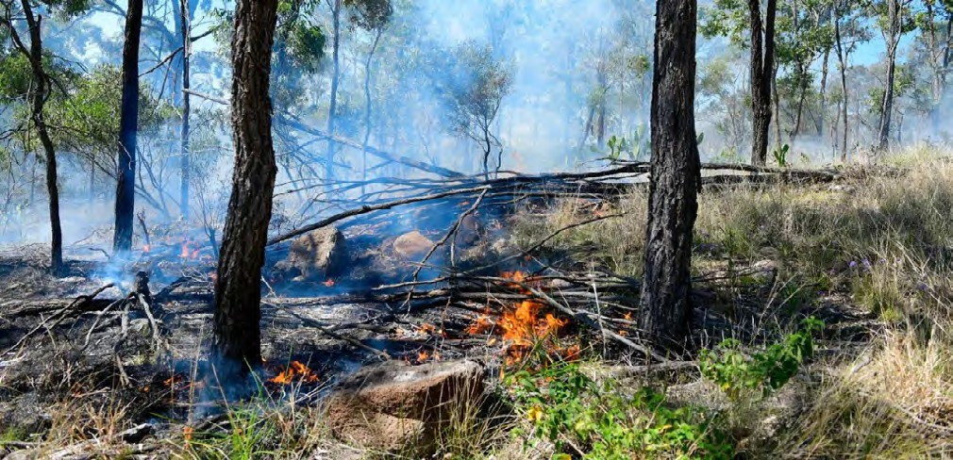
Image: Traditional burning of Ironbark woodland. Source: Southern Queensland Landscapes.

Figure 22: Comparison of average annual growth. Source: AussieGrass – Long Paddock.

2,000
1,800
1,600
1,400
1,200
(kg/ha/yr)
1,000
800
600
400
200
0

1888–2021
2000–2021

Balonne Maranoa Murweh Paroo Quilpie Bulloo

Figure 23: Annual pasture growth for region’s local government areas. Source: AussieGrass – Long Paddock.
3,500
3,000
2,500
(kg/ha/yr)
2,000
1,500
1,000
500
0
2000
2001
2002
2003
2004
2005
2006
2007
2008
2009
2010
2011
2012
2013
2014
2015
2016
2017
2018
2019
2020
2021

Year
1888–2021

Balonne Bulloo Maranoa Murweh Paroo Quilpie

The impacts of the most recent prolonged droughts are driving significant ‘on-farm’ land management practice change. The
Figure 24: Roma Cattle Saleyards annual selling numbers and regional average annual rainfall. Source: Maranoa Regional Council.

ABARES Natural Resource Management and Drought Resilience survey (2021) measured the uptake extent of 20 progressive land management related practices on 478 Queensland farms and properties.
The drought preparation practices with the highest uptake were:
- de-stocking early in low rainfall periods to preserve groundcover (68% of farms)
- improving soil water retention (64% of farms)
- increasing fodder and grain storage (58% of farms).
However, whilst 68% of the surveyed Queensland primary producers self-reported they are de-stocking earlier, other sources of information do not offer such a conclusive picture. The high rate of fodder subsidies during the drought could
2013/14
2014/15
2015/16
2016/17
2017/18
450,000
400,000
350,000
300,000
250,000
200,000
150,000
100,000
50,000
0
2012/13
2018/19
2019/20

Year
600

500

400

300

200

100

0
2020/21

possibly be interpreted as producers holding onto their stock and feeding, rather than destocking. Sale numbers through the Roma saleyards indicate the highest annual throughput for the last decade occurred in 2012/13 when the regional
rainfall was at its lowest. This would seem to indicate producers were moving stock off their properties, but throughput for
the 2015–19 period was consistent and does not follow the rainfall trend. Similarly, analysis of the DRAS expenditure for the area shows a relatively low number of producers accessed road transport stock freight subsidies at the end of the drought period, but this does not necessarily indicate
a lack of re-stocking activity. This is an area that needs further investigation.

“Many find it hard to destock, so delay the decision which leads to denuded landscapes and stock too poor to transport.”

Community member

Figure 25: 2010–2020 Drought subsidies total by subsidy type for the South West Queensland region (Dam desilting subsidy introduced in 2019).
Source: Department of Agriculture and Fisheries, Queensland Government.

$8,000,000

$7,000,000

$6,000,000

$5,000,000

$4,000,000

$3,000,000

$2,000,000

$1,000,000

$0
2010/11 2011/12 2012/13 2013/14 2014/15 2015/16 2016/17 2017/18 2018/19 2019/20 2020/21
Year

Transport of Fodder
Transport of Animals returning from agistment Emergency Water Infrastructure

Transport of Water
Transport of Animals purchased for restocking Dam Desilting

The ability of native terrestrial fauna to survive the impacts
of drought is dependent on their access to healthy and diverse refuge areas sufficient in both size and connectivity. The
total areas of remnant woody vegetation (trees and shrubs) for the Brigalow Belt in 2018 was 50.2% (0.8% decrease from 2014/15) and 66.7 % for the mulga lands (12% increase from 2014/15).30 Although there have been many improvements due to legislation, voluntary uptake of carbon and environmental offset markets, and funded NRM programs, the biodiversity health improvements achieved through the increased revegetation of the landscape have been constrained by extensive tree deaths resulting from extended periods of drought as seen in the image of a drought.

“Our mulga survived the last drought,
but a lot of box and Ironbark trees didn’t.”

Charleville grazier
The Brigalow Belt biogeographic region had the highest woody vegetation clearing rate in Queensland with 207,000 ha/year (52% of total statewide woody vegetation clearing) for 2015–16. This represented a 57% increase from the woody vegetation clearing rate of 132,000 ha/year in 2014–15. Clearing in this bioregion results from regrowth control and land development to improved pastures or farming. The figures produced indicate that regrowth control and/or land development continued through the drought. The clearing rate for the mulga lands increased by 30% in 2015 compared to the 2014–15 woody vegetation clearing rate of 66 000 ha/year. Source: Land cover change in Queensland 2015–16 (Statewide Landcover and Trees Study (SLATS) Report).

Fodder trees and shrubs, particularly mulga, are an important natural resource supporting animal production over a large area of south-western Queensland. This fodder resource is used as
a normal part of land management and during droughts. For generations, property owners have used fodder harvesting successfully and sustainably by:
- understanding the nature of the mulga lands
- using and managing fodder species as a normal part of property management
- managing stock numbers before, during and after drought
- having a long-term sustainable fodder management plan.
Southern Queensland Landscapes are delivering natural resource management programs promoting practices to improve water infiltration into the soil (soil rehydration) in the western and central areas of the region, with great success.
Some land holders have been reclaiming scolded land through ponding for decades whilst others have just started reclaiming areas of their properties. On some properties, up to 30% of the total property area has been bought back into production, providing valuable pasture in dry years.

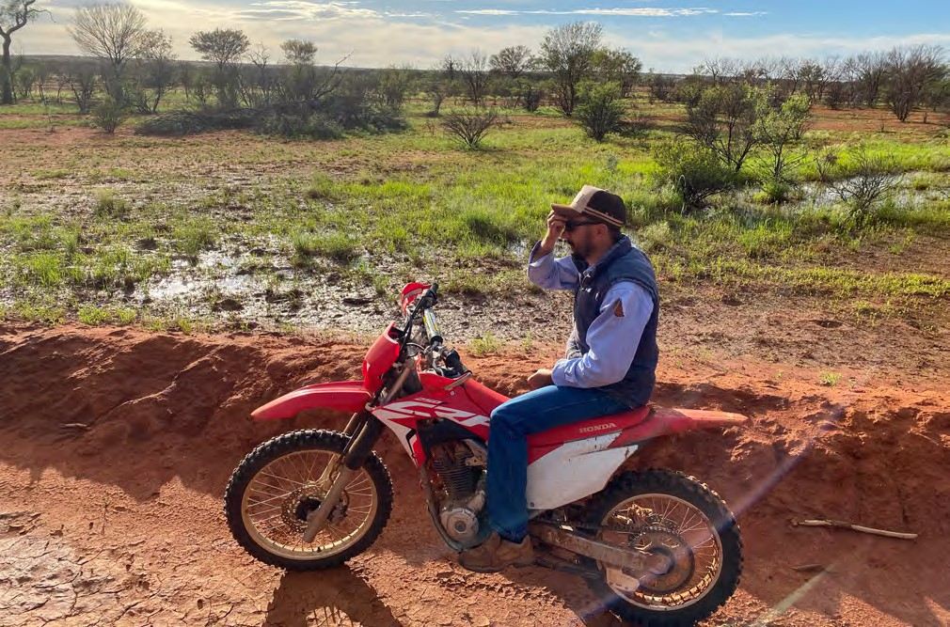
Images: Landscape rehydration banks. Source: Southern Queensland Landscapes.

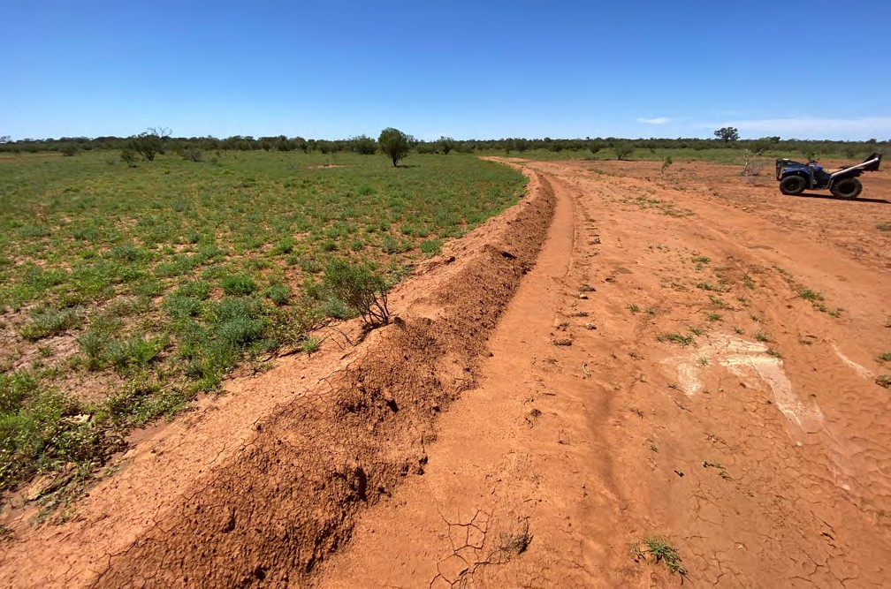

Extreme events including droughts, can create ideal conditions for weeds to extend their range and invade new areas or out- compete native species in their existing ranges. The extent of invasive weeds (particularly cacti) increase during drought due to a reduction in competition from pastures. It has also been noted that invasive cacti are likely to tolerate a more variable climate and will be an increased threat into the future as a weed species. Much of the region have infestations of highly invasive cacti such as Tiger Pair, Coral Cactus, Tree Pair and White
Spine Hudson Pair. Staff of Southern Queensland Landscapes have observed these cacti plus other weeds such as Mothers of Millions, survive drought conditions well and flourish in wet years. Source: Pers com Southern Queensland Landscapes.
Cattle movements have contributed to the spread of some weeds such as Prickly Acacia. Fodder is also another carrier of weed seed. Increased cattle movements and fodder during drought increases the risk of weed spread. Public vehicles wash down facilities have been installed in Injune, Roma and
Charleville to help reduce the spread of weed seed by stock and utility trucks as well as general vehicles. There are a number
of private wash down facilities in the region. Source: Desert Channels Queensland.

Infrastructure and built environment
Figure 26: Major South West Queensland infrastructure. Source: SWQ Regional Organisation of Councils Prospectus.
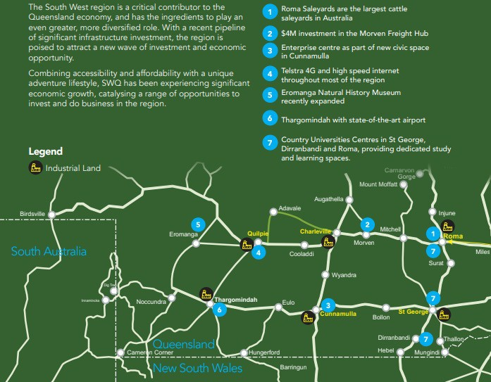

Infrastructure takes many forms including physical infrastructure such as roads, rail lines, water storages/ structures (Beardmore Dam and numerous weirs), buildings, weather stations and communication towers and other utility services infrastructure and non-physical infrastructure such as that to allow digital connectivity.
For some physical infrastructure, increased heat and little or no moisture can have significant impact their condition (i.e. road surfaces, wooden and metal structures, painted surfaces, earthen-based structures etc.) For most infrastructure, the significant impacts of drought come from: increasing lack
of funds for infrastructure investment and/or maintenance; decrease in available (or able) personnel to carry out construction and/or maintenance. On-farm improvements or maintenance are often neglected, avoided or postponed and the upkeep of ‘in-town’ community infrastructure is sometime neglected or abandoned. Drought frequently causes a reduction in investment (both public and private) in new infrastructure
‘in town’ – in particular, the availability of affordable housing (new or existing) declines.
Drought may also result in increased use of some infrastructure such as roads and rail. This is particularly relevant to the South West Queensland roads (over 3000km of sealed road) which
service the country’s biggest cattle saleyard (Roma) as well as the new Morven Freight Hub. Stock transport increases to these facilities significantly at the onset of drought and after drought for saleyards. Maranoa Shire Council reports that 5.8 million head were sold through Roma saleyards between 2012 and 2020. There have been reports that government programs
that supported on-farm infrastructure improvements were successful – for those who had enough resources to government grants and loans.
Water availability is critical to all aspects of the regional community. Water is sourced from a combination of surface water infrastructure and sub surface (primarily artesian) infrastructure. The Beardmore Dam is the largest piece
of water infrastructure in the region and provides water to the St George irrigation scheme. Large on-farm irrigation reservoirs exist down steam from the Beardmore Dam to the NSW Border.
Numerous weirs exist throughout the region, particularly near major towns. These weirs, along with artesian bores, are the major source of water for the towns. Due to the access to artesian water, the towns of the region generally have high water security during drought.
Community feedback regarding on-farm water facilities and other improvements varied with some saying empty dams provided an ideal opportunity to desilt them whilst others stated this wasn’t possible due to little or no income. The uptake of state and commonwealth subsidies to allow for desilting of dams and installation of emergency water infrastructure for animal welfare needs, indicate that some primary producers were taking the opportunity to work
on water infrastructure during drought.

“The aging infrastructure does not get upgraded or replaced during droughts as there are insufficient funds and time.”

Cunnamulla Grazier

However, for others, finances were not sufficient, and/or they were not able to access affordable labour (or were too elderly to do it themselves) and on-farm improvements, which may have contributed to drought resilience, were not possible.

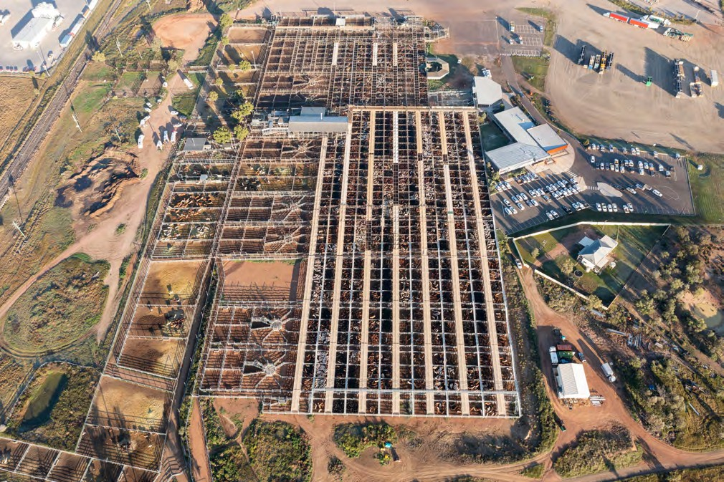
Image: Roma Cattle Saleyards.

While drought has little or no direct impact on digital connectivity, the most recent drought highlighted the lack of digital connectivity and the flow-on effects on other drought impacts. Many government support or relief programs
often required on-line applications and/or the proficient use of computers to access form or information. Even many
mental health and counselling services were forced to utilise ‘telehealth’ sessions via the internet as their first option. During our engagements, many people remarked how their access
to services and their ‘community connectivity’ decreased during the drought as they were faced with either having
to access online (sometimes impossible and often problematic) or faced a long drive to the nearest regional centre.

“No coverage to have electronic monitoring of watering facilities.”

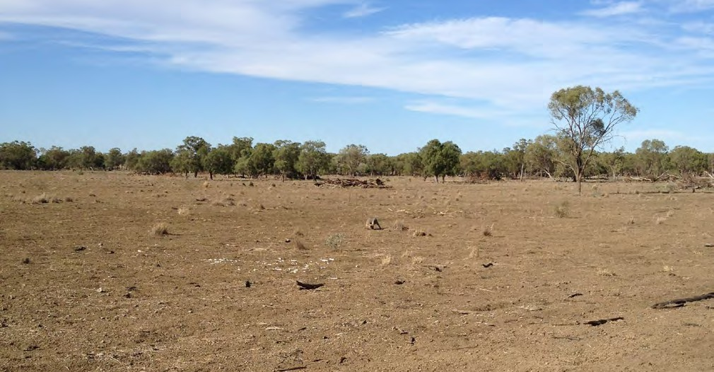
Paroo Shire Council submission to the Regional Telecommunications Review 2021

Image: Augathella property. Source: Andrew Drysdale.
The importance of good digital connectivity is critical to reduce some of the impacts of drought. Community feedback regarding the importance of digital connectivity is supported by government reports 31 which state high quality digital connectivity facilitates social inclusion and connects industries to their markets. The Darling Downs and South West RDA produced a Digital Connectivity Audit and Strategy which identified the eastern parts of the region are reasonably well serviced in terms of network coverage, mobile blackspots are more frequent in the western, less populated areas and there are mobile black spots for rural and remote areas within the region. The Paroo Shire Council has 2021 Australian Digital Inclusion Index of 63 compared to the Queensland average
of 73. The average for the Darling Downs and SWQ region is 65.

“There is no weather radar within a 2000km radius of the district. This means that Longpaddock information for the south west corner is extrapolated from between Longreach and Broken Hill.”

Thargomindah related business owner

It has also been identified that having infrastructure associated with measuring climatic conditions is essential for building the capacity of primary producers, and community more generally, to take pre-emptive action leading into drought.32 An example of this essential infrastructure is the Australian Government’s Bureau of Meteorology Weather Watch Radar network that consists of 60 radars across Australia. The eastern portion of the region have adequate optimal radar coverage. The optimal radar coverage for the western portion of the region is lacking.

Figure 27: Optimal Radar Coverage (200 km radius from station). Source: Bureau of Meteorology.
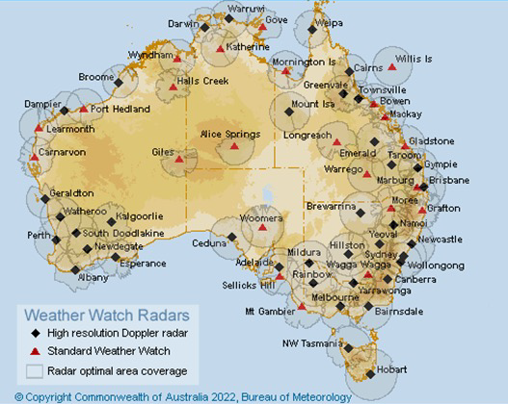

In this section, we have reflected on the previous and current impacts of drought in the South West Queensland region and used systems analysis supported by the
South West Queensland
Likely future impacts (risks) of drought in this region
best available knowledge and data to understand what the likely future impacts of drought are. This meant also considering where we were vulnerable and understanding and highlighting potential risks. These processes highlighted a recognition of the diverse values, perspectives and understanding amongst the many stakeholders. Local, traditional and historical
knowledge was ‘blended’ with ‘outside’, ‘expert’/scientific data and information. Allowing people to explore, share and articulate these complex issues in their own words was critical to developing and working with a common understanding.
The future likely impacts of drought will also be shaped by the compound effects of a range of extreme shocks. The South West Queensland region is affected by national and global ‘megatrends’, which may exacerbate and compound the effects of drought yet also present opportunities for action and improved drought resilience. Such ‘megatrends’ 33 include: ‘global warming’; climate change and increased climate variability (and costs to humans and infrastructure); an overall ageing population and an ageing (and diminishing) agricultural workforce; decreasing availability of productive agricultural land; increasing global demand for (safe) food; an escalating risk from viruses and antibiotic-resistant bacteria; increasing concerns about global human migration; concerns about the
geopolitical status and regional and global security; decreasing rural populations; decline in housing affordability; and increasing infrastructure maintenance costs – to name but a few. A critical megatrend directly affecting agriculture and rural and regional communities is the global transition to low carbon economies and the consequent uptake of low greenhouse gas (GHG) emission technologies for commodities, on-farm energy and supply chain logistics.
Analysis of the future temperature and rainfall graphs indicate that at best (under a low emissions scenario) the average medium temperatures across the region will rise by 2°C across the region by 2070 and under a high emissions scenario will rise up to 3.4°C. Whilst the forecasted annual average precipitation is predicted to vary little and even increase under a high emissions scenario, the combination of higher temperature and longer periods of higher temperature is predicted to
lift the pan evaporation rate by up to 24% across the region by 2070. (Long Paddock – Future Climate Dashboard). These
predictions, coupled with much of the region having moderate to high rainfall variability (refer to map on page 15) lead to the assumption that “it is likely that the region will experience more time in drought”.
As of 12 May 2022, the Paroo and Bulloo shires were still drought declared and have been for more than 72 months. The remainder of the shires have been drought free for
1–6 months. Examining the likely future impacts – and in doing so, exploring our risks and vulnerabilities, we have assumed another ‘prolonged’ drought will commence in the region, within 8–12 years. The following likely impacts of the next drought in the region are based on knowledge (traditional, local and ‘outside’) and patterns from the past; trends and future predictions/forecasts from ‘best practice science’
and data sources. They also take into account adaptation pathways already in place, but not the intervention options and alternative adaptation pathways described later in this regional Drought Resilience Plan.

Figure 28: Forecasted medium temperature changes for SWQ relative to 1986–2005 reference period. Source: Long Paddock – Future Climate Dashboard.

3.5
3
2.5
2
°C
1.5
1
0.5
0
Balonne Maranoa Murweh Paroo Quilpie Bulloo

Low Emmissions 2030
High Emmissions 2030

Low Emmissions 2050
High Emmissions 2050

Low Emmissions 2070
High Emmissions 2070

Figure 29: Forecasted rainfall for SWQ relative to 1986–2005 reference period. Source: Long Paddock – Future Climate Dashboard.

0.1
0.05
mm/day
0
-0.05
-0.1
-0.15
Balonne Maranoa Murweh Paroo Quilpie Bulloo

Regional Drought Resilience Plan 2022–2030
Low Emmissions 2030
High Emmissions 2030

Low Emmissions 2050
High Emmissions 2050

Low Emmissions 2070
High Emmissions 2070

People, culture and community

General trends and likely / possible impacts related to drought

Regional population will decrease with only Maranoa Shire having minimal increase.

- Fewer people in rural towns and villages.
 | 2021 | 2031 | 2041
Balonne (R) | 4,299 | 4,046 | 3,808
Maranoa (R) | 12,670 | 12,827 | 12,944
Murweh (R) | 4,039 | 3,810 | 3,597
Paroo (R) | 1,473 | 1,260 | 1,083
Quilpie (R) | 728 | 631 | 553
Bulloo (R) | 329 | 311 | 291
Queensland | 5,224,822 | 5,901,905 | 7,161,661

- Less people in local workforces.
- Drought-affected communities will become more isolated and more ‘remote’.
- Less government services available locally.
- Decreases in social capital, ‘connectedness’ and declines in membership of social institutions/groups.
“Reduced number of people, increased workload, people are tired and have less time to be involved in the community.”

Increase in ageing – both ‘on-farm’ and in regional centres and towns/villages.

- Population will be ageing (less capable of heavy manual work, more prone to heat-related illness, and less technically capable of using ‘Ag Tech’ for agricultural practices.
“Lack of commitment from many, leaving community involvement to a few.”

“Increasing heatwave occurrence in regions already experiencing water stress and/or prolonged drought conditions will exacerbate issues currently facing many rural Queensland communities.”

- Increased heat-related health issues.
- Increased demand for health support services – especially mental health, drug and alcohol support, suicide prevention.
- Increased difficulty in (locally) recruiting and retaining capable professional staff to meet health, ‘wellbeing’ and social support needs.
- Possible increase in crime and social disorder problems.

42

Economy

General trends and likely / possible impacts related to drought
‘Increase in livestock, fish stock, and crop losses as a result of the exacerbation of drought conditions may result in significant consequences for already strained business owners and communities.’  ‘Substantial impacts to the agricultural community and wider sector are almost certain due to the impact of sustained elevated temperatures on crops, livestock, and the exacerbation of pre-existing drought conditions and underlying bushfire risk.’  ‘Where the heatwave leads to extended periods of disruption and greater impacts to infrastructure, recovery costs for damage to infrastructure and non-supply periods are likely to be high.’  Source: Queensland State Heatwave Risk Assessment (2021). | “Will there be capacity to ‘fill the cupboards’ during the good seasons to provide for the hard seasons?”  “Droughts lead to less production therefore less money and the flow on affect will continue to affect our small communities.”  “Closure of small towns due to unemployment.”  “Tougher operating conditions lead to financial demise of those unwilling or unable to adapt.”  “There will be diminished equity as the period between drought and rebuild horizon spans generations, not three to five year cycles.”
“Rural economies will contract without income sources which are ‘drought proof’.”  “Need for rural industries that require little/less water… or those that use recycled water.” | “Reduced agricultural productivity, reduced profitability, reduced standard of living, degradation of natural assets, reduced quality of life for people currently living in drought prone areas.”  “Spiralling rural debt will deflate the property market.”
“Higher prices at the supermarket.”  “There will be more volatility of markets.” | Local producers will pass on costs of drought to consumers – increased focus on export markets = higher local prices.

43

Landscape and natural environment

General trends and likely / possible impacts related to drought

- More hot days and warm spells are projected with very high confidence.
- Fewer frosts are projected with high confidence.
- Average winter rainfall is projected to decrease with high confidence. There is only medium confidence in spring decrease. Changes in summer and autumn are possible but unclear.
- Increased intensity of extreme rainfall events is projected, with high confidence.

Increase in number of heatwave days (over 35°C) in a given year
Shire 2070
Medium Emissions High Emissions
Balonne | 5–10 | 10–20
Maranoa | 5–10 | 10–20
Murweh | 5–10 | 10–20
Paroo | 5–10 | 5–10
Quilpie | 5–10 | 10–20
Bulloo | 5–10 | <3

“The future impacts of drought on weed extent and density are expected to remain much the same as they are now, thus managing weeds is likely to remain a constant for the foreseeable future.”
Source: CSIRO (2022).
- A harsher fire-weather climate in the future (high confidence).
- On annual and decadal basis, natural variability in the climate system can act to either mask or enhance any long-term human induced trend, particularly in the next 20 years and for rainfall.
- The time in drought is projected to increase over the course of the century (medium confidence).

“Under a scenario of more and longer droughts, a number of species will increasingly be threatened particularly where there is poor connectivity between tracts of natural vegetation such as in the Brigalow Belt. In the western areas of the plan area where grazing of natural pastures is dominant, more frequent and severe droughts would be detrimental to ground cover and possibly grassland composition. Increased deep soil cracking with more frequent or intense droughts may particularly affect perennial grasses”.
Source: Queensland State Heatwave Risk Assessment (2021).
“Financial assistance to spell country and for fencing to control grazing pressure is required.” After the 2001–2007 drought,
the then NRM body for SWQ, South West NRM, surveyed what incentive graziers would require taking country out of production to allow it to regenerate. Some simply requested that the rates and rents for that country be covered by SWNRM.

Stock routes will continue to play an important role in reducing the impacts of future droughts. These corridors of native vegetation will continue to provide feed for traveling stock whilst also providing intact habitat to support native fauna and flora during times of drought and protection of significant First Nations’ cultural areas. The future extent, purpose
and management of stock routes has been under review in Queensland for the past decade.

44

Infrastructure and built environment

General trends and likely / possible impacts related to drought
‘If continued investments are not made to maintain current water infrastructure, this could pose water security issues for the region and decrease the region’s liveability, as well as affect agricultural capacity.’  Source: Queensland State Heatwave Risk Assessment (2021). | “The water infrastructure subsidy is good but often hard to find 50% cash contribution in the middle of a drought”.  “The aging infrastructure does not get upgraded or replaced during droughts as there are insufficient funds and time.”
While the condition of soft infrastructure assets such as that associated with digital connectivity, may not be adversely affected by drought climatic conditions, the use of this infrastructure may significantly increase thus putting pressure on the network.  - Increase demand (and use of) online health services (telehealth) – especially mental and physical health support during drought  - Connectivity is also critical in the use of telematics, which is growing in use through innovative agricultural practices. | - Changing climatic conditions will influence the volume, variability and location of crop and livestock production thereby influencing the nature and distance of transportation.”  - The extent of stock movements increase as drought starts to take grip and for the medium term after drought has broken.  - The transportation of fodder increases during drought with much of this occurring by road transport. This increase in infrastructure use (rail and road) places increase pressure on the condition of the asset. With the prediction of more and longer droughts, the stress on rail and road infrastructure may increase.  - The cost of freight is a major input cost for primary producers during drought. The predicted increase cost of fuel will impact significantly on farm viability.
‘With the prediction of more and longer droughts and hotter days water supply for urban and rural use will continue to be placed under stress. Lower rainfall and increasing evaporation will cause increase depletion of soil moisture leading to reduced groundwater and surface water supplies.’  Source: The Long Paddock | “Employment and infrastructure subsidies to support the local economy required”.
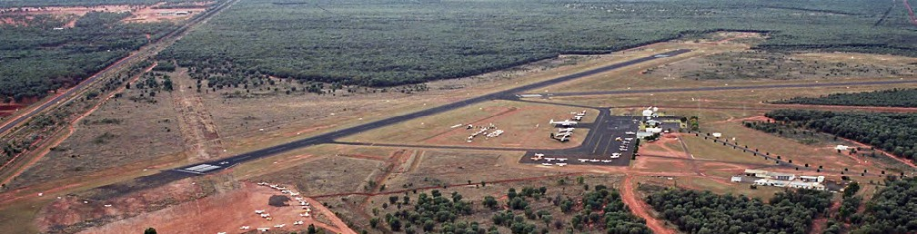
Image: Charleville Airport. Source: Wikimedia.
45

Lessons learnt from the past – stories of resilience

“Became involved in community activities.”
South West Qld Grazier

“Got help from the rural financial counselling service and other financial advisers.”
Grazier

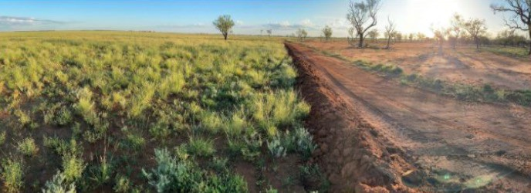
Case Study: Southern Queensland Landscapes – actual vs effective rainfall

Project Officer Glenn Landsberg recently visited a project site in Cunnamulla after a few months of small rainfall events to check on the progress of landscape rehydration works.
South West Queensland
Building drought resilience in our region
About the works, Glenn said that the key was to find points in the landscape where SQ Landscapes could target artificial drainage points (in this case an old, abandoned bore drain just behind where Glenn took the photo), and with minimal cost, restore large areas. He said the works were leveraging the power of the actual rainfall and turning it into effective rainfall.
“You can see the massive area above the works that can no longer drain as fast allowing water infiltration and pasture growth”, Glenn said.
The land managers involved in this project said they were astonished at the results so far.
“Of all the Drought Assistance, Exceptional Circumstances payments, hay drives and other assistance we’ve had,
the work SQ Landscapes has done will have the most profound impact on the land’s drought resilience, productivity and health”, the land manager said.
This project is supported by Southern Queensland Landscapes with funding from the Queensland Governments Natural Resource Investment Program.
#NRIP #Drought Resilience #LandscapeRehydration
Source: SQ Landscapes – Published by HubSpot (February 28, 2022)

“Did a Rural Leadership Course, changed banks eventually and shared their stories.”
Regional Drought Resilience Plan 2022–2030
South West Qld Grazier

Our vision statement

Strong and healthy people living with the land and resilient to drought.
In examining a range of possible futures, we have contemplated three scenarios:
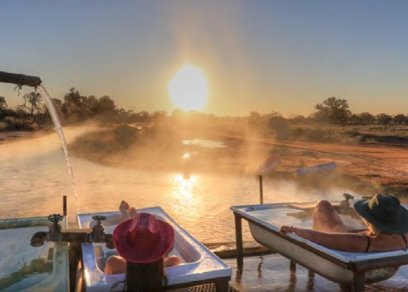
- one where we Do Nothing – where we make little change and we continue on thinking, behaving, and making decisions in the region, much the same as we have

Case Study: Building financial diversification through farm tourism

Charlotte Plains is a family-owned, operated sheep station and campground, near Cunnamulla – Queensland. Our Artesian Bore Baths offer a naturally heated water park for adults, kids and
families looking for a place to warm up in the winter under the stars.
Charlotte Plains offers an authentic Australian outback experience to visitors, combining an insight into sheep station life and offering weekly tours! We continue to run several thousand head of sheep, which we shear in our historic woolshed. There is also a spectacular array of natural birds for bird watchers and other animals surrounding the campgrounds.
Source: Charlotte Plains – charlotteplains.com.au
in the past
- one where we Do More – where we learn, adapt
and modify; where we increase the intensity, scope, size or frequency of our actions. This could mean more people; more money, more often, etc
- one where we Do Things Differently – where
we undertake transformative change and where we move towards making systemic changes.

Key aims and objectives
The objectives guide a set of strategic actions for which investment cases will be developed. Development of both
the objectives and priorities have been informed by community feedback and tested with stakeholders.
- A regional drought surveillance program in place that monitors and analyses key indicators of current and emerging environmental (meteorological and landscape), social and economic conditions, which are markers of drought.
- There is widely shared and well-informed regional engagement with managing drought risk for long-term community resilience.
- The region comes together to build drought resilience.
- Widespread enterprise level drought risk management is established across the region.
- Implement measures to limit impacts of drought and better respond to drought.
- Adequate and appropriate drought risk management essential infrastructure in place and stress tested
for times of drought.

South West Queensland

Establishing priorities
The priority-setting criteria used the overarching and regionally agreed goals of:
- Infrastructure that collects, reports and builds knowledge of the cause, impacts and likelihood of occurrence of drought. This knowledge base is essential in taking pre-emptive action to reduce the impacts
of drought.
- Knowledge of those sections of the community
who are most vulnerable and why, to the risks associated with drought.
- Strategic actions that build communities capacity to better prepare for, manage and minimise existing impacts and recover from drought.
- Systems and frameworks that measure, evaluate and report the community’s drought resilience capacity.
This plan also builds on and complements existing regional planning undertaken by the Darling Downs and South West RDA (2019–2020), which identified five key issues for the region, namely:
- Population attraction including decentralisation of government services and the settlement of migrants and refugees in regional areas.
- Improving transport and logistics including maintaining road infrastructure, reducing freight costs and improving access to markets.
- Progressing zonal tax incentives.
- Access to energy including meshing the grid
i.e. connection to the South Australian power grid.
- Improving digital connectivity.

After reviewing and reflecting on the ideas and issues generated through the analysis from the initial engagements, stakeholders were asked to prioritise the issues from two perspectives:
- the priority of the issue in terms of its relative importance
to the region (2) the priority in terms of the importance of taking action to increase drought resilience.
Later, as part of a deliberative and reflective model of co-design, regional stakeholders further prioritised and
sequenced pathways and actions prior to development of the final draft of this RDRP. This final review process was informed by additional requested information requested by stakeholders.
The engagement and co-designed planning processes highlighted two significant issues requiring ongoing priority and attention. The need to:
  - develop more effective governance structures and arrangements to develop and deliver sustainable drought resilience initiatives – this includes resolving the issue of ‘ownership’ of the RDRPs
  - ensure all drought support programs utilise a ‘tiered support’ approach that requires – at its foundation
– both enterprises and communities develop a multi- faceted drought resilience plan in order to be eligible for further support.

Building drought resilience in our region Regional Drought Resilience Plan 2022–2030

Key priorities
Figure 30: Three pillars for the South West Queensland Regional Drought Resilience Plan.

Localised implementation
- Effective employment incentives introduced.
- Regional alliances strengthened.
- Community uptake of ‘self-help’ options.
- Diversification opportunities are identified.
- Promote recovery, rehabilitation and reconstruction successes.
- Drought tolerant agricultural systems in place.
- Water security is increased.
- Farm and community infrastructure maintained during drought.
Pillar 3
Build future resilience
Pillar 1
Planning and monitoring
Coordination
Pillar 2
Respond to drought events
- Agreed vulnerability and risk profiles known.
- Agreed vulnerability indicators (community, landscape, economic, infrastructure) established.
- Local and Indigenous knowledge is being used.
- Adequate drought monitoring and early warning systems.
- Local capacity to support interpretation of relevant tools and services.
- Biophysical and socioeconomic indicators linked.
- Effective data collation, management and dissemination.
- Effective Drought Resilience education programs are developed and available.

Drought poses a significant risk to regional communities’ economies, health, landscapes and infrastructure.
South West Queensland
RDRP conceptual framework
Managing drought to reduce its impacts, needs to follow a simple risk management framework. This plan provides a pathway for establishing a risk management approach to building drought resilience for the Darling
Downs communities. It establishes the context, identifies impacts and confirming related risk management activities and requirements, such as risk assessment, management, recording, reporting, monitoring and review. This approach establishes the current risk drought presents and what action is required in future
to ensure that ongoing impacts of drought are managed appropriately to reduce its impacts on regional communities.
This plan draws on and adapts the ‘D-RAMP’ model 34
(Crossman, 2018) for Drought Resilience, Adaptation
and Management that was chosen by stakeholders during early stakeholder engagements for its practical logic
and ease-of-use.
The model outlines three pillars to prepare, respond and limit:
- Implement drought monitoring, early warning systems and plans for responses
- Identify and address those vulnerable and at risk of droughts
- Implement measures to limit the impacts of and respond better to drought.
The prioritised strategic pathways and key actions generated by the stakeholders and decision agencies in the Darling Downs region have been summarised under each pillar to develop
a unique plan for the region that is consistent with national planning frameworks and also complements other state and regional planning programs. Further details on the underlying framework and key pillars are shown in Figure 31.

Figure 31: Key pillars and actions of the DRAMP framework. Source: Adapted from Crossman, 2018.
Increase
resilience to increasing drought risk
Prepare, respond and recover from drought
Transformation
of governance and policy systems
Actions
Reduce vulnerability to drought
Transfer and share drought risks
Reduce exposure
to drought
Plan for drought responses, implement drought monitoring and early warning systems
Pillar 1

Manage responses during drought by dealing with impacts, vulnerability and risk
Pillar 2
Implement resilience measures to limit future impacts of drought and better respond to drought
Pillar 3

South West Queensland
Regional Strategy: actions and initiatives

This Regional Drought Resilience Plan is a locally led and regionally coordinated plan and actions will be driven from a regional level. It is acknowledged that some actions require involvement of additional stakeholders such as state or federal agencies, regional governance, local stakeholder groups, charities, NRM bodies and community groups. Where this is the case, actions will be driven through local leadership and while stakeholders may work together to deliver the actions, this plan
does not commit these additional stakeholders to any responsibility, resourcing or funding.
The regional actions in this plan most commonly fit one of three categories:
- single actions or initiatives producing a drought resilience outcome across most or all of the region
- actions and initiatives ‘rolled out’ consistently in communities across the region
- actions and initiatives with uniform regional objectives, allowing flexibility in how they are implemented in individual communities.
Although all actions are designed to produce long-term drought resilience outcomes, it is understood some actions may only be ‘triggered’ by the next drought declaration. It is intended the practical implementation of this RDRP will commence with the co-design and development of a detailed Implementation Plan.

ACTION PLAN
People, culture and community

Pillar 1 – Planning and monitoring
Projected outcome: A regional drought surveillance program in place that monitors and analyses key indicators of current and emerging environmental (meteorological and landscape), social and economic conditions, which are markers of drought.
Priority | Resilience activity | Priority action
Adequate drought monitoring and early warning systems. | Design effective drought monitoring and early warning systems, integrating climate, soil, water and socioeconomic indicators, along with real time drought assessment products that provide timely information to support decisions.  Key stakeholders: Federal and State governments. | Undertake an analysis of what is needed, what is here, what are the gaps of monitoring and early warning systems.
 | Invest in developing and maintaining weather and other early warning infrastructure to ensure there is coverage for all South West Queensland at a local scale.  Key stakeholder: Regional Development Australia (RDA). | Increase the number of BoM radar stations to provide optimal coverage for all South West Queensland.
Local capacity to support interpretation of relevant tools and services. | Build local teams in the South West Queensland region to provide effective interpretation and usage of drought monitoring, early warning and short time forecasting products.  Key stakeholders: Federal and State governments. | Place more climate information dissemination officers – such as Climate Mates – in the region by 2025 to deliver capacity building workshops.

Pillar 2 – Respond to drought events
Projected outcome: A drought risk and vulnerability assessment framework is updated annually to identify and rate the anticipated exposure and sensitivity to harm of the region’s communities generally and recognised more vulnerable demographic groups specifically.
Priority | Resilience activity | Priority action
Agreed vulnerability and risk profiles known. | Develop risk profiles of vulnerable groups, including women, children, the elderly, farmers, pastoralists, marginalised communities and Indigenous groups.  Key stakeholders: Federal and State governments. | Establish vulnerability indicators for different demographic groups.
 | Establish trends in key health indicators of individuals and communities including well-being, population trends and health service provision for South West Queensland.  Key stakeholders: Federal and State governments. | Carry out a literature review of existing indicator trends and test these with focus groups.
 | Establish ‘tipping points’ for key health indicators moving through the risk scale of low, medium and high.  Key stakeholders: Federal and State governments. | Carry out a literature review of existing 'tipping points' and test these with focus groups.

Pillar 3 – Build future resilience
Projected outcome: There is widely shared and well-informed regional engagement with managing drought risk for long-term community resilience.

Priority | Resilience activity | Priority action
Effective employment incentives introduced. | Introduce employment incentives and opportunities for affected communities in South West Queensland.  Key stakeholders: Federal and State governments. | Run six 'think tank' forums around the region to identify potential employment opportunities.
Community uptake of ‘self-help’ options. | Enhance community’s capacity for self-help through having health and financial support workers to be locally based and not only prioritised to areas of greatest need but also to communities that have taken efforts to reduce their vulnerability.  Key stakeholder: RDA. | Establish and educate people on how to use local support services to deliver government emergency relief funding for those areas where these do not exist.
Regional alliances strengthened. | Promote social networking/community events in droughts so that “a problem shared is a problem halved”.  Key stakeholder: RDA. | Run a regional small grants program to encourage social networking events.
Effective Drought Resilience education programs are developed and available. | Develop and implement a comprehensive framework of Drought Resilience education programs, including school education programs, vocational and tertiary programs, ‘professional’ training programs, training for agricultural enterprises and local businesses, academic programs and research.  Key stakeholders: Education providers, businesses, peak associations, Federal and State governments. | Carry out a review of existing available ‘drought-related’ education. Identify gaps and key lessons learned, as well as recommend a draft framework.

Projected outcome: The region comes together to build drought resilience.
Priority | Resilience activity | Priority action
Regional alliance strengthened. | Establish peer to peer learning networks inviting credible local and respected early adopter producers and where possible, laggard adopters  Increase regional capacity to share drought risk and coordinate supported by knowledge experts as  drought resilience as a priority for the whole region. required.  Key stakeholders: RDA, Darling Downs and South West Council
 | of Mayors (DDSWCOM), Western Queensland Alliance of Councils (WQAC). | Connect the not-for-profit service providers (physical health, education, finance and commerce, NRM and mental health) to each other and the community to develop holistic support programs.

ACTION PLAN
Economy

Pillar 1 – Planning and monitoring
Projected outcome: A regional drought surveillance program is implemented that monitors and analyses key indicators of current and emerging environmental (meteorological and landscape), social and economic conditions, which are markers of drought.

Priority | Resilience activity | Priority action
Adequate drought monitoring and early warning systems. | Further develop and fund monitoring frameworks to track farm and town business viability.  Key stakeholders: Federal and State governments. | Carry out a desk top analysis of existing monitoring frameworks that track business viability and  assess them for appropriateness and  currency for this region.
Biophysical and socioeconomic indicators linked. | Establish the link between biophysical, economic and social early warning indicators and that there is regional and local capacity to disseminate these early warnings.  Key stakeholders: Federal and State governments, Universities. | Contract a study to establish the links between biophysical and socioeconomic early warning indicators.
Effective data collation, management and dissemination. | Investigate initiatives that focus on improving data collation, management and dissemination for community sustainability priorities.  Key Stakeholders: Federal and State governments. | Establish a data users focus group to analyse the practicality of existing data collation, management and dissemination.

Pillar 2 – Respond to drought events
Projected outcome: A drought risk and vulnerability assessment framework is annually updated to identify and rate the anticipated exposure and sensitivity to harm of the region’s economy generally and recognised more vulnerable enterprise types, supply chains and financial arrangements specifically.

Priority | Resilience activity | Priority action
Agreed vulnerability and risk profiles known. | Analyse agricultural enterprise types under medium-  and long-term climate change, land condition and market prediction scenarios to establish viability risk profile.  Key Stakeholders: Federal and State governments, Universities. | Contract an analysis of enterprise types and their vulnerability to drought impacts.
Agreed vulnerability indicators (community, landscape, economic, infrastructure) established. | Establish the critical economic inputs that drive business viability in drought and establish trends in those key economic input costs for farming and town businesses.  Key Stakeholders: Federal and State governments, Universities. | Contract an analysis of business inputs over a 15-year time frame.
 | Establish ‘tipping points’ for key viability indicators moving through the risk scale of low, medium and high.  Key Stakeholders: Federal and State governments, Universities. | Carry out a literature review of existing 'tipping points' and test these with focus groups

Pillar 3 – Build future resilience
Projected outcome: A widespread enterprise level drought risk management is established across the region.

Priority | Resilience activity | Priority action
Promote recovery, rehabilitation and reconstruction successes. | Support free/ low-cost Business Mentoring programs, such as Rural Financial Counsellors, to better prepare farming and town businesses, and to assist them in preparing and planning for and managing their businesses during drought.  Key stakeholders: Federal and State governments. | Four extra business mentoring officers to be appointed to regional towns in the region.
Diversification opportunities are identified. | Establish on and off farm business diversification opportunities along with analysis of opportunities, risks, blockers to uptake and establishment costs associated with these diversification opportunities.  Key stakeholder: RDA. | Fund four business forums across the region focusing on identifying business diversification options.
Promote recovery, rehabilitation and reconstruction successes. | Design “build back better” approach that reduces risk to viability and enhances preparedness to future droughts by utilising effective and targeted investments during the recovery, rehabilitation and reconstruction phases.  Key stakeholders: Federal and State governments. | Fund two priority projects in the region that focus on improving digital connectivity across the region.

ACTION PLAN
Landscape and natural environment

Pillar 1 – Planning and monitoring
Projected outcome: A regional drought surveillance program is implemented that monitors and analyses key indicators
of current and emerging environmental (meteorological and landscape), social and economic conditions, which are markers of drought.

Priority | Resilience activity | Priority action
Adequate drought monitoring and early warning systems. | Continue to design participatory, tailored and comprehensive drought monitoring and early warning systems, integrating multi-scale climate, soil and water information.  Key stakeholders: Federal and State governments. | Carry out a ‘stock take’ of existing drought monitoring and early warning systems and identify where
 | Ensure appropriate hard and soft infrastructure is in place to capture and disseminate early warning indicators.  Key stakeholders: Federal and State governments. | opportunities exist to improve coverage and uptake.
Local capacity to support interpretation of  relevant tools and services. | Increase local capacity for effective interpretation and usage of drought monitoring, early warning and short time forecasting products.  Key stakeholders: Federal and State governments. | Place more climate information dissemination officers – such as Climate Mates – in the region by 2025 to deliver capacity building workshops.

Pillar 2 – Respond to drought events
Projected outcome: A drought risk and vulnerability assessment framework that is updated each 5 years to identify and rate the anticipated exposure and sensitivity to harm of the region’s landscapes generally and recognised more vulnerable waters, lands and ecosystems specifically.

Priority | Resilience activity | Priority action
Agreed vulnerability indicators (community, landscape, economic, infrastructure) established. | Establish agreed landscape vulnerability and risk indicators for landscapes and natural environment.  Key stakeholder: Queensland Department of Environment and Science (DES). | Work with NRM bodies to establish appropriate landscape and natural environment vulnerability and risk indicators.
Local and Indigenous knowledge is being used. | Use local and Indigenous knowledge on drought characteristics, impacts and risks on landscape and natural environment wherever feasible.  Key stakeholder: Local Indigenous group. | Establish an Indigenous focus group to identify traditional land management practices they believe will reduce drought impacts on landscapes.
Promote recovery, rehabilitation and reconstruction successes. | Improve communication and information-sharing processes to increase awareness of risks to landscapes and natural environment associated with drought.  Key stakeholders: Climate Centre, Natural Resource Management Bodies (NRM Bodies). | Run five information sharing workshops in region.

Pillar 3 – Build future resilience
Projected outcome: Implement measures to limit impacts of drought and better respond to drought.

Priority | Resilience activity | Priority action
Drought tolerant agricultural systems in place. | Implement land use planning at landscape scale to encourage sustainable land use in drought-prone areas.  Key stakeholders: Local and State governments. | Identify what parts of the region are considered highly drought prone.
 | Promote agricultural production systems that are drought resistant.  Key stakeholders: Industry, NRM Bodies. | Establish a grants program that subsidies the development and implementation of on farm sustainability plans.
 |  | Design incentives schemes to encourage early destocking.
 |  | Establish and promote land management options to increase soil hydration capacity and rainfall use efficiency.
 |  | Establish animal nutrition requirement workshops and services to allow for better animal and pasture management decisions.
 | Encourage the cultivation of drought-resistant species and varieties in drought-prone areas to improve crop, meat and fibre yields during drought.  Key stakeholders: RDA, DES. | Contribute to existing crop, meat and fibre yield trials.
 | Design “build back better” approach that reduces risk  to landscape health and enhances preparedness to future droughts by utilising effective and targeted investments during the recovery, rehabilitation and reconstruction phases.  Key stakeholders: NRM Bodies, Industry Bodies. | Fund a drought planning program which build producers knowledge of the essential elements required to achieve drought recovery, rehabilitation and reconstruction.

ACTION PLAN
Infrastructure and built environment

Pillar 1 – Planning and monitoring
Projected outcome: A regional drought surveillance program in place that monitors and analyses key indicators of current and emerging environmental (meteorological and landscape), social and economic conditions, which are markers of drought.
Priority | Resilience activity | Priority action
Adequate drought monitoring and early warning systems. | Funding infrastructure that provides and/or informs early warning systems is a priority of governments.  Key stakeholders: Federal and State governments. | Increase the number of BoM radar stations to provide optimal coverage for all South West Queensland.

Pillar 2 – Respond to drought events
Projected outcome: A drought risk and vulnerability assessment framework is updated each 10 years to identify and rate the anticipated exposure and sensitivity to harm of the region’s built infrastructure.
Priority | Resilience activity | Priority action
Agreed vulnerability and risk profiles known. | The level of infrastructure required to service rural communities is known.  Key stakeholders: Local and State governments. | Carry out an analysis of existing drought related infrastructure and whether it meets needs to increase drought resilience.
Agreed vulnerability indicators (community, landscape, economic, infrastructure) established. | Regular assessment of infrastructure condition and adequacy is carried out.  Key stakeholders: Local and State governments. | Carry out an audit of the condition of existing drought related infrastructure.
 | Ensure that adequate resources are available to build and maintain essential infrastructure.  Key stakeholders: Federal and State governments. | Develop a drought infrastructure maintenance and capital development plan.

Pillar 3 – Build future resilience
Projected outcome: Adequate and appropriate drought risk management for essential infrastructure is in place and stress tested for times of drought.

Priority | Resilience activity | Priority action
Water security is increased. | Increase water supply options through investment in sustainable approaches to water harvesting, locating new potential resources, building new storages and groundwater recharge.  Key stakeholders: Federal and State governments. | Establish further options to build water security in the region.
Implement principles of Integrated Water Resource Management to reduce pressure on water resources and increase availability of water to reduce the number of people exposed to drought impacts.
Key stakeholders: NRM Bodies, Local Government.
Farm and community infrastructure maintained during drought. | Build financial capacity in farm enterprises to allow for the maintenance of property infrastructure during drought.  Key stakeholders: Federal and State governments. | Continue the water infrastructure related subsidy schemes.

Key Evaluation Questions
South West Queensland
Monitoring, evaluation and learning (MEL)
The Key Evaluation Questions for the Regional Drought Resilience Plan (the Plan) are:
- To what extent has the Plan been implemented and has impacted on the regional stakeholders’ capacity and resources to better plan, manage and recover from climate challenges?
- What changes/support are/is needed to ensure that the Plan best provides an effective framework for action and stakeholders can effectively work together towards implementing those actions?

Assumptions underpinning the implementation of the Plan
The FDF MEL plan identified the following assumptions for the plan to be effectively implemented:

Key assumptions affecting outputs to 1–2 year outcomes
- Regional stakeholders have the capacity and capability to participate in strategic planning
- Regional stakeholders are willing to cooperate with each other on regional planning
- Program design is sufficient to give regional stakeholders opportunities to identify and communicate regional drought resilience needs
- Relevant planning at other scales can be aligned
- Regional communities are motivated to take ownership of completed plans and actively seek to implement them
- Communities are willing to share learnings with other regions
- There are sufficient learnings to inform future program design

Key assumptions affecting outcomes from 2+ years
- Supporting consortia of local governments/stakeholders representing a region will result in changes in practice through those regions
- There are sufficient opportunities for regions to implement elements of plans
- Plans contain implementable activities to build drought resilience across Australia
- Regions continue to review, update and implement their plans
These assumptions will need to be monitored during the implementation phase to provide feedback and highlight areas that require further intervention.

Regional Drought Resilience Plan 2022–2030

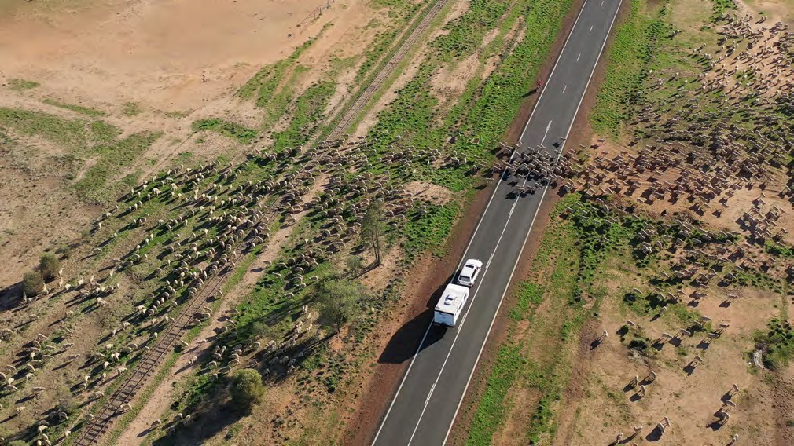
Image: Charleville sheep muster.

Monitoring progress and evaluating outcomes
The following table is based on the relevant FDF MEL framework indicators and the actions developed in this Regional Drought Resilience Plan. The Plan includes a number of indicators against identified actions.

FDF Standard Indicators | Specific Regional Indicators | Evaluation Approach
Outcome level: Impacts 4+ years
- Agricultural landscapes are functional and sustainable, with healthy natural capital (environmental resilience).  - Agricultural businesses are self- reliant, productive, and profitable (economic resilience).  - Agricultural communities are resourceful, adaptable, and thriving (social resilience). | Strong and healthy people living with the land and resilient to drought.  - People, culture and communities: Communities’ drought resilience has improved.  - Economy: Business owners are pursuing opportunities to increase financial security of their business before, during and after drought.  - Landscape and natural environment: Land managers are implementing land management practice change to improve the resilience of the landscape and the natural environment to drought.  - Infrastructure and built environment: Investing in building, maintaining and improving infrastructure has contributed to increasing the communities’ drought resilience.  Note 2030 indicators in Action Plan  tables. | These longer-term impacts are best captured at a national level by the federal Government through ABARES surveys and other national statistics based on a benchmark and taking into account climate, market and other influences impacting on this outcome.

FDF Standard Indicators | Specific Regional Indicators | Evaluation Approach
Outcome level: Long-term outcomes 4+ years
- Stronger connectedness and greater social capital within communities, contributing to wellbeing and security.  - Communities implement transformative activities that improve their resilience to drought.  - More primary producers preserve natural capital while also improving productivity and profitability. | Key Aims and Objectives  - A regional drought surveillance program is in place that monitors and analyses key indicators of current and emerging environmental (meteorological and landscape), social and economic conditions, which are markers of drought.  - There is widely shared and well- informed regional engagement with managing drought risk for long-term community resilience.  - The region comes together to build drought resilience.  - Widespread enterprise level drought risk management is established across the region.  - Measures are implemented to limit impacts of drought and better respond to drought.  - Adequate and appropriate drought risk management essential infrastructure in place and stress tested for times of drought. | Critical to regional-level monitoring of, and improvement to, the Plan will be an on-going regional oversight group (ROG) comprising of the Plan ‘owner(s) and  key stakeholder representatives. This group would have the role of initiating actions in line with the plan, reviewing progress against the plan objectives and making changes to the Plan as needed to maintain its relevance and usefulness.  While some of these indicators will be captured in national surveys and  statistics as above, monitoring actions that should be taken at regional level by the ROG would include:  - Monitoring and reporting of regional level indicators that are captured  as part of Local Government  surveillance, surveys and annual reporting.  - Liaising with the regional Drought and Innovation Hub to ensure that key indicators for the region are captured and provided over time.  - Recording case studies of changes made and benefits evident as a result of actions taken from the implementation of the Plan.

FDF Standard Indicators | Specific Regional Indicators | Evaluation Approach
Outcome level: Success measures and intermediate outcomes 2–4 years
Actions have been taken based on the plans  - The majority of plans have had elements implemented.  - Primary producers and businesses supported to improve their sustainability and resilience.  Decisions have been made to implement  - Regional representatives have considered and planned incremental, transitional and transformational opportunities to strengthen resilience.  - Identified actions, pathways and opportunities (including innovative and transformative) to improve regional drought resilience, mitigate risks and adapt to change.  - Communities use relevant data and information to better understand their resilience to plan for drought.  Capacity has been developed  - Regional leaders are in a stronger position to implement strategic actions, adapt to change and take advantage of opportunities to build economic resilience as they arise.  - Partnerships, networks and engagement are built between stakeholders managing natural resources. | The achievement of Key Pillars to underpin the achievement of objectives are:  - Drought monitoring, early warning systems and plans for responses are being developed and refined.  - Those most vulnerable and at risk of droughts have been identified and steps taken to address their vulnerability.  - Measures have been initiated to limit the impacts of and respond better to drought.  Action steps have been taken in line with the Action Plan tables around the key outcome areas of:  - People, culture and community  - Economy  - Landscape and natural environment  - Infrastructure and built environment  Implementation steps have been undertaken as per the Communication engagement table. | Monitoring actions that should be taken at a regional level by the ROG include:  - Recording of steps taken, actions initiated, and resources gained that have been triggered by the Plan framework, strategies and planned actions.  - Annual reporting and review of plan implementation, engagement, participation, actions, barriers and  opportunities to regional stakeholder organisations and government – and changes to the Plan made as needed to best meet regional needs.  Should external evaluation be undertaken, as well as taking the national data, above information and annual review into account (against planned actions), a range of regional stakeholders should be interviewed / surveyed to gauge their understanding, engagement and actions they have taken as a result of Plan guidance and initiatives.  Types of questions should include:  - Their level of awareness and understanding of the Plan – and how aware they think others are.  - How invested they are in engaging with other stakeholders around the Plan implementation.  - How confident they are that they have the skills and resources to make changes highlighted.

FDF Standard Indicators | Specific Regional Indicators | Evaluation Approach
Outcome level: Success measures and intermediate outcomes 2–4 years Continued
- Increased community understanding of the region’s current and future drought resilience, considering the region’s unique economic, environmental and social characteristics.  - Natural resource management capability is improved across region.  Regional Stakeholders are involved  - Plans have buy-in from key stakeholders in the region.  - The number of, and participation in, local networks and programs to enhance drought resilience increases.  - Communities share knowledge, collaborate and partner with government more often to build drought resilience.  - Greater sharing of learnings related to drought resilience between communities. |  | - What decisions and/actions they have taken – or aware of – that have been initiated as a result of the Plan.  - How the Plan has impacted on extra resourcing or support to the region to improve drought resilience.  - How they think the Plan has added value and made a difference in increasing drought resilience in the region.  - What is working and what needs to change with respect to the Plan and its effective on-going implementation.  - Organisations nominated for actions in the Plan including for the communication engagement  activities, should also be interviewed to review what was undertaken,  how it was done, what response was gained and, if not, why not.  - Case studies should be further captured/developed to understand/ demonstrate the program logic / the theory of change and inform recommendations for changes /  support needed to maximise the Plan effectiveness.  A critical part of an external review would be find an on-going ROG who were invested in using the Plan as a framework towards improved resilience, outputs and actions arising and how well this was working towards the Plan’s objective.  Such external reviewing should be taken annually for the first three years (pilot regions) to provide lessons for plan development and implementation in other regions, then every three years.

South West Queensland
References

1 Irvine, S. A. (2021), ‘Mapping drought declaration areas from 1936 to 1964 for Queensland, Australia”, The Rangeland Journal 3(3)
2 Red Cross Queensland, ‘Not If…but When… Helping Queensland communities plan for the Challenges of Drought’ (2021)
3 Queensland Reconstruction Authority, ‘Drought Resilience Strategies’ (2021) and Resilient Queensland in Action (2020)
4 UNDDR, GAR special report on Drought (2021)
5 Commonwealth Scientific and Industrial Research Organisation (CSIRO), ‘Resilience Adaptation Pathways and Transformation Approach’ version 2, 2019
6 Commonwealth of Australia, Bureau of Meteorology,
‘Climate Change Glossary’ (2022)
7 QLD Department of Agriculture and Fisheries, ‘Local Drought Committee Guidelines’ (2021)
8 World Bank, ‘Building Resilience: Integrating Climate and Disaster Risk into Development’ (2013)
9 CSIRO, ‘Drought Resilience Mission – Impact’, https://www.csiro.au/en/about/challenges-missions/ drought-resilience (2021)
10 CSIRO, Australia’s changing climate, State of the Climate 2018 (2018)
11 State Library of Queensland, Queensland Aboriginal and Torres Strait Islander languages map.
12 https://www.swqict.com/home
13 Speedy, Cahr (2003), The Bulloo River System: life along the Bulloo River 1880–1920s
14 The Long Paddock – Rainfall Posters
15 Stokes, Chris J.; Ryan R. McAllister; Andrew J. Ash; John E. Gross (2008). "Changing Patterns of Land Use and Tenure in Dalrymple Shire, Australia"
16 Queensland Government (2009), South West Regional Plan
(Department of Infrastructure and Planning)
17 The McConnell Foundation (2017), What is Community Vitality? https://www.mcconnellfoundation.org/what-is- community-vitality/

18 Schirmer, J. et al (2019), Wellbeing, Resilience and adaptive capacity: a review of current knowledge of social conditions in the Murray-Darling Basin
Regional Drought Resilience Plan 2022–2030
19 Murry-Darling Basin Authority / Panel for Independent Assessment of Social and Economic Conditions in the Murray–Darling Basin (2020), Independent assessment of social and economic conditions in the Murray–Darling Basin: Key messages from Panel-commissioned research.
20 Queensland Statisticians Office, ‘South-West Queensland’ Report, created 2022
21 Ivan C. Hanigan and Timothy B. Chaston (2022), Climate Change, Drought and Rural Suicide in New South Wales, Australia: Future Impact Scenario Projections to 2099, International Journal of Environmental Research and Public Health
22 Western Queensland PHN, 2021, A five-year plan (2021–2026) to improve mental health, suicide prevention and alcohol and other drug treatment services in Western Queensland
23 ABARES (2021), Natural resource Management and Drought Resilience, https://www.awe.gov.au/abares/research-topics/ surveys/nrm-drought-resilience
24 Evans, Scarlett (2020), Drought: how water scarcity could affect mining in Australia, Mining Technology, https://www. mining-technology.com/
25 ABC Rural. (2021). Corporate carbon farms 'locking up the land' are locking out the people, critics say. Retrieved from https://www.abc.net.au/news/rural/2021-04-10/ rural-community-fights-against-corporate-carbon- farning/100048920
26 Modern Farmer, 2022, A Guide to Drought resistant Farm Animals, https://modernfarmer.com/2022/06/drought- resilient-farm-animals/
27 Meat & Livestock Australia. (2020). Benchmarking delivers key insights, Retrieved from MLA website: https://www.mla. com.au/
28 Meat & Livestock Australia. (2022). Global Snapshot Goat Industry. Retrieved from MLA website: https://www.mla. com.au/
29 Kerwin D (2006), Aboriginal Dreaming Tracks or Trading Paths: The Common Ways
30 Queensland Government (2012) Landcover change in Queensland 2011–12 – Datasets
31 Infrastructure Australia (2022) Regional Strengths and Infrastructure Gaps Regional Analysis Queensland report
32 Crossman N.D, (2018) Drought Resilience, Adaptation and Management Policy (DRAMP) Framework 2018.
33 ABARES, (2021) Stocktake of megatrends shaping Australian agriculture (2021 update) https://algorithm.data61.csiro. au/the-megatrends-that-will-impact-australia-in-the-
next-10-20- years
34 Crossman: Crossman (2018), also NDNQFRRA (2019) and the Department of Agriculture (2019), ‘Drought Resilience, Adaptation and Management Policy (DRAMP) Framework’.

