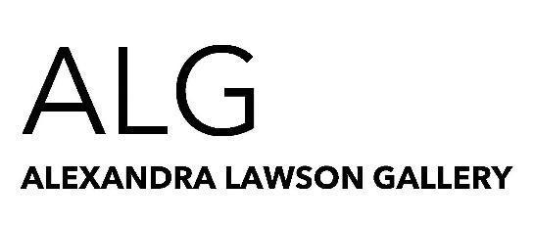

Object Studies

Kyle Jenkins, Peta Berghofer

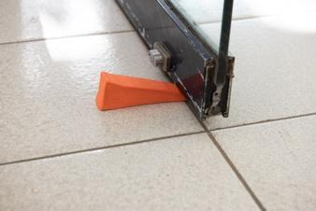
- Kyle Jenkins, Painting/Object #4, 2021, stained stoneware, 3x15x5cm, $300

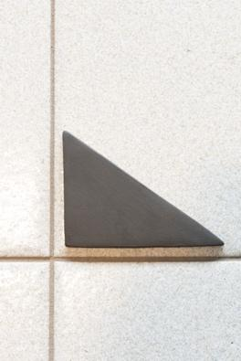
- Kyle Jenkins, Painting/Object #3, 2021, stained stoneware, 2 x 10 x 3cm, $300
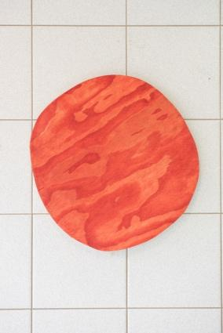
- Kyle Jenkins, Painting (Celare) #26, 2021, oil on plywood, 59 x 56cm, $1500
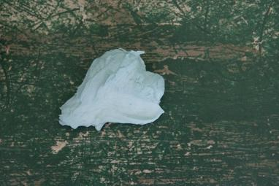
- Peta Berghofer, Blue Paint, 2021, stained porcelain, 3 x 8 x 5cm, $50
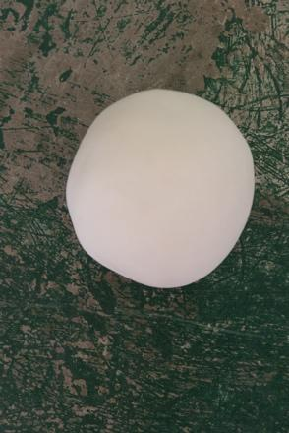
- Kyle Jenkins, Painting/Object #5, 2021, stained stoneware, 12 x 12 x 12cm, $350
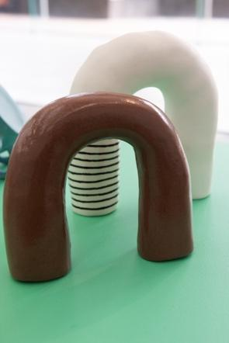
- Peta Berghofer, Brown Handle, 2021, glaze on stained porcelain, 14 x 15 x 4.5cm, $170
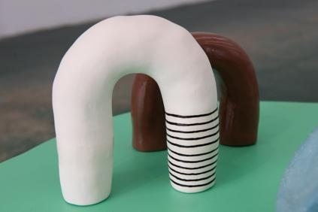
- Peta Berghofer, Striped handle, 2021, underglaze and glaze on earthenware, 18 x 14 x 6cm, $185
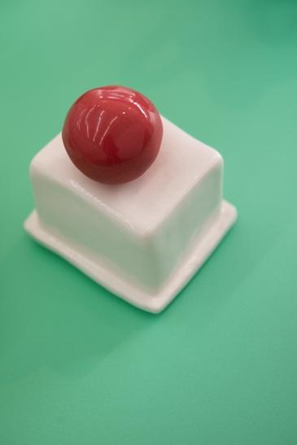
- Peta Berghofer , White Plinth with Red Ball, 2021, glaze on earthenware & glaze on stained porcelain, 9 x 5 x 5.5 cm, $150
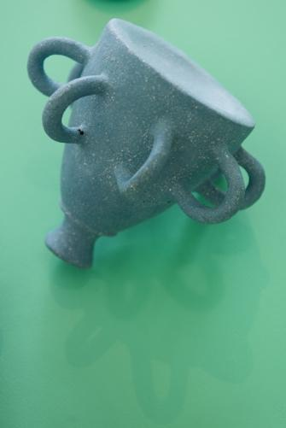
- Peta Berghofer , Wedgwood Study, 2021, stained raku, 13 x 13 x 14cm, $350
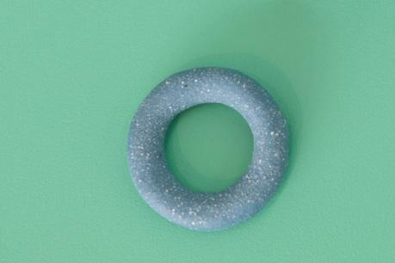
- Peta Berghofer , Blue Continuous Handle, 2021, stained raku, 1.5 x 5.5 x 5.5cm, $50
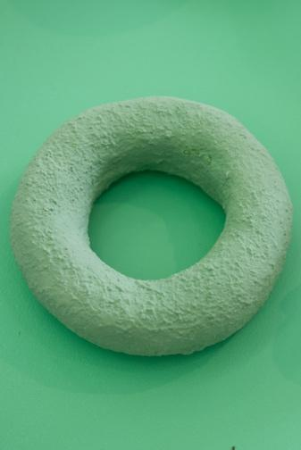
- Peta Berghofer, Green Continuous Handle, 2021, underglaze on raku, 13 x 13 x 4cm, $100
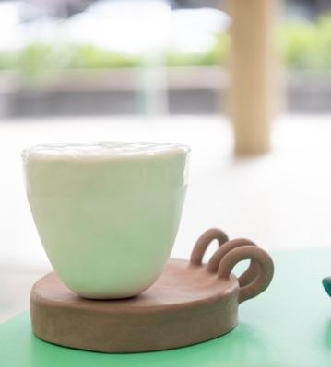
- Peta Berghofer , Handled Plinth with Vessel Body, 2020-21, stained stoneware and glaze on earthenware, 12 x 18 x 13cm, $300
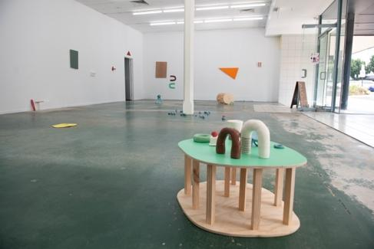
- Peta Berghofer , Painting/Sculpture/Plinth #1, 2021, acrylic on plywood, 33 x 72 x 58cm, $300
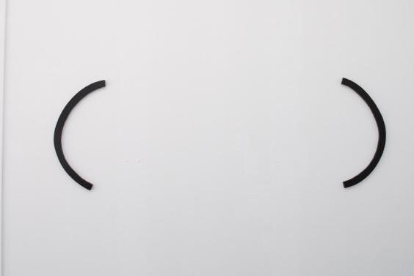
- Kyle Jenkins, Painting/Object #8, 2021, acrylic on plywood, 88 x 5 x 3 each, $2400
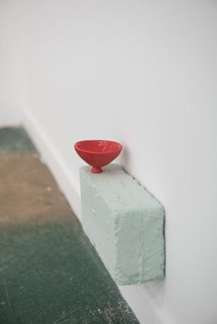
- Peta Berghofer, Blue Brick with Red Vessel, 2021, glaze on stained stoneware and porcelain, 15.5 x 20 x 7cm, $350
- Kyle Jenkins, Painting/Object #2, 2021, acrylic on plywood, 167 x 1 x 1.5cm, $800
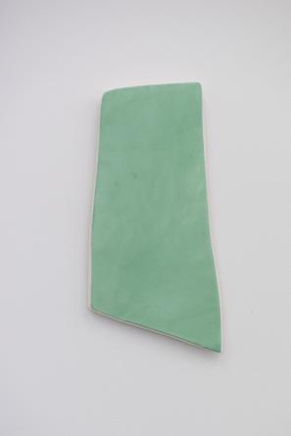
- Peta Berghofer, Green Slab Painting, 2021, underglaze on earthenware, 31 x 15cm, $230
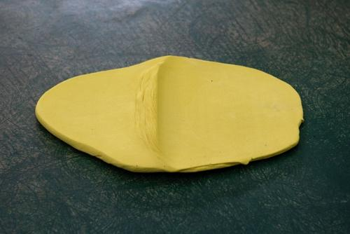
- Kyle Jenkins, Painting/Object #7, 2021, stained stoneware, 40 x 30 x 2cm, $500
- Kyle Jenkins, Painting (Celare) #30, 2021, acrylic on plywood, 60 x 58cm, $3600
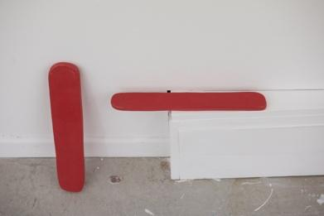
- Peta Berghofer, Red Slabs, 2021, glaze on stained stoneware, 31 x 42.5 x 8cm, $280
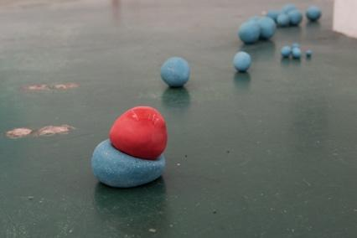
- Peta Berghofer, When Blue and Red Meet, 2021, glaze on stained stoneware and raku, dimensions variable, $380
- Kyle Jenkins, Painting (Celare) #28, 2021, acrylic on marine ply, 60 x 37cm (Australian green), $1800
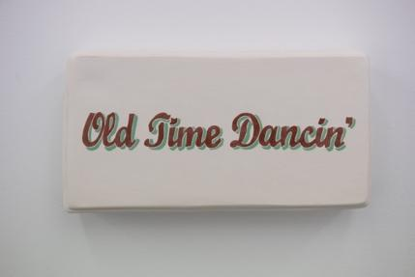
- Peta Berghofer, Old Time Dancin’, 2021, underglaze and glaze on earthenware, 14 x 25 x 5cm, $380
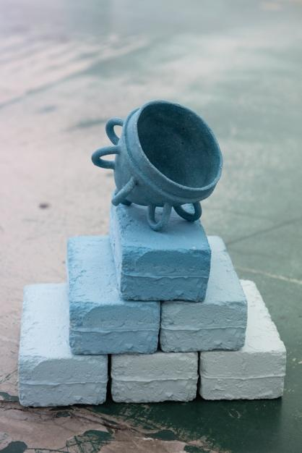
- Peta Berghofer, First Bricks Then Vessels, 2021, glaze on stained raku and porcelain, 39 x 32 x 20cm, $600
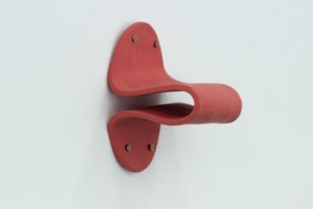
- Peta Berghofer, Red Fold, 2021, stained stoneware, 18 x 15 x 10cm, $280
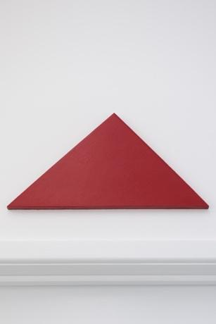
- Kyle Jenkins, Painting (Celare) for B.P #29, 2021, acrylic on marine ply, 40 x 21cm, $1100
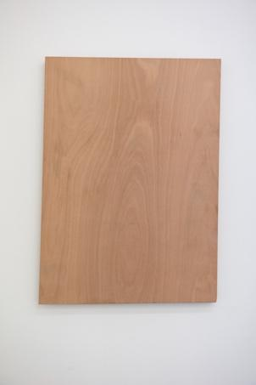
- Kyle Jenkins, Panting/Object #1, 2021, marine ply, 96 x 63 x 2cm, $2600
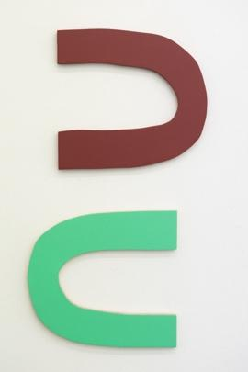
- Peta Berghofer, Brown and Green Handles, 2021, acrylic on plywood, 69 x 32cm, $280
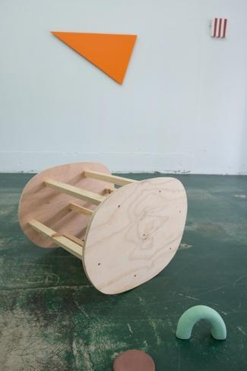
- Peta Berghofer, Painting/Sculpture/Plinth #2, 2021, acrylic on plywood, 43 x 52.5 x 56cm, $300
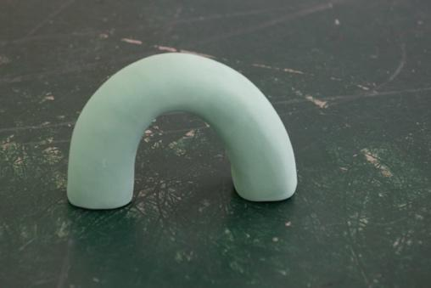
- Peta Berghofer, Green Handle, 2021, underglaze on earthenware, 10 x 16 x 5cm, $165
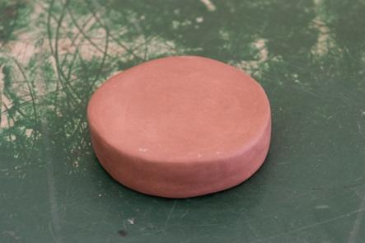
- Peta Berghofer, Brown Base, 2021, stained stoneware, 3 x 10 x 10cm, $130
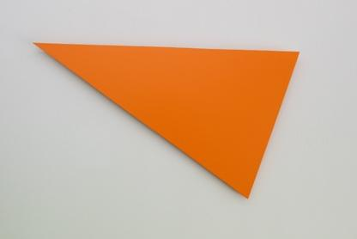
- Kyle Jenkins, Painting (Celare) for J.N #27, 2021, acrylic on marine ply, 103 x 67cm, $3200
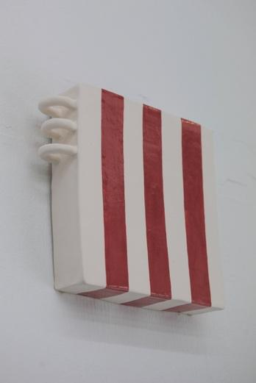
- Peta Berghofer, Striped Handled Canvas, 2021, underglaze and glaze on earthenware, 20.5 x 20 x 5cm, $380
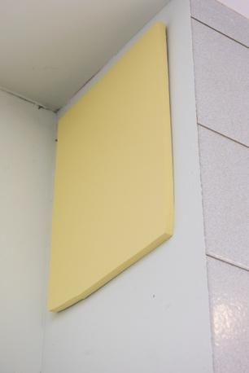
- Kyle Jenkins, Painting (Celare) for K.M #25, 2021, acrylic on plywood, 57 x 43cm, $1800
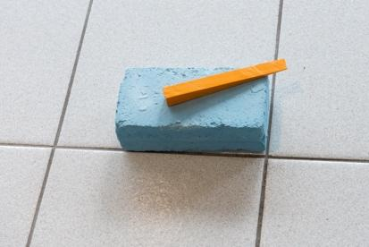
- Peta Berghofer, Blue Brick, 2021, stained porcelain, 7 x 20 x 10.5cm, $180
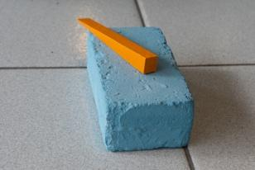
- Kyle Jenkins, Painting/Object #3, 2021, acrylic on marine ply, 10 x 2 x 3, $250
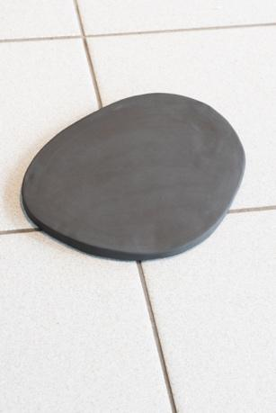
- Kyle Jenkins, Painting/Object #9, 2021, stained stoneware, 29 x 23 x 2cm, $350

Please contact:
www.alexandralawsongallery.com
info@alexandralawsongallery.com
0418 603 695
Open Wednesday - Saturday noon-5.30pm

