The University of Southern Queensland (USQ) Integrated Student Learning Journey Initiative (ISLJI) Key scoping report:

An overview of the provision of academic language literacy and learning skills

May, 2012

Report written and prepared by
Ms Lynette Faragher

Enquiries
Further enquiries about this report should be addressed to:
Ms Lynette Faragher
Learning and Teaching Support (LTS)
Global Learning Division
University of Southern Queensland (USQ)
Springfield Queensland 4350 Australia

Tel: +61 7 34704405
Mob: +61 431220334
Fax: +61 7 34704401
Email: lynette.faragher@usq.edu.au

This document should be cited as:
Faragher, L. (2012, 12th May). The University of Southern Queensland Integrated Student Learning Journey Initiative (ISLJI) Key scoping report: An overview of the provision of academic language literacy and learning skills. Report submitted to the Pro-Vice Chancellor (Learning, Teaching and Quality), University of Southern Queensland.

Contents
The University of Southern Queensland (USQ) Integrated Student Learning Journey Initiative (ISLJI) Key scoping report: 1
An overview of the provision of academic language literacy and learning skills 1
EXECUTIVE SUMMARY 5
1 Background, purpose and terms of reference for the series of scoping studies 6
1.1. Defining academic language literacy and learning skills for higher education 6
1.2. Language literacy and learning skills competencies and skills needed to engage in higher education 6
2. Current provision of language literacy and learning skills to USQ students 8
2.1. The USQ policy context and strategic agenda for the provision of language literacy and learning skills to USQ students 8
2.2. Current practice institutionally for the provision of language literacy and learning skills to USQ students 9
2.3. Current practice locally (faculty-based) for the provision of language literacy and learning skills to USQ students 10
3. Current trends, issues and provision of academic language literacy and learning skills to Australian higher education students 11
3.1. National trends, issues and research related to the provision of academic language literacy and learning skills 11
3.2. Provision of academic language literacy and learning skills in the local Brisbane universities 13
3.2.1. Bond University 13
3.2.2. Griffith University 13
3.2.3. Queensland University of Technology (QUT) 14
3.2.4. University of Queensland (UQ) 15
3.3. Provision of academic language literacy and learning skills in the Regional Universities Network (RUN) 15
3.3.1. Central Queensland University (CQU) 15
3.3.2. Southern Cross University (SCU) 16
3.3.3. University of Ballarat (UoB) 17
3.3.4. University of New England (UNE) 17
3.3.5. University of Southern Queensland (USQ) 17
3.3.6. University of the Sunshine Coast (USC) 18
3.4. Provision of academic language literacy and learning skills in the relevant Australian distance education providers 18
3.4.1. Deakin University 18
3.4.2. Open Universities Australia (OUA) 19
3.4.3. TAFE 19
4. Current trends, issues and provision of academic language literacy and learning skills internationally 20
4.1. Provision of academic language literacy and learning skills international exemplars 20
4.1.1. Open University (UK) 20
4.1.2. University of Cape Town 20
5. CONCLUSION AND RECOMMENDATIONS 22
6. REFERENCES 23
7. APPENDICES 25
Appendix A 25
Open University exemplar 25
Appendix B 27
Table representing additional data relating to ALL support 27
Appendix C 29
ADAPTED VERSION OF Alex Barthel’s Table 2(Barthel, 2011d) 29
Appendix D 30
Alex Barthel’s Table 2(Barthel, 2011d) 30

EXECUTIVE SUMMARY
This is a report of the scoping study into the provision of academic language literacy and learning skills at the University of Southern Queensland (USQ), universities in the Brisbane area, members of the Regional Universities Network, selected distance education universities and selected international universities.
The study includes a description of the USQ policy context and strategic agenda for the provision of Academic language literacy and learning skills (ALL). Existing Learning and Teaching Policy specifies that learning support shall be provided; however little is said in the forward-looking planning documents about any changes to this.
Current provision of ALL support at USQ is comprehensive, in line with the clear policy mentioned above. It is provided in Learning Centres at each of the three campuses in the form of one-on-one consultations and workshops. On-line support is provided through Wimba workshops, Study Desk and online resources through Learning Centre web pages. Pre-Semester programmes are run on all three campuses with the strongest running at Springfield campus.
ALL support in the faculties varies from faculty to faculty and the LTS support is provided in the form of LITE teams and workshops provided on an ad hoc basis as well as Meet-Up.
A comprehensive literature survey was conducted into current trends, issues and provision of ALL support nationally, three key documents were identified; the Good practice Principles for English language proficiency for international students in Australian universities, Alex Barthel’s databases on the AALL website and the First Year Experience in Australian Universities: Findings from 1994 to 2009. The First Year Experience literature was included because of its relevance to how support might be provided.
An analysis of the papers presented at the recent AALL Conference was done and the top three themes were the use of digital technology, embedding skills in courses and collaborative methodology.
The provision of ALL in the Brisbane universities was surveyed as well as the Regional Universities Network, two distance Higher Education providers, two selected international universities and TAFE Queensland. All of the Australian universities provide one-on-one support, online support and centralised Learning Centres. Most provide some sort of student mentoring programme, integrated non-credit courses, generic non-credit courses, have research active staff and support research students and educational development. Some provide ESL tuition and few provide Meet-Up/PASS, integrated credit courses, diagnostic assessment or pre-semester intensive ALL support. USQ provides a full suite of support in comparison as well as rich online support for all including on-campus students.
In the Conclusion and Recommendations it was recommended that consideration be given to increasing staff numbers, focussing research on some of the dominant themes in the industry, and that attention be given to developing the reconstructed LTS into a mature centre.

1 Background, purpose and terms of reference for the series of scoping studies
The drivers, purpose and terms of reference for the series of scoping study reports on language literacy and learning skills is articulated more fully in Southwell (2012).
The USQconnected transition - a shift from the traditional focus on the presentation (production and delivery) of content to that of ensuring the interaction and engagement of students with the core concepts and skills of a course– is a key internal driver within the USQ community.
Implications of this transition for students include the wider range of knowledge and competencies needed to engage successfully and efficiently with the new range of learning experiences.
The primary purpose of this scoping study is rapidly to map the extent, range and nature of research activity and current practice in the broad institutional provision of language literacy and learning skills to higher education students.
The intended outcomes of this scoping study are to strengthen the planning, development and implementation of the ISLJI.
The findings will be used as a basis for discussion to inform and clarify the outcomes USQ seeks to achieve in order to provide language literacy and learning skills to USQ students.
For the purpose of this series of scoping studies, academic language literacy and learning skills is comprised of direct language literacy and learning skills to students.

Defining academic language literacy and learning skills for higher education
For the purpose of this study Academic language literacy is the ability to read and write in a discourse that is recognizable as belonging to the academic community. The learning skills that students require to establish their identities as members of the academic community involve a range of Higher Order Thinking Skills (HOTS) as well as the metacognition to develop those skills. Amongst the HOTS are comprehension, analysis, knowledge utilisation and self-system thinking (Marzano, 2001)

1.2. Language literacy and learning skills competencies and skills needed to engage in higher education
For the purpose of this study, language literacy is considered to include the ability to read and decode academic texts and to write clear academic prose including the ability to utilise the appropriate software. Academic reading ability will include the ability to read – fast and focussed, select necessary and appropriate texts and extrapolate what is needed for assignments. In addition the reading skill will be applied to research, finding relevant articles, skimming abstracts, selecting information, paraphrasing and referencing.
The learning skills competencies and skills include the HOTS referred to above as well as the ability to interpret questions, plan responses, plan research strategy and mind map.
There is some cross-over between the two sets of skills which includes organisational skills in writing including the ability to include necessary information from readings, to reference authorities and to integrate that information into texts. Referencing includes the ability to show a quantity of relevant research and synthesise it into writing.

Current provision of language literacy and learning skills to USQ students

2.1. The USQ policy context and strategic agenda for the provision of language literacy and learning skills to USQ students
In the USQ Learning Teaching Policy, Principle 2.5., states that the University aims to create and maintain a learning environment that provides an integrated range of appropriate student support initiatives to enhance learning… that are supported by quality learning resources and technologies. In addition in Principle 2.4 the University aims to initiate and maintain practices that are inclusive and ensure that all students have equal opportunities in the learning process. In alignment with this policy Learning and Teaching support (LTS), a sub division of Learning Teaching and Quality (LTQ), provides a range of support mechanisms for face to face (f2f) and external students that apply to students registered across the three campuses. Details of this support are provided in the following Section 2.2.
Currently USQ has admission policy which requires minimum IELTS or equivalent scores for international students. If they fail to qualify on the basis of the English language qualification then they will be offered the opportunity to study English in a USQ programme. However there is no English language requirement for domestic students with local school leaving qualifications. This is an issue because research at other institutions (Barthel, 2011a; Harper, Prentice, & Wilson, 2011; Murray, 2010) as well as the Good Practice principles for English language proficiency for international students in Australian universities(Good Practice Principles for English language Proficiency for international students in Australian universities, 2009) indicates that many non-international students also do not enter university with the requisite academic literacy skills in place. The Australian government’s widening participation agenda which this university has embraced, will lead to increasing numbers of non-traditional and pathways students being enrolled and if their success is to be supported it is likely that increased levels of Academic Language and Literacy (ALL) support will be required. At present our student to ALL staff ratio is under the average for Australia (Barthel, 2011c) cf also Appendix B in this document.
Over the last two years a number of discussion papers and models of planning for the future have been generated; Prof Phil Candy’s paper,(Candy, 2010) made it clear that USQ needs to concentrate on aspects of the quality of the student experience and amongst other things that we need to benchmark our practice against practice elsewhere (this scoping report is part of an initiative to address that). The paper does not specify any differences to the existing model of ALL support but it makes it plain that future offerings must have an enhanced student focus which could have implications for the range and quality of services provided by LTS. Subsequent forward looking policy documents from the Global Learning Division similarly do not mention the provision of ALL support –except in the Aggregated Goal plans for 2012(Aggregated Goal Plans for 2012, 2011). An outcome for Priority Plan 1 is that Staff development and student support structures should be focussed on priority areas which include increased representation of Indigenous students and low SES students as well as women and students with disabilities. In addition one of the Key Organisational Goals is to increase retention of students at all levels by 2% and student support for blended learning has to be enhanced. Presumably the quality and quantity of support would feature in those goals. In that same document the following list of Social Justice and Equity support interventions is mentioned as being important:
- DARE programme
- Beams mentoring programme
- SmartSteps
- Open to My Future
- LSES student intervention programme
- GEMS mentoring programme
All of the above are aimed at recruiting non-traditional students from schools to enrol at USQ
In addition there is mention of the various pathways programmes available through the Open Access College; Tertiary Preparation Programme (TPP), the Access Diplomas and TPP in schools. The Fraser Coast Campus has a significant outreach initiative to the schools in the area it serves. If all those social justice and equity initiatives bear fruit and bring more non-traditional students into the university the ALL needs of the student body are likely to be increased. In a different context but relevant here Professor Janet Verbyla said that future policy initiatives are likely to include additional attention being paid to the Academic language and learning needs of all students including our non-traditional cohort. (Prof J. Verbyla, personal communication, April 25, 2012)
Finally a series of Strategic Planning workshops is underway that is underpinned by a Situational Analysis(Situational Analysis - USQ, 2012) that is too broad a document to mention the issue of ALL support directly but there are inferred references in the questions at the end of the document, specifically Q10 which refers to the initiative to include more low SES and Indigenous students “However such outcomes as outlined earlier are not resource neutral: resources and innovative programmes are required to support these outcomes as well as the maintenance and growth of productive partnerships.
- Are these all secure?
- Is there any required increase?
- Are there more avenues for seeking further external support for such students?
- Are there still other improvements to the learning and teaching process (eg via digital enhancement and interactivity?) to boost success for such students?”(p49)

2.2. Current practice institutionally for the provision of language literacy and learning skills to USQ students

In line with the University’s Learning and Teaching Policy the following provision is made for ALL support in Learning Centres in each of the three campuses.
- Students can take advantage of one on one consultations on a drop-in or booked basis for
  - Academic learning skills problems
  - Mathematics or Data Analysis
  - Just-in-time Digital Literacies support (Springfield only)
- One on one consultations are offered at all three campuses for both on-campus and external undergraduate and post graduate students up to Masters level. PhD students at present need to attend at Toowoomba campus
- Weekly f2f and Wimba workshops are presented on all three campuses covering a range of generic ALL skills
  - http://www.usq.edu.au/learningcentre/workshops
- Study Desk is available in all courses and also incorporates discussion forums
  - Meet-Up is run on all three campuses
  - http://www.usq.edu.au/learningcentre/workshops/meetup
- Building Pathways to Academic Success- Transitions is an induction programme run as part of Orientation at Springfield campus. It provides participants with an on-campus experience that prepares them for the start of the new semester.(Faragher, 2012)
- Toowoomba and Fraser Coast run ALL workshops as part of O week.
- Springfield runs a student mentoring programme that runs for the first 5 weeks of the semester.
- In the new Learning Innovation Teaching Enhancement (LITE) teams initiative ALL specialists will contribute if required by the process in individual courses and programmes where there is need to embed academic learning skills in the course.
- The Learning Centre web pages contain a range of printable Quick Tips that cover the basic ALL skills as well as Mathematics and IT issues.
- There are also online resources available to all students that cover much the same ground as well as additional areas.
- AWARE is an online self-administered diagnostic programme that enables students to self-assess their ALL problems and gives them guidance as to where to go for assistance.
- There is a new initiative SPARS which will enable online students to access support from a single automated enquiry point.

2.3. Current practice locally (faculty-based) for the provision of language literacy and learning skills to USQ students

- Meet-Up is run on all three campuses across all the faculties in a number of First Year courses as well as some 2nd year ones. This is a growing programme and is gaining in recognition. It is part of the University’s Retention Programme.
- The Faculty of Education – runs an online First Year Infusion programme which enables students to access course-based one on one support via the internet.
- The Faculty of Science runs a mentor programme that links new students with more experienced students to provide guidance in their academic programmes.
- The Faculty of Science at Springfield runs an academic writing tutorial in specific first year courses presented by an LTS staff member in S1 and 2.
- The Faculty of Business and Law at Springfield has piloted the use of the First Learning Intervention Programme (FLIP) which is an early intervention programme to identify ‘at risk’ students and will include a remediation process.
- The Faculty of Business and Law runs a programme UPGRADE which provides once a semester intensive workshops to post graduate students with an ALL and Library skills agenda.
- LTS staff is frequently invited to present ad hoc ALL workshops in specific courses across the faculties.

Current trends, issues and provision of academic language literacy and learning skills to Australian higher education students

National trends, issues and research related to the provision of academic language literacy and learning skills

In conducting a basic literature survey to provide an overview of the above topic certain seminal documents were identified; the Good practice Principles for English language proficiency for international students in Australian universities (GPP) (Department of Education, 2009) and the work of Alex Barthel(Barthel, 2011a, 2011b, 2011c, 2011d) which provides a set of benchmarking data and statistical tables that provide a quantitative overview of ALL provision at all but one university in Australia. The tables provide a list of contact details for ALL centres in the universities, a table of staff: student ratios and details of ALL activities on all campuses. This data is used extensively in the detailed information about individual universities in the following section. In addition in 2007 AALL funded a team project on benchmarking, the outcomes of which include an annotated bibliography (Dearlove, Moore, Percy, Purser, & Rosetto, 2007).
The GPP provides clear guidelines as to what should be implemented to support international students for whom English may not be their primary language as well as other students but it is not an unproblematic document and it should be read and analysed in the light of the critiques provided by Rowena Harper et al (Harper, Prentice, & Wilson, 2011) and Neil Murray (Murray, 2010) who make recommendations as to how universities might interpret and implement the GPP. The above papers include discussions of academic literacy and language proficiency and how they intersect as well as how they can be enhanced and the work of McNaught & McIntyre, (2011) relates to this and suggests that low levels of academic literacy predict poor levels of academic achievement.
Throughout the ALL literature there is debate about the benefits of embedding literacy skills in the curriculum and how this can best be done, (Harper, et al., 2011; Murray, 2010) both touch on this and it is specifically dealt with by others;(Price, Becker, Clark, & Collins, 2011; Proctor, Wartho, & Anderson, 2005; Skinner & Mort, 2009); who report on specific projects where an embedding process was undertaken and researched using student responses as well as quantitative research. At the other end of the spectrum from embedding skills in courses and programmes is the issue of one-to-one consultations, Wilson et al while admitting that these are expensive, describe one-to-one consultations as a unique and powerful learning environment(Wilson, Collins, Couchman, & Li, 2011). Huijser, Kimmins, & Galligan(Huijser, Kimmins, & Galligan, 2008), report research in which investigation into one on one consultations was closely linked to argument for embedding academic skills in the curriculum. In all cases the researchers conclude that embedding skills in the curriculum can be advantageous to both students and teaching academics in faculties and courses.
Another issue that recurs frequently in the ALL literature is that concerning post-entry language assessment (PELAs) in Australian universities. Katie Dunworth conducted a wide ranging study of their use in Australian universities (Dunworth, 2009) and it seems that the jury is still out as to their value. However according to Dunworth several more universities were going to use them and so there will be new research as to their experiences.
The literature survey was extended to include, the First Year Experience (FYE) which provides valuable context and important insights into the language, and academic literacy needs and demands of first year students. The fundamental document here is the report of the research surveys done by James, Krause and Jennings which identifies important trends and changes from 1994 to 2009 (James, Krause, & Jennings, 2010). Also important are the papers by Professor Keithia Wilson(Wilson, 2009) and Sally Kift (S. Kift, Nelson, & Clarke, 2010; S. M. Kift, 2008). Their work also illuminates aspects of the FYE that impact on the decisions made about ALL provision in Higher Education Institutions (HEI’s). Included here was a paper about the epistemological beliefs about ‘knowing’ of FY students (Brownlee, Walker, Lennox, Exley, & Pearce, 2009), which is included because it reflects results that have implications for how FY students can best be supported. Trotter & Roberts(Trotter, 2006), also contribute to this debate in their UK research on how to enhance the FYE. A paper by Liz Thomas (Thomas, 2002) deals with the ways in which the values and practices of a HEI impact on student retention. This paper is included because it does not focus on student support as the primary means of ensuring retention and progression but on the ‘habitus’ of the institution in allowing students to be who they are.
To get a sense of the trends in research done by ALL practitioners an analysis was done of the topics covered in the papers presented at the recent (November 2011) AALL conference in Adelaide, in order of popularity they were:
  - The use of digital/technology
  - Embedding skills in courses
  - Collaborative methodology
  - Academic Writing
  - Internationalisation
  - Issues involving the ALL profession
  - Specialist issues e.g numeracy, plagiarism, thinking and memory .
  - Other issues were Curriculum and methodology, employers/industry, post-graduate students, pathway programmes, first year experience,
Other research worth noting is that done into strategic developments in Teaching and Learning Centres in Australian universities (Palmer, Holt, & Challis, 2011).Teaching and Learning Centres were described as being prone to reorganisation and restructuring usually as a result of new appointments to university senior executive and that this process sometimes turned mature centres back into embryonic centres. It could be argued that this is what is happening currently at USQ. A further conclusion reached in this report was that Centres would benefit from more direct engagement with students, a key wish was for better and more productive relations between Centres and faculties and finally it was seen that Centres would benefit from having strategic partnerships with the university’s Senior Executive.

3.2. Provision of academic language literacy and learning skills in the local Brisbane universities
In this section the following pattern has been adopted: the first information is the university’s learning support URL, this is followed by other relevant information from the website and then there is detail derived from Alex Barthel’s (Barthel, 2011d) database and some from the AALL Conference 2011.

3.2.1. Bond University
http://www.bond.edu.au/student-resources/student-support/student-learning-support/index.htm
- The Student Learning Support team offers personalised help in one-on-one sessions and small group workshops or seminars to improve skills in:
- Oral presentations
- Citing and referencing
- Grammar and punctuation
- Developing your reading skills
- Organising and structuring an essay
- Managing time and selecting ways to study
- Preparing for exams
- Student Learning Support also offers Maths Help and an English Language Skills Assessment (ELSA) test.
- Bondmate programme
http://www.bond.edu.au/student-resources/student-support/bond-mate-program/index.htm
- According to Barthel(Barthel, 2011d) Bond offers all the ALL activities except decentralised support units and integrated and generic credit-bearing ALL courses

3.2.2. Griffith University
http://www.griffith.edu.au/library/workshops-training/workshops
Academic Skills Workshops
- Concept mapping
- Editing and proofreading your assignment
- Exam strategies
- Getting started on your assignment
- Managing your reading
- Managing your reading and note taking
- Managing your study
- Moving beyond description
- Note taking and note making
- Oral presentations
- Reading a journal article
- Structuring and writing an academic assignment
- Time management
- Understanding expectations at university
- Unpacking the question
- Using the ideas and words of others
- Writing a reflective assignment
- Writing an undergraduate literature review
- Writing introductions and conclusions
- Writing paragraphs
- Writing reports
In addition they offer post graduate workshops, computing skills workshops and Library Research skills workshops
According to Barthel (Barthel, 2011d). Griffith University offers all the ALL activities except generic credit bearing courses and decentralised support.
A paper at the AALL conference in November 2011 reported on credit-bearing courses built into the degree programmes – English Language Enhancement Courses (ELEC). It is mandatory for all international students and is part of a university-wide strategy for addressing English language proficiency issues. The paper reported on how the program has developed in the year since its inception and the challenges and successes of delivering such a large-scale, complex initiative. (Fenton-Smith, Lobo, Michael, Walkinshaw, & Humphreys, 2011)

3.2.3. Queensland University of Technology (QUT)
http://cms.qut.edu.au/student/international/language-and-learning-support/workshops-and-programs
Their Academic Language and Learning Service targets international students and NESB domestic students
  - They offer assessment support f2f and online
  - Individual appointments f2f limited to 1 hour and online to 50 mins
  - Number of appointments is limited to 1 per week or 3 per month
  - Advise students to send their written work ahead of time in preparation for the appointment.
  - Students advised to book a longer time for assessments over 3000 words
Language and learning support workshops cover:
- academic writing
- speaking
- study skills
- critical thinking
- understanding assessments
- intercultural competence.
Specific Language Development Programs are offered for Higher Degree students. The Faculties of Health and Education and the Business School all offer a range of specific and generic support that is advertised on this page. ESL Connect is a program that provides support in the form of individual appointments, workshops and a networking newsletter. They also offer an IAP program for AusAid students and have links to other workshops and support services.
According to Barthel(Barthel, 2011d). All the ALL activities in the table are offered except diagnostic assessment.

Partners in Crime, a paper presented at the AALL conference in November 2011 reported on an experimental process called QUT Library Study solutions in which librarians and ALL staff collaborated to assist students to develop academic literacy (Derrington, Hayes, & Peacock, 2011). However, the main focus of the project was to address librarians’ concerns regarding their confidence and experience with assisting students to develop academic literacy.

3.2.4. University of Queensland (UQ)
http://www.uq.edu.au/student-services/learning
The above link is to a range of online interactive support materials as well as to information about upcoming workshops which run for an hour and cover a complete range of issues from assignments to stress management and run on all their campuses. In April there are workshops on every working day. The following topics are links to fully interactive learning materials
- Assignment writing
- Reading researching and note-taking
- Exam preparation
- Time and study management
- Postgraduate research
- Presentation skills
- Group work
- Statistics support

Appointments are offered but students are advised to attend the relevant workshop before asking for an appointment. http://www.uq.edu.au/student-services/learning-appointments . Expectations around appointments are clearly laid down.
According to Barthel (Barthel, 2011d)the ALL activities offered are: integrated credit and non-credit courses, generic non-credit course, support for research students and 1:1 consultations, none of the others.

3.3. Provision of academic language literacy and learning skills in the Regional Universities Network (RUN)

3.3.1. Central Queensland University (CQU)
http://www.cqu.edu.au/study/useful-info/support
There are three centres
Learning Support Unit
- Working with case studies
- Analysing course-specific assessment tasks
- Getting the most out of lectures and tutorials
- Group work.
Communications Learning unit
- availability of staff for student drop-in sessions in campus libraries;
- an online submission service where students can submit final drafts of assessment items and receive advice on structure, grammar, spelling, punctuation and referencing;
- a range of resources available for academic staff to use in their courses; and
- YouTube presentations for students.

Mathematics Learning Centre
- diagnostic testing to identify any knowledge gaps in basic mathematics, and the provision of resources to help students overcome these gaps;

Monitoring Academic Progress (MAP) describes an intervention programme that identifies student readiness for academic activity.
Student Mentor and Leadership Programme – lasts 2 semesters, structured and carefully monitored.
According to Barthel (Barthel, 2011d) the following activities are also offered; integrated and generic non-credit courses,1:1 consultations, educational development, research active staff and ESL tuition

3.3.2. Southern Cross University (SCU)
http://www.scu.edu.au/academicskills/index.php/25/
Each academic school has an embedded Academic Skills Development staff member “Academic Skills Development staff has a key liaison role with individual schools within the University. This role includes working with School Directors of Teaching and Learning and school teaching staff to plan and facilitate academic skills development within individual units of study. One member of each School Portfolio team will attend school board meetings and provide advice to these meetings.”
5 academic skills workshops are run early in the semester as well as exam preparation later on. Drop in sessions are provided at the Gold Coast campus one day a week.
The website has online spelling and grammar tips as well
PASS is run – equivalent to Meet-Up
Students are encouraged to develop independence in checking assignments, an assignment checklist is provided to assist in this. Students are also encouraged to attend workshops.
Group workshops are offered on an ad hoc basis for students to organise.
Academic staff are offered collaborative assistance with teaching critical literacy skills in their courses and it is here that 1:1 assistance is offered for students as referrals especially wrt re-submits.
According to Barthel(Barthel, 2011d)integrated and generic non-credit courses, 1:1consultations, educational development, and research active staff are offered.

3.3.3. University of Ballarat (UoB)
http://www.ballarat.edu.au/current-students/learning-and-study/resources/workshops
A student mentor programme is run for the first 5 weeks (similar to Springfield campus)
A pre-orientation programme – UBReady is run for 6 days similar to Building Pathways at Springfield.
PASS is run here
3 Seminars are run at the start of the semester in Researching, Referencing and Writing.
There are online tutorials in essay writing, drug calculations, APA, Assist, finding and managing information effectively and PowerPoint
There is also a range of online study and writing skills downloadable resources that cover skills necessary for successful study.http://www.ballarat.edu.au/current-students/learning-and-study/resources/downloads. They cover issues such as Memory, Abstracts vs Summaries, Glossary of Instructional Words...
There is no easy-to-find reference to 1:1 consultations except in Student Services which does not refer to academic issues.
According to Barthel (Barthel, 2011d)ALL activities are offered except for integrated credit and non-credit bearing courses, support for research students and research active staff are offered.

3.3.4. University of New England (UNE)
http://www.une.edu.au//tlc/aso/staff/index.php
There is a range of online resources covering the essential areas of student assignment writing needs as well as links to a range of Fact Sheets that cover a comprehensive range of academic study skills issues including mathematics.
According to Barthel(Barthel, 2011d) all the ALL activities are offered except generic credit bearing courses and ESL tuition.

3.3.5. University of Southern Queensland (USQ)
http://www.usq.edu.au/learnteach this link on the website has immediate links to consultations with full information about how to book and outlines expectations from consultations.
It also links to a comprehensive range of online resources covering matters like Effective study, Academic writing, Assessment, Reading and research, Grammar and writing, Lectures and tutorials
Workshops are spread through the semester and cover the basic issues relating to assessment for students and including mathematics and computer literacy.
Meet-Up is run on all three campuses – equivalent to PASS.
Online workshops are offered via Wimba that equate to the f2f ones.
There is a link to a range of Quicktips that are downloadable flyers about
- Planning and time management,
- Reading and writing skills,
- Graduate qualities and skills,
- ePortfolios,
- Lecture and tutorial skills,
- Assessment skills,
- Microsoft Office 2007 (covering a range of issues)
- Mathematics (covering a range of issues).
According to Barthel(Barthel, 2011d) Integrated non-credit courses, support for research students, 1:1 consultations, educational development and research active staff are offered.

3.3.6. University of the Sunshine Coast (USC)
http://www.usc.edu.au/study/support-and-services/academic-support/academic-and-study-support.htm
A pre-semester skills preparation course is advertised but there was no more information available.
Academic skills workshops are advertised as is English language support and Assignment writing. The last two target NESB students and in each case further information is available from Student services.
F2f sessions with academic skills advisers are advertised with clear expectations outlined as to the sessions.
Drop in appointments are also advertised at specific times.
They also run a student mentor programme that lasts for the full semester.
According to Barthel (Barthel, 2011d) integrated and generic non-credit courses, support for research students, 1:1 consultations, educational development and research active staff are offered there.

3.4. Provision of academic language literacy and learning skills in the relevant Australian distance education providers

3.4.1. Deakin University
www.deakin.edu.au/current-students/study-support/study-skills/index.php This link provides access to a range of information with regard to; workshops which cover the basic academic skill areas and are presented across 4 campuses, online workshops; HDR seminars, email enquiries, the A-Z study skills index and IDeal, their English language diagnostic tool. This last-mentioned is compulsory for all students, it is fully confidential and directs students to appropriate remedial material on the basis of their results.
According to Barthel(Barthel, 2011d). the full range of ALL activities is offered except decentralised support, integrated and generic credit bearing courses and ESL tuition.

3.4.2. Open Universities Australia (OUA)
www.open.edu.au/public/student-admin-and-support/study-resources/help-with-assignments is a link to their smart thinking tool which operates 24/7. They have assignment support as well as maths and IT and other disciplines. It is free up to a point and after that students pay for the service.
There is also access to a Macquarie University support resource called Gateway to Academic Literacy which offers 3 modules; 1. Getting started: Writing at University, 2 Writing Tutorials which teach how to analyse the assignment, develop an argument and editing and proofreading and 3 Sample Essays and Reports in Different Disciplines.
There is also a series of learning skills modules which focus on advice for students as to how to manage their study journey.
On the same page there is a live chat button as well as an online enquiry button.
Students are advised to join the student community forum for study support and can also contact academics and tutors.
No specifics are provided in Barthel’s(Barthel, 2011d) Table 2.

3.4.3. TAFE
TAFE Queensland
According to their website they offer Learning Centres and learning support and each TAFE College has their own specifics.

4. Current trends, issues and provision of academic language literacy and learning skills internationally

4.1. Provision of academic language literacy and learning skills international exemplars

4.1.1. Open University (UK)
This is a huge website with myriads of links to every possible ALL issue. One example of an opportunity for students and public to browse and learn from this website was selected. In their LabSpace in the section Business and Management>Learning to Learn> is a section 3.4.2. Academic Skills that covers
- reading for meaning,
- note taking, selecting and using evidence,
- writing in an academic way that includes different points of view and
- reflecting on your learning.(Vygotsky, 1986)
It goes on to develop metacognitive reflections for the students. An example is the article entitled What is Academic Writing? It is included as Appendix A Anyone interested in improving their writing is able to access the website and read the material there and it covers every possible angle.

4.1.2. University of Cape Town
At this leading South African University, Academic Development plays an important role in the faculties as well as in the University as a whole. The Centre for Higher Education Development (CHED) has the status of a Faculty and the Academic Development Programme is based in the CHED. In addition all the faculties have ADP units that are embedded in the faculties. ADP/CHED academics concern themselves with supporting and embedding academic literacy skills in the courses and those students who are most in need usually enrol in a stream that provides for an extra year to the degree. The additional time is used for the development of the academic literacy and language skills required for success in the academy. In the review (Schwikkard, 2010) when assessing the effectiveness of the ADP it was said that therefore, admitting students into extended programmes not only widened access to students who would otherwise not have been admitted into these degree programmes, but also changed the racial composition of the intake cohorts. Both of these achievements were in line with the greater University agenda.
When the website is explored useful links appear and lead to valuable information for students and staff. http://www.ched.uct.ac.za/departments/adp/interfac_proj/ldg/ this link leads to links to the Language Development Group and the Writing Centre each of which has its own website with information and materials for students. Their clientele is mainly students from disadvantaged backgrounds who are talented but lack the necessary ALL skills for success. The CHED has been in existence in some form since the 1980s. It has grown since then into a multi project ‘Faculty’ providing assistance to thousands of students and academics throughout the university.

CONCLUSION AND RECOMMENDATIONS
At the University of Southern Queensland in terms of our support for new students we are doing at least as well as some of the bigger universities in terms of our orientation activities and student mentoring programme and Meet-Up however in the process of transitioning to USQconnected USQ appears to be in danger of losing sight of the need to provide ALL support whether on campus or online as it is not overtly mentioned in the documents that were accessed for this report. This appears to be a gap in the policy framework within which we are working. While USQ provides adequate f2f and online ALL support and indeed better than some in reproducing the workshops online, we are under the national average in terms of staff: student ratios and as ALL lecturers, we are not researching our practice in terms of the popular themes, nor are we experimenting much with the use of technology, collaboration between the ALL staff and academics or advocating for embedding credit or non-credit ALL courses in existing programmes and courses. It is possible that such exercises do exist but are not reported accessibly. The LTS at USQ has undergone restructuring recently and this might have resulted in it reverting to an embryonic state.

If adequate support is to be provided for our students f2f and online it is to be recommended that our staff: student ratios should be increased to come closer to the national average. It is also to be recommended that to build our profile as academics and enhance our service to our students, that we should research our practice in some of the areas that were identified as being popular especially the use of technology in teaching. And we need to provide more online early entry support in the form of an online Building Pathways to Academic Success – Transitions programme and possibly more online Meet-Up. In terms of the results of our restructuring we need to reflect on our state and find ways to fast track our status to maturity in the new structure.

6. REFERENCES
Aggregated Goal Plans for 2012. (2011). University of Southern Queensland.
Barthel, A. (2011a). Comments for Tables 1a, 1b and Table 2 Retrieved 10 December, 2011, from http://www.aall.org.au/sites/default/files/2011%20AALL%20tables%20updateCOMMENTS-2.pdf
Barthel, A. (2011b). Table 1a – Academic Language and Learning (ALL) centres/units Australian Universities Retrieved 10 December, 2011, from http://www.aall.org.au/sites/default/files/table1a-ALLcentresNov2011-3.pdf
Barthel, A. (2011c). Table 1b – ALL staff:student ratio, Retrieved 10 December, 2011, from http://www.aall.org.au/sites/default/files/table1b-ALLstaffStudratio2011-3.pdf
Barthel, A. (2011d). Table 2 – Academic Language and Learning activities, from http://www.aall.org.au/sites/default/files/table2-ALLservicesTypesNov2011-2_0.pdf
Candy, P. (2010). The mouse that roared: Rethinking USQ's approach to learning and teaching. A Discussion Paper University of Southern Queensland.
Derrington, K., Hayes, G., & Peacock, J. (2011). Partners in crime: a collaborative approach to solving students' study and learning mysteries. Paper presented at the Forging New Directions in Academic Langauge and learning: AALL biennial conference, Adelaide.
Dunworth, K. (2009). An investigationinto post-entry English language assessment in Australian universities. Journal of Academic Language and Learning, 3(1), A1 - A13.
Faragher, L. (2012). Building Pathways to Academic Success - Transitions: Poster presented at the Community Engaged Research Evening Poster. LTS. University of Southern Queensland.
Fenton-Smith, B., Lobo, A., Michael, R., Walkinshaw, I., & Humphreys, P. (2011). English Language Enhancement: The Griffith Experiment
. Good Practice Principles for English language Proficiency for international students in Australian universities. (2008). Sydney.
Huijser, H., Kimmins, L., & Galligan, L. (2008). Evaluating individual teaching on the road to embedding academic skills. Journal of Academic Language and learning, 2(1).
James, R., Krause, K.-L., & Jennings, C. (2010). the First Year Experience in Australian Universities: findings form 1994 - 2009 (pp. 1 - 83). Melbourne: University of Melbourne.
Marzano, R. J. (2001).
Designing a New Taxonomy of Educational Objectives (first ed.). Thousand Oaks: Corwin Press, Inc.
Murray, N. (2010). Ten ‘Good Practice Principles’ … ten key questions: considerations in addressing the English language needs of higher education students. Higher Education Research & Development, 31(2), 233-246. doi: 10.1080/07294360.2011.555389
Palmer, S., Holt, D., & Challis, D. (2011). Strategic leadership of Teaching and Learning Centres: from reality to ideal. [Article]. Higher Education Research & Development, 30(6), 807-821. doi: 10.1080/07294360.2010.539600
Price, R., Becker, K., Clark, L., & Collins, S. (2011). Embedding information literacy in a first-year business undergraduate course. Studies in Higher Education
1. doi: 10.1080/03075071003725350
Proctor, L., Wartho, R., & Anderson, M. (2005). Embedding Information Literacy in the Sociology Program at the University of Otago. [Article]. Australian Academic & Research Libraries, 36(4), 153-168.
Rowena Harper, S. P. a. K. W. (2011). English language perplexity: Articulating the tensions in the DEEWR "Good Practice Principles". The International Journal of the First Year in Higher Education
2(1), 36-48. doi: 10.5204/intjfyhe.v2i1.51
Schwikkard, P. J. (2010). Academic Review of the Academic Development Programme (ADP). Cape Town: University of Cape Town.
Skinner, I., & Mort, P. (2009). Embedding Academic Literacy Support Within the Electrical Engineering Curriculum: A Case Study. [Article]. IEEE Transactions on Education, 52(4), 547-554. doi: 10.1109/te.2008.930795
Thomas, L. (2002). Student retention in higher education: the role of institutional habitus. [Article]. Journal of Education Policy, 17(4), 423-442. doi: 10.1080/02680930210140257
Trotter, E. a. R., Carole A.,. (2006). Enhancing the early student experience. Higher Education Research and Development, 25(4), 371 - 386. doi: 10.1080/07294360600947368
Vygotsky, L. S. (1986). Language and Thought. Cambridge: The MIT Press.
Wilson, K., Collins, G., Couchman, J., & Li, L. ( 2011). Co-constructing academic literacy: Examining teacher-student discourse in a one-to-one consultation. Journal Of Academic Language And Learning, , 5(1).

7. APPENDICES

Appendix A

Open University exemplar
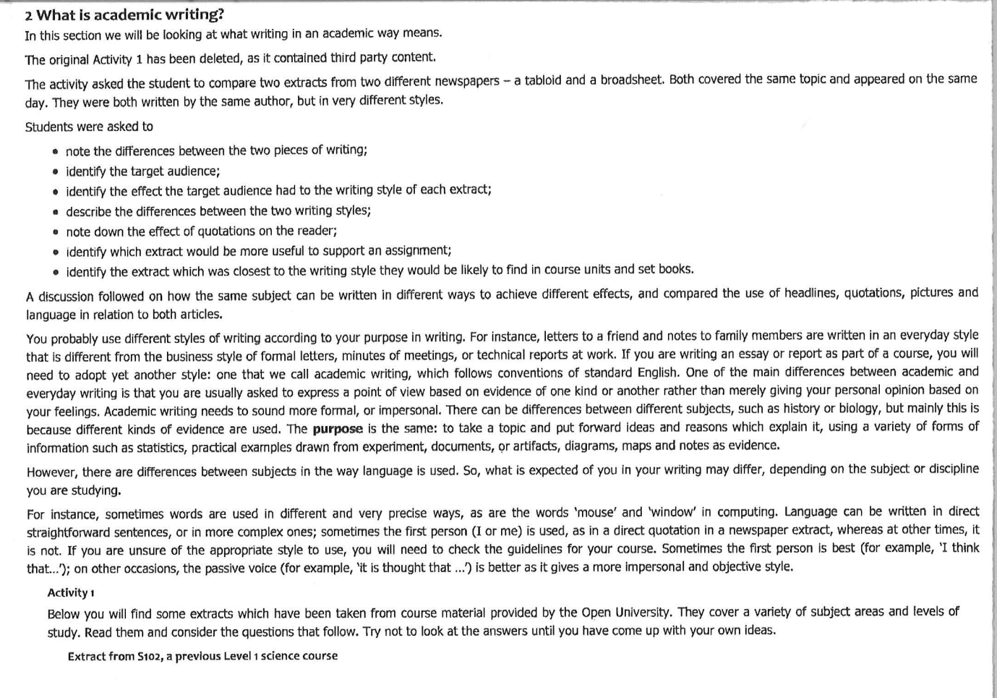
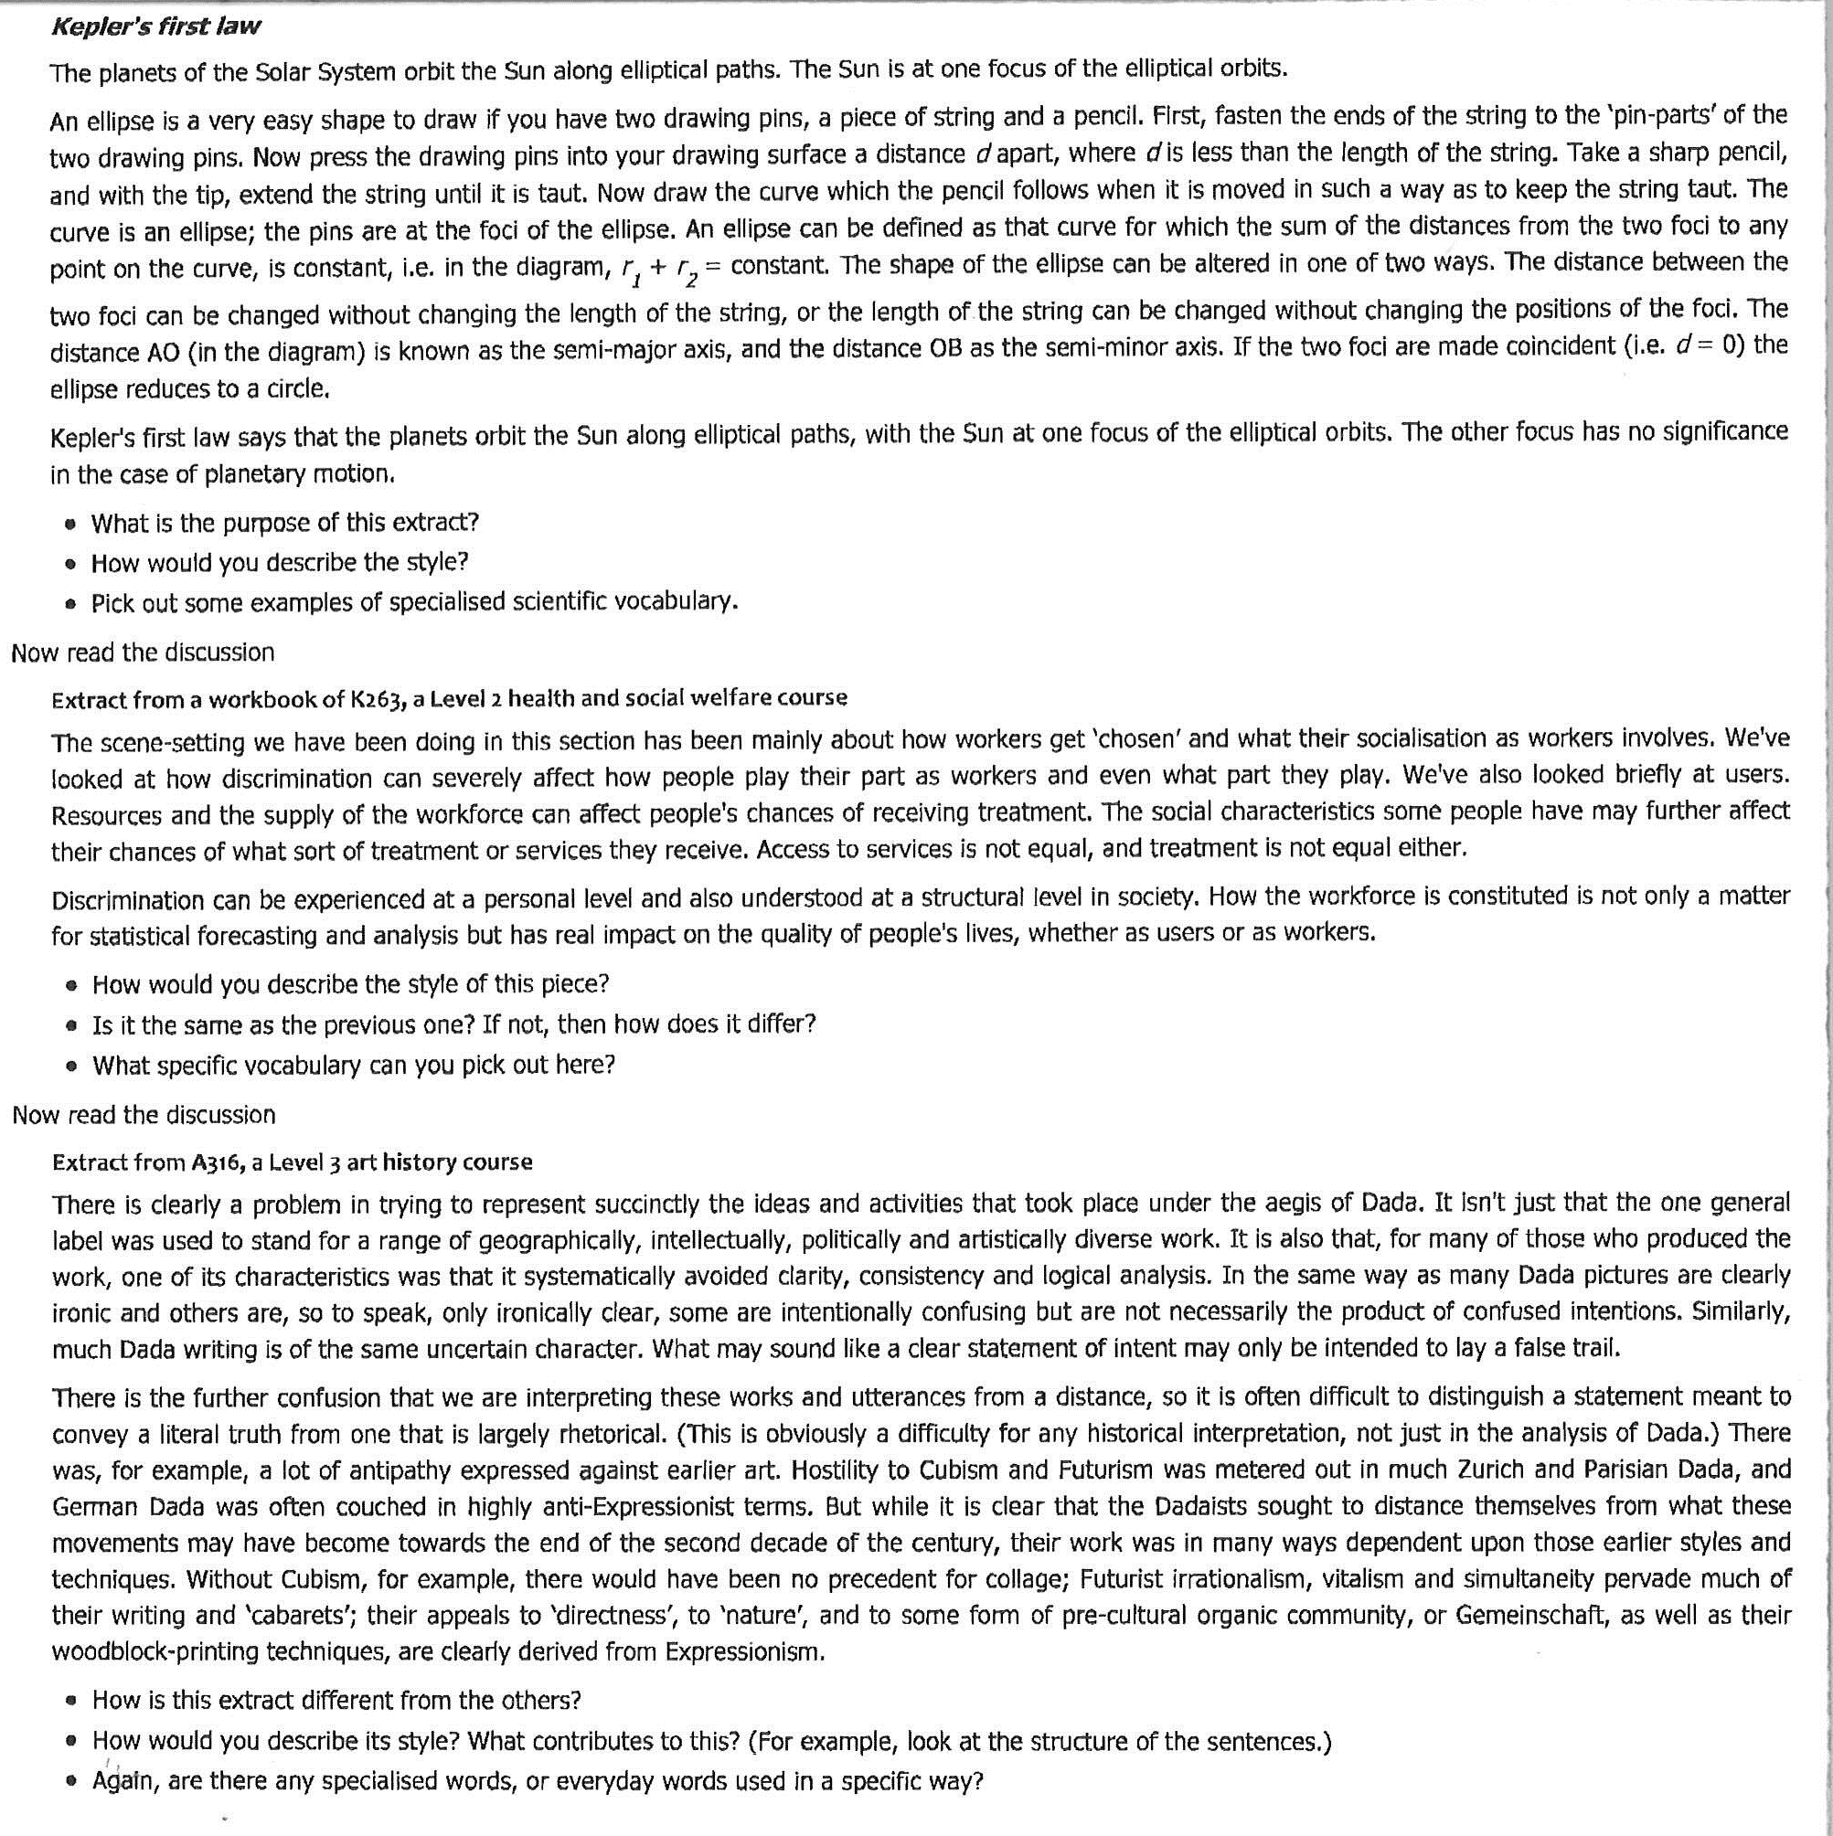
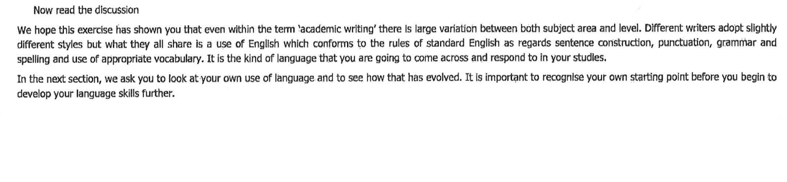

Appendix B

Table representing additional data relating to ALL support

 | Total Student enrolment 2010 and staff: student ratio(Barthel, 2011c) | One-on-one | mentoring | Pre-semester intensive ALL | Meet-Up/PASS
USQ | 25,572  1:5 328 | Yes | Yes (1 campus) | Yes (1 campus) | Yes
Bond | 6900  1:1 150 | Yes – only allowed one appointment per week | Yes
Griffith | 42 619  1:1 776 | Yes | Yes
QUT | 41 946  1: 1 589 | Yes targets NESB  Limited 1 per week/3 per month
UQ | 43 830  1:7 429 | Advised to attend workshop before asking for appointment | Yes Jumpstart and Thrive
CQU | 19 519  1: 1 135 | Yes | Yes runs for 2 semesters
SCU | 15 749  1:2 351 | Yes |  | yes | Yes
University of Ballarat | 11 643  1:6 468 | yes | yes | yes | yes
UNE | 18 068  1:3 115 | yes |  |  | ? last reference in 2007
USC | 8 956  1:3 199 | yes | yes | yes
This table is intended to supplement Alex Barthel’s Table 2 .
The predominantly distance learning universities were not included because the services referred to above are mainly aimed at on-campus students.
The International universities were also not included because they are so different from the Australian ones.

Appendix C

ADAPTED VERSION OF Alex Barthel’s Table 2(Barthel, 2011d)

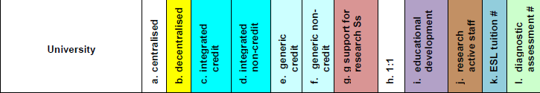
Aggregated Goal Plans for 2012. (2011). University of Southern Queensland.
Barthel, A. (2011a). Comments for Tables 1a, 1b and Table 2 Retrieved 10 December, 2011, from http://www.aall.org.au/sites/default/files/2011%20AALL%20tables%20updateCOMMENTS-2.pdf
Barthel, A. (2011b). Table 1a – Academic Language and Learning (ALL) centres/units Australian Universities Retrieved 10 December, 2011, from http://www.aall.org.au/sites/default/files/table1a-ALLcentresNov2011-3.pdf
Barthel, A. (2011c). Table 1b – ALL staff:student ratio, Retrieved 10 December, 2011, from http://www.aall.org.au/sites/default/files/table1b-ALLstaffStudratio2011-3.pdf
Barthel, A. (2011d). Table 2 – Academic Language and Learning activities, from http://www.aall.org.au/sites/default/files/table2-ALLservicesTypesNov2011-2_0.pdf
Candy, P. (2010). The mouse that roared: Rethinking USQ's approach to learning and teaching. A Discussion Paper University of Southern Queensland.
Derrington, K., Hayes, G., & Peacock, J. (2011). Partners in crime: a collaborative approach to solving students' study and learning mysteries. Paper presented at the Forging New Directions in Academic Langauge and learning: AALL biennial conference, Adelaide.
Dunworth, K. (2009). An investigationinto post-entry English language assessment in Australian universities. Journal of Academic Language and Learning, 3(1), A1 - A13.
Faragher, L. (2012). Building Pathways to Academic Success - Transitions: Poster presented at the Community Engaged Research Evening Poster. LTS. University of Southern Queensland.
Fenton-Smith, B., Lobo, A., Michael, R., Walkinshaw, I., & Humphreys, P. (2011). English Language Enhancement: The Griffith Experiment
. Good Practice Principles for English language Proficiency for international students in Australian universities. (2009). Sydney: Retrieved from www.deewr.gov.au/HigherEducation/Publications/Documents/Final_Report-Good_Practice_Principles.pdf.
Harper, R., Prentice, S., & Wilson, K. (2011). English language perplexity: Articulating the tensions in the DEEWR "Good Practice Principles". The International Journal of the First Year in Higher Education
2(1), 36-48. doi: 10.5204/intjfyhe.v2i1.51
Huijser, H., Kimmins, L., & Galligan, L. (2008). Evaluating individual teaching on the road to embedding academic skills. Journal of Academic Language and learning, 2(1).
James, R., Krause, K.-L., & Jennings, C. (2010). the First Year Experience in Australian Universities: findings form 1994 - 2009 (pp. 1 - 83). Melbourne: University of Melbourne.
Marzano, R. J. (2001). Designing a New Taxonomy of Educational Objectives (first ed.). Thousand Oaks: Corwin Press, Inc.
Murray, N. (2010). Ten ‘Good Practice Principles’ … ten key questions: considerations in addressing the English language needs of higher education students. Higher Education Research & Development, 31(2), 233-246. doi: 10.1080/07294360.2011.555389
Palmer, S., Holt, D., & Challis, D. (2011). Strategic leadership of Teaching and Learning Centres: from reality to ideal. [Article]. Higher Education Research & Development, 30(6), 807-821. doi: 10.1080/07294360.2010.539600
Price, R., Becker, K., Clark, L., & Collins, S. (2011). Embedding information literacy in a first-year business undergraduate course. Studies in Higher Education
1. doi: 10.1080/03075071003725350
Proctor, L., Wartho, R., & Anderson, M. (2005). Embedding Information Literacy in the Sociology Program at the University of Otago. [Article]. Australian Academic & Research Libraries, 36(4), 153-168.
Schwikkard, P. J. (2010). Academic Review of the Academic Development Programme (ADP). Cape Town: University of Cape Town.
Situational Analysis - USQ. (2012). University Document. University of Southern Queensland.
Skinner, I., & Mort, P. (2009). Embedding Academic Literacy Support Within the Electrical Engineering Curriculum: A Case Study. [Article]. IEEE Transactions on Education, 52(4), 547-554. doi: 10.1109/te.2008.930795
Thomas, L. (2002). Student retention in higher education: the role of institutional habitus. [Article]. Journal of Education Policy, 17(4), 423-442. doi: 10.1080/02680930210140257
Trotter, E. a. R., Carole A.,. (2006). Enhancing the early student experience. Higher Education Research and Development, 25(4), 371 - 386. doi: 10.1080/07294360600947368
Vygotsky, L. S. (1986). Language and Thought. Cambridge: The MIT Press.
Wilson, K. (2009). Success in first year: the impact of institutional, programmatic and personal interventions on an effective and sustainable first-year student experience'. Paper presented at the First year in higher education conference, Brisbane. http://www.fyhe.com.au/past_papers/papers09/ppts/Keithia_Wilson_paper.pdf
Wilson, K., Collins, G., Couchman, J., & Li, L. ( 2011). Co-constructing academic literacy: Examining teacher-student discourse in a one-to-one consultation. Journal Of Academic Language And Learning, , 5(1).

Appendix D

Alex Barthel’s Table 2(Barthel, 2011d)

In this case ‘at risk’ students are identified by early failure to engage or deliver a pass quality assignment.
In his Comments Barthel makes the point that the ratios are not accurate because there is a high level of casualization in ALL centres in Australia.

