- ‘When The Night Comes’ (Solo Exhibition)
(Dates: June 4th - June 26th 2021)
When the Night Comes is a series of new paintings by Toowoomba based artist David Usher. David’s works at large directly reference the landscapes that he’s spent time in, responding to characteristics of the site including physical objects, horizon lines, and the light and colour of the landscape, with a focus on the feeling, or emotion of the place.
The new paintings are the first works made since David’s shift in material from acrylic paint to enamel/oil-based paint for the first time in over six months. David felt these new works required a shift to allow him to build up luscious layers, developing translucency, which translates into deeper spaces and atmosphere.
The night paintings depict the landscape in a veil of darkness, some of the works in this exhibition appear to be Dark, that is, until closer inspection, through the layers of pigment and colour, which form deep space, where the night landscape appears.
David speaks about the night landscape as being different to painting during the day, largely because of the feeling the night creates, he describes it as more ‘closed in’, explaining that space is more intimate at night because you can only see a short distance. The colours of the night landscape, and in these paintings are therefore muted by the darkness.
These new works capture the sense of softness, intimacy and depth that occurs at night.
The three long paintings in the exhibition are an example of how David responds to the environment or landscape he spends time in, these paintings have evolved directly from a series of work he made while on residency in Moree, where he was making a series of paintings along a river. These long vistas have within them, trees that frame the painting, indicating where it begins and where it ends.
The night paintings ask us to slow down and look through and into the painting; to become immersed in the soft environments that they create.
David writes:
This group of paintings explores the idea of the ‘nightscape’ and is an investigation of the night’s ‘hidden places’.
As the shadows of evening roll over us and the daylight leaves, we wander out into the night to listen to the murmurings of a different world. A world that balances the activity of the day with a shift, a pause into night. A time for other senses; for listening, for intimacy, for healing, for unravelling pain.
Occasionally these moments are interrupted by a storm on an invisible horizon, or the sounds of night critters going about their business. It is a time for the unknown, the unseen, of changing forms, of trees resting weary limbs from the toils of the day. These paintings move through this world into the next world, an un-silent realm.
The experiences of the ‘nightscape’ offer new information toward my ongoing exploration of the Australian landscape, allowing me to revisit familiar places that become something else, something known but now seen through the lens of the night.
- Alexandra Lawson, June 2021
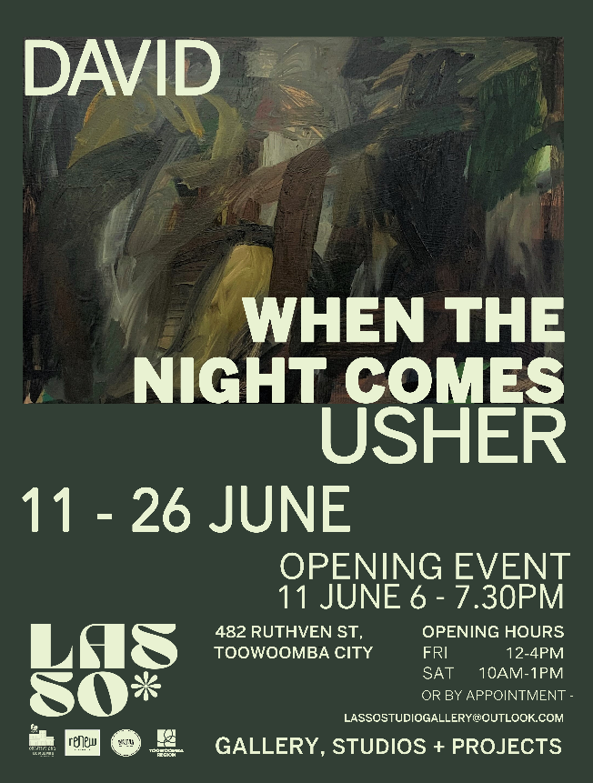
Image #4 - ‘When The Night Comes’ Invite/Poster June 2021

