File | Thumbnail | Description
Ann Russell__Local Wildlife_digital_2017 | 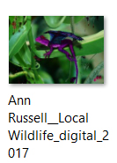 | Glicee print: digital work on canvas – 600mm x 600mm 2017  Photo credit: Ann Russell
Ann Russell__Local Wildlife_digital_2017_original photo | 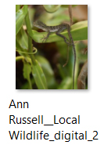 | Original photograph used to create Local Wildlife featured in the exhibition.  Photo credit: Ann Russell
Ann Russell_documentation_2017 winners_scrncpture | 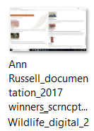 | Screen capture of MBRAA winners  from Moreton Bay Region Art Awards 2017 website
Ann Russell_documentation_featured artist work_scrncpture | 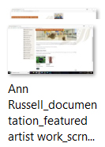 | Screen capture of MBRAA featured artist works  from Moreton Bay Region Art Awards 2017 website
Ann Russell_documentation_invitation_scrncpture | 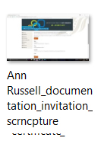 | Screen capture of MBRAA invitation to opening event  from Moreton Bay Region Art Awards 2017 website
Ann Russell_documentation_merit certificate | 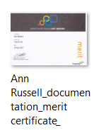 | Scanned merit award certificate: awarded to Ann Russell for Tree of Life
Ann Russell_Tree of Life_mixed media assemblage_2016 | 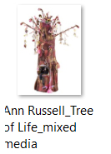 | Tree of Life  Mixed Media Assemblage, 2016  1900mm x 1900mm x 1900mm  Photo Credit: Brisbane City Council.
Ann Russell_Tree of Life_mixed media assemblage_2016_Ann Russell merit | 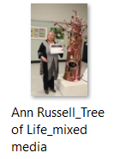 | Ann Russell with Tree of Life sculpture and merit certificate at opening night, Strathpine, Q.  Photo credit: William Russell
Ann Russell_Tree of Life_mixed media assemblage_2016_detail MBRAA | 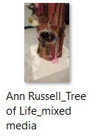 | Tree of Life detail in situ at Moreton Bay Region Art Awards.  Photo credit: William Russell
Ann Russell_Tree of Life_mixed media assemblage_2016_detail | 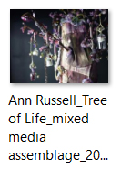 | Tree of Life - detail  Photo Credit: Brisbane City Council.
Ann Russell_Tree of Life_mixed media assemblage_2016_MBRAA | 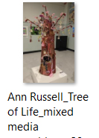 | Tree of Life with Local Wildlife in the background on display at the Moreton Bay Region Art Awards, Strathpine.  Photo Credit: William Russell
Ann Russell_with artworks_in situ | 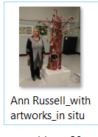 | Ann Russell with Tree of Life and Local Wildlife in the background on display at the Moreton Bay Region Art Awards, Strathpine.  Photo Credit: William Russell

