SHIFT WORK AND POOR MENTAL HEALTH A META-ANALYSIS OF LONGITUDINAL STUDIES
Luciana Torquati^{1,2}, PhD, Gregore I. Mielke², PhD, Wendy J. Brown², PhD, Nicola W. Burton³, PhD, and Tracy L. Kolbe-Alexander⁴, PhD
¹ Sport and Health Sciences, University of Exeter, United Kingdom; ² Human Movement and Nutrition Sciences, University of Queensland, Australia; ³ School of Applied Psychology, Griffith University, Australia; ⁴ School of Health and Wellbeing, University of Southern Queensland, Australia

ABSTRACT
Objectives. To assess the pooled effects of shift work on poor mental health and evaluate whether these differ in men and women.
Method: PubMed, Scopus and Web of Science databases were searched for either longitudinal or case-control studies of shift work exposure associated with adverse mental health outcomes. These outcomes were grouped as: anxiety symptoms, depressive symptoms or general poor mental health symptoms. We calculate pooled effect sizes (ES) using random-effect models, and meta-regression analysis to explore sources of heterogeneity.
Results: Seven articles were included, with 28,431 unique participants. Compared with day workers, shift workers had a higher risk of any adverse mental health outcomes (ES: 1.28; 95%CI: 1.02-1.62, I²:70.6%), specifically for depressive symptoms (ES: 1.33; 95%CI: 1.02-1.74, I²: 31.5%).Gender and overall risk of bias explained 90% and 0.61% of the heterogeneity of results, respectively. Sensitivity analysis showed that the pooled effect size for adverse mental health outcome was higher in female shift workers than female day workers (ES 1.73, 95%CI 1.09-2.76).
Conclusions: Shift workers, in particular women, are at increased risk of depressive symptoms and adverse mental health outcomes. Workplace health promotion programs and policies are needed to minimise shift workers’ risk of poor mental health.
BACKGROUND
Shift work is characterised by alternating and rotating morning, afternoon, and night shifts, with employees often working outside the standard hours of 7am to 6pm¹. About 20% of the working population in the United States, Australia and Europe are engaged in this work pattern^{2, 3}. Given service and production demands, industries in the transport, hospitality, manufacturing and health-care sectors depend on shift work³. Because shift work includes night work, the normal sleep-wake cycle (circadian rhythm) is disrupted, with potential consequences for shift workers’ physical and mental health^{4, 5}.
Altered sleep patterns due to shift work have been associated with irritability, depressed mood, anxiety and nervousness^{6, 7}. Sleeping at odd times of the day, together with shift schedules, create challenges for maintaining healthy work-life balance in shift workers, as opportunities for family, social, and leisure activities are constrained^{8, 9}. This may lead to social isolation and contribute to poor mental health in this occupational group⁸. Mental disorders accounted for 14.4% of the total global burden of disease in 2017 ¹⁰, and are estimated to cost billions of dollars to the health system ¹¹.
Cross-sectional studies have suggested a positive association between shift work and poor mental health.¹² In a large cohort study of Dutch employees, Driesen et al. reported that shift workers were twice as likely to report depressed mood as those working day-only shifts (OR 2.05 95%CI 1.52-2.77).¹² Similarly, Lee et al found that Korean nurses who worked shifts had 1.5 times greater odds of experiencing higher severity of depressive symptoms than non-shift workers (OR = 1.52, CI = 1.38–1.67) ¹³. Longitudinal studies have however, provided conflicting results. Some studies have found increased risks of anxiety and depression in shift workers^{14, 15}, while others have found that shift workers scored higher for psychological wellbeing and general mental health than non-shift workers^{16, 17}. The contradictory findings from these studies may be explained by differences in occupations, industry sectors and the context of shift work in different countries.
Tolerance to shift work is defined as the ability to adapt to it without adverse health effects. This may explain individual differences in responses to shift work exposure¹⁸, as well as gender-differences. A recent systematic review of data from 60 studies of several occupations in 23 countries has shown that male shift workers have better sleep and less fatigue than female shift workers.¹⁸ A prospective study of working conditions in the general Swedish population has shown that female shift workers had higher risk of low psychological wellbeing than male shift workers (RR 1.60, 95%CI 1.0-2.8)¹⁷. In contrast, Bara and Arber¹⁵ reported that male night workers in the UK have higher risks of poor mental health (OR 2.58, 95%CI 1.22-5.48) and anxiety/depression (OR 6.08, 95%CI 2.06-17.92), than their female counterparts (OR 1.06, 95%CI 0.49-2.27 and 1.69, 95%CI 0.60-4.76; respectively).Given these findings, the associations between shift work and the risk of poor mental health in men and women are unclear. Therefore, the aim of this study was to assess the pooled effects of shift work exposure on adverse mental health outcomes and evaluate whether these differ in men and women.
METHODS
We followed the framework proposed by the Meta-Analysis Of Observational Studies in Epidemiology (MOOSE) group¹⁹ for design, research strategy, analysis and reporting. Peer-reviewed publications were searched using three major databases: PubMed, Scopus, and Web of Science. All searches were performed using title/abstract/keywords fields combining shift work and mental health terms, with publication up to August 2018. Search terms used to identify studies with adverse mental health outcomes were based on a previous publication on optimal strategies to retrieve mental health content in MEDLINE ²⁰, and included truncated wildcard terms such as “depress*”, “anxi*”, “psychol*”, “stress*”; and other key words including “mental health”, “mental distress”, “mental OR psychological wellbeing”. We used hierarchical MeSH terms in the PubMed database to optimise inclusion of a range of adverse mental health outcomes (i.e. ‘mental health” [mh]; “emotions” [mh]; “mental disorders” [mh]). Shift work search terms were similar to those used in a previous systematic review on shift work and metabolic risk factors:²¹ “shift work” OR “shiftwork” OR “irregular hours” OR “rotating shift” OR “rotating hours”. A complete list of all search term combinations used in each database is available on request. Reference lists of the included articles were also scanned for relevant studies and for systematic reviews on shift work and mental health.
Two authors scanned titles and abstracts independently to determine whether each article met the following inclusion criteria:

- Prospective cohort or case-control study
- Included a measure of shift work defined as either night shift, irregular work, rotational work, or a combination of these
- Provided an estimate of risk of adverse mental health outcome which was assessed 1) via self-report using a validated scale score outcomes (e.g. poor psychological wellbeing, general poor mental health) and/or 2) diagnosed by a professional as mental illness (e.g. anxiety, clinical depression).²²
- Described shift work as the main exposure and had an independent referent group.
- English language
- Peer-reviewed journal article or government report.

Studies were excluded if shift work exposure was a secondary factor to insomnia, family/social conflict, or similar outcomes. For example, studies of job strain, or relationships at work and similar exposures, were excluded. There was no exclusion based on year of publication.

After selecting potentially eligible studies based on title/abstract, a full-text scan was performed. Disagreement on study inclusion arose for two studies, which analysed data from the same cohort, but with different outcomes^{7,23}. These were resolved by consulting with a third reviewer to reach consensus, which was to include the study with the most recent analysis⁷. After full-text review, seven articles met all the selection criteria; their data were included in the meta-analysis.

Data-extraction
Two authors independently extracted data from each included study. This included information on author/year, study design, follow-up duration/years, sample size, participants’ age and gender, industry in which participants worked and/or cohort name (if ongoing cohort study), definition and assessment of shift work, duration of exposure to shift work (if reported), adverse mental health outcome, and variables used in the adjusted model for risk estimate. Risk estimates were extracted for both crude and adjusted models of odds ratio, relative risk, or hazard ratio. These were included in the analyses if they were measured using validated tools and specific to the outcome reported (e.g. General Health Questionnaire (GHQ) used to identify poor mental health).

Risk of bias assessment
We used a tool from a previous meta-analysis on shift workers’ risk of poor physical health outcomes²⁴ to assess the risk of bias in the included studies in our meta-analysis. Two authors independently assessed the following major domains of bias: (1) exposure definition, (2) exposure assessment, (3) reliability of assessments, (4) confounding, and (5) analysis methods (research-specific bias). The tool also considered the following minor domains of bias: (1a) blinding of assessors, (2a) attrition, (3a) selective reporting, (4a) funding, and (5a) conflict of interest. Each criterion was rated as high, low, or unclear risk of bias, as described in Appendix I. Based on these ratings, we classified studies as low (if all major domains and more than 2 minor domains scored low risk); moderate (if 4 major domains and 2 or more minor domains scored low risk); or high risk (if fewer than 4 major domains scored low risk) of bias.

Data management and statistical analyses
Odds ratios, risk ratios and hazard risks were extracted from each study as a measure of risk estimates, including their respective standard errors or 95% confidence intervals (95%CI). The reference group used in all studies was non-shift workers, defined as those workers either not doing rotational shifts with night shift included, or those who only worked day shifts (7:00-18:00h). For each study, we extracted those estimates with the highest level of adjustment for covariates. When studies calculated the risk estimates for men and women separately, two independent estimates were included in the meta-analysis. For those studies with analyses of sub-groups based on years of shift work, we included data from cumulative groups wherever possible. If a study included more than one type of work schedule (e.g. rotational shifts or permanent night shift), we extracted risk estimates for both groups. We created three categories of adverse mental health outcomes 1) Depressive symptoms; 2) Anxiety symptoms. 3) General poor mental health symptoms (e.g. risk estimates using GHQ score cut-off for caseness).

Risk estimates were used to calculate the pooled effect-size (ES) using random-effects models, to assess the association between shift work and overall risk of adverse mental health outcomes (all three categories combined). We chose this approach as, unlike fixed-effect models, random effect models assume that the shift-work effect might vary between studies, but also within subjects in each study²⁵. We first conducted an “overall effect analysis” including all estimates in a ‘non-exposure vs. exposure’ meta-analysis, with shift work as the exposure group. We then conducted two sub-group analyses: 1) by poor mental health outcomes, using the classification previously described (depressive symptoms, anxiety symptoms, general poor mental health symptoms,); and 2) by gender to assess the risk of adverse mental health outcomes (all three categories combined).

The I-squared test was used to assess heterogeneity. To assess robustness of data and potential sources of heterogeneity, we conducted sensitivity analyses using univariate meta-regression. Variables included in the sensitivity analyses were: type of poor mental health outcome (depressive symptoms, anxiety symptoms, general poor mental health symptoms); gender; exposure definition (low or high risk of bias); industry/occupation (nursing, other); follow-up (<1 year, >1 year); risk of bias (moderate, high); average age of the cohort (<35 vs. > 35 years old); sample size (<1000, >1000); and tool used to measure outcomes (GHQ, other). Funnel plots and the Egger test were used to evaluate publication bias. All analyses were conducted using STATA v12.1 (StataCorp. 2012. Stata Statistical Software: Release 12. College Station, TX, USA).

RESULTS
The results of the systematic review are shown in Figure 1. We retrieved 1902 articles, and after removing duplicates, reviewed 639 by title and abstract and 51 articles by full-text. Of the eligible studies, two studies were not included because of data format (continuous data),²⁶ ¹⁶ which resulted in 7 studies being included in the meta-analysis. These papers included 14 separate estimates of the association between shift work and adverse mental health outcomes.

Study characteristics
Study characteristics are summarised in Table 1. All studies were prospective cohort studies, three had a follow-up ≤ 1 year, and four had a follow-up between 2 and 10 years. The latter studies had larger sample sizes than those with ≤ 1 year follow-up (n= 37-1582 vs 420-9765, respectively)^{15, 17, 27, 28}. The majority of the studies (n= 4) measured general poor mental health symptoms using the 12-question General Health Questionnaire (GHQ) ^{14,15,17,26}. One study also used the Nottingham life-quality questionnaire, but to avoid duplication of estimates we only included the general poor mental health symptoms estimate defined with GHQ¹⁷. One study used the 28-GHQ anxiety and depression sub-scales to define cases of combined anxiety and depressive symptoms. The remaining studies used either the Hospital Anxiety and Depression scale (HADS-14) to define cases of anxiety and depressive symptoms,²⁹ or a self-reported checklist from the Health and Work Productivity Questionnaire (HPQ) for cases of depressive symptoms.²⁷ One risk estimate was excluded from the analysis, as the authors measured symptoms of anxiety and depression together using a single self-reported question.¹³ The average age of participants in the studies was 39.7 years, with a range of 18-60 years.

Risk of bias assessment
The risk of bias was high in more than half the studies, and moderate in the remaining studies (see Table 2). Exposure assessment (e.g. using self-report), and attrition (lost to follow-up>20%) were the two domains with high risk of bias in the majority of the studies. Three studies scored a high risk of bias for exposure definition. No studies reported on the blinding of assessors or researchers undertaking the studies. As this aspect is not relevant to the included studies, the risk of bias was unclear for this item.

Definition and measure of exposure to shift work
Six studies used self-report to measure shift work exposure, and one used company records.³⁰ Studies defined shift work differently, with most using a work pattern consisting of rotations between morning, afternoon and night shifts, or between day and night shifts ^{14, 27-30}. Two studies considered “working nights” as shift work, but without a specific pattern definition (e.g. frequency of night shifts) ^{15, 17}.

Effect of shift work on adverse mental health outcomes
The results of the meta-analysis for the association between shift work and adverse mental health outcomes (three categories combined) are shown in Figure 2. The pooled effect size (ES) shows shift workers had a higher risk of adverse mental health outcomes than those who only worked during daytime hours (ES: 1.28; 95%CI: 1.02-1.62). However, there was substantial heterogeneity among studies (I² = 70.6%). In the sub-analysis by specific adverse mental health outcomes, shift work was associated with 33% higher risk of depressive symptoms (ES: 1.33; 95%CI: 1.02-1.74). The risk of anxiety symptoms and general poor mental health symptoms was higher in shift workers than in day-only workers; however these associations were not statistically significant (ES: 1.20; 95%CI 0.85-1.69 and ES:1.18; 95%CI 0.72,1.91, respectively).
In the sub-group analysis in Figure 3, female shift workers were at higher risk of adverse mental health outcomes (ES 1.78, 95%CI 1.39- 2.14) than female non-shift workers. However, this was not the case for male shift workers (ES 1.14, 95%CI 0.49-2.65).

Sensitivity analysis
Results of the sensitivity analysis are shown in Table 3. The meta-regression results show that gender and overall risk of bias could explain 90% and 0.61% of the heterogeneity of results. The rest of the factors measured resulted in a negative I², which can be interpreted as zero .³¹ When the pooled effect size included estimates from women only, the effect of shift work was higher in female shift workers than in female day workers (ES 1.73, 95%CI 1.39-2.14). But this was not the case for male shift workers (ES 1.25, 95%CI 0.49-2.65). The pooled effect sizes were significant for depressive symptoms, studies with low risk of bias in the exposure definition, studies of nurses, those with large sample size (>1000), and in studies with moderate overall risk of bias.

DISCUSSION
To our knowledge this is the first meta-analysis to investigate the pooled effects of shift work on the risk of adverse mental health outcomes, including symptoms of depression, anxiety, and general poor mental health. The results show that shift work was associated with an increased overall risk of adverse mental health outcomes (poor mental health). Specifically, the risk of depressive symptoms was 33% higher in shift workers than in non-shift workers. Gender differences explained more than 90% of heterogeneity, with female shift workers more likely to experience depressive symptoms than female non-shift workers (OR 1.73, 95%CI 1.39-2.14).
Our results are comparable with a previous meta-analysis that investigated depression risk in shift workers ³². Lee et al. ³² reported a RR 1.43; 95%CI 1.24-1.64, which is similar to our pooled estimate for depressive symptoms (ES:1.33; 95%CI 1.02-1.74). Another review and meta-analysis of longitudinal studies found the majority of studies reported an increased risk of depression with night work, but the pooled effect size was not significant (ES: 1.42 95%CI 0.92-2.19).³³ Our study adds to previous literature by showing shift workers’ risk is also higher for adverse mental health outcomes, not just depression, and this risk might differ between men and women.
Although our study did not specifically assess positive mental health outcomes, our findings of an increased risk of symptoms related to depression and poor mental health outcomes seem to contrast those of Nabe-Niesen et al.¹⁶, who found that Danish shift workers had better mental health and vitality scores than day workers. These differences might be explained by that study inclusion of younger sample, shorter follow-up and exposure to shift work, and participants’ higher control over working times. Sub-group analysis in the other study showed that shift workers with low control of planning working hours scored the poorest in mental health and vitality scales (i.e. how often participants felt energetic, felt worn out, or were tired= “Vitality”; or felt nervous, blue or happy = “Mental health”). ¹⁶.
While not assessed in our study, low job control has previously been demonstrated to have a negative impact on mental health^{34, 35}. This suggests a mediating role for work-related factors in the shift work and mental health relationship. Two recent meta-analyses have reported that specific work related factors such as job strain, low decision latitude, and low social support were associated with higher risk of poor mental health in the working population ^{36,37}. These factors are common characteristics of shift-work and could contribute to the risk of adverse mental health outcomes³⁸. Interestingly, one study showed shift work was not associated with poor mental health after adjustment for psychosocial working conditions ²⁷.
Previous studies have shown that tolerance to different work stressors (i.e. job insecurity, life-work balance) differs by gender, with lower tolerance associated with higher incidence of major depressive disorders in women than in men.³⁹ This might explain the observed higher pooled effect size for general poor mental health in females than in the overall effects in our sub-group analysis (ES: 1.73 vs 1.28). Our findings are comparable to other research reporting increased odds for depressive symptoms in female shift workers than female non-shift workers (OR= 1.52, 95%CI 1.38-1.67)¹³. Cross-sectional analysis from a large Dutch cohort study also reported higher odds of depressed mood in female shift-workers than in their day-shift counterparts (OR = 5.96, 95% CI 2.83–12.56). This was higher than the odds reported for male shift compared with non-shift workers (OR 2.05, 95% CI 1.52–2.77) ¹². Such findings suggest that female shift workers are at higher risk of adverse mental health outcomes than male shift workers.
The higher risk of depression in female than male shift workers may be partly explained by the higher risk of depression among women than men in the general population⁴⁰. This increased vulnerability has been attributed to gender differences in physiological stress responses, biological load and hormones, interpersonal orientation, rumination and internalisation of difficulties, and exposure to other adversity (e.g., relationship violence, discrimination)⁴⁰. Future research on the impact of shift work on adverse mental health outcomes could include measures of other relevant factors, such as alcohol abuse and aggression, that are more prevalent among men than women.
These results suggest that employers should consider strategies for reducing the mental health burden on shift workers, such as giving more control and flexibility over shift schedules, reducing job strain and providing more social support at work. Workplace policies, programs and practices could promote awareness of associated risks and protective factors, and enable access to mental health services, without stigmatisation. Depression accounts for 4.3% of global burden of disease and incidence,⁴¹ with mental disorders worldwide predicted to cost US$ 16.3 million by 2030⁴². Untreated mental health conditions are costly to workplaces in terms of absenteeism, presenteeism and compensation claims. With 1 in 5 people in the United States and Europe doing shift work,^{2, 3} and the increased risk of poor mental health among shift workers, shift work industries are a priority context to reduce this burden.

Strengths and limitations
The strengths of this study include the use of comprehensive search terms, with a combination of keywords that has previously been shown to be appropriate in maximizing retrieval of studies on shift work and poor mental health^{20,43}. We also used large databases, conducted by-hand searches in reference lists of relevant papers, and contacted authors for data, to optimise the data. The exclusion of two studies^{16,26} because of data format (continuous instead of categorical) remains a potential limitation, however it is unlikely that this decision would significantly changed our findings. One study²⁶ had a very small sample size (n=60) and reported similar findings to our study, while the other¹⁶ reported both negative and positive associations between shift work and mental health/vitality. The findings from these studies are similar to those reported in other included studies¹⁷, and earlier in the discussion we explored possible reasons for the differences in associations
We conducted sensitivity analyses on the effects of gender and other factors, however we could not do this for personality traits or job-related factors, as such information was not available in the included studies. We conducted sensitivity analysis on participants’ occupation (nursing vs other), but the lack of occupation information in most studies limited our ability to explore potential moderating effects of specific occupations. Given the large body of literature on these factors, these variables should be considered in future meta-analyses as mediators of overall pooled effect size. To enhance specificity, we grouped estimates into types of adverse mental health outcomes (i.e. anxiety symptoms, depression symptoms, general poor mental health symptoms) and used a dichotomy of present/not present. We acknowledge this could be perceived as a simplistic approach, and that measures used in the included studies were sometimes very basic (e.g. one question item to define clinical depression) and used cut-off scores to identify of adverse mental health outcomes. This approach would be insufficient for diagnostic purposes. We have therefore, used language about “symptoms” (rather than diagnoses) and excluded estimates of anxiety and depression assessed with a single question¹³. Future studies of the effects of shift work on adverse mental health outcomes could include sub-analyses to assess the effects of gender and job-related factors.

CONCLUSION
Shift workers are at increased risk of symptoms relating to depression and adverse mental health outcomes, and this is particularly true for female shift workers. Workplace health promotion programs and policies are needed to minimise shift workers’ risk of poor mental health.
CONFLICT OF INTEREST
Authors declare no conflict of interests or financial conflicts.
REFERENCES
1. Straif K, Baan R, Grosse Y, Secretan B, Ghissassi FE, Bouvard V, Altieri A, Benbrahim-Tallaa L and Cogliano V. Carcinogenicity of shift-work, painting, and fire-fighting. Lancet Oncol. 8:1065-1066.
2. Eurofound. Sixth European Working Conditions Survey – Overview report (2017 update). 2017.
3. Alterman T, Luckhaupt SE, Dahlhamer JM, Ward BW and Calvert GM. Prevalence rates of work organization characteristics among workers in the U.S.: Data from the 2010 National Health Interview Survey. Am J Ind Med. 2013;56:647-659.
4. Wyse CA, Celis Morales CA, Graham N, Fan Y, Ward J, Curtis AM, Mackay D, Smith DJ, Bailey ME, Biello S, Gill JM and Pell JP. Adverse metabolic and mental health outcomes associated with shiftwork in a population-based study of 277,168 workers in UK biobank. Ann Med. 2017:1-10.
5. Torquati L, Mielke GI, Brown WJ and Kolbe-Alexander T. Shift work and the risk of cardiovascular disease. A systematic review and meta-analysis including dose-response relationship. Scand J Work Environ Health. 2018;44:229-238.
6. Karatsoreos IN. Effects of circadian disruption on mental and physical health. Current Neurology and Neuroscience Reports. 2012;12:218-225.
*7. Berthelsen M, Pallesen S, Bjorvatn B and Knardahl S. Shift schedules, work factors, and mental health among onshore and offshore workers in the Norwegian petroleum industry. Ind Health. 2015;53:280-292.
8. Drake CL and Wright K. Shift work, shift-work disorder, and jet lag. Principles and Practice of Sleep Medicine. 2011;1:784-98.
9. Cheung T and Yip PSF. Lifestyle and Depression among Hong Kong Nurses. Int J Environ Res Public Health. 2016;13.
10. Patel V, Saxena S, Lund C, Thornicroft G, Baingana F, Bolton P, Chisholm D, Collins PY, Cooper JL, Eaton J, Herrman H, Herzallah MM, Huang Y, Jordans MJD, Kleinman A, Medina-Mora ME, Morgan E, Niaz U, Omigbodun O, Prince M, Rahman A, Saraceno B, Sarkar BK, De Silva M, Singh I, Stein DJ, Sunkel C and UnÜtzer J. The Lancet Commission on global mental health and sustainable development. The Lancet. 2018;392:1553-1598.
11. AIHW. Australian Burden of Disease Study: Impact and causes of illness and death in Australia 2011. Australian Burden of Disease Study series no 3 BOD 4 2016.
12. Driesen K, Jansen NWH, Kant I, Mohren DCL and van Amelsvoort LGPM. Depressed mood in the working population: Associations with work schedules and working hours. Chron Int. 2010;27:1062-1079.
13. Lee HY, Kim MS, Kim O, Lee IH and Kim HK. Association between shift work and severity of depressive symptoms among female nurses: the Korea Nurses' Health Study. J Nurs Manag. 2016;24:192-200.
*14. Lin P-C, Chen C-H, Pan S-M, Pan C-H, Chen C-J, Chen Y-M, Hung H-C and Wu M-T. Atypical work schedules are associated with poor sleep quality and mental health in Taiwan female nurses. Int Arch Occup Environ Health. 2012;85:877-884.
*15. Bara AC and Arber S. Working shifts and mental health - Findings from the British Household Panel Survey (1995-2005). Scand J Work Environ Health. 2009;35:361-367.
16. Nabe-Nielsen K, Garde AH, Albertsen K and Diderichsen F. The moderating effect of work-time influence on the effect of shift work: A prospective cohort study. Int Arch Occup Environ Health. 2011;84:551-559.
*17. Bildt C and Michelsen H. Gender differences in the effects from working conditions on mental health: a 4-year follow-up. Int Arch Occup Environ Health. 2002;75:252-258.
18. Saksvik IB, Bjorvatn B, Hetland H, Sandal GM and Pallesen S. Individual differences in tolerance to shift work – A systematic review. Sleep Med Rev. 2011;15:221-235.
19. Stroup DF, Berlin JA, Morton SC, Olkin I, Williamson GD, Rennie D, Moher D, Becker BJ, Sipe TA and Thacker SB. Meta-analysis of observational studies in epidemiology: a proposal for reporting. JAMA. 2000;283:2008-2012.
20. Wilczynski NL, Haynes RB and Team H. Optimal search strategies for identifying mental health content in MEDLINE: an analytic survey. Ann Gen Psychiatry. 2006;5:4-4.
21. Proper KI, van de Langenberg D, Rodenburg W, Vermeulen RC, van der Beek AJ, van Steeg H and van Kerkhof LW. The relationship between shift work and metabolic risk factors: A systematic review of longitudinal studies. Am J Prev Med. 2016;50:e147-e157.
22. American Psychiatric Association. What Is Mental Illness? 2018;2018.
23. Thun E, Bjorvatn B, Torsheim T, Moen BE, Magerøy N, Pallesen S. Night work and symptoms of anxiety and depression among nurses: A longitudinal study. Work & Stress. 2014 Oct 2;28(4):376-86
24. Ijaz S, Verbeek J, Seidler A, Lindbohm M-L, Ojajärvi A, Orsini N, Costa G and Neuvonen K. Night-shift work and breast cancer – a systematic review and meta-analysis. Scand J Work Environ Health. 2013:431-447.

25. Riley RD, Higgins JP, Deeks JJ. Interpretation of random effects meta-analyses. BMJ. 2011;342:d549
26. Bohle P and Tilley AJ. The impact of night work on psychological well-being. Ergonomics. 1989;32:1089-99.
*27. Driesen K, Jansen NWH, van Amelsvoort LGPM and Kant I. The mutual relationship between shift work and depressive complaints - a prospective cohort study. Scand J Work Environ Health. 2011;37:402-410.
*28. De Raeve L, Kant I, Jansen NWH, Vasse RM and van den Brandt PA. Changes in mental health as a predictor of changes in working time arrangements and occupational mobility: Results from a prospective cohort study. J Psychosom Res. 2009;66:137-145.
29. Berthelsen M, Pallesen S, Mageroy N, Tyssen R, Bjorvatn B, Moen BE and Knardahl S. Effects of Psychological and Social Factors in Shiftwork on Symptoms of Anxiety and Depression in Nurses A 1-Year Follow-Up. J Occup Environ Med. 2015;57:1127-1137.
*30. Poole CJ, Evans GR, Spurgeon A and Bridges KW. Effects of a change in shift work on health. Occup Med (Oxford, England). 1992;42:193-9.
31. Higgins JP, Thompson SG, Deeks JJ, Altman DG. Measuring inconsistency in meta-analyses. BMJ. 2003 Sep 4;327(7414):557-60.
32. Lee A, Myung SK, Cho JJ, Jung YJ, Yoon JL and Kim MY. Night shift work and risk of depression: Meta-analysis of observational studies. J Korean Med Sci. 2017;32:1091-1096.
33. Angerer P, Schmook R, Elfantel I and Li J. Night work and the risk of depression-A systematic review. Deutsches Arzteblatt International. 2017;114:404-411.
34. Dalgard OS, Sorensen T, Sandanger I, Nygård JF, Svensson E and Reas DL. Job demands, job control, and mental health in an 11-year follow-up study: Normal and reversed relationships. Work & Stress. 2009;23:284-296.
35. Bentley RJ, Kavanagh A, Krnjacki L and LaMontagne AD. A longitudinal analysis of changes in job control and mental health. Am J Epidemiol. 2015;182:328-334.
36. Stansfeld S and Candy B. Psychosocial work environment and mental health--a meta-analytic review. Scand J Work Environ Health. 2006;32:443-62.
37. Theorell T, Hammarström A, Aronsson G, Bendz LT, Grape T, Hogstedt C, Marteinsdottir I, Skoog I and Hall C. A systematic review including meta-analysis of work environment and depressive symptoms. BMC Public Health. 2015;15:738.
38. Åkerstedt T, Garefelt J, Richter A, Westerlund H, Hanson LLM, Sverke M and Kecklund G. Work and sleep-A prospective study of psychosocial work factors, physical work factors, and work scheduling. Sleep. 2015;38:1129-1136.
39. Wang J, Patten SB, Currie S, Sareen J and Schmitz N. A population-based longitudinal study on work environmental factors and the risk of major depressive disorder. Am J Epidemiol. 2012;176:52-59.
40. Kuehner C. Why is depression more common among women than among men? Lancet Psychiatry. 2017;4:146-158.
41. WHO. Mental Health Action Plan 2013-2020 2013;ISBN 978 92 4 150602 1
42. Bloom DE, Cafiero ET, Jané-Llopis E, Abrahams-Gessel S, Bloom LR, Fathima S, Feigl AB, Gaziano T, Mowafi M, Pandya A, Prettner K, Rosenberg L, Seligman B, Stein AZ and Weinstein C. The Global Economic Burden of Noncommunicable Diseases.2011 [online] Ideas.repec.org. Available at: https://ideas.repec.org/p/gdm/wpaper/8712.html [Accessed 21 Dec. 2018].
43. Bekkers MB, Koppes LL, Rodenburg W, van Steeg H and Proper KI. Relationship of night and shift work with weight change and lifestyle behaviors. J Occup Environ Med. 2015;57:e37-44.

Tables and Figures

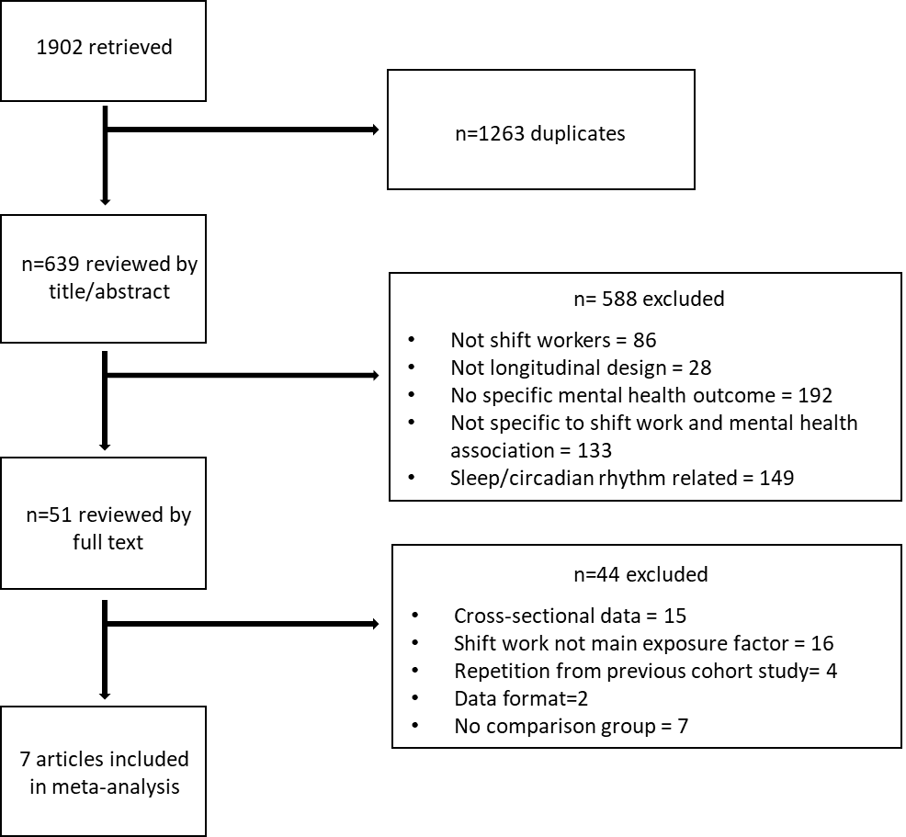
Figure 1 - Flow diagram of literature search and selection of studies
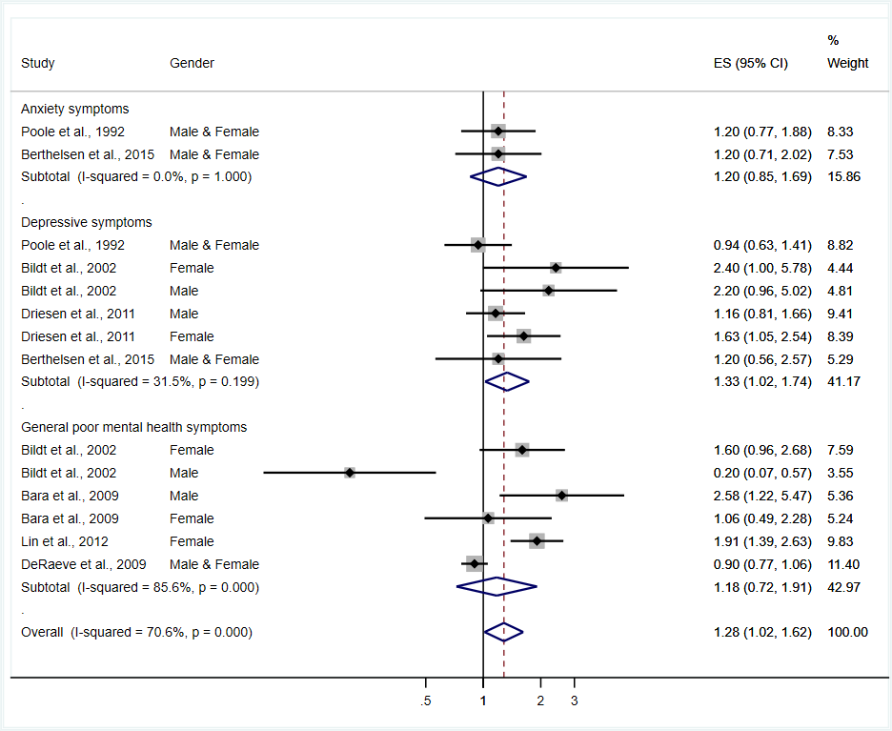
Figure 2 – Effect of exposure to shift work on adverse mental health outcomes.

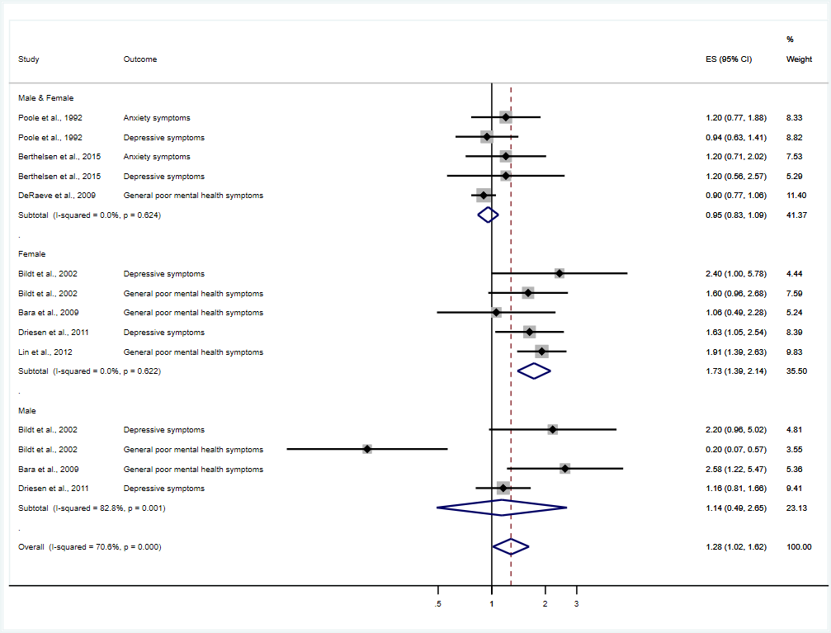
Figure 3 - Effect of shift work on adverse mental health outcomes, by gender

Table 1 – Characteristics of the studies included in the meta-analysis
Author, year | Study design | Follow-up | Outcome category | Tool used | Case definition | Sample size | Age in years* | Gender | Occupational group
Poole et al., 1992 ²⁸ | Cohort study | 6-months | Anxiety and depressive symptoms | GHQ-28 anxiety and depression scales | Score >4 in respective scales | 298 | 35 (18-60) | F&M | Factory employees
Bildt et al., 2002 ¹⁷ | Cohort study | 4 years | General poor mental health symptoms | GHQ-12 | Score >75th percentile | 420 | 46-63 | F&M | Not specified
Bara et al., 2009 ¹⁵ | Cohort study | 8 years | General poor mental health symptoms | GHQ-12 | Score >4 | 9765 | 21-73 | F&M | Not specified
De Raeve et al., 2009 ²⁸ | Cohort study | 2 years | General poor mental health symptoms | GHQ-12 | Score >4 | 6828 | 41.72 (8.70) | F&M | Not specified
Driesen et al., 2011 ²⁷ | Cohort study | 10 years | Depressive symptoms | Self-report HPQ checklist | Current/past treatment of depressive disorder | 8178 | 40.1(8.0) | F&M | Not specified
Lin et al., 2012 ¹⁴ | Cohort study | 1 year | General poor mental health symptoms | GHQ-12 | Score >4 | 1360 | 29.9 (20-45) | F | Nurses
Berthelsen et al., 2015 ⁷ | Cohort study | 1 year | Anxiety and depressive symptoms | HADS-14 | Score >8 in respective scales | 1582 | 30 (21-60) | F&M | Nurses
* Average age at baseline, or the highest mean when the study presented the population in stratified groups, with standard deviation or range presented in parentheses ();F female; M males; GHQ General Health Questionnaire; HADS Hospital Anxiety and Depression Scale; HPQ Health and Work Performance Questionnaire.
Table 2 – Risk of bias assessment in the seven studies

Study | Risk of bias per item |  |  |  |  |  |  |  |  |  | Overall risk of bias
 | Major Domain |  |  |  |  | Minor Domain
 | 1 | 2 | 3 | 4 | 5 | 1a | 2a | 3a | 4a | 5a
Poole et al., 1992 | 0 | 0 | 0 | 1 | 1 | ? | 1 | 1 | ? | ? | High
Bildt & Michelsen, 2002 | 1 | 1 | 0 | 0 | 0 | ? | 0 | 0 | ? | ? | High
Bara & Arber, 2009 | 1 | 1 | 0 | 0 | 0 | ? | 0 | 0 | 0 | 0 | High
De Raeve et al., 2009 | 1 | 1 | 0 | 0 | 0 | ? | 1 | 0 | ? | 0 | High
Driesden et al. 2011 | 0 | 1 | 0 | 0 | 0 | ? | 1 | 0 | 0 | ? | Moderate
Lin et al., 2012 | 0 | 1 | 0 | 0 | 0 | ? | 1 | 0 | 0 | 0 | Moderate
Berthelsen et al., 2015 | 0 | 1 | 0 | 0 | 0 | ? | 1 | 0 | 0 | 0 | Moderate

Items (1) exposure definition, (2) exposure assessment, (3) reliability of assessments, (4) confounding, and (5) analysis methods in the study (research-specific bias); (1a) blinding of assessors,(2a) attrition, (3a) selective reporting, (4a) funding, and (5a) conflict of interest. 1 high risk, 0 low risk; ? unclear. Overall risk of bias defined as Low 0 in all major domains + >2 minor domains=0; Moderate 4 major domains =0 + 2 or more minor domains=0; or high risk <4 major domains=0.

Table 3 – Analysis of potential contributing factors to the effect of shift work on adverse mental health outcomes

Covariate/sub-group | n | ES pooled (95% CI) | I² | Meta-regression  OR (95% CI) | % heterogeneity  explained (R2)
Outcome |  |  |  |  | -57.04
Depressive symptoms | 6 | 1.33 (1.02 – 1.74) | 31.5% | 1.17 (0.57 – 2.37)
Anxiety symptoms | 2 | 1.20 (0.85 – 1.69) | 0.0% | 1.00 (0.38 – 2.59)
General poor mental health symptoms | 6 | 1.18 (0.72 – 1.91) | 85.6% | Index
Gender
Both | 5 | 0.95 (0.93 – 1.09) | 0.0% | Index | 90.5
Male | 4 | 1.14 (0.49 – 2.65) | 82.8% | 1.25 (0.71 – 2.20)
Female | 5 | 1.73 (1.39 - 2.14) | 0.0% | 1.73 (1.09 – 2.76)
Exposure definition
Low risk bias | 7 | 1.32 (1.07 – 1.62) | 37.1% | Index | -20.78
High risk bias | 7 | 1.27 (0.78 - 2.05) | 78.2% | 0.97 (0.52 – 1.78)
Industry type
Other | 11 | 1.23 (0.95 – 1.60) | 72.2% | Index | -3.22
Nursing | 3 | 1.54 (1.09 – 2.16) | 31.1% | 1.20 (0.60 – 2.42)
Follow-up
< 1 year | 3 | 1.31 (0.84 – 2.05) | 74.3% | Index | -26.27
> 1 year | 11 | 1.39 (1.04 – 1.87) | 71.9% | 1.07 (0.50 – 2.27)
Overall risk of bias
Moderate | 5 | 1.45 (1.16 – 1.82) | 25.3% | Index | 0.61
High | 9 | 1.20 (0.87 – 1.67) | 71.7% | 0.84 (0.46-1.51)
Average age
<35 years old | 5 | 1.29 (0.96 – 1.73) | 50.9% | Index | -24.15
> 35 years old | 9 | 1.29 (0.92 – 1.81) | 76.5% | 1.04 (0.52 – 2.07)
Sample size
< 1000 | 6 | 1.17 (0.72 – 1.91) | 72.9% | Index | -20.90
> 1000 | 8 | 1.34 (1.01 – 1.78) | 72.6% | 1.25 (0.65 – 2.42)
Outcome measure
GHQ | 7 | 1.21 (0.80 – 1.82) | 75.5% | Index | -30.22
Other | 7 | 1.28 (0.98 – 1.68) | 58.7% | 1.07 (0.58 – 1.97)
Overall | 14 | 1.28 (1.02 – 1.62) | 70.6%

