Evaluating for the past, present and future: a values-based evaluation of an Aboriginal-led project in rural and remote Australia
Abstract
We use ideas from futurist Sohail Inayatullah and others to unpack the layers of a values-driven evaluation, and the potential role for such an evaluation strategy to support Aboriginal people in Australia to gain acknowledgement of the past and to support a desired future. Inayatullah’s Causal Layered Analysis (CLA) is used as a way of understanding the deep context of evaluation and the way in which a project might meet community priorities emerging from a dark history and its legacy. We present a proposed evaluation strategy centred around the CLA domains of Narrative, Discourse, Systems and Litany. We then use a case study from remote Australia to illustrate the kinds of community priorities that emerge from this deep context, and suggest that in an environment of complex and evolving relations, rather than measuring the contribution of a particular project to economic opportunity or social change, evaluation may need to focus on the ways in which the project becomes integrated into stories of change and other activities, either as a catalyst, an affirmation of commitment, or as part of an array of connected activities enabling change.
Keywords: formative evaluation; values-based evaluation; Causal Layered Analysis; truth-telling; Aboriginal culture; deep context

Introduction
We argue here that evaluation of an Indigenous cultural project, in the context of a difficult history and unfinished processes of healing and restorative justice, requires a deeper analysis of what really matters to such communities; it might then become clearer how a particular project addresses those articulated needs, concerns and aspirations that emerge from the past, present and future. The South-West Queensland Indigenous Cultural Trail was a project that itself tapped into memories and stories of the past and provided an opportunity for Aboriginal participants to articulate histories of inter-generational and inter-racial relations, of privation and resilience; these also provided deep context for the project evaluation conducted by the authors. The stories informed an evaluation strategy that sought to elicit the value and meaning of the project in ways that went beyond the outcomes and impacts envisaged in the project plan and the business plan. We use ideas from futurist Sohail Inayatullah and others to unpack the layers of a values-driven evaluation, and its potential role in commemorating the past and supporting a desired future. Specifically, we draw on Inayatullah’s point about the potential value of Causal Layered Analysis in evaluation, to ensure depth of analysis and a consistency across all levels of program implementation (2015, p. 21).
The South-West Queensland Indigenous Cultural Trail was the culmination of several years of planning and community consultations by the project leader, the Surat Aboriginal Corporation. In the most recent stage of the project, university researchers including the authors were commissioned to gather stories from community members in six towns along the proposed Trail, to develop content for a tourism website and brochure. The broad objectives of the Trail project, as stated in its project plan and business plan, were to convey to the wider public some of the Aboriginal history and culture of each town along the Trail, and to develop entrepreneurial and employment opportunities in Aboriginal tourism and creative industries. Development of research outputs has been focused on interpretation of stories in the context of debates about truth-telling and post-contact Aboriginal heritage, reflections on the process of story-gathering and the significance of the Trail project for communities and for researchers.
During the time that the research team was working on development of content for the Trail, the funding administrator commissioned the same researchers to develop an evaluation framework and to begin the evaluation process. This simultaneous development of an evaluation framework would provide a context for future evaluations of impact and outcomes. In developing the framework, we took as our starting point that the Trail was both an economic opportunity and a form of cultural engagement for those who contributed content, for those who would be involved in activities associated with the next implementation phase, and for those who visited the communities to experience the Trail sites and stories. Partal et al (2016, p. 8) draw attention to the potential confusion between the impact of culture (where ‘culture’ may, for example, be the activities of a cultural institution) in a range of domains, and the impact on culture of interventions (whether the interventions are cultural or not). Our study was concerned with the impact of engagement with culture on communities, in domains that included the social, cultural and economic.

A values-driven evaluation strategy
In developing an evaluation strategy for the Trail project, we initially drew upon the project plan and the business plan to develop evaluation questions (or ‘Key Evaluation Questions’ (BetterEvaluation, 2016)) using the project objectives, outcomes and impacts. Evaluation questions are ‘the overarching questions guiding an evaluation’ as opposed to specific survey or interview questions (CDC National Asthma Control Program, 2013. See also NSW Department of Premier and Cabinet 2018). Evaluation questions are questions evaluators ask themselves in order to develop an evaluation plan, and to clarify the purpose and the methodology of the study: Why are we doing this study and who is it for? What are the unusual or unique aspects of the context? What might we miss? Who might we miss? They are similar to the questions Mulligan and Smith (2010, p. 100) asked themselves in implementing a community development project in Australia:
‘What are issues that are controversial? Who are the people driving change? Who are the people who are most critical in these places at the moment?’ And ‘who will have some interesting things to say about those places…?’
We used the evaluation planning process to develop evaluation questions that ranged outside the projected outcomes and impacts described in the Trail’s project plan and business plan. Although these plans had been developed in consultation with communities, we sought the ‘hidden’ or not yet identified objectives that project participants may have, and their understanding of what success would look like. In line with this wider exploratory approach, evaluation questions for future stages of evaluation included: ‘What were the unintended outcomes and impacts?’
However as we continued to work in our other role, on developing the story content for the Trail, it became clear that another kind of question was being constructed for us as evaluators: a meta-question that sat above all of our evaluation questions. We had reviewed the project plan and business plan with their envisaged impacts and outcomes, including a ‘SWOT’ analysis that drew attention to potential strengths, weaknesses, opportunities and threats to the project; we had added questions to elicit objectives for the Trail that may not have been included in the plans, and questions that would look at unforeseen outcomes and impacts. It soon became obvious that the Trail project was enmeshed in, and needed to be evaluated in the light of, a much bigger picture: historical relations between Indigenous and non-Indigenous people, a growing tide of truth-telling about the post-colonisation period, and older Aboriginal people’s concerns about the present generation’s disengagement from culture and the future preservation of cultural knowledge. The physical erasure of Aboriginal history – by flooding, roadworks, housing or land clearing – includes the razing of shelters (humpies) and other important places on the former fringe camp sites where Aboriginal people were forced to live on the outskirts of the towns until the late 1960s. One Aboriginal community leader who instigated the construction of an interpretive structure and a replica humpy on the site where she spent her childhood said to us: ‘They bulldozed us away, but they won’t be able to bulldoze this. They can’t pretend we weren’t here.’
Partal and Dunphy (2016, p. 3) point out that all impact assessment ‘assumes an intervention whose effects will be measured against a set of potential stakeholders’ needs.’ Evaluations too need to be clear in identifying stakeholders and their needs. This is especially the case when the researchers/evaluators are also involved in the development of the project itself, and hence where both community and researchers are stakeholders. Wadsworth (1997) notes in her discussion of the many potential variables in designing an evaluation:
We need to find a way through all this, especially when it comes to all the different interpretations of ‘value’ or ‘worth’ of an effort, and it is at the planning stage we can find it. The primary task is to focus on the ultimate purposes of the evaluation, and to sort out how all the different parties to an evaluation relate (or don’t) to these ultimate purposes (p. 12).
For the Trail project, as a consultancy commissioned by an Aboriginal organisation, it was clear from the outset that the primary goals were community goals. Research findings and outputs were something that the researchers value-added throughout and after the course of the project. Moreover in the case of the evaluation study, the researchers’ brief was explicitly to evaluate community outcomes and impacts.
What became evident was that ‘stakeholder needs’ for Aboriginal people in these communities were complex and rooted in history as well as in current concerns and hopes for the future; the Trail project therefore also needed to be located within this past, present and future. Beyond the evaluation questions we had set ourselves, the question – a meta-question – that emerged to drive the whole of our evaluation framework was: ‘What matters most to the community?’ It is a similar kind of question to that posed by Cairney et al. (2015, p. 13) in working with Aboriginal communities on wellbeing research, that is, to find out ‘what communities wanted to get out of the research.’ They found that there were key issues governing communities’ interest in participating, which also emerged from past, present and future, including: empowerment of Aboriginal people, provision of empowered and sustainable health services, and partnerships ‘where governments listen to, respect and accommodate the views of community leaders.’
What matters most to the community may, as we found in our evaluation study, only emerge after the evaluation process has commenced. As we learned more about the history of communities through developing story content for the Trail, the continued presence of this history in the here-and-now became increasingly evident. As we began to develop our evaluation strategy, we realised that the value and meaning of the Trail project was framed by this history, by the current needs of the Aboriginal community for truth-telling and acknowledgement, and by hopes for a future in which knowledge would be passed down the generations and the wider public would be aware of this history and its legacy.

Evaluating for the past, present and future
Meta-questions seek a higher order or hidden meaning or purpose that may not be evident until articulated in response to questions that search more widely than those built upon a project plan or business plan, with their already-identified objectives and indicators. In this regard, evaluation as a process is analogous to research conceived of as necessarily linked to the good of society. Erich Jantsch (1972), for example, drew attention to the importance of purpose and meaning in the work of universities, work that should, he claimed enhance ‘society’s capability for continuous self-renewal’ (Jantsch, 1972, p. 12 (italics in original)). Jantsch focused on science, and suggested that, rather than maintaining itself as an ‘autonomous enterprise,’ science should be embedded in debates about social systems, meanings and values. The result would be ‘the organization of science toward an end’ (Jantsch, 1972, pp. 14, 15)
Twenty-five years later, Jane Lubchenco (1998) argued that in the face of rapid environmental change, science had to enter a new social contract for the 21st century that recognized human health, social justice and the economy as integrally connected to environmental ecologies (p. 491). She quoted John F Kennedy: ‘Scientists alone can establish the objectives of their research, but society, in extending support to science, must take account of its own needs,’ and argued that public investment in science should be ‘tied to outcomes that are beneficial to society’ (p. 494).
This idea of a higher (social) order of value that needs to direct the research of scientists also encompasses the idea of evaluation as playing a role connected with values. Evaluating cultural initiatives, Dunphy suggests, must occur ‘against a set of shared ideas about what is valuable’:
What do we value, and therefore what do we need to measure, about the outcomes of arts engagement, or any other activity?’ (Dunphy, 2015, p. 248).
The answers to such questions may come in the form of complex stories about the community that draw together many threads and situate the project within a relational web connecting it to history, to the needs and issues of the present, and to beliefs and hopes about the future of the community. This is especially so in the area of cultural heritage, the subject of our case study, with its intangible aspects of ‘ethical values, social customs, traditions and practices, stories, beliefs and myths’ (Harrington, 2004, p. 63) that are connected in deep ways both with the way history is valued and, in turn, with the politics and needs of the present:
[H]eritage has always been with us and has always been produced by people according to their contemporary concerns and experiences.
This is especially so in the case of Indigenous and other politically-contested heritage:
[A]ll heritage values proceed from a political tug of war for the control of power (González Zarandona, 2015, p. 177)
Of course identification of what matters most to communities – Wadsworth’s ‘primary task’ – would ideally occur at the initial design stage of any project by seeking input from a community on its most important needs and priorities and how the proposed project might support these. However projects are born of many parents – for example funding sources (government and non-government) and/or researchers with a defined brief. Even where a project originates in community, its design may reflect the interests of a particular community group. As Wadsworth (1997) notes, evaluation against criteria already laid down in a project description ‘may always need to be complemented by evaluation against as-yet unnamed, unarticulated and unthought of criteria’ (p. 7). Hence the value of the meta-question at the evaluation stage, especially in a developmental or formative evaluation (discussed below) which can inform the ongoing development and implementation of the project. As Figure 1 illustrates, the meta-question may initiate both the planning and measurement stages of evaluation, but may also arise only after the design, or even the measurement, stages have begun, as was the case in the Trail evaluation. Indeed the evaluation process may be the first opportunity that community members have had to articulate responses to such a question.
The layers of meaning we developed for the evaluation of the Trail were based on Inayatullah’s Causal Layered Analysis, where exploring an issue can occur at several levels: the first level, ‘litany,’ shows quantitative trends, ‘statements of fact’, followed by the second level, ‘system,’ which concerns social, economic, cultural or historical factors underlying these trends. The third level consists of the prevailing discourses and worldviews that support systemic factors, and finally the fourth level of exploration reveals the underlying myth or metaphor – a collective archetype or narrative that drives these worldviews and systems (Inayatullah, 1998, p. 820; 2015). Evaluations, especially summary evaluations, are often focused on the ‘litany,’ that is, on gathering quantitative data that will demonstrate a change and can be stated as a ‘fact,’ for example: the number of tourists visiting a town; the income received by small businesses; the number of new jobs; or even the number of anecdotal reports of interest in the project. Blomkamp points to this tendency in evaluation when he notes that the largest group of cultural indicators today consists of economic measures – culture as commodity (2015, pp. 19, 20), followed by the even less descriptive ‘frequency of engagement’.
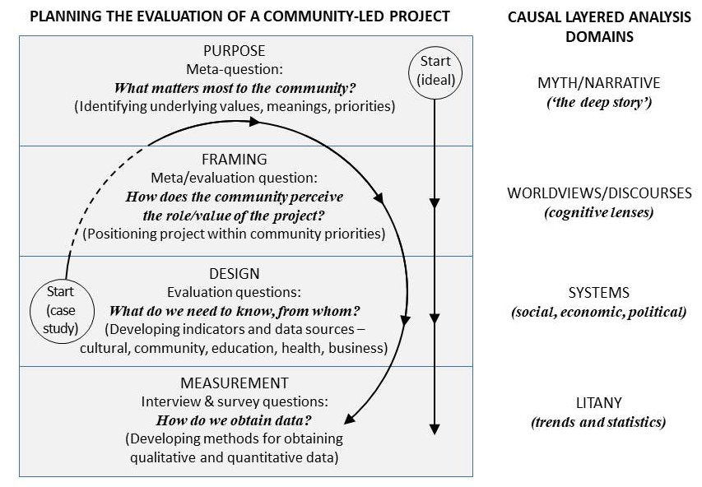
Figure 1: Layers of evaluation derived using Causal Layered Analysis
(after Inayatullah, 1998, 2008)
Figure 1 suggests that evaluation planning should instead begin at the deepest level, first seeking to learn from communities their most important values and priorities. Through understanding this, evaluators can ask community members how a project such as the Trail sits within these values and priorities: the role and value it might have in addressing the community’s most important needs or aspirations. The evaluation strategy then needs to look at how social, economic or cultural changes might be revealed by drawing on diverse sectors of the community, and then what sorts of interview or survey questions are needed to elicit evidence – qualitative or quantitative – of change. The results of implementing such an evaluation strategy could show for example increased intergenerational communication about culture, or a sense of prosperity evident in tourism businesses planning for the future. At a deeper level, it might show changes in discourse or worldview – increased optimism about the future evident in community and local government meetings and their communications with the public. Finally, the evaluation might reveal changes in the community ‘narrative’: from ‘backwater’ to ‘hospitality hub’, from ‘dying town’ to ‘thriving town,’ from ‘racially divided’ to ‘multi-culturally proud’.
Obtaining this kind of data through qualitative research enables participants to articulate the deeper levels of meaning that the project has in their world. Discourse and myths or deep narratives especially are unlikely to emerge in standard interviews based on key performance indicators – they require open-ended questions that allow reflective discussion, where deeper issues, and the way that a particular project might be perceived to sit within them, can be explored. Mulligan and Smith (2010, p. 99) point out, in the context of community development, how easy it is ‘to focus on people’s needs and problems … rather than the interesting and often neglected stories that they can tell;’ such stories, they suggest, might themselves prompt reflection and greater understanding within a community. Our evaluation framework needed to allow such stories to be told; it needed to enable connections to be made between the project and what mattered most to the community, emerging from the historical and ongoing difficult relations between Indigenous and non-Indigenous people in post-colonisation Australia, a history of ‘top-down’ interventions by government organisations in Aboriginal communities with little input from the communities themselves, and the complex but under-explored relationship (Anderson, Baum, & Bentley, 2007; McCalman et al., 2010, p. 160) between social, emotional and spiritual wellbeing, and cultural engagement. The meta-question – ‘what really matters to the community?’ and then ‘How does this project connect with it?’ – are implicit questions, the answers to which would emerge through conversations that were allowed to go beyond the ‘litany’ of numbers and trends, and even beyond descriptions of social or economic factors such as access to education, disparities in wealth, or unemployment. The outcome of these conversations during the Trail evaluation study is described later in this paper.
Inayatullah (2015, p. 21) points out that the indicators of success measured at the ‘litany’ level should emerge from and reflect the deeper changes that the community wishes to see at the systemic, discourse and ‘metaphor’ levels. In looking at the importance of historical context and current concerns and aspirations of communities, our meta-question could be expanded by adapting other terms used by Inayatullah: ‘How does the Trail project sit within over-arching community priorities that emerge from the ‘weight of history,’ the ‘push of the present’’ and the ‘pull of the future’ (2008, p. 8). Figure 2 adapts Inayatullah’s ‘futures triangle’ to suggest that the higher order purpose of evaluation emerges from a consideration of these three forces. A project such as the Trail invokes dark history, the needs of the present (truth-telling, addressing economic disadvantage, preserving knowledge) and hope for healing, reparation, acknowledgement, and a process of makarrata (peace-making) in the future. The Trail’s evaluation is thus doubly situated within this temporal frame: the evaluation is intrinsically a process to be driven by community priorities that emerge from this past, present and future, but it is also required to assess the value of the Trail itself as a project designed specifically as a form of truth-telling about the past in the present.
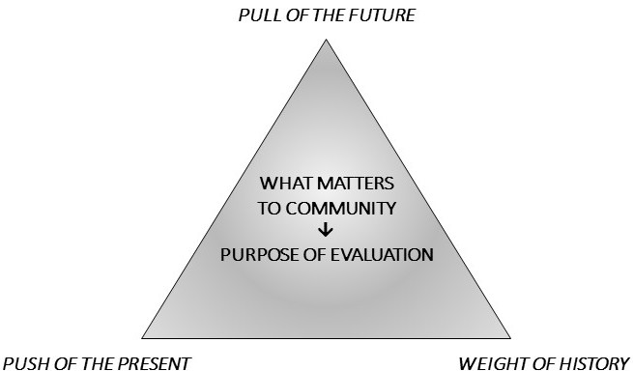
Figure 2: Drivers of evaluation strategy
(after Inayatullah, 2008)
Finding out ‘what matters,’ is a collaborative process between community and researchers/evaluators. We found that responses to open-ended questions from evaluators can lead to complex discussions about where a project might sit within a broader complex of issues and priorities, with the emerging articulation of these issues and priorities becoming a touchstone for future evaluations. In our interviews, we asked direct questions about the participant’s objectives and indicators of success, but also used broader questions such as:
- What are some of the issues that your community is facing today?
- How do you think this project might help with these issues?
These discussions and articulations enabled us, through a thematic analysis that we outline below, to develop qualitative indicators that could be used in the future to assess the impact of the Trail on issues of importance to communities. For Aboriginal people in South-West Queensland, the perpetuation of cultural knowledge, the re-engagement of young Aboriginal people with their heritage and with their Elders, and the sharing of Aboriginal history with non-Indigenous people were of paramount importance. These are cultural indicators that ‘tap the structure of beliefs and values serving to maintain society’ (Badham, 2015, p. 198, and citing J. Zvi Namenwirth 1984), in contrast to economic or social indicators of cultural engagement that focus on measures such as wealth generation or audience numbers.
As the value of culture ‘turns on people’s own experience, conveyed in their own words,’ evaluating a cultural project such as the Trail must use ‘tools best suited for that purpose: story, image, metaphor, and experience’ (Goldbard, 2015, pp. 222, 226). Future evaluations of the Trail will need to connect it with the experience of multiple stakeholders, in an evolving context of continued truth-telling and reconciliation efforts, alongside ongoing racism and economic, education and health disparities. The indicators of the Trail’s success that are more important to Indigenous people – community cohesion, intergenerational learning and respect for Elders, and recognition of the past by non-Indigenous people – will be hard to measure, and any measured changes harder to attribute to the Trail itself. It is in these kinds of circumstance that, as Goldbard points out, story-based data will be most valuable. A story pulls together diverse factors into a coherent whole that illuminates the relationship between things rather than the quantitative contribution of any particular thing: a story ‘enacts connectivity’ (Griffiths, 2007).
There will, however, still be a place for numbers. Tanguay points out, in discussing culturally relevant indicators of wellbeing, that numbers are still needed to inform policy and programs, and, in her case study of wellbeing evaluation in Melanesia, looks at developing innovative quantitative indicators that reflect Melanesian values:
‘If Melanesian values are left at the level of inspirational rhetoric, conventional indicators will continue to play unwitting roles in Melanesian society (Tanguay, 2015, p. 170).
We discuss at the end of this paper some of the challenges in obtaining quantitative data to measure the impact of the Trail project in terms that matter to its stakeholders.

Methodology for evaluating the South-West Queensland Indigenous Cultural Trail

Summative,-formative, and developmental evaluation
The evaluation study we undertook for the Trail project can be seen as a form of developmental evaluation as defined by Patton (2011). In his discussion of the distinctions between summative, formative and developmental evaluation Patton describes a summative evaluation as a ‘judgement of overall merit’ (p. 44) which occurs at the end of a project using methods such as impact and outcome evaluation and cost-benefit analysis; formative evaluation relies on similar methods, but occurs during the period of project implementation, with a view to improving the project model based on feedback (pp. 2, 39). (The purpose of formative evaluation has been described elsewhere as ‘to get ready for summative evaluation,’ and enable further development of ideas after seeing how they ‘work in practice’ (Gujit, Kusters, Lont, & Visser, 2012, p. 1)). Patton distinguishes formative from developmental evaluation: while the former is concerned with improving the project model, the latter, he argues, takes account of a wider context and enables a project to respond strategically, and more radically, to changes in ‘the economic, political and technological environment’ (p. 51) This kind of evaluation can be seen to connect with deeper layers in the Causal Layered Analysis framework, since it can be influenced by changes at the systemic and discourse levels. It should be noted that while summative and formative evaluations may assess changes at systemic or discourse levels, the methods employed to measure such impacts, as we noted above, generally focus on the ‘litany’ level, that is, numbers and trends. Figures 3 and 4 summarise the differences between summative-formative evaluation and developmental evaluation.
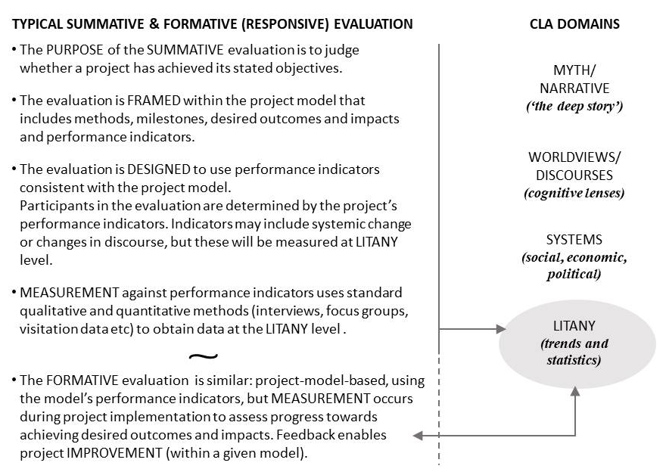
Figure 3: Relationship of summative and formative evaluation
to Causal Layered Analysis domains

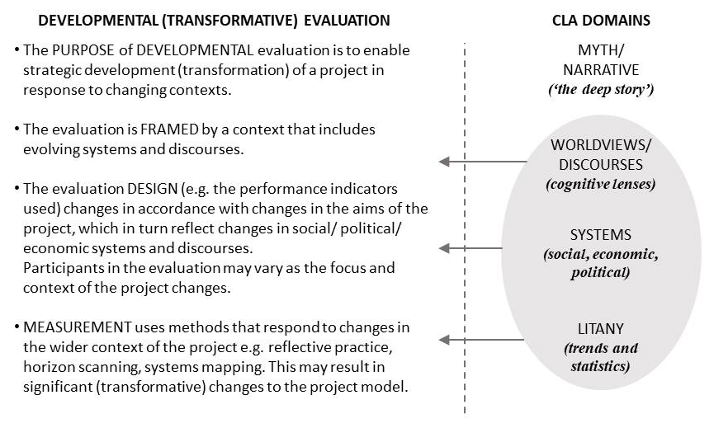
Figure 4: Relationship of developmental evaluation
to Causal Layered Analysis domains
Developmental evaluation has also been taken to require an evaluator embedded in the project team who ‘actively [intervenes] to shape the course of development.’(Dozois, Langlois, & Blanchet-Cohen, 2010, pp. 12, 14). While the evaluation strategy for the Trail project has many elements of developmental evaluation – for example a focus on wider context and the deeper layers of Causal Layered Analysis – it differs in important ways. Firstly, at a practical level, the evaluators may not be involved in future modifications and developments of the project (due to funding constraints); nor did the researchers attempt to ‘shape the course’ of development. Secondly, and most significantly, all the domains of Causal Layered Analysis were centred in designing the evaluation strategy, from ‘deep story’ through to ‘litany.’ Rather than drawing upon these domains for ‘data’ to evaluate the project (summative-formative), or modifying the project model in responses to changes in these domains (developmental), we found as we worked with communities that the CLA domains helped us to understand how we might approach the evaluation strategy itself. Martin and Mirraboopa’s (2003) seminal paper on Indigenous and Indigenist research argues that all research by and for indigenous people should be based on ‘the protection and preservation of our country and its Entities and the protection and preservation of our Ways of Knowing, Ways of Being and Ways of Doing’ (p. 211). This is also a way of describing the fundamental (meta-) purpose of evaluating an Indigenous-led project. As can be seen in Figure 5, the approach to all parts of an evaluation strategy then flow from this, right down to the litany level where the concept of ‘yarning’ as a method might replace ‘interview’ as a way of seeking data (Laycock, Walker, Harrison, & Brands, 2011). We should note here that the evaluation strategy represented in Figure 5 underlies, rather than replaces, any future formative and summative evaluations. Its power lies in its reframing of any evaluation so that the deeper levels of Causal Layered Analysis are not simply sources of data but rather domains in which the evaluation itself is situated.

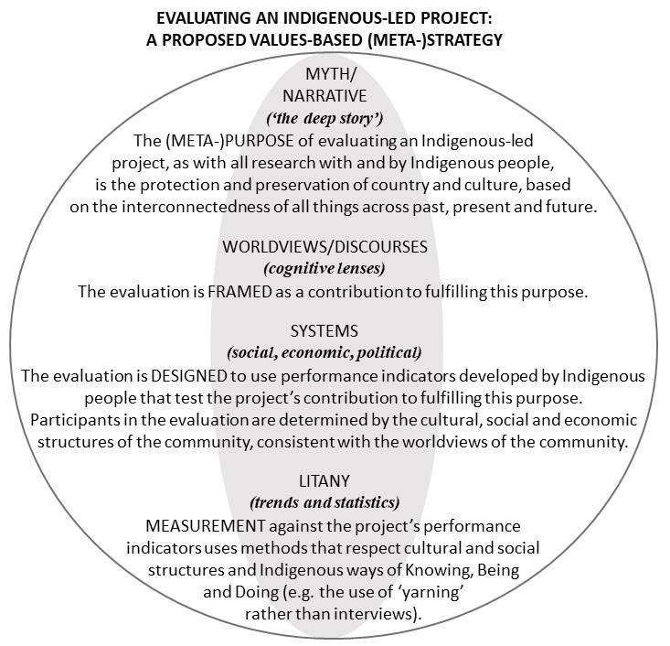
Figure 5: Relationship of a proposed values-based evaluation strategy
to Causal Layered Analysis domains

Evaluation questions
This paper is focused not on outcomes and impacts of the South West Queensland Indigenous Cultural Trail, about which it is too early to pronounce, but concerns instead those broader questions about development of indicators of success or value. Mitchell and Parkins’ (2011) discussion of cumulative impact assessments suggests that in developing indicators, we need to ‘focus our energies more on the social processes that feed into a determination of these social indicators’. This means more attention to case studies and historical accounts that help to identify those indicators that are ‘valued and prioritized by humans within a given assessment context.’ The kind of evaluation strategy developed for the Trail project required a participatory approach to the development of indicators; this is where the importance of evaluation questions emerges, such as:
- Who is at the table when these decisions are made?
- What interests are reflected by these indicators?
- Who is privileged in this process and who is left out? (Mitchell & Parkins, 2011)
These questions can be combined with those that developmental evaluation seeks to answer:
- What is getting developed in interaction with the complex environment?
- What are the implications, the anticipated consequences of that being developed? (Gujit et al., 2012, p. 2, emphasis added)
The first of Gujit’s questions is connected with another question ‘what is effective for whom, under what conditions?’ (Gujit et al., 2012, p. 5), which replaces the ‘static’ question ‘Does it work?’; this is particularly relevant to evaluating the Trail project, since ‘conditions’ are complex and dynamic, involving changes in demographics, education, employment and economic regional profiles, multiple government and non-government programs, interventions and funding sources, evolving cross-cultural relations between Indigenous and non-Indigenous people in the region, and a history of material and ‘invisible’ losses (Turner, Gregory, Brooks, Failing, & Satterfield, 2008) that have accumulated, and continue to accumulate, in Indigenous communities over more than 200 years of colonization.

Indicators
In such an environment, where culture, history, employment, education, family and economic circumstances, health and social and emotional wellbeing all interact, identifying the ‘anticipated consequences’ of the development of the South West Indigenous Cultural Trail requires input from the kind of ‘historical, descriptive, and democratic accounts’ alluded to by Mitchell and Parkins (2011). In seeking such accounts, we found articulations by community members of the challenges their communities are facing and how the Trail project sat within an array of hoped-for future changes to address these challenges. In our discussions with community members, both Indigenous and non-Indigenous, ‘aspirations’, ‘anticipated consequences’ and ‘indicators of success’ were almost indistinguishable – intergenerational preservation of Elders’ stories, greater community cohesion, more employment and economic opportunities, fitted all of these domains.
An evaluator in the future may be able to identify the Trail simply as an intermediary step, or as working in combination with other activities, in addressing community priorities. There is no measuring unit for the ‘essentialness,’ or degree of importance, of the Trail in the network of relations that support increased cohesion, intergenerational learning and other outcomes, but the Trail’s visibility in anecdotes and stories will itself be an indicator that it holds a role in change. Our interviews with Indigenous and non-Indigenous participants suggested that the Trail might act simply as a demonstration that something can be done to change the system, or that someone in the community is prepared to invest in the possibility of change; it might also act as a recognition of the need to keep culture alive.
You know, it's good to see someone actually thinking what can happen.
[from transcript of interview with non-Indigenous local business owner, 10 February 2017].
I reckon [the Trail]'s a good thing….it [will be] something to look back on when our grandkids and great grandkids and that know where they've come from.
Well if we don't do it now, we're going to lose that knowledge.
[from transcript of interview with two Kamilaroi Elders, 29 September 2016]
The Trail may thus act effectively as an encouragement, a message, or a catalyst, rather than a ‘successful program’ in accordance with the project plan; such changes may nonetheless be of critical importance in the context of the history and current concerns of Aboriginal communities. Success therefore needs to be unpacked as ‘successful for whom?’, and ‘successful in what context?’ And what is the ‘it’ that is successful? Only by speaking with people in participating communities, and understanding more about the past, present and hoped for future, can we answer these questions.
Our study was thus focused on developing indicators that would show changes at a deeper level supporting ‘what matters most’ (‘the deep story’’) – rather than measures such as ‘number of new jobs created’, ‘number of people accessing the website’ etc (‘litany’). The indicators needed to be couched in relational terms: what role does the Trail play in the complex relations between the transmission of knowledge and community cohesion, between cultural (re-)engagement, and employment and economic growth? Moreover the indicators are ongoing – ‘what role is the Trail playing…’ rather than ‘what role has it played’; as these relations will continue to evolve over time. We expect that the Trail’s role in knowledge transmission or economic opportunity for example might evolve from catalyst or ‘affirmation’, to regularly-used educational tool, or tourism attraction and job provider. Whatever the trajectory of its evolution, its connection with community narratives and priorities, government initiatives and emergent social and economic conditions will be an essential part of its outcomes and impact. Descriptions of these evolving relations will be elicited through listening to stories people tell about change in their communities.

Interviews
At the beginning of the evaluation study, the evaluation questions we set ourselves were:
- What are participants’ objectives, or hidden objectives, for the project that may differ from/add to the project objectives?
- What are participants’ indicators of project success?
Questions about outcomes and impacts have been reserved for follow-up evaluations after the Trail’s implementation, which may or may not involve the same team of evaluators.
As our knowledge of context developed over the project, we realized that our interview questions needed to do more than address these evaluation questions; they also needed to open up discussion about the meta-question: ‘What really matters to the community?’ and then ‘What role did the community perceive for the Trail in addressing what really matters?’ This led to other evaluation questions – ‘What do we need to know about the actual or envisaged impacts of the Trail project in this wider context?’ and ‘From whom can we seek this knowledge?’ Accordingly, we sought input from community members, Indigenous and non-Indigenous, across multiple sectors including health, education, business, law enforcement, the arts and culture, and from Elders, young people and others. The interview questions developed by the evaluation team at this early stage of project implementation included:
- Why did you participate in this project?
- What are some of the issues that your community is facing today?
- How do you think this project might help with these issues?
- What do you hope will come out of the project – for you, for your community? That is, what would count as success for the project?
Between 1 August 2016 and 8 April 2017, the evaluation team of researchers interviewed 75 people in six communities, including Elders and other Aboriginal and non-Aboriginal community members, school principals and Aboriginal teacher aides, police liaison officers, local government representatives and officials, directors of nursing, health service directors and allied health workers at hospitals and clinics, Aboriginal youth workers, librarians, local museum volunteers, business owners, tourism association representatives, and Aboriginal radio station anchors. Many of these also contributed stories for the SW Indigenous Cultural Trail website, as part of the researchers’ other work on development of the Trail.
The discussions that took place were recorded and transcribed, or, where recording was not permitted, were summarised by one of the interviewers in notes during and after the interview.

Results: The complex environment in which the Trail is embedded
Analysis of these transcripts revealed four broad themes:
Community issues. This first theme concerned both positive and negative aspects of each of the six communities for Indigenous and non-Indigenous people. It has set the scene for follow up interviews in later years that will seek perspectives on whether the Trail has contributed to addressing the problems identified, such as unemployment, economic precarity, intergenerational relationships and respect, substance abuse, domestic violence, family breakdown, youth disengagement from culture and history, and racism.
Value of the Trail. This theme concerned the envisaged impact of the Trail in addressing some of these issues and in creating new opportunities. Participants also spoke about ways in which they envisaged the Trail ‘product’ (e.g. website, future apps) could be further developed.
Connections of the Trail to other projects. There were many other projects already underway or in planning in each community, which have the potential to support Aboriginal people’s engagement in cultural work, reinforce or enhance tourists’ experience of the Trail, assist with publicity for the Trail, provide support infrastructure e.g. signage, or connect youth and school kids to the Trail.
Challenges for the Trail. Participants were not asked directly about challenges or impediments to implementation of the Trail, but several important issues arose during interview discussions so that this emerged as an important theme. Examples of challenges ranged from disengagement of youth from culture, to a lack of management skills and lack of infrastructure such as cheap camping facilities.
The descriptions below of challenges facing communities, existing initiatives and plans in the communities that might connect with the Trail, and challenges for the Trail, give a broad-brush overview which indicates the complex web of relations in which such a project sits. Aboriginal interview participants focused more on social issues such as loss of cultural knowledge, young people’s disengagement from culture, and family breakdown. Non-Indigenous interviewees focused more on economic and employment issues. However there was a significant overlap of concerns across both groups, for example between Indigenous and non-Indigenous business owners, and between Indigenous and non-Indigenous health and education workers.
The common challenges across all six communities were diminishing populations, and a lack of employment, education and training opportunities which, in a minority of families, can lead to drug and alcohol abuse and hence domestic violence, child neglect and family breakdown. This was exacerbated by a shortage of specialist support services.
I would just say there's no maybe guidance by parents and then if there is a situation at home……there's no [place of] safety where to go to get them off the streets, yeah
[From transcript of interview with Indigenous School Liaison Officer, 7 March 2017].
There’s one boy that doesn’t go to school, and I think all the boys around that crew just look up to him so they don’t go to school and just smoke and drink alcohol. So they’re basically following, not leading
[From transcript of interview with Indigenous youth representative on local council, 10 February 2017].
A lack of recreational activities and facilities, and a concern about the extent of young people’s use of technology (smart phones and iPads), were also issues for communities. Intergenerational relations were seen as under strain: in the case of Indigenous people in particular, this was described as a loss of respect paid by young people to older people, and youth disengaged from culture. It was emphasised that most young people, Indigenous and non-Indigenous, were ‘doing well,’ although in some towns only a few school students progressed to Grade 12 (final year) and many had to leave town to pursue education and employment. More specifically, the most important challenges to the Trail project itself were perceived by participants as ranging from a general apathy and lack of follow-through on new projects, to a loss of interest in culture by younger generations of Aboriginal people.
There are however many tourism and community development projects underway or already operating in each town that could be used to foster intergenerational learning, to develop shared community activities, and to link tourists with the Trail to support local businesses and employment. Participants in interviews were keen to see school students involved in activities associated with the Trail, and wanted the Trail to be introduced at schools and connected in some way with the cultural activities that students undertook through school, and with sporting events.

Results: The value of the Trail
Participants in the evaluation study were asked, inter alia:
What do you hope will come out of the Trail project – for you, for your community? That is, what would count as success for the project?
Responses made clear that participants saw the value of the Trail as being both immediate and longer term. Its immediate value lay in its educational role for visitors and for Indigenous and non-Indigenous community members, especially young people. This was seen as having the potential in the long term to heal intergenerational conflict, and educate young Aboriginal people about their past and their identity (‘the deeper story’).
There was some uncertainty about the employment and economic benefits of the Trail, but most interviewees believed that tourism needed to be promoted as a part of future community economies. It was hoped that work for Indigenous youth in particular would emerge, for example as tour guides, rangers, protecting sites or selling art. Other comments concerned the role of the Trail as a catalyst for cultural change. It was hoped that, in helping to make non-Indigenous Australians more aware of Aboriginal culture, the Trail might encourage authorities to better protect significant sites. The Trail was seen as one form of recognition of the need to keep culture alive and pass on knowledge, to recognise Traditional Owners and respect them; this was particularly important as much knowledge has already been lost. Elders might be encouraged by the Trail to re-engage in cross-generational storytelling.
Because a lot of oldies, they've stopped telling their stories because some of them feel that kids don't respect it or haven't got the respect. So I think if this [the Trail] is done properly and the Elders feel safe in telling their stories, we could actually use them for future generations
[From transcript of interview with senior Indigenous health care manager, 10 February 2017].
Regardless of the impact of the Trail, it was important as a way of supporting local Aboriginal people to ‘make them proud’; two non-Indigenous participants also suggested that, while the Trail may not have much impact on the economy, it would be ‘good for Indigenous people.’ Educating not only the wider public but also non-Aboriginal kids about Aboriginal culture was seen as having the potential to reduce racism at school:
Now hidden histories are starting to come out and people struggle with that. Kids don’t struggle with it. Kids go home and tell their parents and then these conversations occur as a result of us teaching kids [about] that.
[From transcript of interview with Indigenous school principal, 4 August 2016].

Measuring future change
The data from the interviews revealed a diverse, although consistent, set of indicators of the Trail’s success, based on stakeholders’ priorities. The detailed data analysis provided in the full report will be a guide for interviews with community members over the next few years. Based on the evaluation team’s findings about what really matters to communities, a future impact evaluation will need to include a substantial qualitative component: for example, interviewees could be asked particularly to reflect on the 2-3 years (or more) preceding the interview, to discuss the evolving nature of community issues such as Indigenous – non-Indigenous relations, engagement of young people with Aboriginal culture and intergenerational relations. Open-ended discussion should also be encouraged about perceptions of changing community identity, and expectations for the future, which would indicate changes at the ‘deep story’ or ‘discourse’ level within communities. The role of the Trail could then be discussed and how it has, or has not, connected to other initiatives and broader changes within each community.
Statistical trends (e.g. in hospital admissions, police incidents, health status of Aboriginal community members) are unlikely to be identifiable even after several years. This is partly because of the difficulties in disentangling the impact of the Trail from that of other co-occurring initiatives in each community, and because any social changes – reductions in crime or improvements in wellbeing – would be measured from a very low population base; any economic changes, such as an increase in tourist numbers, are also likely to be small for some time into the future. However, it will be possible to measure trends in online interest in the Trail. These trends, combined with reports from Visitor Centres or tourism organisations, anecdotal reports on trends from businesses and service providers, and review of ‘comment’ logs at museums, galleries and libraries are more likely than formal statistics to provide a clear indication of the economic and employment outcomes of the Trail in the longer term.
The ‘deep’ strategy for evaluation described in this paper will, we hope, frame future evaluations of the Trail project in a way that enables evaluators to look at impacts and outcomes, costs and benefits, trends and statistics in relationship to the most important narratives of the communities, their worldviews and their social, spiritual, cultural and economic wellbeing. It could also serve as a model for planning evaluation of community-led projects more broadly, as such projects necessarily sit within the broader aspirations, discourses and structures of each community.

Conclusion
Evaluation of a cultural project such as the South West Queensland Indigenous Cultural Trail must, we argue, connect with the past, present and future, in order to focus on what matters most to communities. We suggest that something deeper than ‘key evaluation questions’ is needed to anchor such an evaluation process, and that CLA offers a way of understanding the levels at which evaluation planning and implementation needs to operate, beginning with the meta-question ‘What really matters to the community?’ This will shape the evaluation questions and the development of interview questions. Part of the value for communities of a project such as the Trail might be found, for example, in its role as a ‘catalyst’ for changing perceptions – for recognition – of Aboriginal history and Aboriginal people, or as an ‘affirmation’ of the importance of Aboriginal stories and of gathering those stories before they are lost. Such impacts are not easily measurable, but a deep evaluation process – one that emerges from, and is integrated across, all of the CLA domains – will seek stories that can position the change-making role of a project such as the Trail within a complex history, and within a shift now and in the future towards truth-telling, peace-making and social justice.
References
Anderson, I., Baum, F., & Bentley, M. (Eds.). (2007). Beyond bandaids: Exploring the underlying social determinants of Aboriginal health: Papers from the social determinants of Aboriginal health workshop, Adelaide, July 2004. Darwin: Cooperative Research Centre for Aboriginal Health.
Badham, M. (2015). Democratising cultural indicators: Developing a shared sense of progress. In L. MacDowall, M. Badham, E. Blomkamp, & K. Dunphy (Eds.), Making culture count: The politics of cultural measurement (pp. 195-213). Basingstoke, UK: Palgrave MacMillan.
BetterEvaluation. (2016). Specify the key evaluation questions (KEQs). Melbourne: Australia and New Zealand School of Government https://www.betterevaluation.org/en/plan/engage_frame/decide_evaluation_questions Accessed 3 August 2018.
Blomkamp, E. (2015). A critical history of cultural indicators. In L. MacDowall, M. Badham, E. Blomkamp, & K. Dunphy (Eds.), Making culture count: The politics of cultural measurement (pp. 11-26). Basingstoke, UK: Palgrave MacMillan.
Cairney, S., Abbott, T., & Yamaguchi, J. (2015). Study protocol: The interplay wellbeing framework and methodology to assess wellbeing in Aboriginal and Torres Strait Islander people in remote Australia. (CRC-REP Working Paper CW024) Alice Springs: Ninti One Limited.
CDC National Asthma Control Program. (2013). Good evaluation questions : A checklist to help focus your evaluation. Atlanta, GA: Centres for Disease Control and Prevention https://www.cdc.gov/asthma/program_eval/AssessingEvaluationQuestionChecklist.pdf Accessed 3 August 2018.
Dozois, E., Langlois, M., & Blanchet-Cohen, N. (2010). DE 201: A practitioner's guide to developmental evaluation. (British Columbia, Canada: University of Victoria http://vibrantcanada.ca/files/development_evaluation_201_en.pdf Accessed 2 August 2018.
Dunphy, K. (2015). A holistic framework for evaluation of arts engagement. In L. MacDowall, M. Badham, E. Blomkamp, & K. Dunphy (Eds.), Making culture count: The politics of cultural measurement (pp. 243-263). Basingstoke, UK: Palgrave MacMillan.
Goldbard, A. (2015). The metrics syndrome: Cultural scientism and its discontents. In L. MacDowall, M. Badham, E. Blomkamp, & K. Dunphy (Eds.), Making culture count: The politics of cultural measurement (pp. 214-227). Basingstoke, UK: Palgrave MacMillan.
González Zarandona, J. A. (2015). Heritage as a cultural measure in a postcolonial setting. In L. MacDowall, M. Badham, E. Blomkamp, & K. Dunphy (Eds.), Making culture count: The politics of cultural measurement (pp. 173-190). Basingstoke, UK: Palgrave MacMillan.
Griffiths, T. (2007). The humanities and an environmentally sustainable Australia. Australian Humanities Review, 43 http://australianhumanitiesreview.org/2007/03/01/the-humanities-and-an-environmentally-sustainable-australia/ Accessed 16 August 2018.
Gujit, I., Kusters, C., Lont, H., & Visser, I. (2012). Developmental evaluation: Applying complexity concepts to enhance innovation and use. (Netherlands: Wageningen University and Research Centre http://edepot.wur.nl/216077 Accessed 2 August 2018.
Harrington, J. T. (2004). 'Being here': Heritage, belonging and place making. PhD thesis, James Cook University, Townsville, QLD https://researchonline.jcu.edu.au/71/ Accessed 6 September 2018
Inayatullah, S. (1998). Causal layered analysis - poststructuralism as method. Futures, 30(8), 815-829.
Inayatullah, S. (2008). Six pillars: Futures thinking for transforming. Foresight, 10(1), 4-21 http://www.emeraldinsight.com/10.1108/14636680810855991 Accessed.
Inayatullah, S. (2015). The continued evolution of the use of CLA: Using practice to transform. In S. Inayatullah & I. Milojević (Eds.), The causal layered analysis (CLA) reader 2.0: Transformative research in theory and practice (pp. 13-21). Tamsui: Tamkang University Press.
Jantsch, E. (1972). Inter- and transdisciplinary university: A systems approach to education and innovation. Higher Education, 1(1), 7-37.
Laycock, A., Walker, D., Harrison, N., & Brands, J. (2011). Indigenous frameworks and methods for research Researching Indigenous health: A practical guide for researchers (pp. 43 - 64). Melbourne, Victoria: The Lowitja Institute.
Lubchenco, J. (1998). Entering the century of the environment: A new social contract for science. Science, 279(5350), 491-497.
Martin, K., & Mirraboopa, B. (2003). Ways of knowing, being and doing: A theoretical framework and methods for indigenous and indigenist re-search. Journal of Australian Studies, 27(76), 203-214.
McCalman, J., Tsey, K., Wenitong, M., Wilson, A., McEwan, A., James, Y. C., & Whiteside, M. (2010). Indigenous men's support groups and social and emotional wellbeing: A meta-synthesis of the evidence. Australian Journal of Primary Health, 16(2), 159-166.
Mitchell, R. E., & Parkins, J. R. (2011). The challenge of developing social indicators for cumulative effects assessment and land use planning. Ecology and Society, 16(2) http://www.ecologyandsociety.org/vol16/iss2/art29/ Accessed 28 March 2013.
Mulligan, M., & Smith, P. (2010). Art, governance and the turn to community: Putting art at the heart of local government. (Melbourne: Global Research Centre, RMIT University.
Namenwirth, J. Z. (1984). Why cultural indicators? A critical agenda. In G. Melischek, K. E. Rosengren, & J. Stappers (Eds.), Cultural indicators: An international symposium (pp. 85-96). Vienna: Osterreichischen Akademie der Wissenschaften.
NSW Department of Premier and Cabinet. (2018). Evaluation toolkit: Develop the evaluation brief. Sydney: NSW Government https://www.dpc.nsw.gov.au/tools-and-resources/evaluation-toolkit/2-develop-the-evaluation-brief/ Accessed 3 August 2018.
Partal, A., & Dunphy, K. (2016). Cultural impact assessment: A systematic literature review of current methods and practice around the world. Impact Assessment and Project Appraisal, 34(1), 1-13 https://doi.org/10.1080/14615517.2015.1077600 Accessed 8 August 2018.
Patton, M. Q. (2011). Developmental evaluation: Applying complexity concepts to enhance innovation and use. New York: Guilford Press.
Tanguay, J. (2015). Alternative indicators of wellbeing for Melanesia: Cultural values driving public policy. In L. MacDowall, M. Badham, E. Blomkamp, & K. Dunphy (Eds.), Making culture count: The politics of cultural measurement (pp. 162-172). Basingstoke, UK: Palgrave MacMillan.
Turner, N. J., Gregory, R., Brooks, C., Failing, L., & Satterfield, T. (2008). From invisibility to transparency: Identifying the implications. Ecology and Society, 13(2) http://www.ecologyandsociety.org/vol13/iss2/art7/ Accessed 14 February 2010.
Wadsworth, Y. (1997). Everyday evaluation on the run. (2nd ed.). Crows Nest, NSW: Allen & Unwin.

