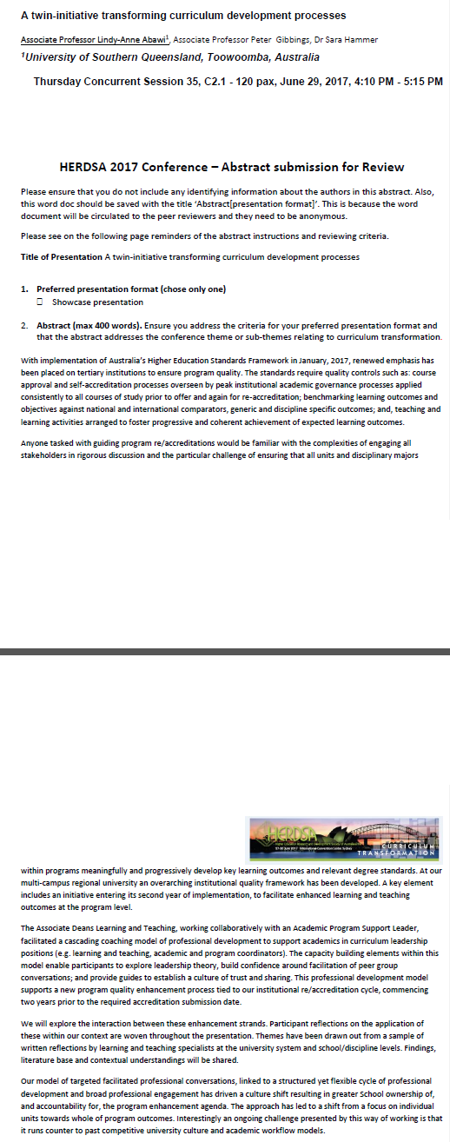
Extract from published proceedings of HERDSA conference 2017

